**DC086979 Rationale**

Overview

DC086979 proposes the remediation of a lapsed sand dress pitch to grass and the creation of a community greenspace at Peel Moat Open Space.

The sand dress pitch forms part of the current Peel Moat Open Space and was formerly part of the Peel Moat Recreation Centre.

Sport England Objection

Sport England objects to this application which would lead to the loss of playing field in an area where there is a deficiency in the provision of playing fields. The proposed development is not considered to accord with any of the exceptions in Sport England’s playing fields policy or any of the specified justifications in Paragraph 99 of the NPPF which both seek to protect playing fields from development.

England Hockey have requested the following as mitigation

Bramhall High School is the main hub for Hockey activity in Stockport. The club has a tripartite agreement in place with Stockport Council and their third party provider. The club manages the finances for the site very well but the site needs some modernisation. As such EH would expect to see the below as a contribution to the only existing Hockey facility in the area.

* £90k to replace the existing Fencing.
* £140k (minimum) to top up the sinking fund.
* £80k to modernise the existing lighting.
* £20k to improve the access and booking system through remote access.
* £20k for improved secure storage on site.

Total of £350k (expected to be costed officially before any agreement is signed).

Football Foundation

FF has no intelligence of when the facility was last used or where play went to when this facility ceased to be used. Aerial imagery suggests that the pitch fell into disrepair sometime between 2013 and 2016.

Though the Stockport PPS identifies Peel Moat Recreation Ground as a lapsed site, reference is only made to the grass playing field. The AGP appears to be an oversight and is not included in either document. FF does not consider the whole playing field site to be lapsed, as there is an active playground (built 2020) within the parcel of land referred to in the PPS.

Site History

The proposed remediation of the sand dressed pitch (DC086979) was formerly part of the Peel Moat Recreation Centre, which closed in April 2012**.** However, the sand dressed pitch, received not trade income for three years prior to this, since 2009.

The former Peel Moat Leisure Centre comprised a sports hall, fitness suite, squash courts, grass pitch sand dress pitch. The sand dress pitch was originally built in 1997. Prior to this the sports facilities were managed as dual use with North Area College. North Area College closed on January 2006

The closure of the Recreation Centre was discussed at full council meeting the November 2011, public questions but demonstrate the current facilities were not in usable condition. <https://democracy.stockport.gov.uk/ieListDocuments.aspx?CId=140&MId=4944&Ver=4>

<https://get-information-schools.service.gov.uk/Establishments/Establishment/Details/130513>

The sports pitches associated with in the former Recreational Centre where to be split between the new Primary School ( grass pitches) and Peel Moat Open Space ( sand dress pitch)

Evidence of the lapsed condition of the sand dress pitch and the closure of the leisure centre is provided below.

**April 2012** – Full Council meeting date for closure of Peel Moat Recreation Centre confirmed as 15th April 2012

<https://democracy.stockport.gov.uk/ieListDocuments.aspx?CId=140&MId=379&Ver=4>

**May 2012 –** Closure of the Leisure centre is discussed at Area Committee <https://democracy.stockport.gov.uk/ieListDocuments.aspx?CId=134&MId=262&Ver=4>

**April 2014** – Evidence of the pitch being in a lapsed state is demonstrated by photographs published by the Manchester Evening News <https://www.manchestereveningnews.co.uk/news/local-news/gallery/6921351>

and

<https://www.manchestereveningnews.co.uk/news/local-news/stockport-council-bosses-consult-school-6921352>

**March 2015** – Planning Approval is granted for the development of park of former Peel Moat Leisure Centre site.

DC057334 - Construction of new key stage 2 school accommodation and outdoor works including external hard-surfaced play areas, grass pitches, public rights of way improvements and car parking, for St Thomas' CE Primary School

Heatons & Reddish Area Committee - <https://democracy.stockport.gov.uk/ieListDocuments.aspx?CId=134&MId=5987>

The application notes; *prior to the closure of the Peel Moat Recreation Centre in April 2012, the site provided the following facilities;*

* *1 No. grass pitch,*
* *1No. Ashlar / ‘All-weather’ pitch*
* *1 No. derelict artificial grass pitch*

The grass pitch was annexed as part of the redevelopment of St Thomas Primary School and has been retained as grass pitches. DC057334 notes the artificial grass pitch (sand dressed pitch) as being *derelict* in 2015.

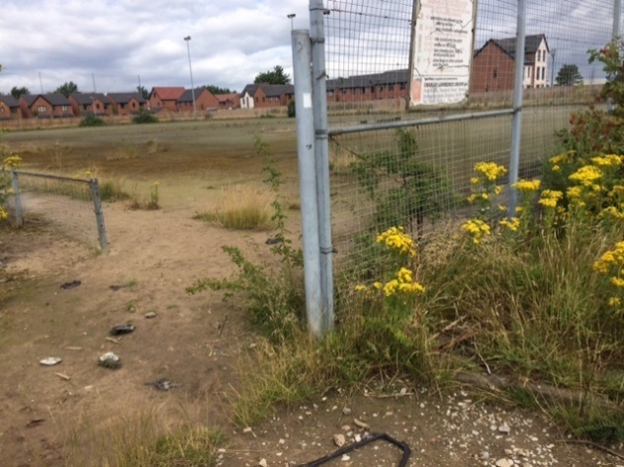 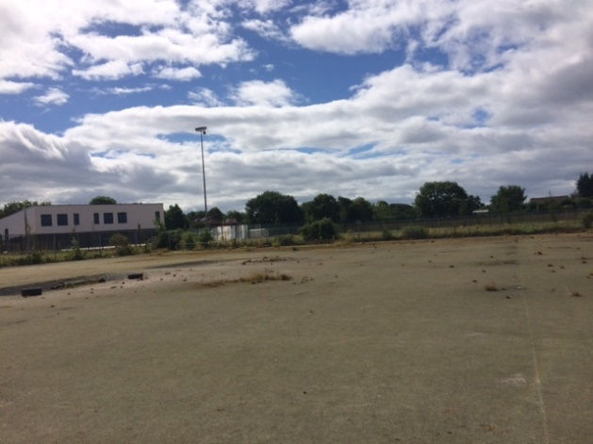

*Site photographs in 2016*

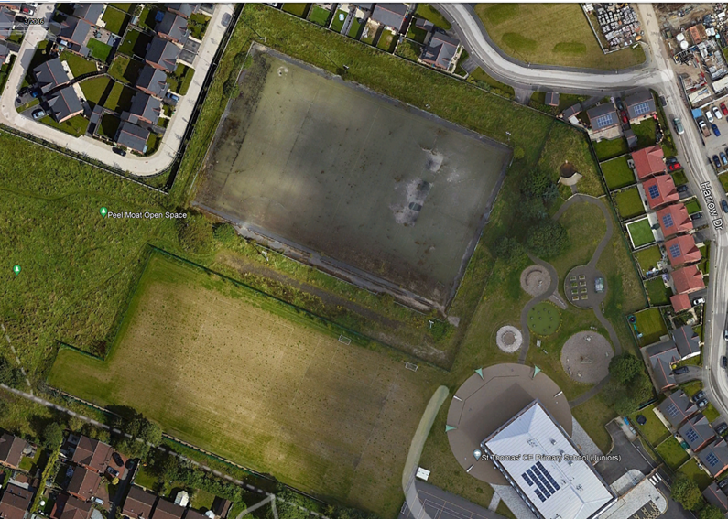

*Source Google Earth Pro – Aerial Photograph from 2016*

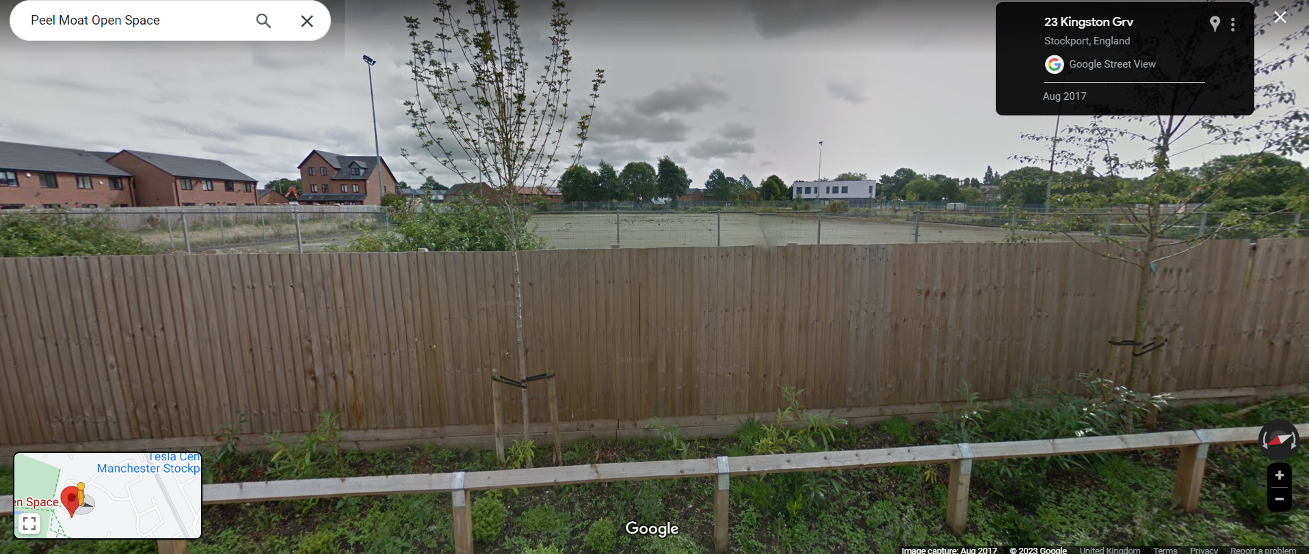

Source: Google Maps street view from 2017.

The current sand dressed pitch, which is now part of Peel Moat Open Space has not been managed or maintained as formal sport provision since 2009, when trading on the hire of the pitch ceased.

There has been no competitive hockey played on the site since the 2003/04 season.

Council Response to the Planning Objection

The sand dressed pitch at Peel Moat Open Space (formerly Peel Moat Leisure Centre) has been ‘lapsed’ for over 13 years*.* It was not suitable for sports use prior whilst it was part of the Leisure Centre and has been a redundant area of Peel Moat Open Space since 2012.

Disused sites are defined as not being used at all by any users and are not available for community hire either. Once these sites are disused for five or more years they will then be categorised as ‘lapsed sites’.

Lapsed sites are sites that last known use was as a playing field more than five years ago. These fall outside of Sport England’s statutory remit but still have to be assessed using against the National Planning Policy Framework. This is set out later in this report.

The Stockport Playing Pitch Strategy (Dec 2019) does not recognise the Peel Moat sand dressed pitch as a current hockey facility in the supply of provision for the sport.

Stockport Council accepts the PPS findings that there is a deficit of 7 hours of supply identified at peak times (Saturday) for competitive Hockey, however, the mitigation request of £350,000 investment at the Bramhall High School site would not be financially achievable.

Stockport Council is committed to addressing the deficits in sports provision and this is evidenced by.

* £200,000 match funding in providing a new AGP provision at Marple Hall School (2021) for the benefit of hockey and football.
* Secured and committed a minimum of £50,000 match funding to a new AGP provision at Reddish High School, the current facility is a disused sand dress facility.
* Werneth School (2020) redevelopment of the school includes new AGP provision for hockey and football (training and casual)
* Provided £10,000 (2022) in match funding towards a new keypad access gate to assist with the management of hockey at the Bramhall site.

Football provision

The grass pitch of the former Peel Moat Leisure Centre was retained and improved as part of the redevelopment of St Thomas Primary School. As part of this the lapsed sand dressed pitch was annexed from the school and became part of Peel Moat Open Space albeit as an unmaintained redundant facility.

The PPS identifies Reddish High School as a neighbourhood and boroughwide strategic priority. Stockport Council are committed to working with the Football Foundation and stakeholders to provide new AGP provision at the site, that is currently identified by the PPS as a disused sand dressed pitch.

The National Planning Policy Framework

The proposal should be considered against Paragraph 99 of the NPPF. This says:

Existing open space, sports and recreational buildings and land, including playing fields, should not be built on unless:

a) an assessment has been undertaken which has clearly shown the open space, buildings or land to be surplus to requirements; or

b) the loss resulting from the proposed development would be replaced by equivalent or better provision in terms of quantity and quality in a suitable location; or

c) the development is for alternative sports and recreational provision, the benefits of which clearly outweigh the loss of the current or former use.

The PPS clearly identifies and it is accepted that there is a deficit in peak time competitive hockey provision across the borough and a deficit in junior football provision in the Heatons and Reddish Area. However, it is also clear that this is a lapse pitch that does not form part of the supply considered in the assessment and has not been so since 2009. Therefore, whether it is surplus to requirements or not, is not relevant.

Stockport Council has taken steps to provide new AGP provision for hockey and football at Werneth School and Marple Hall School. Stockport Council is actively involved in providing new sports provision at Reddish High School, a site that the PPS (Dec 2019) recognises as ‘disused’. There has been significant Council and third party investment in improved hockey facilities since the publication of the PPS.

The proposal is not in conflict with c) NPPF as the land is to be retained for informal recreation provision. The proposal seeks to improve the area as a community greenspace and there is significant interest from the Friends of Peel Moat to make further enhancements.

The proposal is to create a community greenspace complements the wider area of open space in which it is located and which is better to suited to that informal use. The benefits which accrue from the improvements to the land would outweigh the loss of the redundant sports facility.

Conclusion

The sand dress facility was in a lapsed condition in 2009 when it formed part of the Peel Moat Leisure Centre and it has further declined in quality as it has been under no formal management or maintenance regime since then.

The provision at Peel Moat has been unusable for formal sport for over 13 years, the planning proposal seeks to provide a community greenspace, in line with current financial resources, for the benefit of the community.

Stockport Council request that Sport England reconsider their position on the planning proposal. It is further requested that Sport England are considered as a non statutory consultee on the proposal given the amount of time the facility has been in a *lapsed* condition.

Its acknowledged the current and potential future shortfall with regards to sports provision and Stockport Council are committed to working with stakeholders such as England Hockey and the Football Foundation to address these deficiencies. It should be noted there has been significant investment in improved AGP pitches since the publication of the PPS and Stockport Council is an active partner in securing funding for further AGP provision in the borough.

The PPS is being revised and stakeholders will be engaged in this process. However, this process is expected to take 12 months. There would be no benefit of delaying the remediation of the lapsed sand dressed pitch at Peel Moat Open Space for this amount of time.

It would not be feasible for Stockport Council to meet the current mitigation request of £350,000 to enhance hockey provision at Bramhall. We request that England Hockey and the Football Foundation take into consideration the investment that has been made in improved facilities elsewhere in the borough in the last two years, as well as the continued commitment to invest in future projects, such as the AGP at Reddish High School.

ENDS