APPLICATION TO STOCKPORT MUNICIPAL BOROUGH COUNCIL FOR PEEL MOAT OPEN SPACE TO BE DESIGNATED AS A LOCAL GREEN SPACE AND FOR THE CURRENT DEVELOPABLE DESIGNATION TO BE REMOVED
- This application for Peel Moat Open Space (PMOS) to be designated as a Local Green Space (LGS) comprises a request to remove the developable designation and justification for status as a LGS for the site, the two being indivisible. The application is made by Friends of Peel Moat Open Space (FPMOS) and is supported by other community organisations, a local school, environmental and other interest groups. For the purposes of this proposal the boundary of the requested LGS is marked in red on the map enclosed, the site is located at EASTING 38774 NORTHING 392559, postcode SK4 4PW. Please note this application supersedes the applications previously forwarded by FPMOS to SMBC planning. It is requested this application is included as a submission to the draft Stockport Local Development Plan (SLDP) and consultation. Two petitions linked to this request had a total of 748 signatures in support.
- FPMOS is a local interest group with appointed officers and a constitution. FPMOS has a publicly available website which contains additional information.
- The SMBC and FPMOS remediation plan for PMOS was focused on securing the site as an informal recreation area, community open space, outdoor education area and over time enhancing the site by planting and rewilding, (in line with the SMBC Plan 2023-2024, One Stockport 2023, Rewilding Stockport project, Stockport CAN) and providing a broad based and inclusive space available free to access to the community 24/7. Additionally, FPMOS planned to work with SMBC to address flooding issues which affect the site, the adjacent playground and Heaton Moor golf course, by sustainable drainage (SUDS) initiatives.
- Timeline.
1971 - Peel Moat Recreation Centre opened on Buckingham Road, Heaton Moor.
1997 - The AstroTurf pitch is added behind the leisure centre building.
2008 – The AstroTurf pitch is closed to the public with floodlights, fences and pitch covering left in place.
2010 – SMBC recommends the closure of Peel Moat Recreation Centre due to new sports provision being provided by Life Leisure in Reddish. There is much opposition to the closure from the public.
2012 – SMBC confirm Peel Moat Recreation Centre is to close.
February 2015 - Planning application for the demolition of Peel Moat Recreation Centre is approved and the centre is demolished.
April 2015 - Planning application for the construction of new Key Stage 2 school accommodation, for St Thomas' CE Primary School, approved.
2016 – New St Thomas’ junior school opened on the site of the recreation centre.
2017 – PMOS designated by SMBC for development of thirty-five dwellings in the 2017/2018 SHLAA where the site is also noted as “Greenfield”.
2018 – SMBC run a consultation on whether new play equipment should be installed at the grassed area adjacent to the astroturf pitch or in Heaton Moor Park. A fitness trail and playground are installed at Peel Moat, adjacent to Heaton Moor golf course.
2020 – SMBC Councillors Sedgewick, Taylor and Ryness send out a survey requesting public opinion on a future use for the abandoned astroturf site.
Summer 2022 – Fences and lights are removed from the astroturf site.
October 2022 – Application for planning permission DC086979 submitted for the importation of topsoil to cap the rubber crumb, the astro turf having been removed, and return it to a mow-able surface which would allow the area in question to be a usable, grassed, rewilded informal recreation space.
January 2023 – Sport England object to planning application DC086979.
March 2023 - Chemical surveys of the astro turf pitch and surrounding grassed areas completed.
July 2023 - Decision made by SMBC to treat Sport England objection as non-statutory and to proceed with the application to a conclusion.
25 July 2023 - Planning Permission (DC 086979) granted.
19 September 2023 - Anticipated schedule for commencement of Phase 2 works received by FPMOS.
2023 – Initial LGS designation applied for and removal of the developable designation for the entire site is requested.
19 Jun 2024 – FPMOS submit Stage 1 complaint to SMBC.
29 October 2024 – FPMOS submit Stage 2 complaint to SMBC.
25 November 2024 – In response to the Stage 2 complaint SMBC confirm in writing the developable designation first applied in 2017/2018 SHLAA is incorrect and will be amended.
December 2024 – PMOS “meanwhile project” proposal sent to Heatons and Reddish Ward committee and SMBC by FPMOS.
January 2025 – Asset of Community Value status applied for part of the site. SMBC Chief of Planning confirms the remediation plan will not go ahead, the planning application will lapse, and the FPMOS request to have the astro turf designation for development replaced with an LGS designation will not be granted during the upcoming local plan consultation and revision.
- When planning application (DC 086979) for the SMBC/FPMOS remediation project was approved by delegated authority a Sport England objection was set aside with the written support of FPMOS. In approving the application SMBC used the following rationale:
- “The National Planning Policy Framework
- The proposal should be considered against Paragraph 99 of the NPPF. This says:
- Existing open space, sports and recreational buildings and land, including playing fields, should not be built on unless:
- the development is for alternative sports and recreational provision, the benefits of which clearly outweigh the loss of the current or former use.
- The proposal is not in conflict with the NPPF as the land is to be retained for informal recreation provision. The proposal seeks to improve the area as a community greenspace and there is significant interest from the Friends of Peel Moat to make further enhancements.
- The proposal is to create a community greenspace compliments the wider area of open space in which it is located, and which is better suited to that informal use. The benefits which accrue from the improvements to the land would outweigh the loss of the redundant sports facility.”
- The SMBC/FPMOS remediation plan was presented to the SMBC Heatons and Reddish Ward Committee and was supported by the Committee members without adverse comments. SMBC committed an agreed budget of £165000 to commence and complete the work and agreed to support the FPMOS plan for the site (enclosed below). £30,000 of the allocated budget has been used to remove floodlighting and fencing. On 24 02 24 FPMOS wrote to SMBC requesting an update; the response of 29 02 24 stated a start date was not known for the remediation project (DC 086979). On 22 04 24 SMBC informed FPMOS the budget was now insufficient to complete the project as planned. FPMOS responded on the same day offering to fund raise from donors, this being possible only if the developable designation was removed. On 14 06 24 FPMOS asked if an alternative costed plan would be presented at the June ward Committee which SMBC had previously stated they intended to do. To date there has been no presentation of an alternative plan by SMBC. 03 07 24 FPMOS proposed to SMBC a reduced and reworked plan to reduce costs to an affordable level, no response was received. On 09 09 24 FPMOS presented the most recent of their two petitions to the Ward committee requesting the developable designation applicable to the PMOS playground and trim trail is removed and replaced with a LGS designation. Following a Stage 1&2 complaint by FPMOS, commencing 19 Jun 24, the Chief Planning Office replied to FPMOS on 17 Jan 25 finally confirming that the remediation plan will not go ahead, and approved planning application DC 086979 will be allowed to lapse.
- The FPMOS remediation plan is supported by St Thomas’s Primary school, Heaton Moor golf course and the Heaton Manor Residents Association who wrote to SMBC confirming their support. Cheshire Wildlife Trust, Rewilding Stockport, Sustainable Living in the Heatons, City of Trees and Rotary Lamplighters have conducted site visits and agreed in principle to support the FPMOS follow on phase once the initial SMBC remediation phase was completed, and the developable designation was removed.
- The highly popular Peel Moat play area and trim trail also currently falls under the developable designation. These were financed in part by funds provided by Bellway Development under s106 agreements related to Heaton Manor Estate and PMOS. An open spaces commuted sum of £335,017.87 was received across two payments. The play element was invested in the Peel Moat play area. Additionally, £405,000 as part of s106 agreements with Bellway, also related to Heaton Manor estate and PMOS, was spent on replacement sports provision as follows: North Reddish for pitch improvements (£92,918.97), Crescent Park fitness track with outdoor gym (£106,489.58) and Peel Moat for an access path with fitness trail (£55,646.83). £149,000 of unspent s106 funds were returned to Bellway under the terms of the s106 agreement, money which could have been made available to support remediation of the site and thus improve the ratio of open space to residents in Heaton Moor; none of the s106 funds referred to above have been used to overcome the deficiency of open space to residents in Heaton Moor. As noted by SMBC Planning, the NPPF states existing open space, sport and recreational buildings and land, including playing fields, should not be built upon unless an assessment demonstrates they are surplus to requirements.
- The site is approximately 1.5 hectares in size, is not part of the Green Belt or subject to covenant. There are no extant planning permissions granted on the site other than that referred to above. The grass surround of the astro turf pitch has over time rewilded naturally, extensive bramble growth has developed as a habitat for a variety of birds, foxes, hedgehogs, badgers and rodents. Frogs and toads breed on wetter part of the surround and in the swale, which is visited by heron and Canada geese and a variety of other birds. Since the pitch has become derelict willow, birch and oak trees have grown on site as has dogwood and a range of wildflowers. Bees and other pollinators are very evident throughout. The Friend’s plan was to further enhance the site as a habitat for flora and fauna and create two bog gardens as well as planting of trees and other native species to further support biodiversity. To date an Ecological Appraisal has not been conducted on the site, however there is on site and local security camera evidence of badgers and cubs, indicating the presence of setts, which are protected by the Protection of Badgers Act 1992. There is evidence PMOS is a transit route for wild animals, which is consistent with designation as part of the green chain. The part of the site adjacent to the playground has seen considerable tree and other planting by SMBC which continued in 2024. There are also plans by SMBC to plant trees on the astro turf surround. (see enclosed photo of SMBC tree planting plan). It should be noted when removing the fence and floodlights SMBC contractors destroyed considerable naturally rewilded growth of bushes and trees, including semi mature oaks, beech and willow. This was despite a FPMOS email request to Ward Councillors prior to work commencing for this not to happen.
- The proposed LGS is concurrently designated by SMBC as follows:
- developable
- within the green chain (see enclosure), which indicates the site has been prioritised for linking up and restoring habitats.
- a local open space (see enclosure).
- linked to the strategic walking network (see enclosure) and adjacent to the strategic open space of Heaton Moor golf course.
- is not included in the SMBC brownfield sites register. The NPPF prioritizes the reuse of brownfield land over greenfield/open spaces unless they are demonstrably not suitable or viable. Brownfield or previously developed land is defined as: “Land which is or was occupied by a permanent structure, including the curtilage of the developed land (although it should not be assumed that the whole of the curtilage should be developed) and any associated fixed surface infrastructure. This excludes: land that is or was last occupied by agricultural or forestry buildings; land that has been developed for minerals extraction or waste disposal by landfill, where provision for restoration has been made through development management procedures; land in built-up areas such as residential gardens, parks, recreation grounds and allotments; and land that was previously developed but where the remains of the permanent structure or fixed surface structure have blended into the landscape.”
- The commitment by SMBC to develop, as a priority, brown field/previously developed land is welcome, noting PMOS is excluded as previously developed land as defined in the NPPF nor is the site included in the extant SMBC brownfield register nor was it when the site was designated for development in 2017/2018 (see enclosed). The site is beyond the curtilage of the former industrial site which was designated as brownfield, and which now forms part of the Heaton Manor estate.
- The proposed LGS is an extremely popular and well used resource. It is close to extensive residential housing across the Heatons and beyond, and benefits from several pedestrian and cycle routes, with the potential to enhance the existing green chain. Heaton Manor estate (200+ dwellings) has pedestrian/cycle access points to the proposed LGS and at its nearest point is 50m from the site. Harmsworth Drive and the adjoining roads are within 50m of the proposed LGS. Burnage is accessed via a footpath across the Heaton Moor golf course. There is convenient pedestrian and cycle access over the railway line which runs parallel to Tatton Road and four pelican crossings over the A6 which ease pedestrian access from Heaton Chapel and Reddish. There are extensive interconnected and far-reaching non-vehicular routes linked to the site, as detailed in the strategic walking network and the TfGM interactive map http://tfgm.pindarcreative.co.uk/.
- Following Stage 1 & 2 complaints by FPMOS, investigated by SMBC, it was confirmed the developable designation covering the playground and trim trail was applied in “error” in 2017/18 and will ultimately be removed. It is assumed this will occur as part of the 2025 revision of the SHLAA which will precede the revised SLDP. Considering the SHLAA methodology outlined in the 2021 SHLAA Methodology and Findings and all other SHLAAs to date it is difficult to comprehend why the initial “error” was not highlighted and corrected. Heatons and Reddish Ward Committee meetings considered financing and approving the playground and trim trail, situated within the developable designation, and from the records FPMOS have seen at no time was the Committee alerted to the developable designation, which could have influenced their decision. Again, the FPMOS submission of two previous LGS proposals, two petitions, presentations and numerous questions should have alerted the Planning Department and Planning Policy to the “error.” If the playground and trim trail where intentionally included in the developable designation with a view to removing them in due course, as a concession to reduce public objections to the development of PMOS, this would be seen as a transparent and inappropriate ploy. Considering the 7-year “error “detailed above, it is hard to understand how the process of designating the entirety of the site as developable could have followed the procedures described in the 2021 SHLAA Methodology and Findings and all other SHLAAs.
- Implicit in a developable designation is the prospect of ultimate delivery within a specified time. There is also the presumption a developable designation will attract a developer and progress through the planning process without insurmountable, problematic or excessively costly obstacles or objections which would degrade the potential profitability of the site. To date, despite the adjacent Bellway development of Heaton Manor, there are no indications of interest by a developer. The site is situated in a desirable area but since the site was closed to the public in 2008 there has been no serious attempts to develop nor any attempts to have it designated as a brownfield site. This in part could be due to the astro turf and rubber crumb beneath which covers most of the site. Two on site chemical and toxic surveys were conducted on behalf of SMBC. The second survey found hazardous, toxic and potentially carcinogenic elements onsite. (see enclosed extracts from second survey). SMBC were emphatic, during discussions regarding the proposed work by FPMOS, post Phase 2 of DC 086979, that rubber crumb could in no way be relocated on site, planted or cultivated upon, indicating a degree of ongoing concern by SMBC. The presence of chemicals such as polycyclic aromatic hydrocarbons (PAHs), heavy metals (lead, zinc), and volatile organic compounds (VOCs) that can be inhaled or come into contact with skin is a concern which was not fully addressed when the site was designated for development or to date. The enclosed planning portal reference PP11576335 surprisingly details the site as having no evidence of contaminants. Unresolved health and safety concerns, the cost and risks of full removal and safe disposal of the astro turf plus rubber crumb and the associated water run off issues are likely deterring developer interest in the site. With the footprint of the developable designation likely to be reduced in size (see above regarding the playground and trim trial and footnote 8) the reduced housing density would also suggest the site would be less profitable for a developer and hence less attractive.
- When Heaton Manor estate was developed sustainable drainage (SUDS) was not included. This failure exacerbated the existing surface water problems which causes large parts of Heaton Moor golf course to be unplayable and the grassed area around the playground to be unusable. A Google maps search of the estate shows a considerable number of houses have opted for artificial grass and paved drives and gardens thus increasing the amount of water run-off. Policy SD-6 requires a 50% reduction in existing surface water run-off and the incorporation of SUDs to manage water run-off. To develop PMOS as SMBC planning intend would increase this problem whereas the FPMOS remediation and planting plan, which included SUDs would have decreased run off. The height of Heaton Moor above the surrounding area and the extent of water run-off contributed to recent severe flooding. The prospects of continued climate change indicate this is a problem which will get worse if open spaces continue to be developed.
- The congested and narrow vehicle access via Harrow Drive is the only route in and out of Heaton Manor estate and PMOS, extensive pavement parking on the first bend of Harrow Drive further constricts vehicle access. Creating a new access point via Harmsworth Drive would cut through an existing footpath which is used to access St Thomas’s Primary School and entail removing the trim trail and playground. Residents of the Paddocks would likely object to the creation of a “rat run” through a quiet residential estate. Additionally, it should be noted due to the concerns regarding St Thomas’s Primary School pupils’ safety during pick up and drop of times, a School Street closure has been approved and implemented on Buckingham, Brownsville and Tatton Roads, further constricting access. There is also an increased volume of school transport at the same time related to Heatons School. These factors would suggest planning objections related to access, traffic volumes and road safety are highly likely. SMBC assessed PMOS as landlocked when lapsing it as a recreational facility adding weight to considerations of problematic access. The finite capacity of St Thomas Primary school, which would be overlooked if flats are constructed, as most likely would Heatons School, could also be the grounds for further problematic objections.
- Heatons Councillors have consistently stated in correspondence with FPMOS and during Ward Committee meetings they would oppose attempts to develop PMOS. Despite the Labour Government’s increased house building targets, it is assumed the Labour controlled Heatons and Reddish Ward Committee will continue to respond to local interests and wishes rather than be “whipped” to conform with Labour Government/Party direction. The Planning Committee and Council Cabinet it is assumed will continue to adopt a brownfield first approach. The Mirlees Field and Gatley Golf course Inspectorate decisions indicates a divergence in opinion between elected officials and the Planning Department regarding green and open space development. Any proposed development of PMOS, a small site with considerable obstacles to development and potential for objections, could result in similar additional, unnecessary and avoidable Inspectorate costs.
- An open space assessment was not conducted before Heaton Manor planning permission was granted. In allowing development of Heaton Manor SMBC permitted a breach of the open space standards in relation to the permitted population density to open space ratio and play facilities. The SMBC Open Space Provision Commuted Sum Payments SPD 2019 references Development Management Policy SIE-2 “Provision of Recreation and Amenity Open Space in New Developments” states “The requirements from this Policy are for residential development schemes to contribute towards the provision of open space for formal recreation and children’s play, to serve the future occupants. This policy is based on the Fields in Trust Standard (FiT) in meeting the Borough’s open space needs. To meet the Fields in Trust Standard (FiT), Stockport Council must provide 2.4ha (24,000 sqm) of open space provision per 1000 population of which 0.7ha (7,000sqm) should be for children’s play casual recreation and 1.7ha (17,000sqm) for formal recreational space.”
- Therefore, to allow further development on PMOS would be a further breach of the open space standards, thereby compounding the initial error. There is a shortfall of open space and recreation sites in Stockport and specifically in the Heatons which the FPMOS proposal and DC 086979 would have addressed. It is noted that SMBC have in the past conflated open spaces, when attempting to justifying planning approvals across the entirety of Stockport or areas larger than the footprint of individual wards or proposed developments. This is at odds with the designations and purpose of LOCAL open space in that they are intended to service a local community ideally within walking distance of any actual or potential open space. To include open spaces in any assessment at a greater distance such as Highfield Park, or Reddish Vale would be hard to justify, noting PMOS is designated as a Local Open Space and as part of the Green Chain. Whilst it is acknowledged the privately owned Heaton Moor golf course is designated as a Strategic Open Space public access is only permitted on the narrow public footpath which crosses the course.
- The NPPF stresses the importance of open spaces particularly for promoting health and wellbeing, mitigating climate change and enhancing biodiversity which aligns with SMBC Plan 2023-2024, One Stockport 2023, Rewilding Stockport project and Stockport CAN. Proposed developments should demonstrate a measurable net gain for biodiversity, which might be compromised if a site is developed; it is questionable if these considerations were addressed when the site was designated for development. The Knight, Kavanagh Page 2017 report (extract enclosed) and the FiT assessment of Heaton Moor (enclosed) identifies a shortage of greenspaces against the accepted standard, and it is again questioned whether this was considered when designating PMOS for development. The NPPF also stresses “all plans should promote a sustainable pattern of development that seeks to: …align growth with infrastructure, improve the environment, mitigate climate change.” The 2024 revised NPPF also states:
“ Planning policies and decisions should aim to achieve healthy, inclusive and safe places and beautiful buildings which: a) promote social interaction, including opportunities for meetings between people who might not otherwise come into contact with each other…enable and support healthy lifestyles, especially where this would address identified local health and well-being needs – for example through the provision of safe and accessible green infrastructure, ……plan positively for the provision and use of shared spaces….. Access to a network of high-quality open spaces and opportunities for sport and physical activity is important for the health and well-being of communities and can deliver wider benefits for nature and support efforts to address climate change. Planning policies should be based on robust and up-to-date assessments of the need for open space, sport and recreation facilities and opportunities for new provision. Planning policies and decisions should…. encourage multiple benefits from both urban and rural land, including through mixed use schemes and taking opportunities to achieve net environmental gains – such as developments that would enable new habitat creation or improve public access” PMOS when remediated as FPMOS and the local community expected, and designated as LGS, would have met these NPPF requirements. Saved UDP Policy UOS1.3 protects land under a Local Open Space designation unless it meets one of three exceptions listed in the policy. The most relevant is criterion (ii) relating to the demonstration there is adequate provision of open space in the local area and the loss of the site would be detrimental to community well-being or to local amenities. The shortfall of space referred to above clearly indicates the exception does not apply and that the loss would be detrimental and exacerbate an existing shortfall in Heaton Moor. The Town and Country Planning Act 1990 requires decisions to be made in accordance with the Local Development Plan, the 2024 draft of which commits to a brownfield first approach. As stated previously PMOS is not brownfield and nor does it meet the criteria to be so designated. The Act also states if a development plan identifies the area for protection or highlights deficiencies in greenspace, this is a significant material consideration. As mentioned PMOS forms part of the green chain is designated as Local Open Space and there is a deficiency in open space in Heaton Moor. Additionally, the Climate change Act 2008 requires consideration of the impact of greenhouse gas emissions, and protecting greenspaces should align with a Council’s carbon reduction commitments. The Environment Act 2021 enforces biodiversity net gain requirements. If a site has naturalized over time, which PMOS has, its’ ecological value may outweigh the potential for development.
- There is a considerable body of evidence to substantiate that the local community uses the site as an informal recreation area, and it is viewed by residents as a community asset. FPMOS has received numerous commitments from SMBC that residential development of the site is neither imminent nor is it supported by the three Ward Councillors. The site to date has attracted no developer interest and it is questionable if PMOS can be cost effectively delivered as a development for the reasons previously outlined. The failure to restore the site for the benefit of the community for a decade and half contrasts sharply with the aspirations of FPMOS and residents. The site is a valued and well used local asset which if designated as a LGS would be preserved for the local community and more likely to attract donor support to further develop the site with the support of the FPMOS.
- There is concern the presence of toxic and carcinogenic substances referred to in the second chemical survey, accessibility and the water run off risk were not accurately assessed during updates of the SHLAA. SHLAA 2017/2018 states the following had been assessed: “physical limitations or problems such as access…ground conditions, flood risk ...pollution or contamination”, it is now apparent this was not the case.
- The current developable designation of the site is questionable; being based upon a series of contradictions, errors, cursory desk-based assessments, procedural irregularities and failures to consult appropriately in accordance with the SMBC SCI dated Oct 2015 and the Gunning Principles. SMBC plannings’ demonstrable intent from outset was to develop the site for housing and to set the conditions for that by allowing the site to lapse, ignoring community requests and consultations to have it brought back into use. It is disappointing the 17 Jan 25 Chief Planning Officer correspondence (see footnote 8) states “As previously explained, any comments regarding the land and its designation should be made via the Local Plan consultation process…. the rest of the site will still be recognised as having development potential..”. This clearly indicates despite the contents of this submission by FPMOS and all previous requests, SMBC planning do not intend to consider removing the developable designation. This is at odds with the Gunning Principles (see footnote 20, principles 1&4) and the Statement of Community Interest, in that SMBC have pre-determined the outcome of this submission before the Local Plan consultation process has commenced.
- The entire site is better suited to the current use as a playground/trim trail and community open space including the intended FPMOS remediation. The site meets the criteria for designation as an LGS and considering the inappropriateness of the site for residential development the current developable designation should be replaced with an LGS designation. By granting this request SMBC and Ward Councillors would conclusively prove local community opinion matters, and Council planning processes are compliant with obligations regarding public consultation, climate, environment, open space, health and a sustainable quality of life.
Peter Appleby
on behalf of FPMOS.
21 01 25

LGS APPLICATION MAP
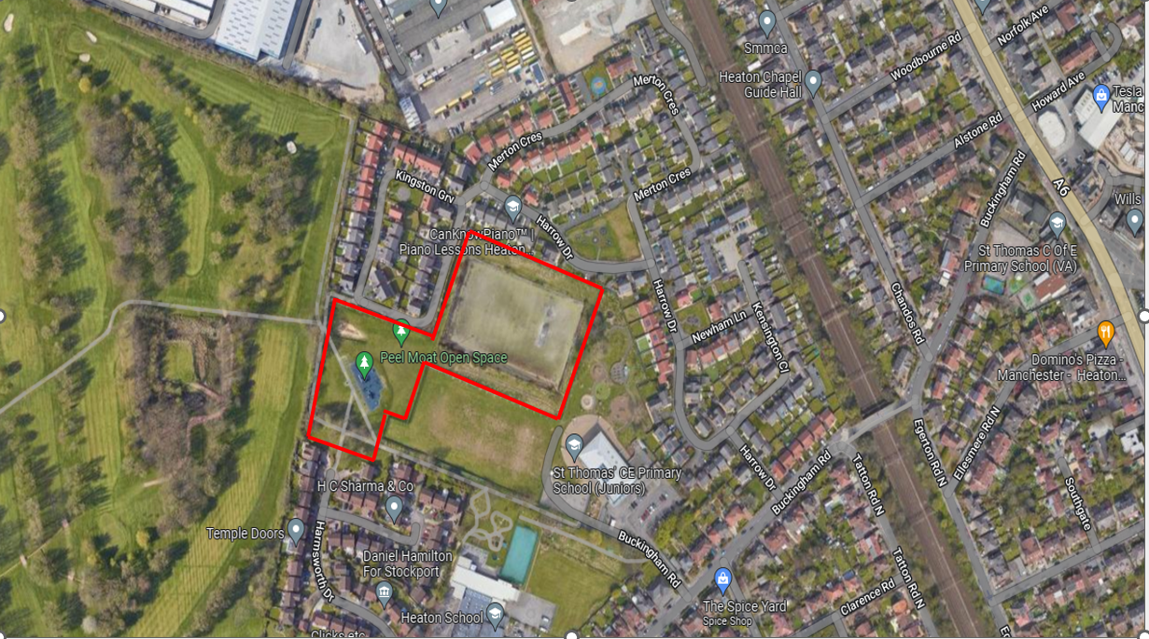

STRATEGIC WALKING NETWORK
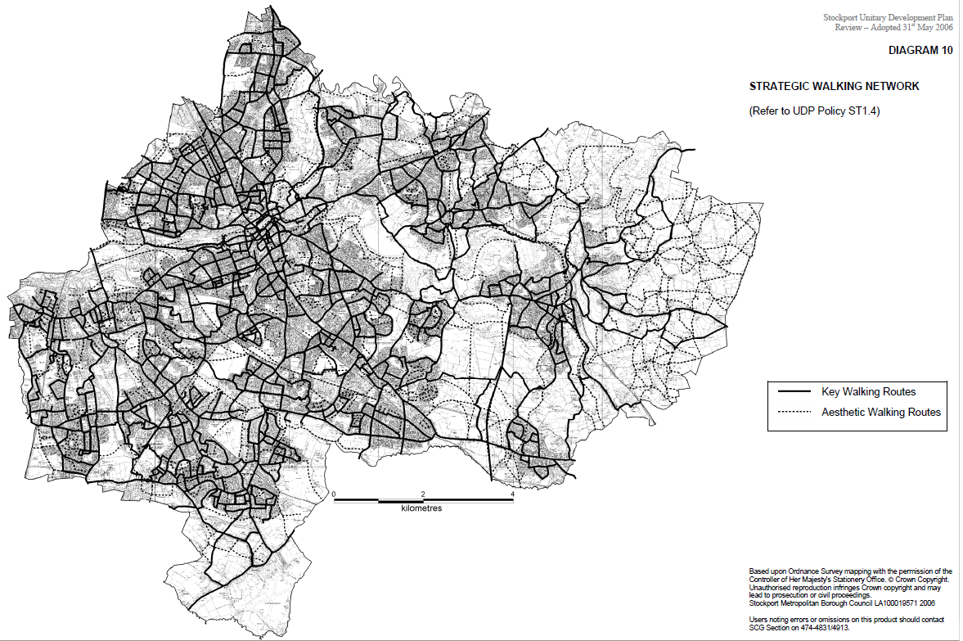

GREEN CHAIN
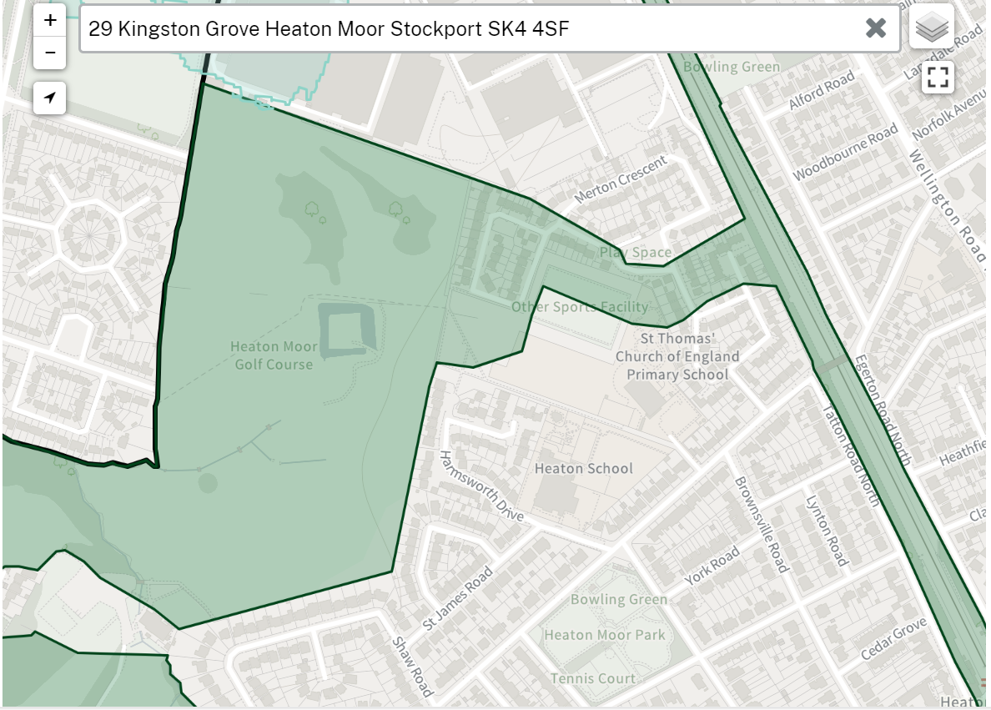
OPEN SPACE
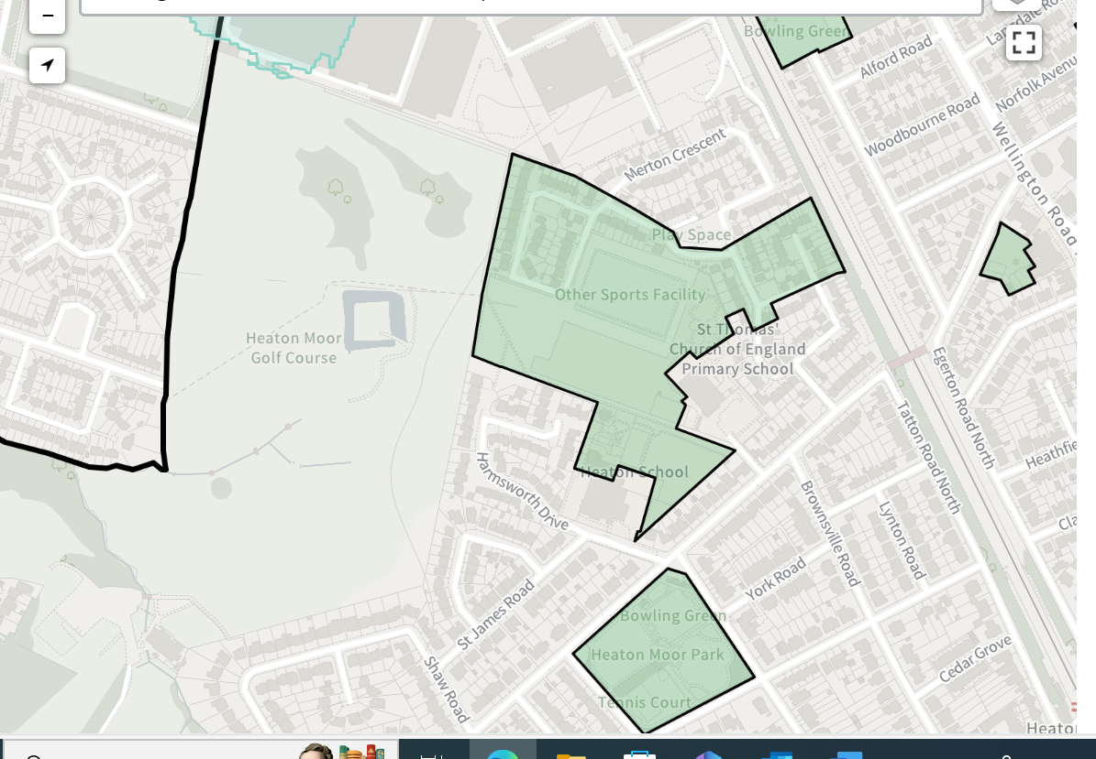
STRATEGIC OPEN SPACE
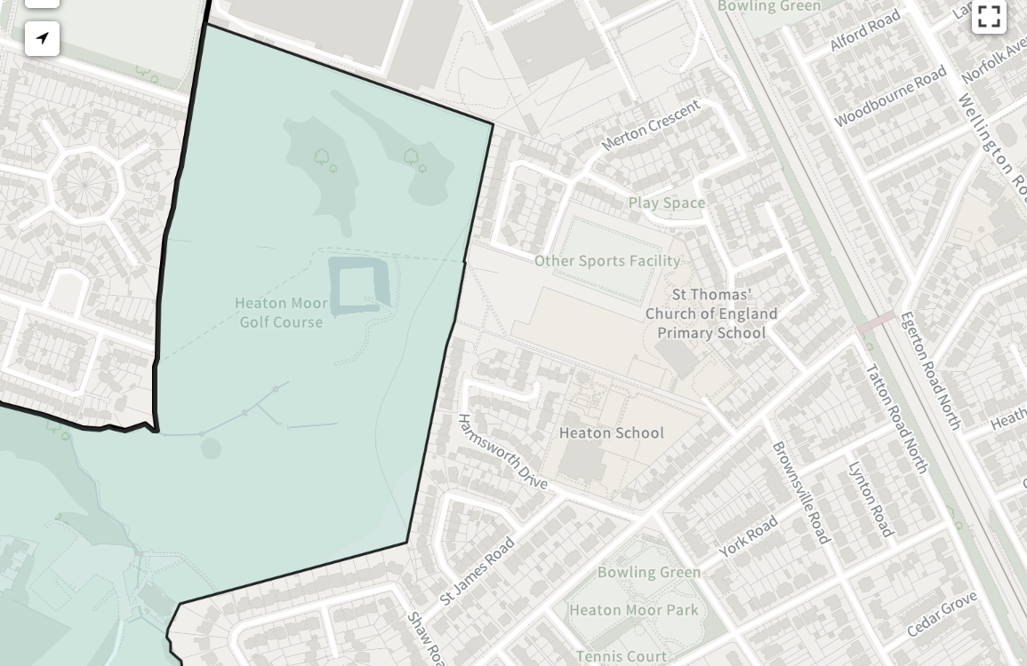
DEVELOPABLE LAND PMOS.
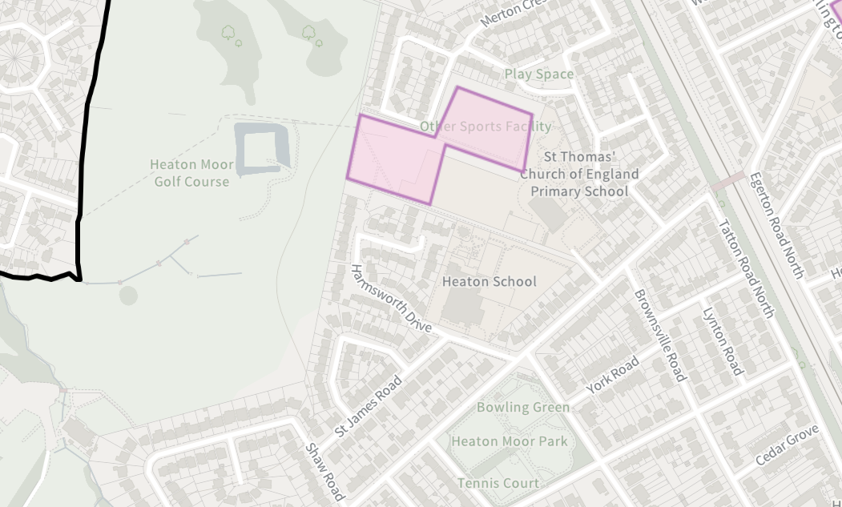

KNIGHT KAVANAGH PAGE REPORT 2017
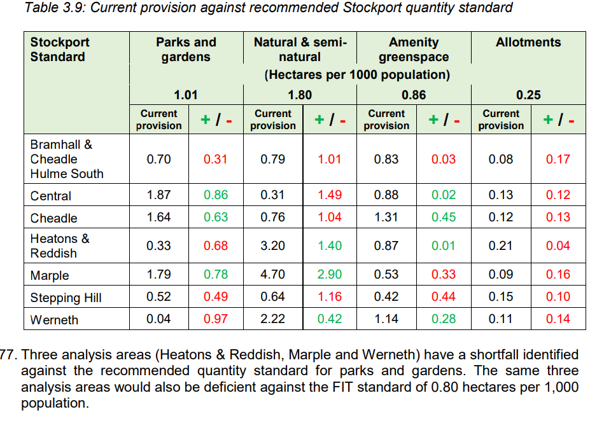
FIELDS IN TRUST GREEN SPACE INDEX - HEATON MOOR
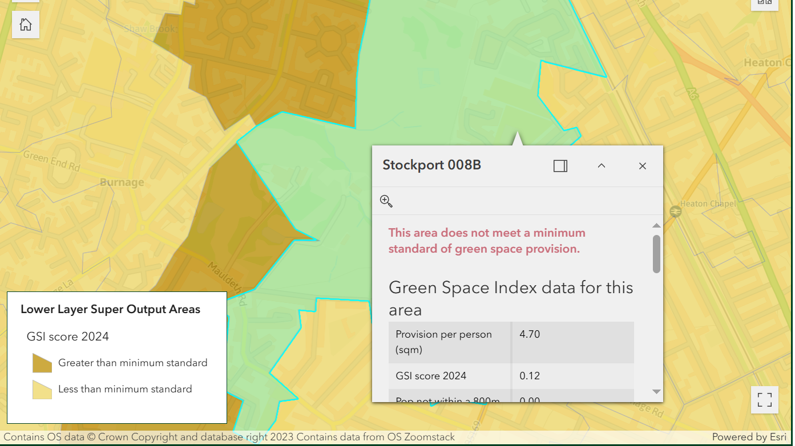

SMBC BROWNFIELD REGISTER
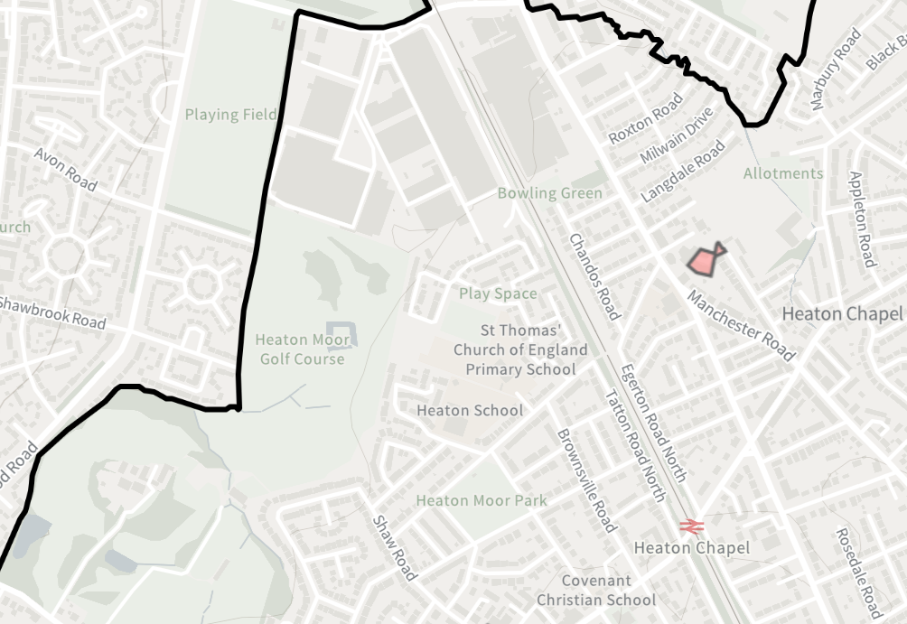
SMBC WATERFLOW MAP
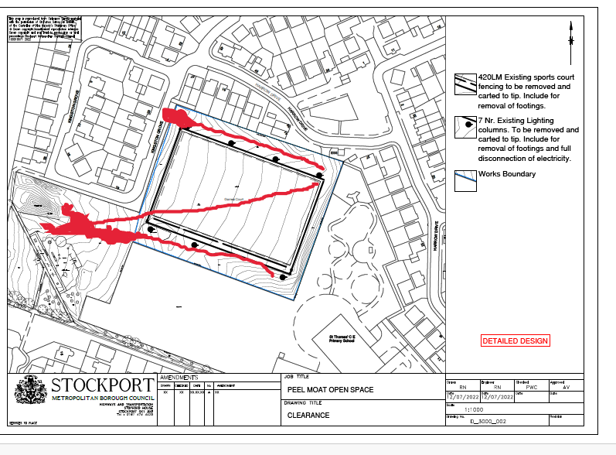
FPMOS PLAN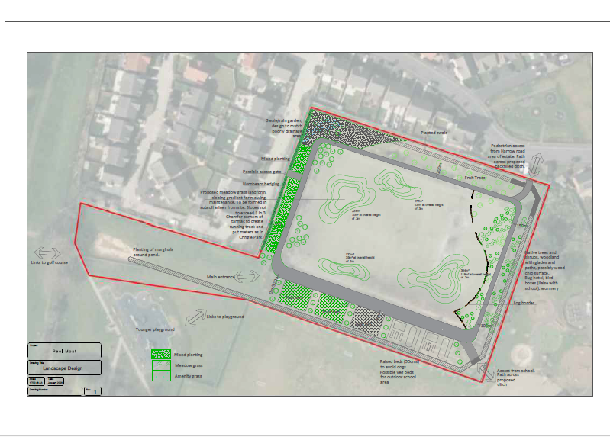
SMBC TREE PLANTING PLAN 2024
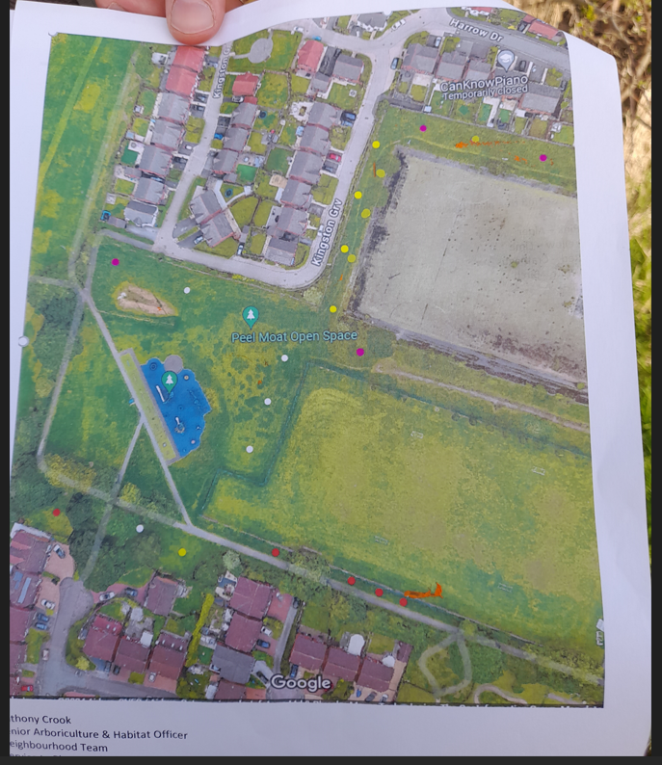

CHEMICAL SURVEY EXTRACT AND PLANNING PORTAL REFERENCE
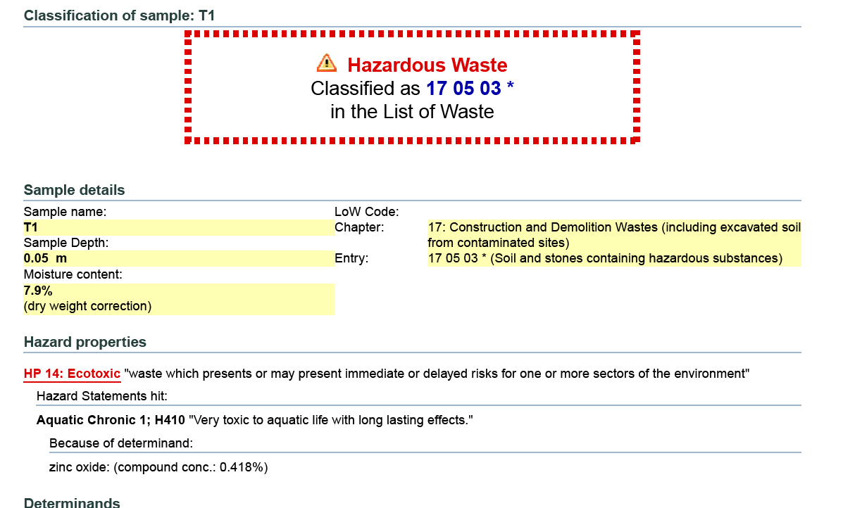

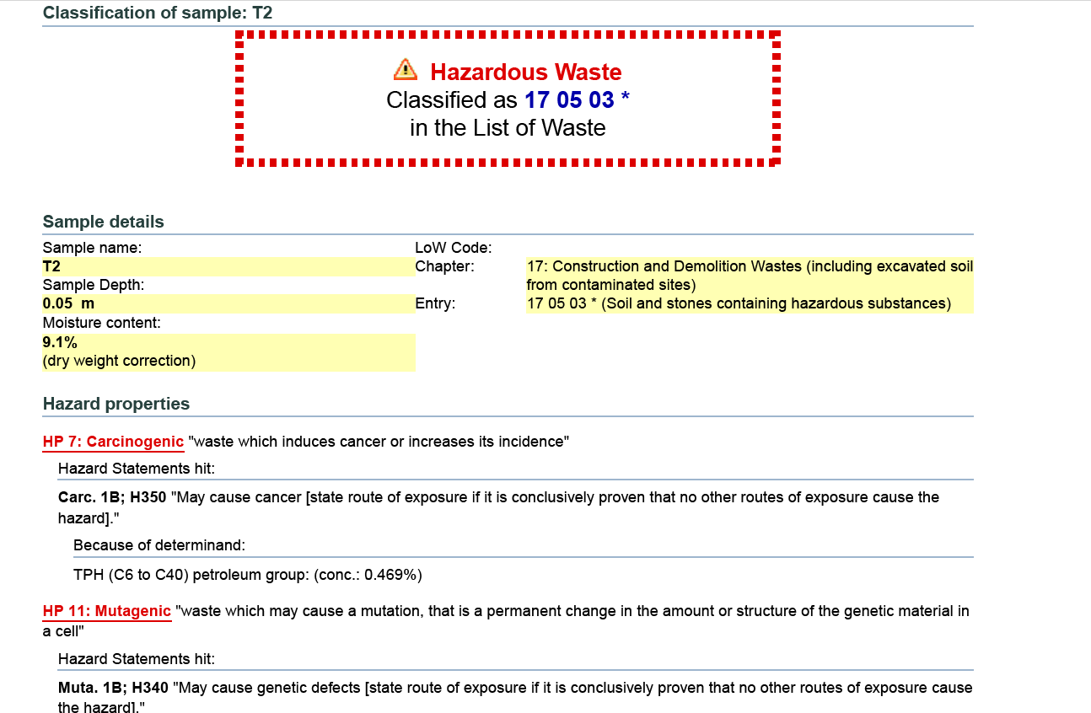

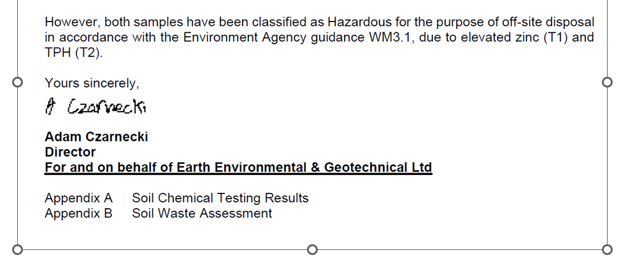
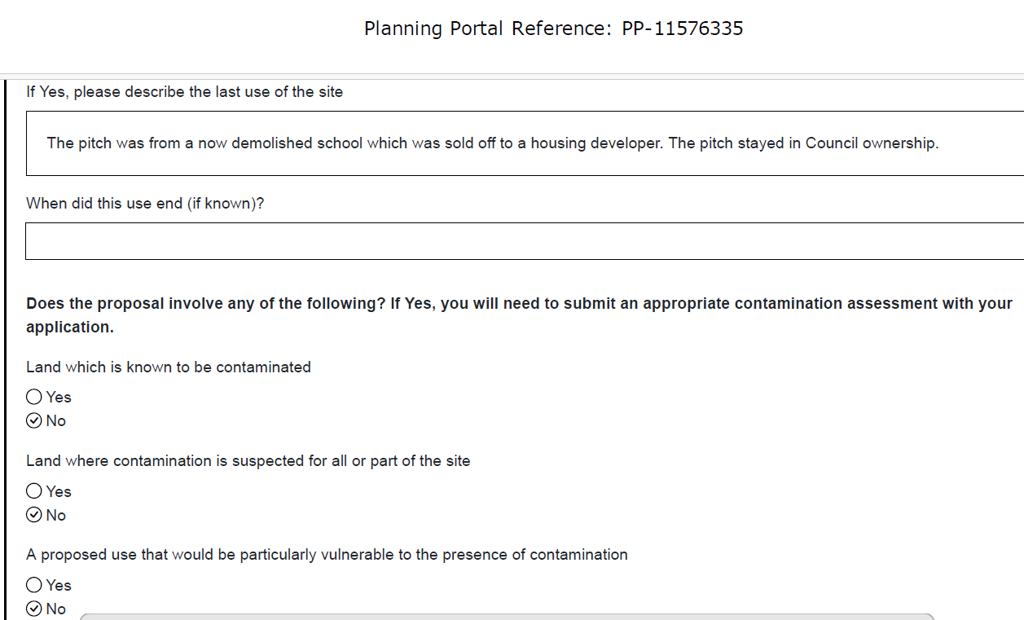

DRAFT LOCAL PLAN 2024-MAP

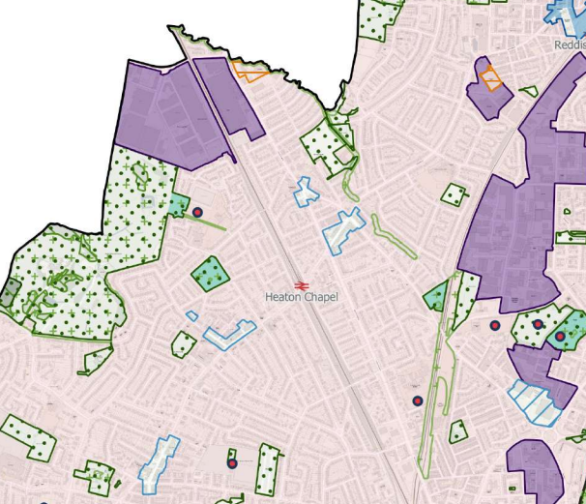
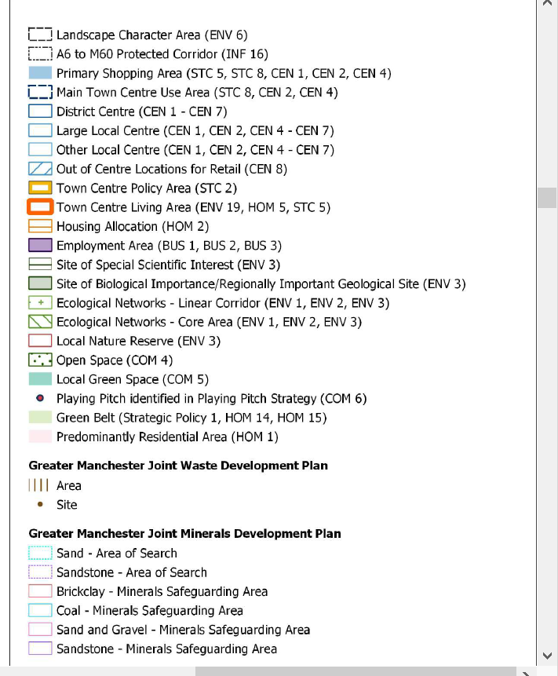

Home - Friends of Peel Moat Open Space (e-voice.org.uk)
Stockport Council Plan 2023 to 2024 print version
*borough-plan.pdf (onestockport.co.uk)
Rewilding Stockport | Cheshire Wildlife Trust
mgConvert2PDF.aspx (stockport.gov.uk); Climate Action Now Plan
FPMOS support for DC 086979 and the setting aside of the Sport England statutory objection was conditional upon the developable designation being removed. This conditional support is now retrospectively withdrawn until the developable designation is removed. In consideration of the failure to date of SMBC to proceed with DC086979 despite offers of support from FPMOS, the planned dereliction of PMOS and failure over fifteen years plus to respond to community requests to return the site to some form of recreational community use, FPMOS would support any Sport England objection to the continued designation of the site for residential development.
The £30000 of the allocated remediation budget has been spent to remove fencing and floodlighting; as the remediation will not commence this money has been inappropriately spent, most likely to enhance the development potential of the site.
Letter response to FPMOS Stage 2 complaint by Emma Curle, Chief Planning Officer dated 17 Jan 25.
Strategic Housing Land Availability Assessment (SHLAA) 2017/2018 and to date.
Complaint case 101007745541 Appleby response dated 25 11 24 from Sandra Shuttleworth SMBC Senior Complaints Officer.
SMBC Executive report summary sheet dated 7 Nov 2016.
SHLAA 2017/2018 para 3.16 “Deliverable sites should be available now, …..and be achievable with a realistic prospect that housing will be delivered on site within five years”.
Refer to SHLAA 2017/2018 para 3.29 & 3.51.
EAC to examine flood resilience as homes and businesses recover from more flooding misery in recent weeks - Committees - UK Parliament
Heaton Wards Councillor’s letter to FPMOS dated 01 03 24. “I am writing to express our strong opposition to any further expansion of housing on the former Peel Moat playing pitch site. I am deeply concerned about the potential ramifications of such development on our community and local environment. However, please be assured there are no current plans to develop this site, but we would strenuously oppose such a move if it were muted. The Heatons is already a densely populated area, and it is crucial to acknowledge that we are already delivering more new housing per square meter than any other area of Stockport outside the Town Centre. Further housing expansion would exacerbate issues related to traffic congestion, strain on local services, and the loss of green spaces, which are vital for our wellbeing and quality of life. Labour councillors in our area have long been committed to and have stood for election on a pledge of developing Peel Moat as a green space for recreation. This commitment reflects the desires of many residents who value the importance of preserving and enhancing our natural environment for future generations to enjoy.”
Stockport Council Plan 2023 to 2024 print version
*borough-plan.pdf (onestockport.co.uk)
Rewilding Stockport | Cheshire Wildlife Trust
mgConvert2PDF.aspx (stockport.gov.uk); Climate Action Now Plan
Gunning Principles 1985 - 1: Consultations must occur while proposals are still at a formative stage. 2: Sufficient information needs to be supplied for the public to give the consultation ‘intelligent consideration’.3: There needs to be an adequate time for the consultees to consider the proposal and respond. 4: Conscientious consideration must be given to the consultation responses before decisions are made. The point of Gunning Principal 1 is that the decision maker (SMBC) cannot consult on a decision that it has already made. If it does the consultation is not only unfair but it is also pointless as the outcome has been pre-determined. Microsoft Word - ConsultationJan2012. These principles were reinforced in the Coughlan case which confirmed that they applied in all consultations and then again in a Supreme Court case in 2014 (R ex parte Moseley v LB Haringey) which endorsed the legal standing of the the four principles.
A: Localism Act 2011. B: National Planning Policy Framework. December 2023/24. National Planning Policy Framework (publishing.service.gov.uk) C: Stockport Local Development Scheme. https://www.stockport.gov.uk/stockport-local-development-scheme/introduction-stockport-local-development-scheme D. Local Nature Recovery Strategies (LNRS). https://www.gov.uk/government/publications/local-nature-recovery-strategies/local-nature-recovery-strategies E. SMBC statement of Community Involvement. Statement of Community Involvement (PDF 670Kb) F. Planning and Compulsory Purchase Act 2004 Section 18. G. Town and Country Planning (Local Planning) Regulation 2012-Regulations 4,5,12,13,17,18,19,20,35 & 36. H. The Town and Country Planning (General Permitted Development Order 2015). I. NPPG 2014. J. Environmental Assessment of Plans and Programmes 2004. K. Conservation and Habitats and Species Regulations 2010.

