APPLICATION TO STOCKPORT MUNICIPAL BOROUGH COUNCIL FOR PEEL MOAT OPEN SPACE TO BE DESIGNATED AS A LOCAL GREEN SPACE (LGS)
23 04 2024
References:
a. National Planning Policy Framework. December 2023. National Planning Policy Framework (publishing.service.gov.uk)

- This application is made by Friends of Peel Moat Open Space (FPMOS) and is supported by other community organisations, a local school, environmental and other interest groups. For the purposes of this proposal the boundary of the requested LGS is marked in red on the map enclosed. The aim is to secure the site now as a community focused local recreation and green space and to enable over time for the site to be further enhanced by volunteers and donor funding as a community asset.
- Please note this application supersedes the application previously forwarded by FPMOS to SMBC planning on 6 March 2024. It is requested this application is included as a submission to the upcoming SMBC planning policy review and public consultation.
- FPMOS is a local interest group with appointed officers and a constitution. The FPMOS committee and volunteers will continue to develop and maintain the site in collaboration with SMBC. FPMOS has a publicly available website which contains additional information.
- National Policy. The revised National Planning Policy Framework (NPPF) came into force in July 2018. The NPPF advocates “a presumption in favour of sustainable development and identifies the three dimensions of sustainable development as economic, social and environmental. Access to high quality open spaces and opportunities for sport and recreation are highlighted as an important aspect of healthy communities and helping to improve biodiversity, thereby contributing sustainable development”. The National Planning Policy Framework (NPPF) paragraph 96 highlights the importance of access to open spaces and opportunities for sport and physical activity as they make an important contribution to the health and wellbeing of communities.
- The SMBC and FPMOS plan is focused on securing the site as an informal recreation area, community open space, outdoor education area and over time enhancing the site by planting and rewilding (in line with the SMBC Plan 2023-2024, One Stockport 2023, Rewilding Stockport project, Stockport CAN) and providing a broad based and inclusive space available free to access to the community 24/7. Additionally, FPMOS would work with SMBC to address flooding issues by sustainable drainage (SUDS) initiatives on the site which affect the site, the adjacent playground and Heaton Moor Golf course.
- This FPMOS plan was presented to the SMBC North Reddish and Heatons Ward Committee and was supported by the Committee members without adverse comments. Two petitions linked to this request, one related to the derelict Astro Turf Pitch and a second to the area surrounding the playground and trim trail had a total of 698 signatures in support as of 23 Apr 24.
- After three meetings and numerous email exchanges the SMBC Play and Infrastructure Officer committed an agreed budget of £165000 to commence and complete the work to renovate the area of the derelict astro turf as a community green space/informal recreation space and agreed to support the FPMOS plan for the site (enclosed below).
- It should be noted SMBC Planning submitted a planning application for the SMBC project, which was approved in 2023 by a delegated authority, with a Sport England objection being set aside with the written support of FPMOS. In approving the application SMBC used the following rationale:

  - “The National Planning Policy Framework
  - The proposal should be considered against Paragraph 99 of the NPPF. This says:
  - Existing open space, sports and recreational buildings and land, including playing fields, should not be built on unless:
  - an assessment has been undertaken which has clearly shown the open space, buildings or land to be surplus to requirements; or
  - the loss resulting from the proposed development would be replaced by equivalent or better provision in terms of quantity and quality in a suitable location; or
  - the development is for alternative sports and recreational provision, the benefits of which clearly outweigh the loss of the current or former use.
  - The PPS clearly identifies, and it is accepted that there is a deficit in peak time competitive hockey provision across the borough and a deficit in junior football provision in the Heatons and Reddish Area. However, it is also clear that this is a lapsed pitch that does not form part of the supply considered in the assessment and has not been so since 2009. Therefore, whether it is surplus to requirements or not, is not relevant.
  - Stockport Council has taken steps to provide new AGP provision for hockey and football at Werneth School and Marple Hall School. Stockport Council is actively involved in providing new sports provision at Reddish High School, a site that the PPS (Dec 2019) recognises as ‘disused’. There has been significant Council and third-party investment in improved hockey facilities since the publication of the PPS.
  - The proposal is not in conflict with the NPPF as the land is to be retained for informal recreation provision. The proposal seeks to improve the area as a community greenspace and there is significant interest from the Friends of Peel Moat to make further enhancements.
  - The proposal is to create a community greenspace complements the wider area of open space in which it is located, and which is better to suited to that informal use. The benefits which accrue from the improvements to the land would outweigh the loss of the redundant sports facility.”
- The SMBC and FPMOS plan is supported by the adjacent school, golf course and the Heaton Manor Residents Association who wrote to SMBC confirming their support. Cheshire Wildlife Trust, Rewilding Stockport, Sustainable Living in the Heatons, City of Trees and Rotary Lamplighters have conducted site visits and have agreed in principle to support the FPMOS project once the initial SMBC funded phase is complete.
- The highly popular trim trail and Peel Moat play area and trim trail also falls under the developable designation. It should be noted these were financed in part by funds provided by Bellway Development under s106 agreements related to Heaton Manor Estate and PMOS. An open spaces commuted sum of £335,017.87 was received across two payments. The play element was invested in the Peel Moat play area. Additionally, £405,000 as part of s106 agreements with Bellway also related to Heaton Manor estate and PMOS was made for replacement sports provision as follows: North Reddish for pitch improvements (£92,918.97), Crescent Park fitness track with outdoor gym (£106,489.58) and Peel Moat for an access path with fitness trail (£55,646.83).
- The site is approximately 1 hectare in size, is not part of Green Belt or subject to covenant. There are no extant planning permissions granted on the site other than that referred to above.
- The grass surround of the astro turf pitch has over time rewilded naturally, extensive bramble growth has developed as a habitat for a variety of birds, foxes, badgers and rodents. Frogs and toads breed on wetter part of the surround and in the swale, which is visited by heron and Canada geese and a variety of other birds. Since the pitch has become derelict willow, birch and oak trees have grown on site as has dogwood and a range of wildflowers. Bees and other pollinators are very evident throughout. The Friend’s plan is to further enhance the site as a habitat for flora and fauna and create two bog gardens as well as planting of trees and other native species plants to further support biodiversity. The part of the site adjacent to the playground has seen considerable tree and other planting by the SMBC which has continued this year (2024). There are also plans by SMBC to plant trees on the astro turf surround. (see enclosed photo of SMBC tree planting plan)
- The proposed LGS is concurrently designated by SMBC as follows:
  - developable
  - within the green chain (see enclosure)
  - an open space (see enclosure)
  - linked to the strategic walking network (see enclosure) and adjacent the strategic open space of Heaton Moor golf course which is accessible by footpaths from the proposed LGS (see enclosure).
  - It is not included in the SMBC brownfield sites register.
- The proposed LGS is a very popular and well used resource. It is very close, as stated, to extensive residential housing across the Heatons and beyond, and benefits from a number of pedestrian and cycle routes with the potential to enhance the existing green chain. Heaton Manor estate (262 dwellings) has pedestrian access points to the proposed LGS and at its nearest point is 50m from the site. Harmsworth Drive and the adjoining roads are with 50m of the proposed LGS. Burnage is accessed via a footpath across the Heaton Moor Golf course. Within a 1km radius of the proposed LGS there are numerous residential dwellings. There is convenient pedestrian and cycle access over the railway line which runs parallel to Tatton Road and four pelican crossings over the A6 which ease pedestrian access from Heaton Chapel and Reddish. There are extensive interconnected and far-reaching non-vehicular routes linked to the site, as detailed in the strategic walking network and the TfGM interactive map http://tfgm.pindarcreative.co.uk/.
- The commitment by SMBC to develop, as a priority, brown field/previously developed land is welcome, noting Peel Moat Open Space is excluded as previously developed land as defined in the NPPF nor is the site included in the extant SMBC brownfield register (see enclosed).

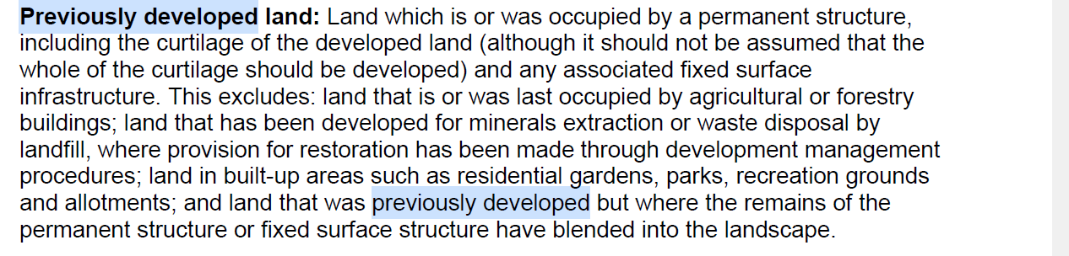
SUMMARY AND CONCLUSIONS.
- Considering the factors listed below,
  - the green chain and open space SMBC designations
  - the linkage to the strategic walking network and the Heaton Moor Golf course strategic green space
  - good access and in due course for those with mobility challenges
  - the proximity of two schools
  - the Council commitment to CAN and rewilding Stockport
  - work and costs committed to date by SMBC develop the site as a recreation and green space.
the current developable designation of the site is perverse and questionable, the site being better suited to the current use as a playground/trim trail and community open space including the proposed FPMOS enhancements.
- Factors against an ongoing developable designation.
  - an open space assessment was not conducted before Heaton Manor planning permission was granted. In allowing development of Heaton Manor SMBC permitted a breach of the open space standards in relation to the permitted population density to open space ratio and play facilities. Therefore, to allow further development on PMOS would be a further breach of the open space standards, thereby compounding the initial failure to follow appropriate planning processes.
  - the shortfall of play and recreation sites in Stockport and specifically in the Heatons. (see enclosed table from Kavanagh Page 2017 report).
  - the landlocked nature of the site.
  - the congested and narrow vehicle access via Harrow Drive.
  - the finite capacity of St Thomas Primary school
  - it is not a SMBC designated brownfield site, nor does it fall within the definition of previous development.
  - the extensive surface water run off problem which would be exacerbated by further development with the increased risk of jeopardizing the viability of the Heaton Moor Golf course, (a strategic green space). See enclosed SMBC waterflow map.

- FPMOS has received numerous commitments from SMBC via the Ward Committee that residential development of the site is neither imminent nor is it supported by the three Ward Councillors. Additionally, the SMBC approved planning application and rationale, allocated budget, commitment of SMBC Play and Infrastructure to develop the site as community green space and to support the FPMOS plan all indicate the continued “developable “designation is inappropriate nor is it supported by a not insignificant number of residents and local groups. The failure to develop the site for the benefit of the community for almost a decade and half contrasts sharply with the aspirations of FPMOS, parts of SMBC and local residents for the site. The site is a valued and well used local asset which if designated as an LGS would be preserved for the local community and more likely to attract donor support to further the develop the site with the support of the FPMOS. The site meets the criteria for designation as an LGS. Taking into account the inappropriateness of the site for residential development it is requested the current designation is replaced with an LGS designation.

Peter Appleby
On behalf of FPMOS

LGS APPLICATION MAP.
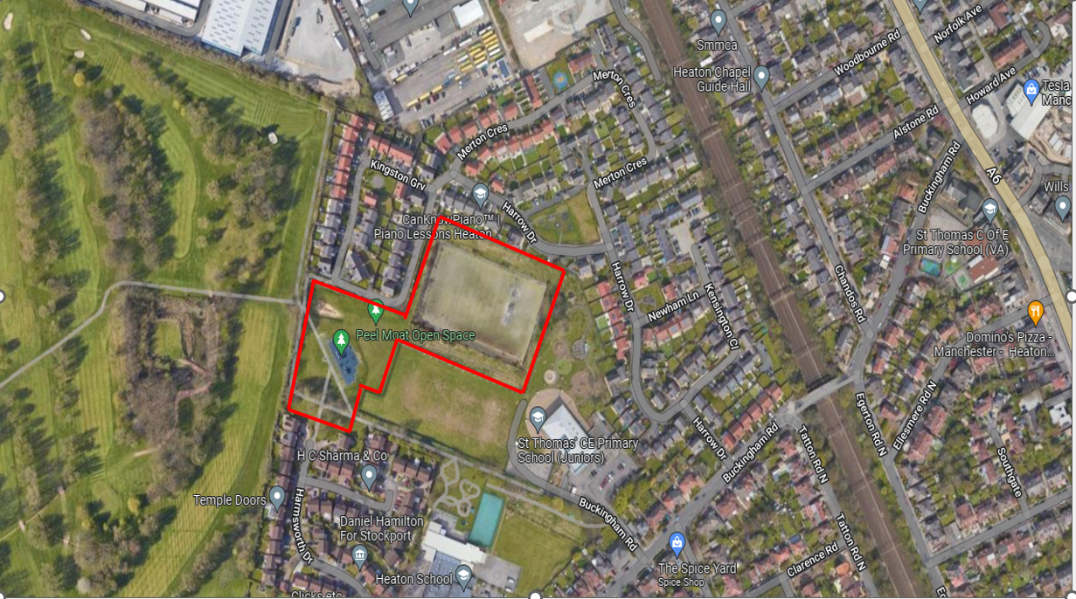

STRATEGIC WALKING NETWORK
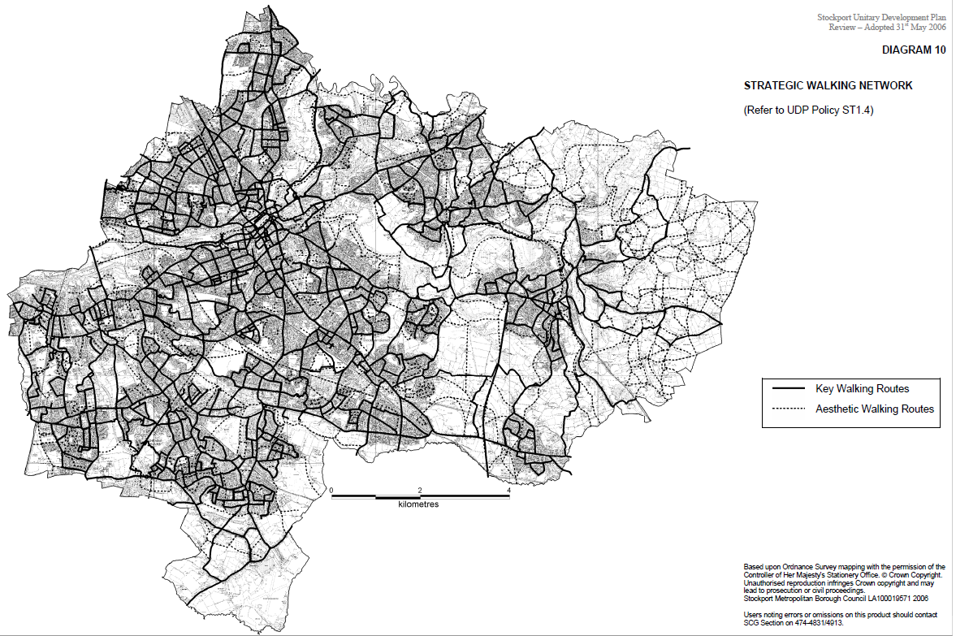

GREEN CHAIN
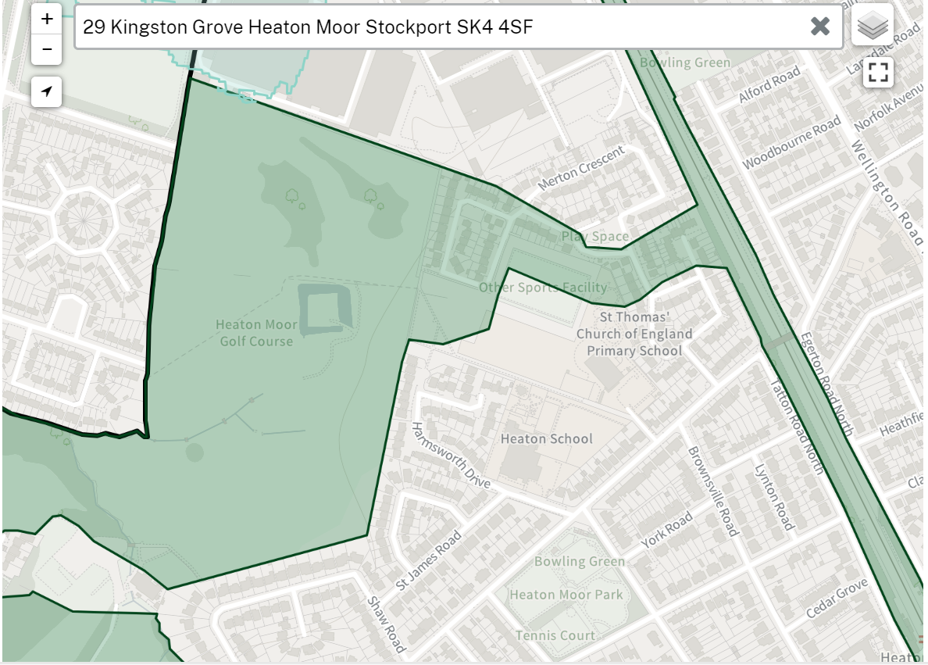
OPEN SPACE
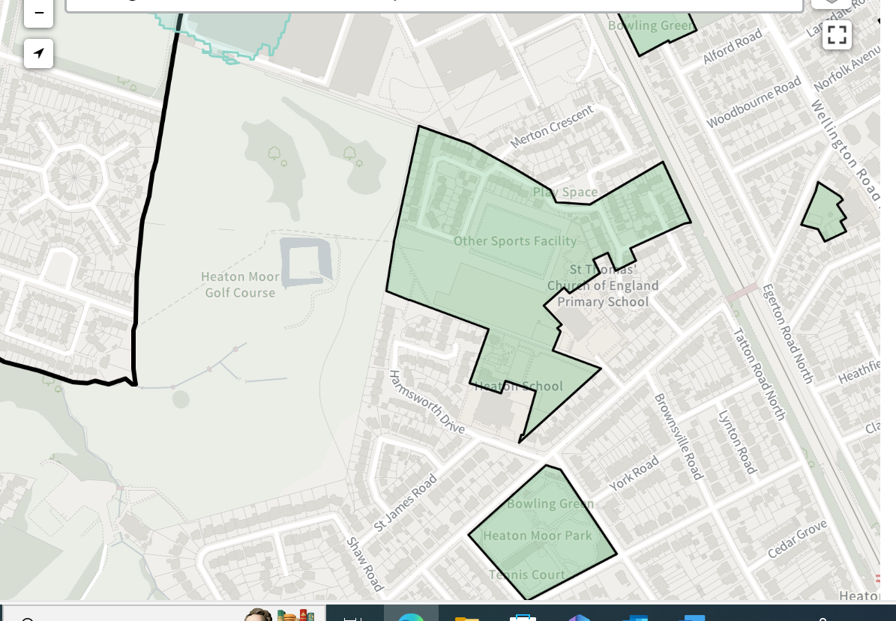
STRATEGIC OPEN SPACE
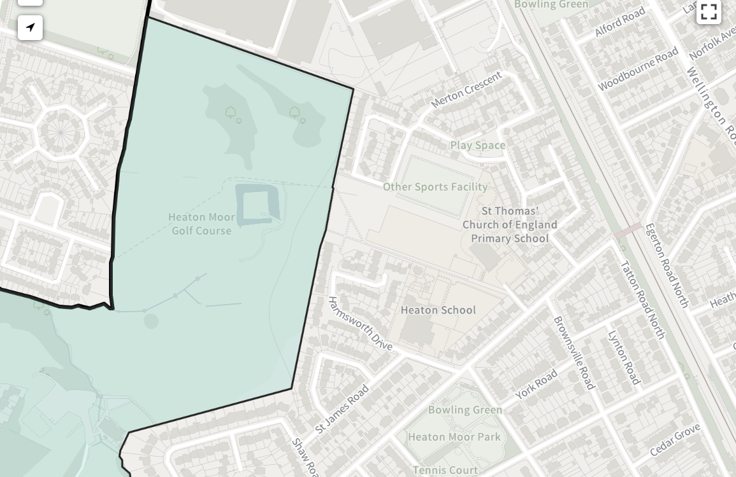
DEVELOPABLE LAND PMOS.
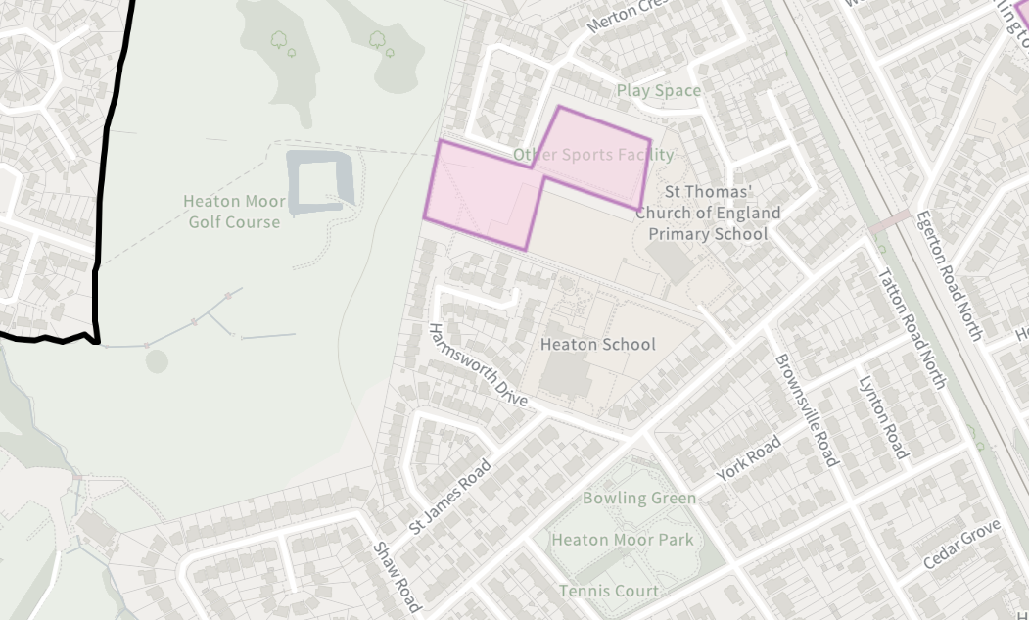

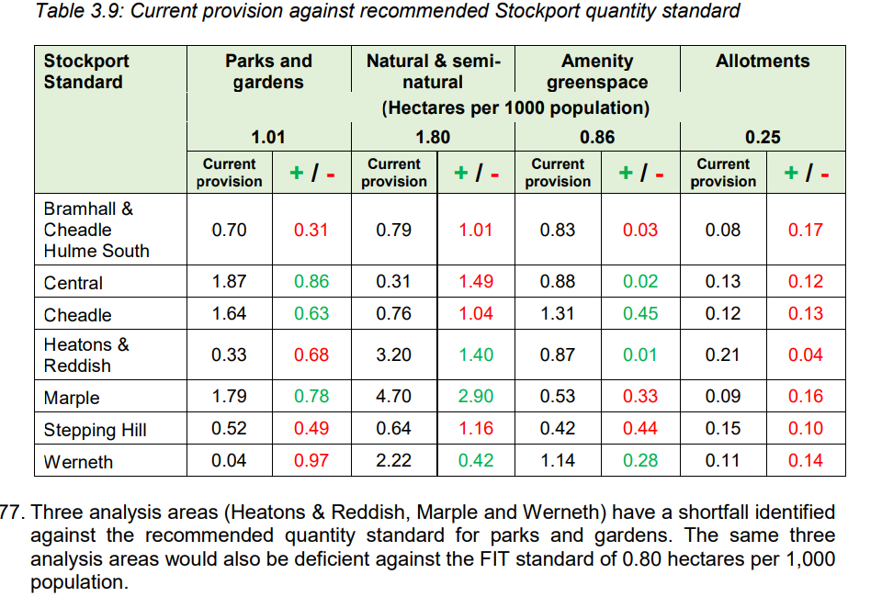
SMBC BROWNFIELD REGISTER
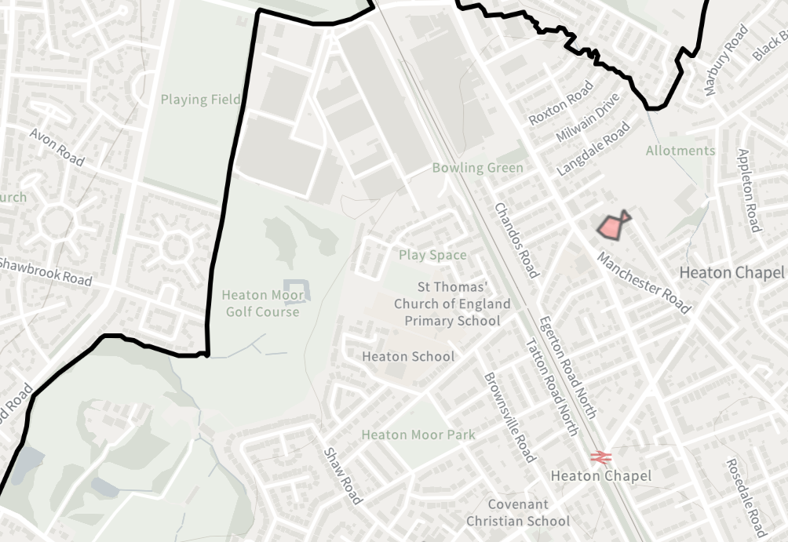

SMBC WATERFLOW MAP
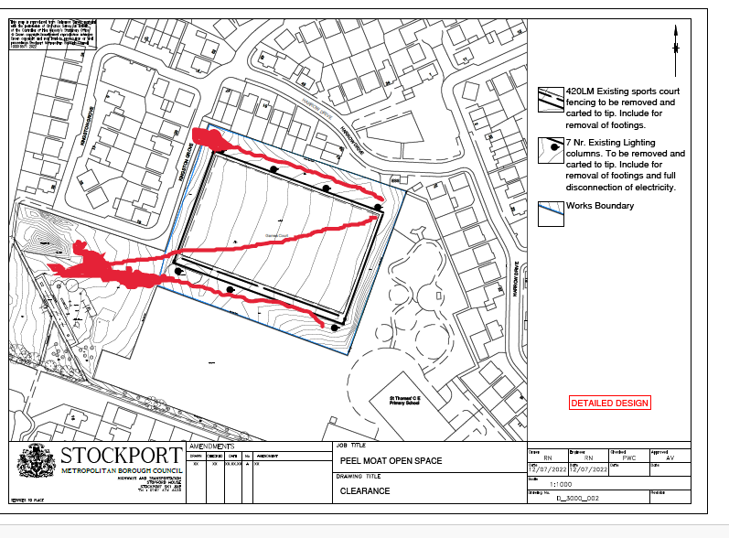FPMOS PLAN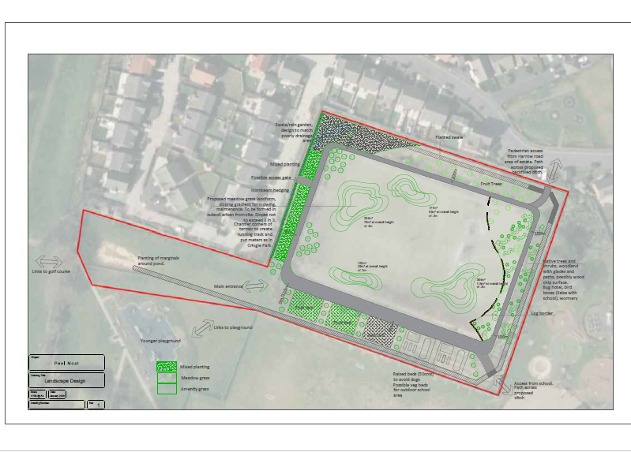
SMBC TREE PLANTING PLAN
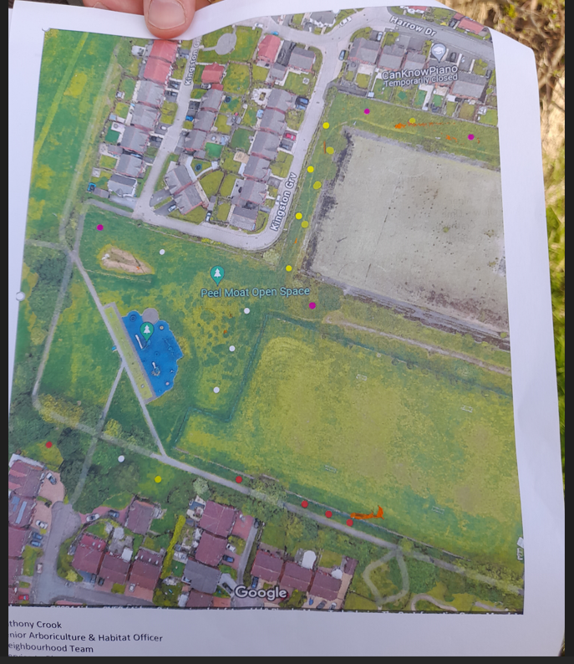

Home - Friends of Peel Moat Open Space (e-voice.org.uk)
Open Space Provision and Commuted Sum payments SPD 2019.
Stockport Council Plan 2023 to 2024 print version
*borough-plan.pdf (onestockport.co.uk)
Rewilding Stockport | Cheshire Wildlife Trust
mgConvert2PDF.aspx (stockport.gov.uk); Climate Action Now Plan
Strategic Housing Land Availability Assessment (SHLAA) 30 June 2022.
Developable: To be considered developable, sites should be in a suitable location for housing development with a reasonable prospect that they will be available and could be viably developed at the point envisaged.

