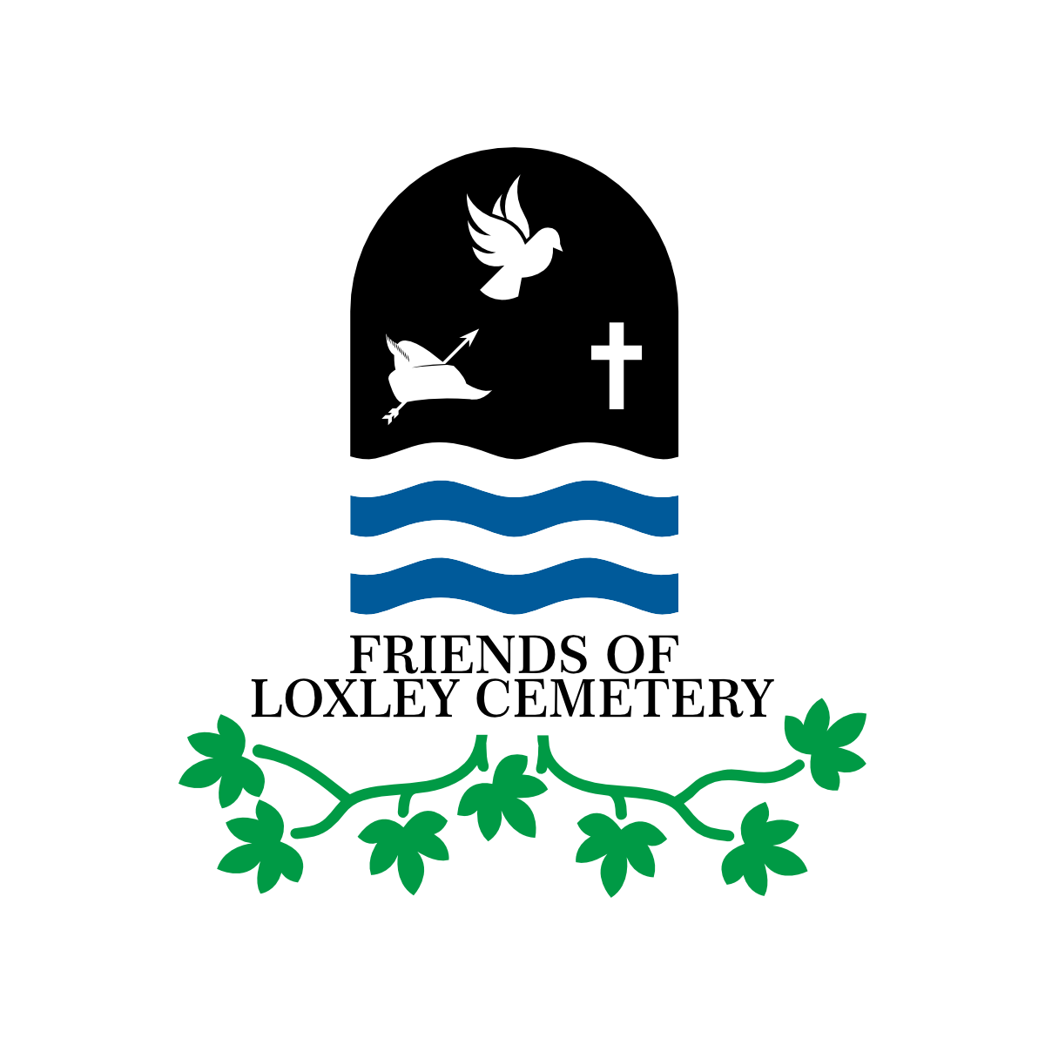

**Mick Drewry, March 2021**

***Text written for The Sheffield Star Retro editions on Saturdays 6th and 13th March 2021, to commemorate the anniversary of the Sheffield Flood***

**Part 1**

Having written a book on the Great Sheffield Flood of 1864 –[*Inundation*](https://sheffieldbooks.co.uk/product/inundation-the-great-sheffield-flood-of-1864/) (2014)– it wouldn’t be difficult for me to cut and paste something to commemorate the forthcoming anniversary but as I am Chair of the Friends of Loxley Cemetery Group I thought I would do a bit more research on the twenty-two or so Flood victims buried in Loxley Cemetery. There may be more victims buried there that we know of as a number of members of families buried at Loxley were not identified immediately after the disaster struck and there is a possibility that their bodies were found at a later date and then reunited in the family grave.

Extensive research on all of the Flood victims has been undertaken by [Karen Lightowler](https://www.lulu.com/spotlight/karenl823) in recent years and her work is invaluable to genealogists and local historians alike. Karen is a member of the Group and has made a contribution to the Group’s Flood anniversary special newsletter that members will have received this week. So, rather than cover what has already been done I thought I would look at the Flood victims buried at Loxley from a different angle; from the compensation claims that were submitted to the special commission set up to judge and award claims against the Sheffield Waterworks Company, who were responsible for the Dale Dyke Dam, which collapsed, sending a huge wall of water down the Loxley Valley and through Sheffield, destroying everything before it.

Of the A-Z of Flood victims buried at Loxley, the Armitage and Bates families are covered in the newsletter and will be familiar to members. The other family graves at Loxley are those of the Bower, Chapman, Crownshaw, Denton, Hudson, Turner, Buckley and Proctor families.

No family suffered a greater loss of life than the **Armitage family of Malin Bridge** as the inundation swept away the Stag Inn taking with it eight of the twelve Armitage family members killed that night. Malin Bridge bore more loss of life to the Flood than any other neighbourhood with at least 102 people being killed. Of all twelve members of the Armitage family lost to the Flood, only the life of 64 year-old landlady of the Stag Inn, Eliza, was claimed for to the Flood Claims Commission. This was submitted by Arthur Green, forgesmith, and his wife Fanny, and steel melter John Banham and his wife Margaret; Fanny and Margaret being Eliza’s daughters and listed as administratrixes. The claim was for £250 but the record states that this was withdrawn, probably due to the daughters being married and not dependent upon Eliza. No claims were made for any of the family’s property lost in the Flood. Seven members of the Armitage family are buried at Loxley, the other five were recorded as unidentified.



Armitage gravestone *(courtesy Karen Lightowler)*

File cutter, William Grant and his wife Jane submitted claims for the loss of the lives of **Thomas and Harriet Bates**, also of Malin Bridge, on behalf of their daughter Annie, Jane being administratrix. The claim for the life of table blade grinder Thomas Bates was for £500, which was withdrawn. The claim for the loss of Harriet Bates was for £300 and this was assessed and agreed by the Commission, who awarded £67-2s, including costs. A further, extensive claim listing property lost by the Bates family amounted to £94-2s. Of this £50 was awarded. The list included work related tools and equipment, furniture and clothing but the single most valuable item was a cured pig at £7-14s.



Bates gravestone *(courtesy Karen Lightowler)*

Seventeen year-old **John Bower** was living with the Chapman family at Little Matlock where he was an apprentice forger to **Daniel Chapman**. All occupants of the Chapmans’ cottage were drowned except John Denton, another apprentice. John Bower’s father, labourer John senior, submitted a claim to the Commission for £10-19s in respect of funeral expenses and expenses for searching for John’s body, which was found at Loxley on 14 March. He also claimed for John’s clothes (£1-5s for a suit of working clothes, 12s for a pair of boots and 13s for his clothes box) and 10s cash lost to the water. John senior also included a claim for loss of crops and damage to a garden that he tended at Bland Row, Loxley (£1-15s). Of the total £15-14s claimed John senior was awarded £7-8s. A further claim for £100 in respect of the loss of John’s life was withdrawn. This may have been due to young John living with the Chapmans and not contributing to the Bower household. It is most interesting to note from the claims that young John’s clothes and effects actually belonged to one Mr. Henry Jubb, a Rotherham solicitor who also owned the garden that John senior rented. Henry Jubb also provided the money to pay for John junior’s funeral. In effect, perhaps excepting what portion was awarded for the loss of crops, the money went to Henry Jubb!



Bower gravestone *(courtesy Karen Lightowler)*

Five members of the **Chapman family** perished as the torrent of water crashed through their cottage at Little Matlock. The bodies of husband and wife, 29 year-old Daniel and 23 year-old Ellen, were found in Sheffield during the following day. Of their three sons, 3 year-old Samuel’s body was found at Loxley on the same day, 14 year-old William’s body was found much later (no date recorded) at Swinton near Rotherham, and the body of 6 year-old Frederick was recorded as not identified. Daniel Chapman’s losses were claimed for by his brother, Thomas and consisted of furniture from the cottage (£88-18s-4d), clothes of the family and an apprentice - this is likely to have been John Denton, who survived – (£48-9s-6d) and £20-10s cash kept in the property. This appears to be a large amount of money to be kept in the house but it is likely to have been for the payment of wages of the men working the forge on the following day, Saturday; £20-10s is the equivalent of around £1,220 at today’s value. The total claim for Daniel Chapman’s material losses was £157-17s-10d, of which £95 was awarded by the Commission. No claim was made in respect of any Chapman life lost.



Chapmans’ cottage *(courtesy Malcolm Nunn)*

**Hannah Elizabeth Crownshaw** was a live-in barmaid at the Stag Inn and died alongside the Armitage family and two lodgers named James Frith and Henry Hall. Known by her middle name, 17 year-old Elizabeth’s father, John Crownshaw, a butchers’ blade grinder of Loxley Bottom, submitted two claims to the Commission. The first was in respect of the loss of Elizabeth’s life and, however he came up with a value on his daughter’s life is beyond me but, he submitted a claim for £160 (£9,500 today). The Commission, however, had no difficulty in putting a value on poor Elizabeth’s life; it was £5 (£296). The second claim was for the loss of a painted deal box and its content of clothes, valued at £10-10s, and for the cost of her funeral, which was £15-15s. John did a little better with this claim and was awarded another £5.



Crownshaw gravestone *(courtesy Karen Lightowler)*

**Part 2**

In continuing the A-Z of the Great Sheffield Flood victims buried in Loxley Cemetery, I must begin part two by going back to ‘B’ and the Bates family, as it was remiss of me not to mention Thomas and Harriet’s three sons, who also lost their lives that terrible night: 19 year-old George, 15 year-old Walter and Thomas junior aged 10 (according to burial records Thomas was 12). A fourth child, daughter Annie Bates survived the Flood as she worked in service and was away. Young Walter was officially recorded as not identified but George and Thomas were buried with their parents at Loxley. According to the official list of the dead published by the Chief Constable, John Jackson, all four bodies were recovered at Green Lane. In respect of claims made against the Sheffield Waterworks Company, none was made for loss of life for any of the three sons but amounts were included in the claim for loss of property at the Bates household for their clothes: George, £7-15s; Walter, £6-15s; Thomas, £2 15s. Some of Annie’s clothes were also claimed for, amounting to £2-10s. It is sad to think that in 19th century Sheffield, the poor children’s clothes were of more value than their lives.

Our next victim buried in Loxley Cemetery is 14 year-old Joseph Denton of Old Wheel, Loxley. There is some confusion within the reports of Joseph’s demise as Samuel Harrison appears to have confused him with John Denton at the Chapman’s cottage, who survived the Flood. However, there is no doubt that Joseph Denton was drowned, his body being found in the ruins of the Old Wheel on 14 March. His father, Thomas Roxbrough Denton, submitted a loss of life claim for his son and it is clear from the claim that the notional value of his son’s life was that which he was likely to earn over a period of six and a half years, with deductions for his board. The amount claimed tells us that Joseph earned £1-10s per week, equating to £507 over six and a half years. Out of this he paid 10 shillings per week board (£169 over six and a half years) leaving a net claim of £338. I would like to have been a fly on the wall when the Commissioners discussed this claim to see how they determined that Joseph Denton was actually only worth £153-3s. Burial records at Loxley Church indicate that one Thomas Denton, who also died in the Flood, is also buried there but he cannot be found in any of the lists of the dead. This remains a mystery for members of the Friends of Loxley Cemetery Group to try and unravel.



Denton Family Grave *(Courtesy Karen Lightowler)*

For our next Flood victims buried at Loxley we return to Malin Bridge, the Grim Reaper’s favourite haunt that dreadful night. In one of three cottages that stood near the confluence of the rivers Loxley and Rivelin at Malin Bridge lived the Hudson family. Forgeman, 39 year-old John Hudson and his wife Eliza, also 39, were probably asleep in bed when the cottages were swept away by the spreading wall of water that swept through the village. Their two children, 8 year-old Mary and 4 year-old George, were taken with them. The bodies of young George and John were found in Sheffield on 12 and 14 March respectively. The location of Eliza’s body was not recorded but was found nevertheless. However, there was some initial confusion about Mary, who was recorded as not identified in the official list of the dead, which also indicated that John, Eliza and George were buried at Loxley, suggesting that Mary hadn’t been found at the time of the burial. Mary’s body was later found and identified, then buried with her family, her name being added to the bottom of the gravestone. The confusion was further fuelled by the two claims made for loss of life. In the first claim, which was in respect of John, Eliza and two children for £200, the beneficiaries are named as Robert Gregory, George Hudson and William Hudson, who actually submitted the claim. Due to the legal definition in respect of beneficiaries, they must be a parent, spouse or child of the deceased. George Hudson is likely to be John’s father as Karen Lightowler’s research found that John’s father was named George. However, William Hudson and Robert Gregory could not be beneficiaries. This is probably why the claim was dismissed. The three men, acting as administrators, also submitted a claim for the Hudson’s property lost in the Flood and for funeral expenses. The property consisted mainly of clothes, furniture and other household items. The only personal item listed was a gold watch and chain belonging to Eliza valued at £10-10s. The claim totalled £147-6s-6d, of which the Commissioners awarded £60. The second loss of life claim was in respect of John and Eliza Hudson and their *‘daughter’;* little George was not included in the claim – being just 4 years-old he would be no source of income for the family and therefore of no material value. The confusion arises from the claim being made by Annie Burgin (spinster) and Rebecca Burgin (widow) of Loxley Bottom, acting as *‘guardian and next friend’* of the beneficiary, who was an unnamed child, i.e. a child of John and Eliza Hudson. The claim was for £500 and was withdrawn but who was the child? Karen Lightowler unearthed the solution to this mystery as she found that Eliza (nee Burgin) had a daughter before she married John Hudson and named her Ann, hence Annie Burgin, spinster, who submitted the claim with her grandmother, Rebecca Burgin. Annie Burgin was the beneficiary of the claim but she received nothing.



Memorial to the 102 Flood victims of Malin Bridge at St Polycarp’s Church

*(Courtesy Karen Lightowler)*

Until pretty recently it was thought that the body of Selina Turner was buried at Wadsley Church. However, research undertaken by Malcolm Nunn and the late John Bailey discovered that she was actually buried in a Loxley grave. Selina was the 39 year-old wife of 48 year-old saw grinder Isaac Turner and they had two children, Sarah Ann, aged 10, and Isaac junior, aged 8. The family lived at Hillsborough near the end of Holme Lane. Living with the Turners and being nursed at the time was Herbert Gravenor Marshall, the 2 year-old son of Sheffield Pawnbroker William Wright Marshall. The infant perished along with the Turner family as the Flood destroyed most of the buildings in this vicinity, along with Hill Bridge, much of which helped save Hillsborough Bridge as debris from its collapse acted as a buffer to protect the span of the second bridge, which only suffered damage to its walls and parapets as the water smashed over it. The body of Sarah Ann was not identified but the two Isaacs and Selina were recorded in the official list of the dead as having been buried at Wadsley Church but Karen Lightowler’s research found that only Isaac and their son were buried at Wadsley. The whereabouts of Selina became a mystery until Malcolm and John discovered she was buried in a plot in Loxley Cemetery owned by one George Wilde, a friend of the Turner family, on 6 May 1864. The burial record states *‘By flood, Hillsborough’.* Clearly Selina’s body wasn’t recovered on 14 March, as recorded in the official list, but much later. Decomposition of the body would have necessitated a hasty burial and the plot at Loxley was perhaps the easiest option at the time.

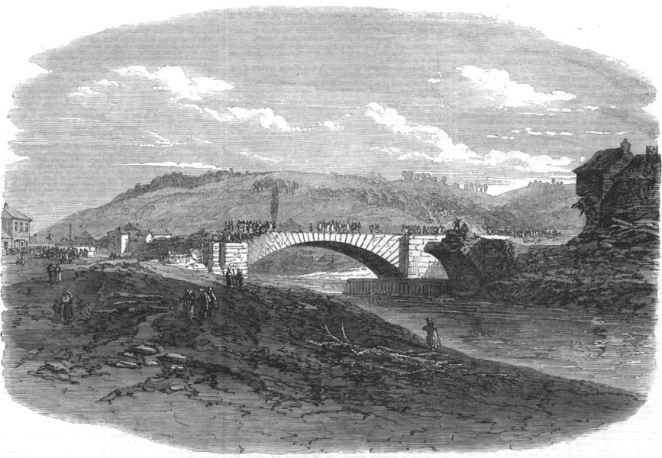

Hillsborough Bridge and the remains of Hill Bridge *(Author’s collection))*

We have come to the end of the A-Z of victims buried at Loxley from the official list of the dead but there were subsequently other poor souls who later died from conditions that they developed as a result of their trauma that night. Shoemaker Jeremiah Buckley lived at No.1 Brick Row, Holme Lane, with his nine children and his sister, a widow named Hannah Birks. Although Jeremiah survived the night of the Flood he developed a fever from his ordeal, from which he never recovered and he died of pneumonia on 12 August 1864. He didn’t live to see the outcome of a claim he and his fellow shoemaker, George Burrell, had submitted for their losses on the night: 48 pairs of *‘men’s strong lace boots ready for bottoming’* valued at £12. They were awarded £9-6s in July 1865.Hannah Birks submitted a loss of life claim on behalf of the children for £1000; they received £229. Jeremiah’s wife, Mary, had passed away two years previously and was buried at Loxley Cemetery, where she was now joined by her husband. My research for this article has highlighted an error in my book-*Inundation* – in that I suggested that Jeremiah Buckley may be the father of the child Mrs Birks was confined with that night. This was probably not Hannah Birks that Samuel Harrison had referred to as Jeremiah Buckley and Hannah were siblings, something I have only now uncovered. In the words of Oscar Wilde *‘The only duty we owe to history is to rewrite it’.* I will be rewriting this bit should a second edition be published.

Our final family of Flood victims buried at Loxley Cemetery is the Proctor family. Unlike the others, where there is clear evidence of their death being directly linked to the Flood, the connection that their deaths had is pure conjecture but convincing nevertheless and I’m grateful to Karen Lightowler for her detective work. Their were four members of the Proctor family who Karen is convinced died indirectly as a consequence of the Flood: 49 year-old Mary (died 30 May 1864), 31 year-old George (died 18 August 1864), 26 year-old Alfred (died 6 May 1864) and Edwin aged just 8 months (died 23 July 1864), all living in different households in the Hill Bridge and Owlerton areas. It was the dates of their deaths that drew Karen’s attention to them. All of the same family, their relationship is a little complicated and takes some digesting. Mary’s husband, William, was Alfred’s brother and George’s cousin. The infant Edwin was George’s nephew. William was also the brother of the above Jeremiah Buckley’s wife, Mary. We needn’t delve any further but anyone wishing to view the whole family tree can find it in Karen’s book on the *Aftermath*. The cause of death attributed on their death certificates also gives grounds to the Flood connection. Mary, who lived at High House Terrace, off Penistone Road (then Low Road) and behind Capel Street (then Chapel Street), died from *‘paralysis of one and a half years and dropsy, six months’.* Whilst the paralysis, due to what we do not know, would not be made worse by the Flood, it may have hindered her escape from her ordeal. Dropsy (oedema), on the other hand, is an excess of watery fluid in the cavities or tissues of the body; something that could be exacerbated by immersion in filthy water. George, who lived at Owlerton, died of hepatitis, a viral infection of the liver, which too could have been caught from toxins in the water. Alfred’s death was due to *‘Chronic Phthisis 7 years’,* otherwise known as pulmonary tuberculosis. Although a sufferer for seven years, being caught up in the Flood would have accelerated his looming demise. The infant Edwin died of bronchitis at Hill Bridge. Of such a tender age he was vulnerable to any disease that emanated from the filthy waters but, as with each of the Proctors, linking it directly to the Flood is pure conjecture. The four Proctors were interred in separate graves at Loxley with Mary joining her husband William in his.

There ends the story of the Sheffield Flood victims buried at Loxley – for now! I have no doubts that the Friends of Loxley Cemetery Group will unearth (pardon the pun) more indirect links in the future.

**The Friends of Loxley Cemetery**

Whilst the central aim of the **Friends of Loxley Cemetery Group** is to restore the cemetery to its former picturesque splendour, it also aims to provide access to the wealth of social history that it holds, unlocking the past for the benefit of the future. In addition to the victims if the Great Sheffield Flood of 1864 there are fourteen Commonwealth War Graves associated with both of the World Wars, a connection with RMS Titanic and other persons of historical interest. The group can also assist people with their family history research. Membership is open to anyone 18 years and over who shares the group’s aims and objectives.

Please check our website: <https://e-voice.org.uk/friendsofloxleycemetery/news/>