LOXLEY CEMETERY SITE PLANS
Loxley Cemetery is divided into two main areas: the old sections around the chapel, and the newer section off Long Lane. These main sections are then sub-divided and the layout is quite complicated. This document should help you understand the different sections and the layout of rows and plots within them.
This is the overall layout of the cemetery:
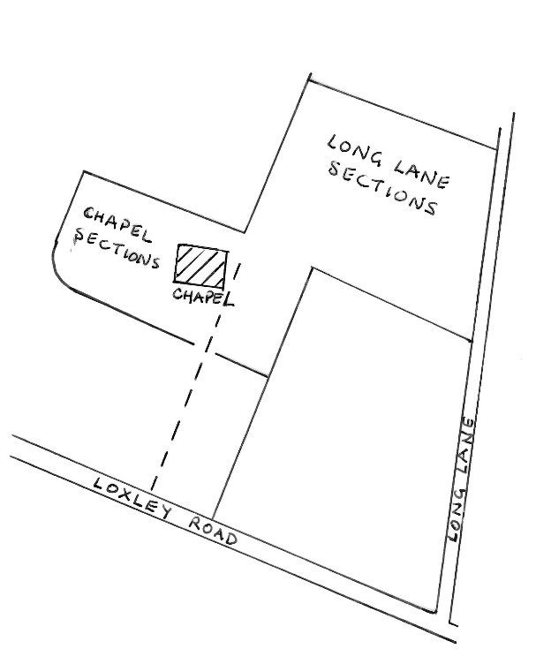
These are the chapel sections:
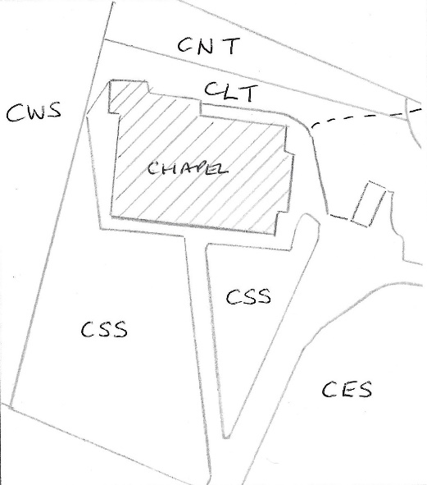

CNT = Chapel North Terrace  CLT = Chapel Lower Terrace | CWS = Chapel West section  CSS = Chapel South section  CES = Chapel East section

LOXLEY CEMETERY SITE PLANS
Chapel Sections: detail
The areas around the chapel hold the older burials, the first being 1806, and most of the rest being in the 1800s and early 1900s. However, some 20th century burials are here too, in existing family grave plots.
There are 5 main sections:
- CSS or Chapel South Section
This section is in front of the chapel and has the oldest burials. It has the drive to the east and a couple of very large trees to the west. It has a diagonal path running through it from the drive to the original front door. Burial dates range from 1806 to 1983, though most are in the 1800s.
The numbering of the rows starts at the south (bottom end) and goes from 1-17 (west to east) across and 1-34 (south to north) up from the bottom boundary of the chapel land. Both rows and plots are numbered so the plot references look like this: CSS 6 13. Some of the Flood victims are buried here.

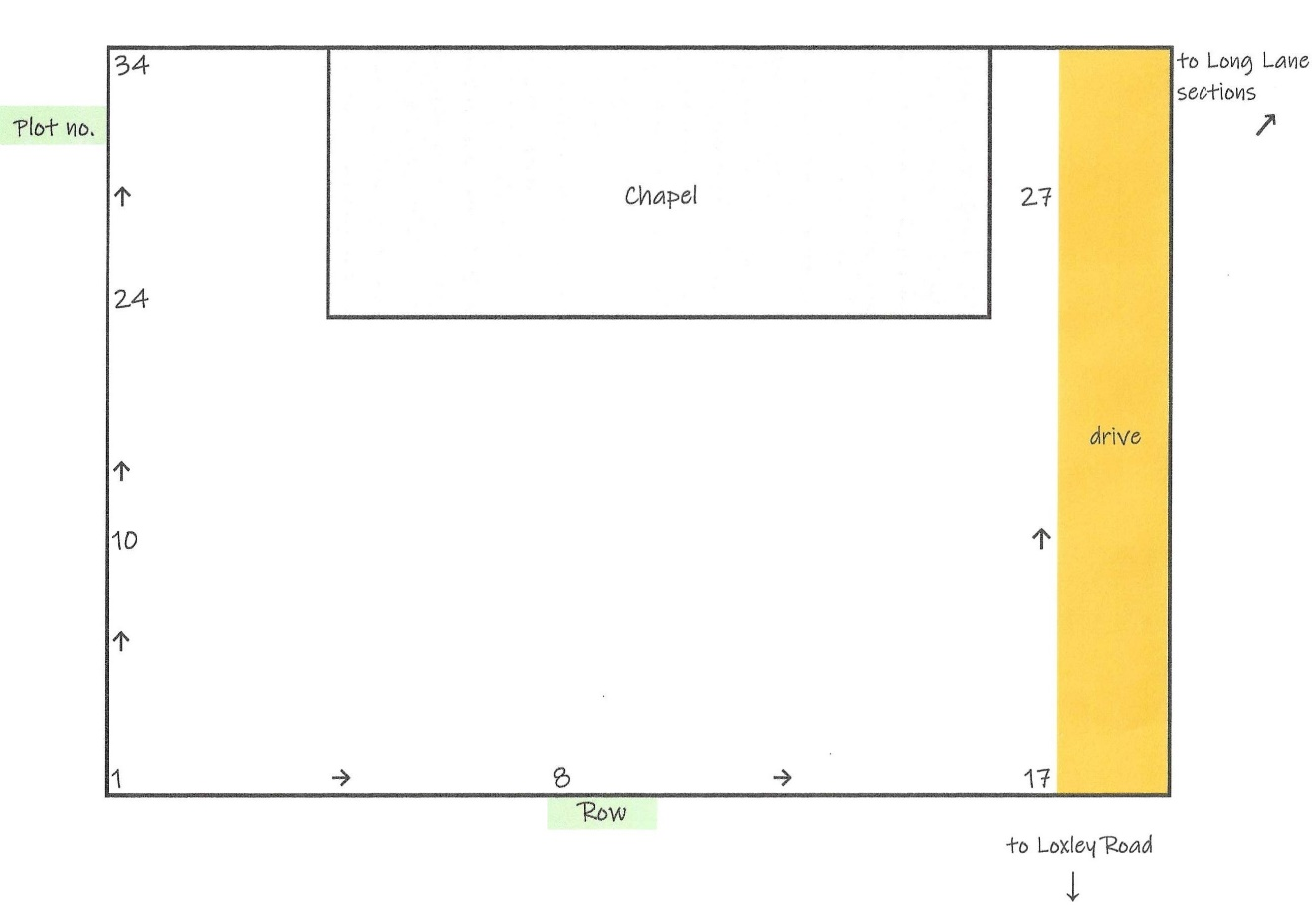

- CLT and CNT or Terrace Sections.
There are two terraces behind the chapel, the Lower Terrace (CLT) and the North Terrace (CNT). The North Terrace holds some graves of the Flood victims.
There are only two rows in CLT; they are numbered 1 and 2, and the plot numbers 1-12 run from east to west. Row 2 is above row 1 (north of it). A reference would look like this: CLT 1 6. Burial dates are 1869-1915.
CNT is larger. The rows are 1-12 starting at the top (the north) and running south towards the chapel. The numbers run from west to east. An example of a plot reference is: CNT 3 10. Burial dates are 1834-1961.

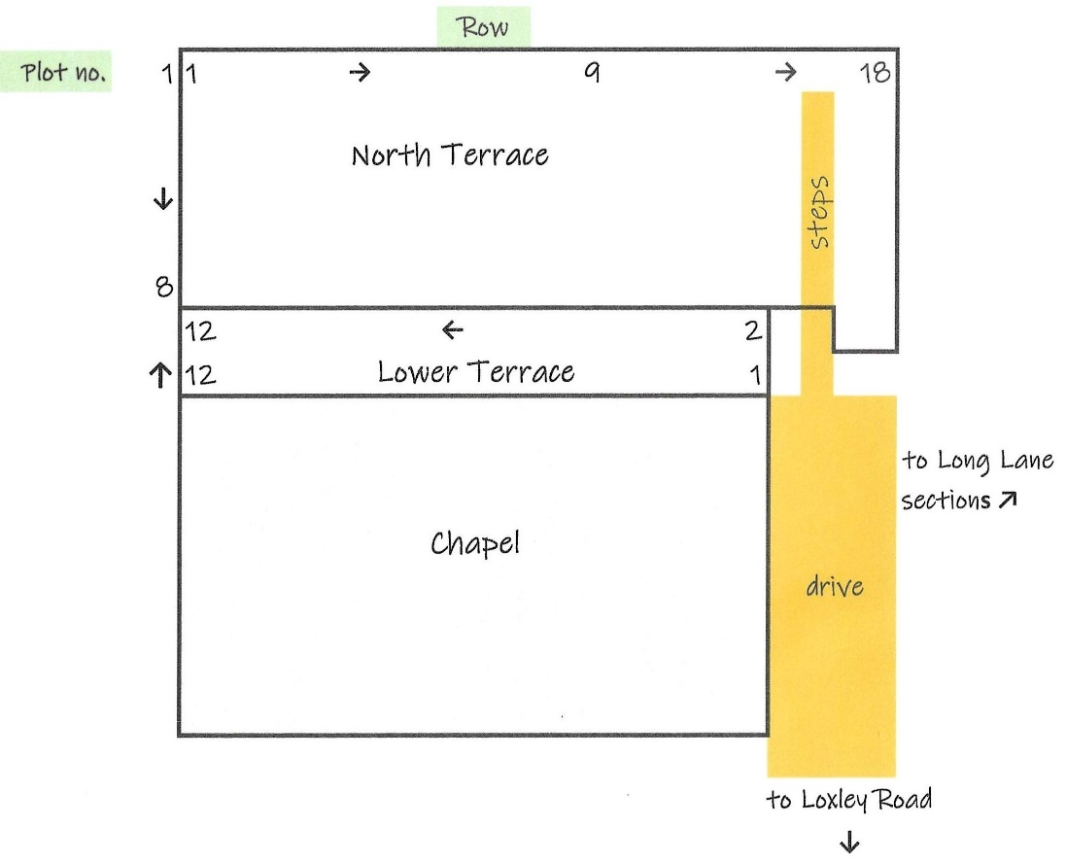

- CIN and CIV Sections
These two sections are inside the chapel itself and cannot be accessed or have disappeared. CIN had graves/memorials for Tingle, Bivens, and Wood families, dated 1812-1837. CIV had graves/memorials for Armitage and Wood families, dated 1831-1906.

- CES or Chapel East Section
This section is to the right (east) of the drive. It has pairs of rows – odd numbers and even numbers, as shown on the plan below. The rows are lettered, and the plots are numbered e.g. CES C 49. The rows run from west to east (A to E) and the numbers run from north to south (1-56). Burial dates are 1892-1995.

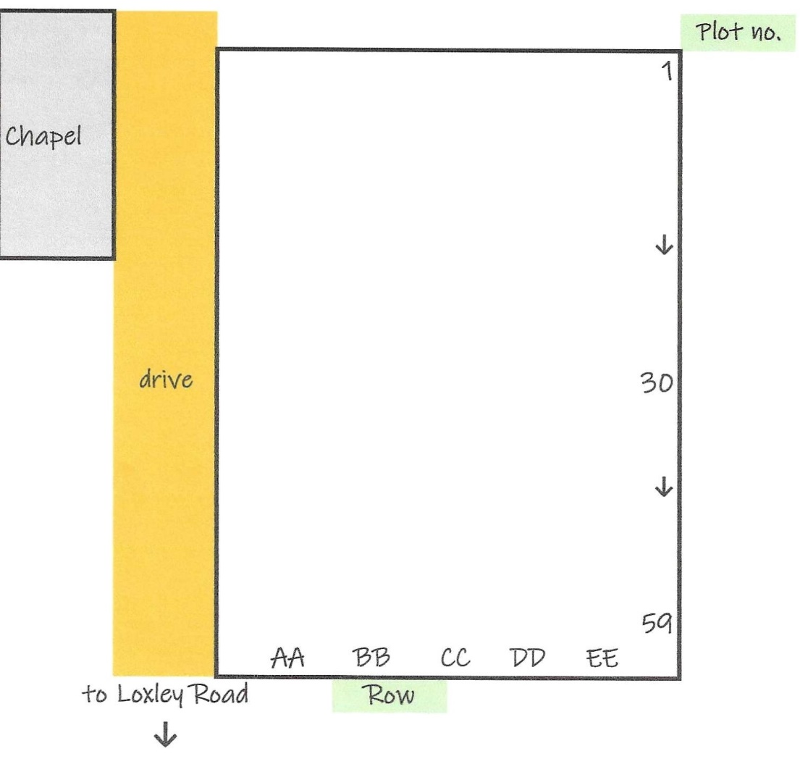

- CWS or Chapel West Section
This section is to the left (west) of the chapel and the CSS section. It is the largest chapel section. Similarly to CES, it has pairs of rows – odd numbers and even numbers; the rows are lettered, and the plots are numbered e.g. CWS H 32. The rows run from east to west (A to J) and the numbers run from north to south (1-90). Burial dates are 1870-1994.

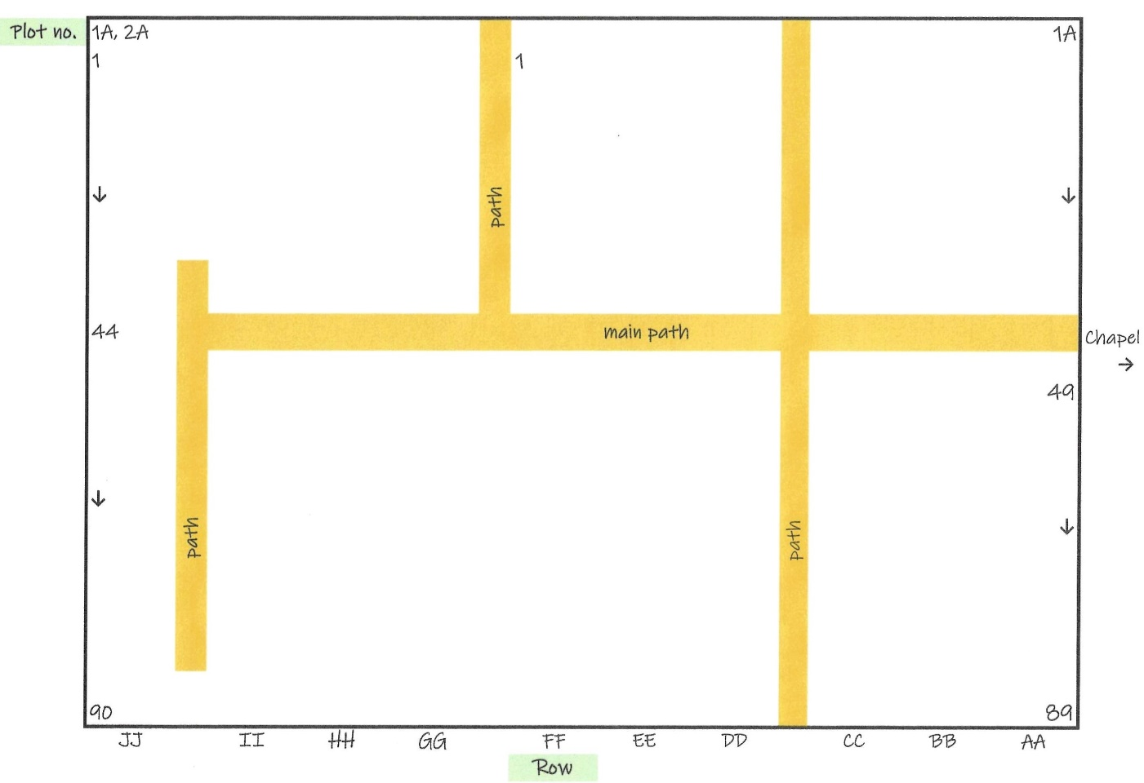

LOXLEY CEMETERY SITE PLANS
Long Lane Sections
The Long Lane section of the cemetery has the more recent burials, with the earliest being 1914, and going up to the present day. These sections have pairs of rows – odd numbers and even numbers; the rows are lettered, and the plots are numbered e.g. G 30. There are two distinct parts to this section, which you may see referred to as NE1, which has rows A-H, and NE2 which has rows I-P. The first part, NE 1, has the rows running from east to west, whereas NE2 has the rows running west to east, leaving us with the odd situation that row A is next to row I – please see the diagram below. The numbers run from south to north, from the bottom to the top.

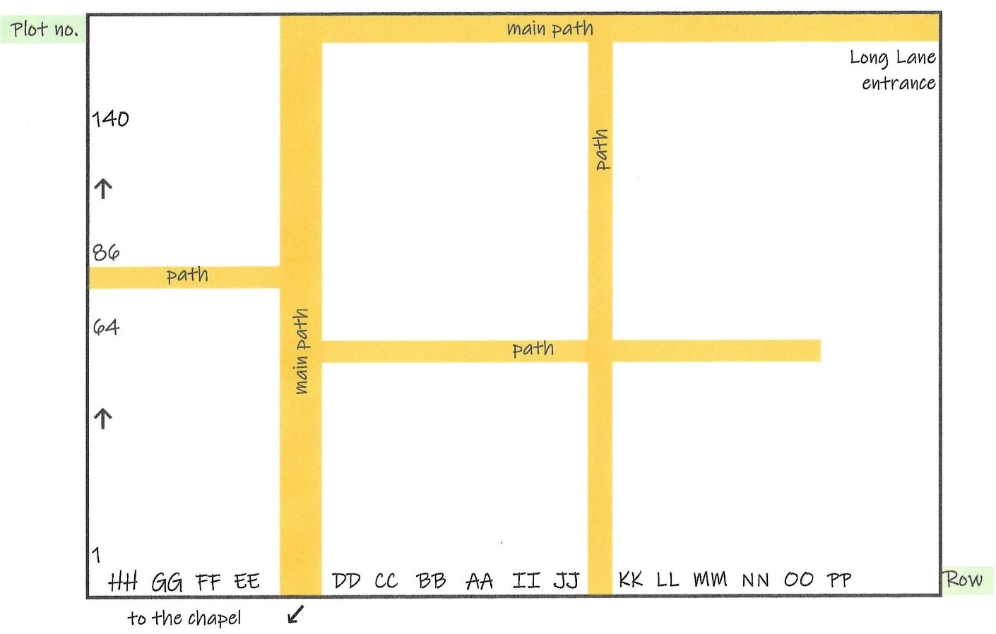

This is a more detailed plan of the rows and plot numbers but note that it is orientated differently to the previous plan – here Long Lane is at the bottom.

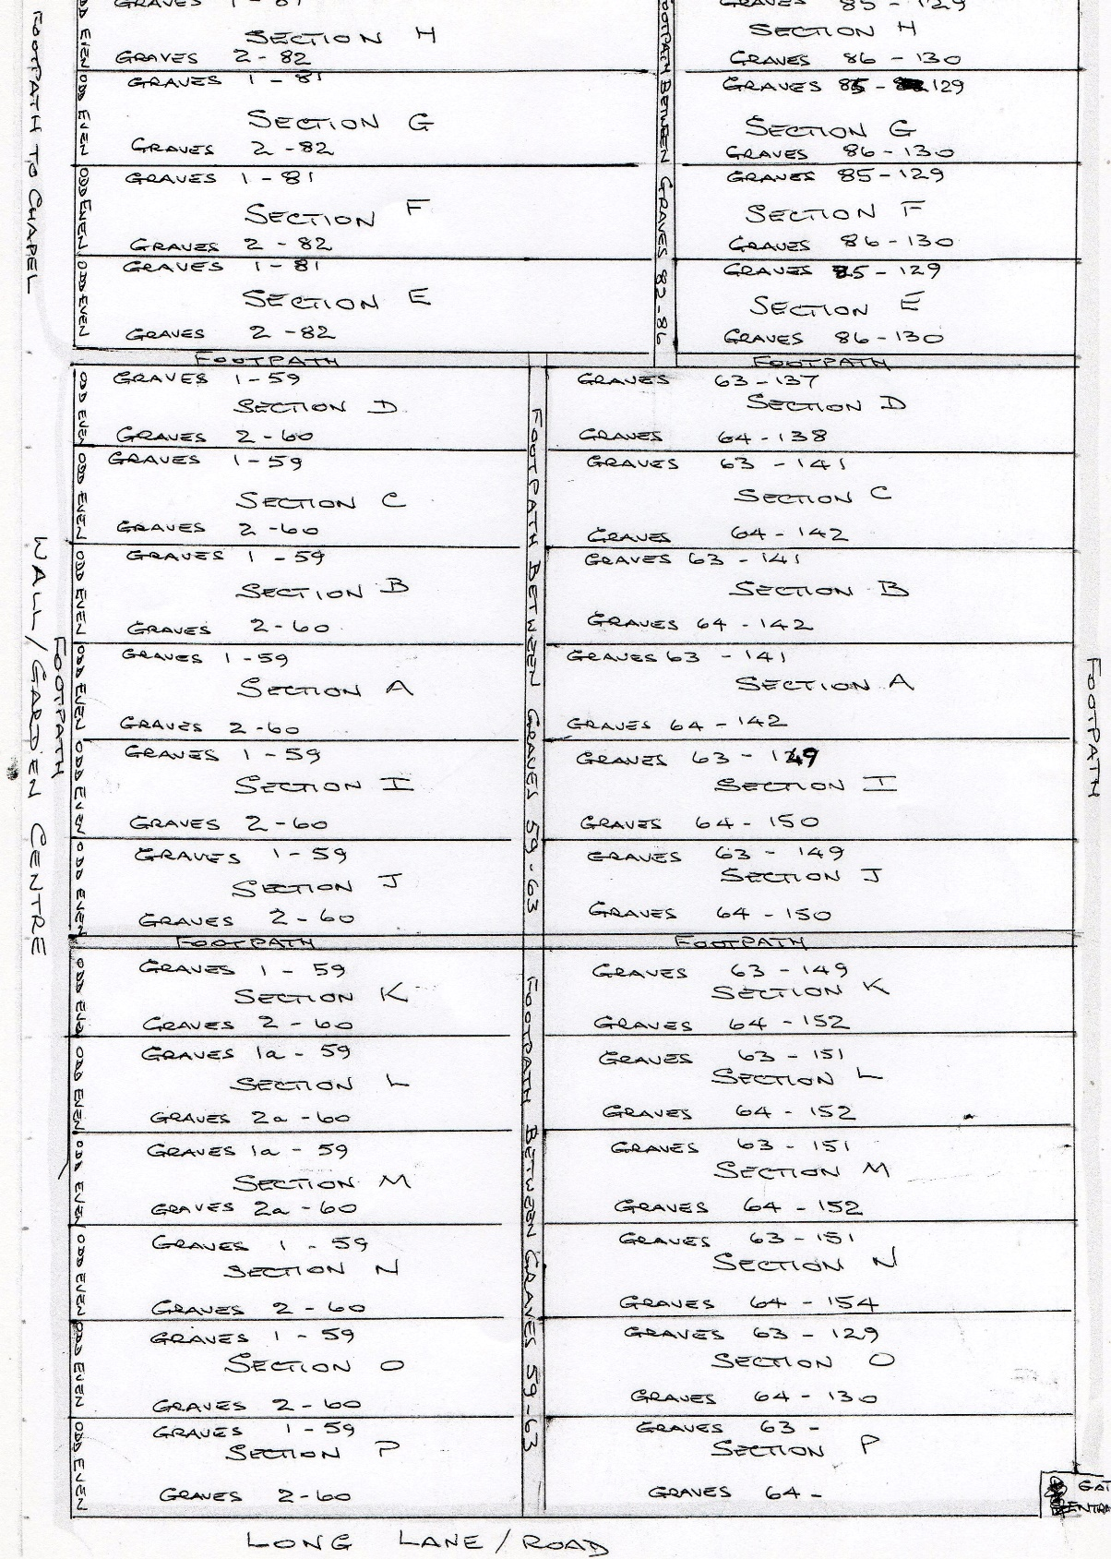

V. Brack, M.Nunn 2023, Friends of Loxley Cemetery

