JAMES DYSON STORY – Flood Survivor

By Janet Wilcockson, descendant of James Dyson and civil partner, Richard John Bramall, 2022

My great great grandfather, James Dyson, a wire worker from Thurgoland, was staying at his brother’s home in Brick Row, Holme Lane, on the night of March 11th 1864 - the fateful day that the Dale Dyke dam at Bradfield burst.

James, then aged 36, worked with his brother, Joseph, at Mary Shaw’s wire works in Owlerton, just off Bradfield Road, and stayed in his brother’s attic bedroom during the week and went home at weekends to his wife, Elizabeth and his children in Thurgoland.

Joseph was the manager of the wire works and lived with his wife, Mary and their six children at Brick Row along with James and two lodgers.

The flood ripped through the area just after midnight on March 12th and Brick Row - a substantial three-storey row of back-to-back houses was severely damaged and in the Dyson household all the residents died except for James. One of Joseph’s children, Selina, was away that night and survived.

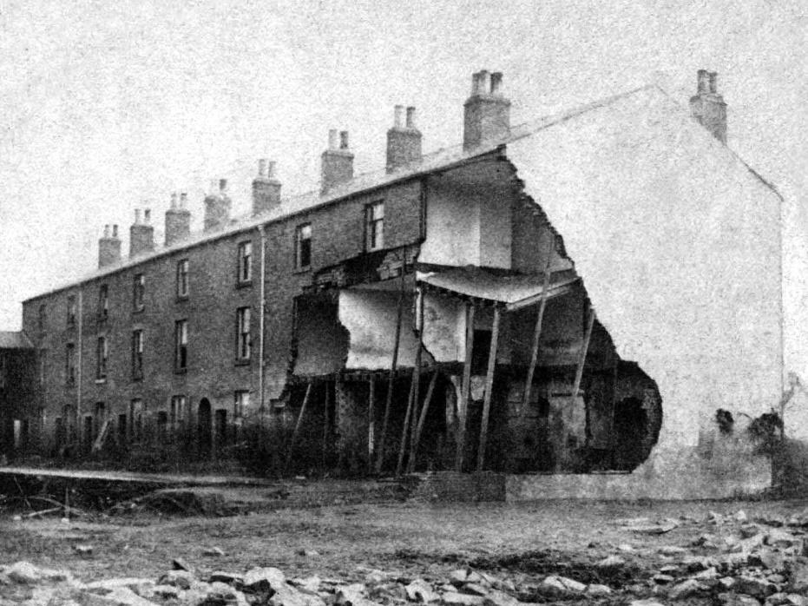

James was able to break through the attic roof and escape the flood and survived. He wandered around the area the next day searching for family members before setting off by train to Thurgoland just as his wife was travelling to Sheffield to search for him.

Later that day they met up and the next day began the task with another brother, Vincent, of sorting out the desperately sad family affairs. Joseph and his family are buried at Thurgoland, Vincent at Burngreave near to where he lived and James (died 9th August 1904) and wife Elizabeth (nee Marsden, died 27 December 1904) are buried in Loxley Chapel cemetery in plot CWS D 82. James had ten children and their eight child - a daughter, Ann, born 1872/1873 is also buried at Loxley in plot CWS E 81.

Fortunately for me James was sleeping in the attic that night or he would have drowned along with the rest of the Dyson family.

Some books about the flood say that it was Vincent (born Vinson) Dyson that survived that night not James and some mention Richard Snape as surviving. Not so - Richard Snape is buried at Thurgoland in 1864 and Vincent lived in the Burngreave area and was not directly affected by the flood though he did administer the estate of his brother and that of Joseph’s surviving daughter, Selina who luckily for her was away at a relatives’ home in Dore that night.

My grandfather, Ralph Robson, is also buried at Loxley in the extension cemetery off Long Lane in grave M22.

The full story of James’ escape was published in Sheffield’s Evening Telegraph on the 11th and 18th August 1888 and is reproduced in Karen Lightowler’s Dyson family flood notes and is also reproduced below.

The detective story of how my partner and I proved that James Dyson rather than his brother Vincent was the sole survivor of the Dyson family tragedy was published in The Star newspaper ‘Retro’ section on 29 April 2017.

The escape of James Dyson from Brick Row on the night of March 11th / 12th 1864
– published in Sheffield’s Evening Telegraph, on 11th and 18th August 1888
Saturday 11th August 1888
BRICK ROW, HILLSBOROUGH. FURTHER LOSS OF LIFE.
Anyone, at this day, can imagine for themselves the awful destruction which a wave of water from 30 to 40 feet in height, and of great depth of backing, would commit in such a locality as Malin Bridge and Hillsborough. At this point of the Loxley valley the right bank of the river is precipitous from behind La Plata Works right down to Hillsborough Bridge. On the left bank of the river the land lies flat. Consequently all the buildings on it were exposed to the full force of the flood. The water made a clean sweep over everything – buildings, roads, fields – obliterating landmarks, and leaving all over the land a thick layer of mud, in which, when the water had subsided, were large lumps of walling, roofs of houses, beds and bedding, machinery, uprooted trees, and all descriptions of furniture. This wreckage, floating down on the top of the flood, and hurled against houses, works, and buildings, and knocking holes in them, the flood thus found an entrance gutting interiors, and in some instances bringing down whole buildings. This was what happened at Brick row.
It is no great distance from Bower’s Buildings to Brick row. Between the two places there was nothing to check the flood of water in those days. The upper end of Brick row consequently caught the full force of the flood as it came rolling down from Bower’s Buildings and the Limerick Wheel. At that time the row was open on three sides. There were no tram stables then, substantially built, standing on an extensive site, to break the strength of the wall of water. In a moment the flood surrounded the houses which were three stories high, and, as the name imports, were built of brick. Back and front the water poured into the top most houses. The row is double – that is to say, there are one set of tenants whose rooms front the roadway, and another set whose rooms look into the long yard behind. The front houses fared the best – though deeply flooded, none of them were washed down. The three top houses at the back suffered most. They were utterly ruined. The topmost one of all was wrecked from garret to ground, and all in them drowned except one lodger. This destruction came principally about because of the heavy trees and other wreckage which the flood brought with great force against the building. Foot by foot the water, once having gained an entrance, reached up into the upper rooms. Part of the gable end fell away, and when the flood subsided the interiors of three of the houses, as seen in our illustration were open to the elements. As already remarked, the first house fared the worst. Both its end and side walls were gone. The next house was similarly damaged, but not to so great an extent. The next to it, again, suffered nearly as much. Other houses in the row had their windows burst in, partition walls knocked down, and the cellars filled with mud. In one house, the clock had stopped at 27 minutes past 12, so that, if the clock was right, it seemed as is the flood had taken a little over half an hour to reach Hillsborough from its first fearful leap through the broken embankment at Dale Dyke.
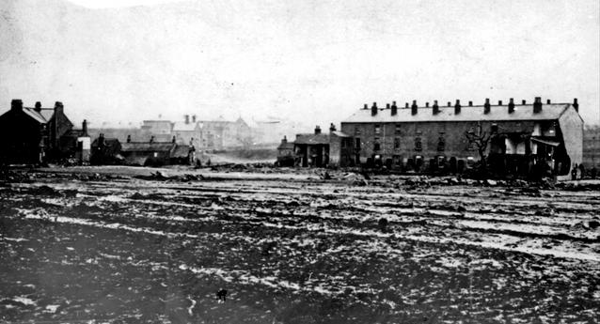
SAD FATE OF THE DYSON FAMILY. On the first house in Brick row, the house at the back of the row which now joins the Tram Company’s stables, dwelt Mr. Joseph Dyson, 42 years of age, a wire worker ; his wife Mary, 34 ; five children who ages ranged from 12 to three ; Samuel Senior, a lodger, 75 years old ; and James Dyson, also a lodger, brother to Joseph ; with an apprentice, Richard Snape. James Dyson, Senior and Snape slept in the garret, well out of reach of the water, and yet only one out of the whole household survived the night to tell his fearful tale. We give his story as told to us, for Mr. James Dyson still resides not far from the scene of his narrow escape from death four and twenty years ago. “At the time of the Flood”, says Mr. Dyson, “I was working at the Owlerton Wire Mill. I work there still. I had been some couple of years or so working in Sheffield, but had not up to that time removed my family to the town. They still remained in Thurgoland. I lodged with my brother Joseph, in the top house of the Brick row, Hillsborough, and was in the habit of regularly going home to my family at Thurgoland at the end of each week. The 11th of March, 1864, had been a raw and gusty day. I got into my lodgings at Brick row about nine o’ clock at night, washed myself, got my supper, and all the household were abed before 11 o’clock. I and an old man named Sammy Senior, a wire drawer, who worked at the same shop, and came from the same neighbourhood as myself, slept together in the same bed in the garret, and in another bed slept a young fellow of 21, Richard Snape who also worked at the Owlerton Wire Mill. “I lay awake for a little time after getting into bed, I had hardly got to sleep when I was awakened by a great commotion, a great noise coming from outside the house. Sitting up in bed, rubbing my eyes, I heard Sammy Senior shouting ‘Oh dear, whateveris the matter? There must be an earthquake.’ I jumped to the conclusion in my first fright that there had been an explosion at the Limerick Wheel. I never heard a thunder clap so loud or half so terrifying as the noise I heard on first being awakened out of my sleep by the flood. Out of bed all three of us in the garret jumped in a moment, I ran to the window, and as I clutched and tore aside the white cambrie curtain stretched across the panes the dread thought came to me in a moment that the dam had burst. I called out, ‘It’s the Redmires Dam’. In the confusion and horror of the moment I substituted the name of Redmires for Dale Dyke. “We struck a light with a match, but it went out. There we were at the top of the house, cut off from the rest of the family. For a month before this happened I had my forebodings. Many people had been saying that the dam above Bradfield was sure to burst before the winter was over. Lodging in the Brick row, I had not been at all easy in my mind, and never went to bed at nights, or came in to dinner, but I speculated as to what would be the best way to escape should the dam burst.
SHOUTING FOR HELP. “Well, there we were in the garret. We could hear the shrieks of my brother’s family coming from the bedrooms below. They were shouting for help. ‘Help us; oh, help us out of this,’ they were shouting. ‘Come here and help us, Jim.’ But we up in the garret could not in that awful moment get down to them or they up to us. Many and many a time, during the few previous weeks, I had whilst lying in bed in the garret speculated how I could escape up on the roof, supposing the flood burst upon us at the dead of night. I knew beforehand that the only way of escape would be on to the slates. With the cries of the inmates below still ringing in my ears, cut off from them, and they from me, I jumped on to my bed in the corner, and commenced to burst a hole through the ceiling so as to reach the ‘under drawing.’ Whilst so engaged, I could hear my brother below praying to God to save the lives of himself, his wife, and his family, and shrieking for help which could not possibly be given them. That was the last I heard of them. Senior and Snape were calling for help beside me in the room. In a few minutes I had broken a hole through the ceiling large enough to climb through. With a spring from the bed I had my arms through the opening, and with a hard struggle landed at last in the under drawing, under the slates. I knew I was no safer there than I had been in the garret below. In the dark, groping about, I ran my hand against the gable end, and fell backwards on to the floor. I was stunned for a moment. Recovering myself, I set to work again, and managed to break through the wood and plaster partitions into the under drawing of the house of an old pensioner named Fisher. There I got a light from the old fellow. Still, I felt far from safe, and could hear poor old Sammy shouting for help in the garret I had left, I had expected that both he and Snape would have followed me. But they lacked the nerve, and probably thought they were safer where they were”.
Next week Dyson’s story of his escape will be concluded. One of our illustrations shows the rear of Brick row, with the demolished houses at the top as they appeared the day after the Flood. The other illustration depicts the ruins higher up, at Malin Bridge.
To be continued.

Saturday 18th August 1888
Last week our story broke off at a point where James Dyson was searching in the “under-drawing” of the houses in Brick Row, Hillsborough, for a way of escape from the death by drowning which overtook the whole of his brother’s family. Our readers will remember that he had already told them how he had broken through the ceiling of the garret in which he had been sleeping, and had burst his way through partitions under the roof until he was now some little distance from where he started. He goes on to say :- “I expected the whole house to tumble down every minute. My object, therefore was to get on the roof and scramble along to the other end of the row. Two joists ran along the cock-loft. On to these I clambered until I reached the roof under the slates. Then, allowing my head to drop downwards, and with my feet touching the slates, I broke through the roof. It was a tough job. I was nearly naked. When I had scuffled through the hole in the slates, working my way out into the open, everything I had on was torn off me-all, except, perhaps, a remnant of a shirt collar round my neck.
“Once on to the outside of the roof my next business was to endeavour to reach the other end of this row. I clambered on to the ridge of the roof, naked as I was, between twelve and one o’clock on a cold and tempestuous March morning. I still was nearly giving myself up for lost. It was bright starlight and there was besides, the light of the moon to guide me. I sat for a minute or two to gain rest, breath and confidence, on the roof-ridging of a row of houses three stories high. There was the water below still surging round the building. As far as I could see water covered the land. I could hear shrieks of the drowning and cries for help from the occupants of houses beneath where I sat. there has been a white hoar frost, and the cold wind pierced to the very marrow of my bones.
SAFE AT LAST. “Once more I started off to make good my escape. What with the hoar frost and the spray blown on to the roof from the flood of water my foothold was insecure. But I struggled onwards, until at last I reached the end of the Brick Row. I could then see that the little stone cottages were there still. Clinging to the brick chimney stack which runs down the gable end, I managed to get on to the top of one of these cottages. There, however, I was no better off. I was nearer the still raging flood. I could hear James Atkinson, his wife and three little children shrieking in a house where I was and calling for help. I felt bewildered, and less safe that when I was on the roof of the Brick Row. The roar of the flood was awful, and with swish of the broken trees and rumble of the big rocks and stones brought great fear to my heart. I remained on the top of the stone cottages not more, as far as I could judge, than a quarter of a minute. Then I started to climb back along the brick chimney on to the roofing of the Brick Row, with the extra hold I had of the rain or “?” pipes. Again I was upon the roofing, more cold and wretched than ever, and almost done up, I pulled off a few slates and again found shelter in the under drawing. This was in the house the second one from the low end of the row. Stretching my legs, and endeavouring with my arms to restore circulation in my benumbed body. I fell right through the …..garret below, which proved to belong a house occupied buy a man named Robinson, who had only been there a fortnight and worked for Mr. Trickett, at the farm near Malin Bridge. There Robinson’s family told me I was at last safe, and there I remained until long past daylight, resting on a box. A kind woman, as soon as it was light, and safe enough, went to the Barracks and brought from the canteen some clothing, boots, and stockings for my use. Clad in these, between seven and eight o’clock I left Robinson’s house. I could not walk, what with cold, bruises and pain.
SAD SCENE ON THE ROADWAY. “As I was being assisted along outside I noticed a few persons standing round a dead body stretched on the ground. ‘“It’s old Billy Wolstenholme, poor fellow’ said one of the crowd. ‘All the while lot of ‘em have drowned.’ ‘”No,’ said another, ‘I’m not so sure o’ that. I’ll bet summat that’s not Old Billy.’ Stooping down as low as my weak state would permit, I partly untangled the hair, and then remarked-“This is no man’s body. It’s the body, I believe, of old Mrs Armitage, of the Stag’”. “Sure enough that turned out to be the case. The body looked horribly disfigured. There was scarcely a rag of clothing on the cold and mud-covered corpse.
“First one person and then another wanted to shelter me for the time being; but as I turned away from the sad scene on the roadway, I accepted help, and was carried down by a conveyance to the railway station, and in due time arrived in Thurgoland, thankful for my escape. My wife had heard of the Flood before I arrived homes, and had started off to find her way to Sheffield and the Brick Row in Hillsborough. We passed one another on the railway without knowing it.”
When the flood had subsided, the house out of which James Dyson had escaped was a wreck. All the front of the house had been washed down, as well as its gable end. It was evident, from the ruins, that as each story, or floor, gave way, those who were in them at the time fell out into the water and were swept away and drowned. The Flood at the Brick Row rose about 20 feet, and therefore, of course, did not reach up to the garret. The Dyson family, as well as Snape and Senior, dropped through into the water as soon as the floorings fell in. In the daylight, looking up at the house the Dysons had inhabited, the hole in the ceiling through which James Dyson had made his escape out of the building could plainly be seen. The holes in the under drawing through which he also made his way along, were never afterwards closed up but serve as communications to this day.
Joseph Dyson’s watch was found amongst the mud in an adjacent field six or seven months after the night of the Flood. The dead bodies of all the drowned family were recovered, except that of Sophia, the eldest daughter and all buried at Thurgoland. The whole six were found on the Saturday some distance from Brick row. When we say that Sophia’s body was not recovered, we mean that it was never absolutely identified. Amongst the bodies at Kilnhurst was that of a girl of 13, which was not identified before burial. Towards the end of April, or beginning of May, James Dyson went over to Kilnhurst, having some reason to suppose that the body of the girl buried there was that of his eldest niece, the daughter of his brother Joseph. Official leave had been obtained to have the grave opened, the coffin lid removed, and the body inspected. James Dyson was satisfied in his own mind that the body was that of his niece. At one time the family resided at Hathersage, and while there the unfortunate girl had had her night-dress set on fire and had been burned badly on the side. The marks of the burns were there on the body after it had lain in the grave six weeks.
The body of old Samuel Senior was found five weeks after the Flood in the canal at Conisborough, where also many other bodies were found. His body was identified by those who had known him in life, by the traces of hard work which appeared on the old and worn hands As has already been stated, old Senior worked at Mr Wadworth’s Owlerton Wire Mills.
NARROW ESCAPES. We now return to note how other families residing at Brick row fared on the ill-omened night, it has already been mentioned that one set of tenants resided in the rooms or houses fronting the highroad, while others resided at the back. None of the front houses were very seriously damaged. In the front however, there were several narrow escapes. In one house resided a man, with his brother and sister-in-law. They were awakened by the noise of the approaching flood. One of the men seized a candle, lighted it, and was rushing downstairs out of his bedroom, when the water struck the gable-end. Dyson’s house went down as related. The front house stood the shock. The man with the candle lost his light, and had a narrow escape from being swept away into the foaming waters. One of his fingers was smashed in his endeavour to save himself. When he partly recovered presence of mind he returned upstairs to his brother and sister-in-law, and the three broke their way through the ceiling into the “under drawing”. There they found the family of their next door neighbour. The two sets of tenants set again to work and broke a hole through another partition, and still another, and another, until several families at last considered themselves comparatively safe some little distance along the row from where they started. Here were four or five families – men, women and children of various ages, but none of them clad with anything more than their night clothing. There they stayed for a time shrieking loudly for help which was not procurable for hours. In a house near the Dyson’s resided a newly married couple called Cooper. They rushed into the garret of their house on the approach of the flood, and stayed there until the water had subsided. Cooper, looking out of a window, and noticing some of his neighbours on the roadway, asked how they had got out of their houses. The reply was that they had walked out-down the stairs. This was before the dawn of the day. Cooper started down stairs, followed y his wife. In the darkness they did not notice that the lower portion of the staircase had been broken down. Cooper fell headlong into the cellar, over head and ears in mud and water, from which predicament he was not extricated without help. His wife, on the disappearance of her husband made good her retreat to the garret.
NOAH’S ARK. Mr James Dyson’s … of his narrow escape, ….cottages adjoining Brick row. The houses are still there on the side of the road, in nowise altered in appearance from what they were on the day of the Flood. In the cottage at the extreme end of the row, resided a family named Birks. Mrs. Birks lad only been confined two and a half hours before the Flood caught her house. The water filled the kitchen up to the ceiling in a moment. Fortunately no one was in the basement room at the time. In the bedroom above lay Mrs. Birks and her baby in bed. Birks was stretched out on the floor resting his head on a low wooden tool. When the water burst into the house Birks attempted to rush downstairs to discover what the matter was. But he was net by the flood of water fast rising up. Returning to the bedroom, he found plenty to do to save his wife’s life. In a few minutes the water was 3 feet 7 inches high in the chamber. The mattress on which Mrs Birks was lying floated off the bedstead, and she was in great danger of being drowned. It was as much as her husband could do to save her I her helpless condition. He did manage it, however, and as the water subsided the mattress settled back on to the bedstead. The woman and newly-born were deluged with water mixed with mud. They were in a wretched plight, and had to remain this until daylight until the flood had fairly subsided and more help was forthcoming. Then when it was safe to remove the poor woman, Mr Birks, his brother Mr Elliott Birks, now residing in Bower’s buildings, and a policeman lifted her and the baby up and carried them out of the house in the Brick row, where James Dyson and other persons who had escaped, were already sheltered.
The scene in Robinsons’ room that morning was one never to be forgotten by those who witnessed it. There was James Dyson crouched, almost naked, shivering from cold, after his two hours’ exposure, on a box in a corner of the room. There was Mrs. Birks and her baby, half dead with fright, drenched to the skin. There, lying about the floor, were young and old persons in their night clothes, and even when the flood had gone down not feeling half safe. But in the course of the forenoon other shelter was provided. Mrs. Birks and her baby were carried from the Brick row as carefully as possible by strong men. They carried her in an arm chair over the “Dyke”, a difficult job, considering the mud and debris all around. On reaching the barrack gates a cab was obtained and mother and baby placed in it and taken to a friend’s house at the back of the Wellington Inn, where she was sheltered for six weeks. In memory of the night of the Flood, the newly-born baby was christened “Noah.” That baby is now a man 24 years old. That circumstance caused the little cottage to be ever after known as “Noah’s Ark.” When the noise of the raging flood was first heard by the Birks family, they fancied an explosion had occurred at the Limerick Wheel. When the water had partly subsided near the Brick row, there still remained a great quantity dammed up at Hillfoot Bridge. Trees, furniture, and other wreckage blocked up the arch for a time. The bridge gave way at last, and as it did so, the noise made by the escaping water could be heard by Birks and his wife, who almost fancied another flood was rushing down the valley, All this family saved saved of their household goods that night was the little stool before mentioned.

