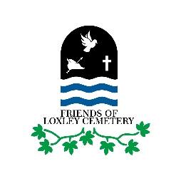
Friends of Loxley Cemetery
Health and Safety Policy Statement

The statement of general policy of the Friends of Loxley Cemetery is:
- To provide adequate control of the health and safety risks arising from our practical on-site volunteering work and activities involving members of the public
- To consult with the members on matters which may affect their health and safety whilst undertaking activities managed by Friends of Loxley Cemetery
- To provide information, clear instructions, and supervision for members
- To make reasonable endeavours to ensure all volunteers are competent to do their assigned tasks and to provide adequate advice and training if required
- Implement appropriate emergency procedures
Responsibilities and arrangements for health and safety management
The Committee of Friends of Loxley Cemetery has overall responsibility for health and safety matters related to the activities of the group and will ensure that:
- Volunteers receive adequate and sufficient information, training and supervision on health and safety matters as appropriate
- A risk assessment is undertaken for each aspect of the activities which Friends of Loxley Cemetery undertakes, taking account of risks to both volunteers and members of the public
- Accidents and incidents are investigated and reported to the committee and, where appropriate, to the appropriate Sheffield City Council Officer
Friends of Loxley Cemetery members shall:
- Take reasonable care of their own health and safety, including the wearing of appropriate footwear and clothing when working in the cemetery
- Take advice from a Friends of Loxley Cemetery activity supervisor when working in the Cemetery
- Report any accident or incident to the nominated Friends of Loxley Cemetery activity supervisor, or if appropriate to the emergency services, at the earliest opportunity

Adopted by the Friends of Loxley Cemetery Committee: Date 5 July 2022

