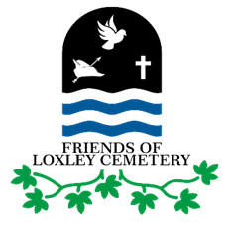
MEMBERSHIP SUBSCRIPTION FORM 2021
Friends of Loxley Cemetery

First name: ____________________________________________
Surname: ____________________________________________
Address: ____________________________________________
Email: ____________________________________________
Tel No: ____________________________________________
Is your membership a renewal? Y / N or new? Y / N
Yearlong Membership subscription costs £5.

Valid from 1st January. Receipts will be sent by email.

Please contact loxley.secretary@yahoo.com for details of payment.

You can pay by cheque / PO (made payable to Friends of Loxley Cemetery) or in cash

THANK YOU

