Friends of Loxley Cemetery Group

Annual General Meeting held at Bradfield Village Hall
7:00 pm, Wednesday 1 September 2021

Chair’s Report

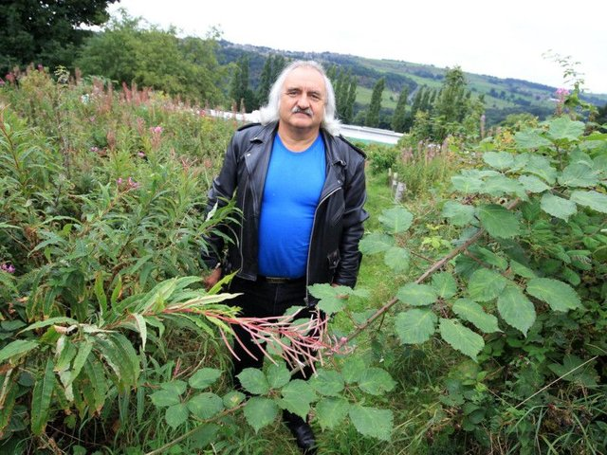

Chair, Mick Drewry, at the Long Lane site following
the arson attack in 1916 (Photo courtesy Sheffield Star)

Although this is the Group’s first Annual General Meeting, it was constituted almost two years ago. However, due to the government restrictions in response to the pandemic, the Group’s activities have been stymied and meetings were not able to take place for much of the last year, thus preventing the arrangements for an AGM last September. However, much has been achieved since the Group’s inauguration but before I report on these achievements, I want to indulge in a bit of personal nostalgia and reflect on the history of the first Friends of Loxley Cemetery Group.

An embryonic group existed as a sub-group of the Hillsborough Community Development Trust when I first volunteered there in 1999, as indeed did the Friends of Wardsend Cemetery Group, the Trust holding a 10 year lease on Wardsend Cemetery at the time. My mum and step-father, Jean and Don Gregory, regularly tended the grave of my grandparents at the time and I told them of the existence of the Friends Group, which had more aspiration than action at the time. With the help of the Trust, Jean and Don were introduced to some of the people associated with the Loxley Cemetery group, including Denise Beaumont and Sue Thompson, who are now members of our group. Notes that my mum kept show that some 31 people were involved in the group, which formed a committee of six that first met on 19 November 2002 at Sue Thompson’s house. Although the group was never constituted, it did much to highlight the overgrown condition of the cemetery and tried to force the then owners, Hague Farming, to improve the site, enlisting the help of the then member of parliament, Helen Jackson, Sheffield Council Environment and Regulatory Services and the Health and Safety Executive. However, non of these agencies were able to enforce action or engender any long term commitment from Hague’s to maintain the cemetery and as we know, things generally got worse in the intervening years. Nevertheless, we cannot underestimate the importance of the contribution these pioneers of the Friends of Loxley Cemetery made to where we are today. We are their legacy. I may write a piece on this history for a future newsletter.

The story of our group begins with a change of ownership of the Church and cemetery and the arson attack on the Church soon after in August 2016. Once more, the state of the cemetery was raised in the local press and once more there was little action. Pressure was brought to bear on the new owner, Mr. Jameel Ali, by local councillors, Penny and David Baker and Vicky Priestly, and a site meeting was arranged with Mr Ali and interested parties, including myself, Ron Clayton and Malcolm Nunn. Mr. Ali revealed his plans for the Church and development of land on the approach to the Church and verbal agreement was made to his commitment to the establishment and support of a Friends group to improve the cemetery. A further meeting was arranged for the following fortnight but this never took place and progress remained illusive. Step forward once more Penny, David and Vicky, who managed to bring the parties together again at a meeting at the Town Hall on 22 May 2019, where Mr. Ali signed an agreement for the Friends group to commence. Penny, David and Vicky arranged a wind-swept awareness-raising event at the Long Lane entrance of the cemetery on Saturday 10 August (they didn’t arrange the wind) and a public meeting for anyone interested in being involved with a Friends group on 18 September at the Wisewood Inn, where a constitution was agreed and a management committee of volunteers established. The Committee met for the first time on 9 October 2019 and formally adopted and signed the Constitution. It goes without saying that we owe a huge debt of thanks to Penny, David and Vicky.

The Committee met regularly at the Wisewood Inn until the Government Covid-19 lock-down in March 2020. At this point I would like to say a big thank you to Olly at the Wisewood Inn for his support in hosting our meetings at that time free of charge.

During this early period a bank account was set up, membership subs of £5 per year were agreed, a Health & Safety Policy was adopted, we took out public liability insurance, regular newsletters began, a Remembrance Day and a Sheffield Flood anniversary commemoration were made and we attended our first event at the Sheffield Heritage Fair in January 2020, co-organised by our very own Ron Clayton, where we had a display board put together by Trisha Childs, who has taken on responsibility for publicity. The event, attended by all available Committee members over the two days, engendered a number of new members and donations, which I’m sure Mike Ford will cover in his Treasurer’s Report.

Our first organised activity day at the cemetery was arranged for early March but had to be postponed and then the lock-down commenced, putting a stop to all activities and Committee meetings.

During the lock-down period, our Secretary, Linda Brownlow announced that due to personal commitments she would unfortunately need to stand down from her officer position, although she was able to attend the only other meeting we were able to have in 2020, in September, and take the minutes – Linda, thank you for your tremendous work as Secretary and dedication to the Group. For a time it looked like the Group was in danger of folding as no-one came forward to replace Linda as Secretary until Verity Brack answered the call and volunteered. Verity was co-opted on to the Committee and elected secretary via an email vote of the Committee. In the short time that she has been on board Verity has proved a great asset to the Group, not least in setting up a Group website, which will be invaluable in promoting the Group and its activities in the future - thank you Verity!

The committee was next able to meet on 19 July 2021 when government restrictions were lifted and it has met just twice this year. However, all necessary work was maintained by email communication and Trisha continued to produce regular newsletters. I put together the Flood anniversary newsletter using material from new research and significant contributions from Malcolm Nunn and Karen Lightowler. Malcolm’s knowledge and access to historical information is invaluable for finding graves and he has been able to answer a number of enquiries from Group members and from members of the public; something that we intend to develop as a public service, along with the publication of articles of historical interest in the newsletters. Newsletters are a most important medium for member communication and publicity. Thank you Trisha, Malcolm and Karen. Our Health & Safety Officer, Anne Williams has also done some important work in undertaking risk assessments during a very trying time. Thank you Anne.

Now for the most important information for me report; work at the cemetery. Government restrictions prevented organized activity days until very recently but that hasn’t stopped individual members taking up the cudgel and getting stuck in to clearing the overgrowth and I have to say, there has been a tremendous improvement made to the Long Lane site by the activities of individuals who have organized themselves into regular working parties on Tuesday mornings: Mark Pickering, Hannah Isherwood, Joy and Phil Wright, Anne Ramsey and others (apologies for not knowing any other active members), including committee members Jane, Verity and Mike. Mike organized the first official activity day on Tuesday 3 August. Future official activity days are now also planned for the first and third Saturdays of the month, led by Jane Pratt. I want to thank and congratulate you all for the magnificent work that you have done and all that you have achieved.

So, here we are today at our first AGM and all that remains for me to do now is to thank each and every member of the Management Committee for their dedication, enthusiasm and commitment to the Group. I am confident that two years in, thanks to the committee, the Friends of Loxley Cemetery Group is now established on sound foundations and its future is assured. Its profile will be raised locally by its work at the cemetery as the site is gradually transformed back to a picturesque haven of tranquillity. Its involvement in the local heritage network will continue and we have joined the National Federation of Cemetery Friends Groups, giving us further opportunities from being involved in a national network.

It has been a privilege to serve as Chair of the Friends of Loxley Cemetery Group and I wish my successor and the new Management Committee my best wishes for a successful, secure and sustainable future and look forward to your future projects and achievements.

Mick Drewry
Chair of the Friends of Loxley Cemetery Group

