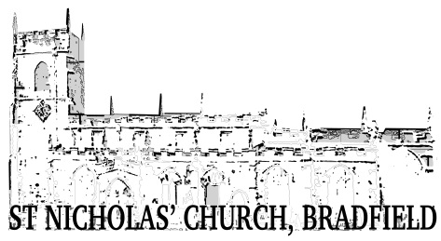
Bulletin No.3 October 2022

St Nicholas’ Church, Bradfield

We are pleased to be returning to something like normal thanks to the visiting clergy who are providing us with a regular Sunday morning service as well as baptisms, marriages and funerals. It is expected that this will continue for the foreseeable future.
The Church Wardens and PCC are working hard to ensure that general matters and maintenance continue but it has become evident that not everyone understands the difficulties we face without a resident Rector. Much of the background administration, decisions and maintenance of the building are now their responsibility. A number of comments have been made on social media about the upkeep of the Church and graveyard. The following are the main concerns:
- Complaints about the upkeep of the graveyard have been made because of the sheep which are there to keep the grass and weeds down. Naturally, they leave droppings on the path but we do try to keep the path cleared when services are due. This is not always possible. An alternative is to hire a contractor to cut the grass around the gravestones but this would cost the Church at least £500 in the summer months.
- Like any other household, the Church requires regular cleaning. This is done by volunteers when they have time but this is no small task. Any help with this would be most welcome when cleaning days are advertised.
- This Grade 1 listed building is expensive to maintain. At present, attention is being given to the completion of the Jane Street wall but there is also an urgent need to replace two gas boilers for heating, to repair two stained glass windows which may not survive the winter, as well as roof repairs. Apart from these matters, the heating and lighting costs of this large building are substantial.

Although the maintenance of the building and grounds is often of concern, we are fortunate in having a Church with bell-ringers, choir, organist and some dedicated people who work to provide festivals and community events. We expect to have our usual Harvest service, Barn Dance, Remembrance observance, Ploughman’s Lunches, and in December, a Christingle service and Christmas Day Service. We look forward to these events and hope you will be able to attend and support us at least on one of these occasions. You are assured of a warm welcome.

St. Nicholas’ Church Wardens and PCC

