AROUND BRADFIELD CALENDAR 2024 - Have you any suitable photographs?
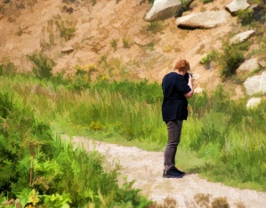
For the past nine years, we have produced a calendar to raise funds for St.Nicholas’ Church. We have been well supported by local people and visitors who send in photographs taken in Bradfield, surrounding villages and countryside. As it is a fund-raising venture, we do not pay for use of the photos but give a complimentary calendar to contributors whose photos are selected. If you have suitable photos in landscape format which you would like to be considered for the calendar, please send to
erwalker715@btinternet.com before 31st July 2023. Thank you.

