Ford Village

Community Action Plan 2024-27

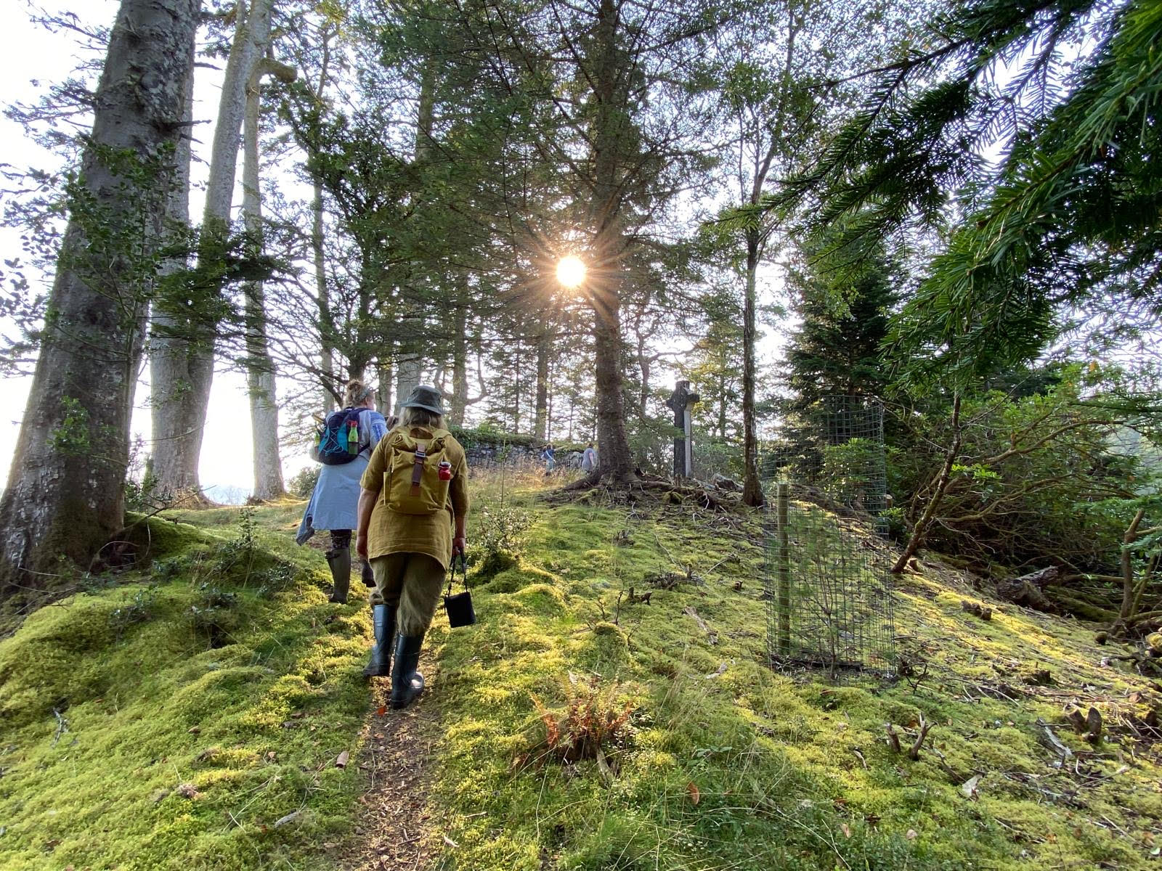

Document produced by Ford Village Hall Committee – summer 2024.

# **CAP 2024-7: What is a CAP?**

A CAP is a Community Action Plan and is very simply a strategy that is based on a consultation of local people which aims to shape the future of the village hall and the services and social events it offers. As the plan is based directly on the views of villagers it is a community plan not a committee plan. The role of the committee is to organise the consultation process, use the resultant data to draw up an agreed plan then support the wider community to deliver it.

# **CAP 2024-7: How did we consult?**

* A website was created for the village and its hall: https://e-voice.org.uk/fordvillageargyll/. Information about the CAP was placed on the site including a link to an online survey. We had 60 online responses.
* Paper versions of this survey were hand delivered to every household in the wider Ford locality. This included homes in Inverliever, Kilmichael Glen and Ederline. We received 13 paper returns.
* The website also had a discussion area for locals to add their views on key questions.
* Three public meetings were held in the Hall during May 2024.

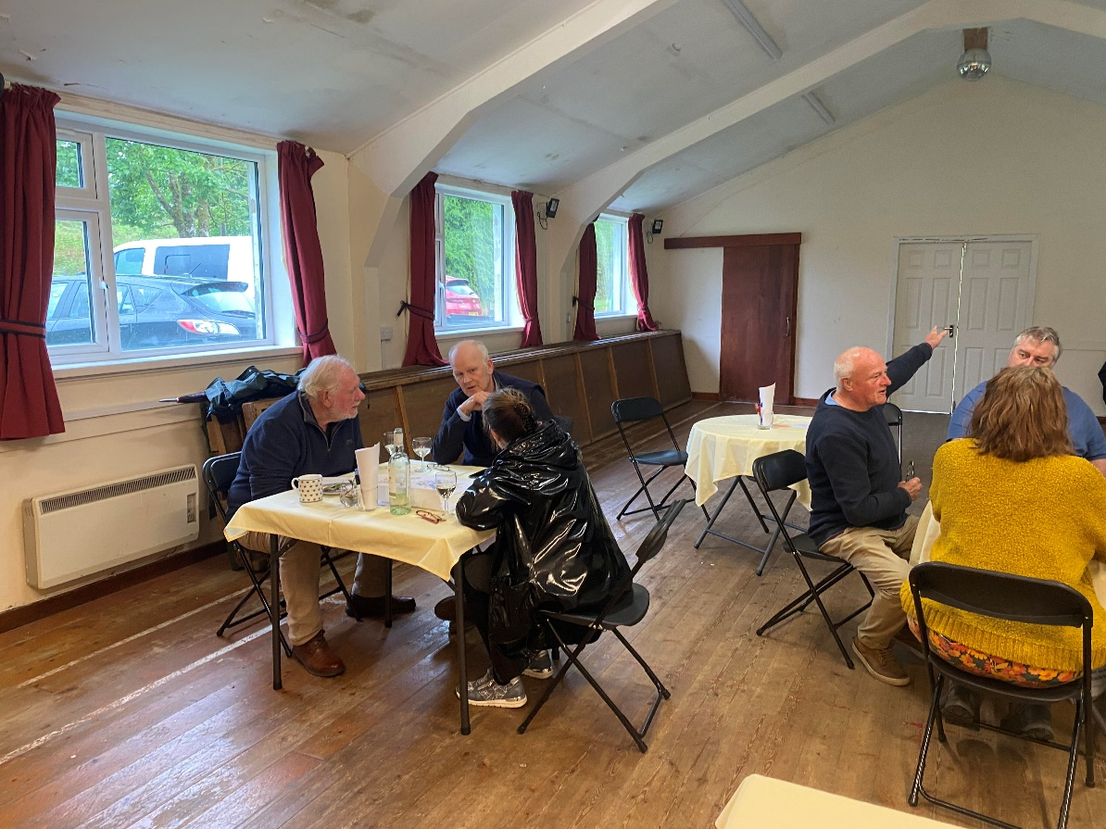

# CAP 2024-27: Positives and Negatives

As part of the surveys, we asked community residents to offer three words which summed up their positive feelings about living in Ford and then three words which summed up their negative feelings. These words were used to create word clouds. These clouds were then used to promote wider discussion at the public consultation meetings.

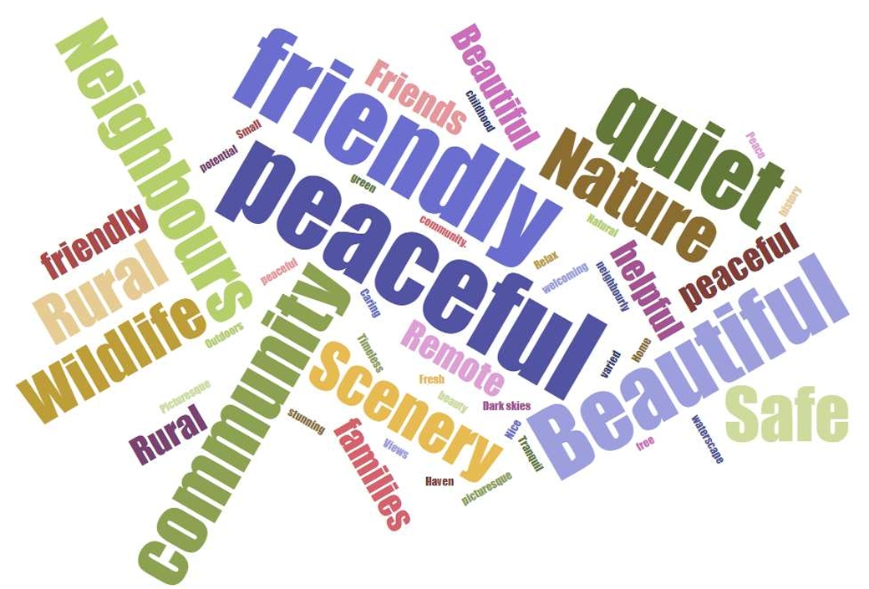

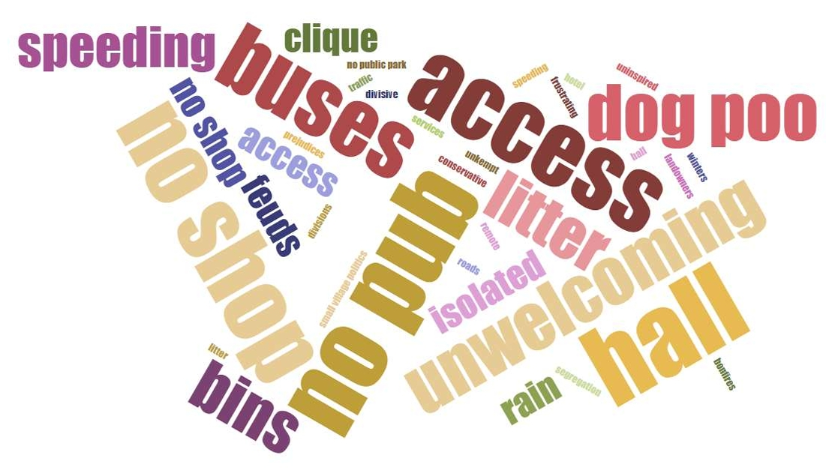

These words would be used to inform the committee in their work to create the CAP, to strengthen what was already popular and develop what needed improvement or creating.

# **CAP 2024-27: The Future of the Hall**

The other major focus of the CAP was to consult on the future of the Ford Village Hall. The survey asked respondents to give their view on the future of the Hall. It was fairly evenly split between those who wanted to save the existing building and those who wanted a new one. This question was discussed further at the three public meetings.

Once the three proposed options were discussed in greater detail it became a choice over cost both environmental and financial. The greener and cheaper option was to renovate the existing hall. A new hall would cost a minimum of £750,000. With no funding currently available. A major renovation would cost a third of that and not require putting the old hall into land fill. A further complication is that if the village stopped using the hall in its current location the village might lose the right to the land it stands on. After much discussion it was agreed at all three public meetings that a project to renovate and decarbonise the current hall would be placed into the community action plan.

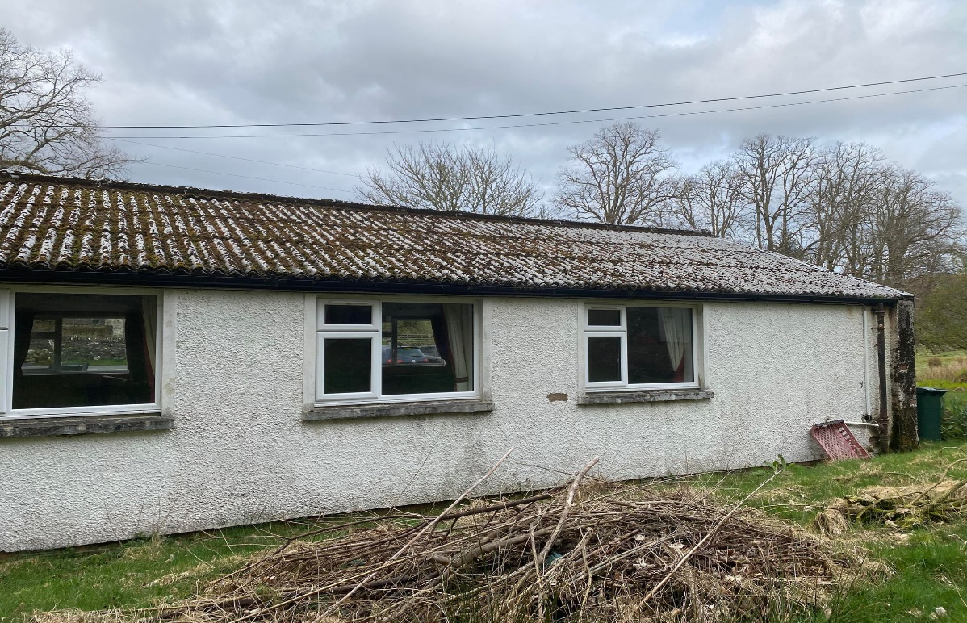

The Ford Community Context:

Ford, Àth na Crà, is a small village at the southern end of Loch Awe in Argyll, Scotland. The village originated as a stopping point on the drove route to Inveraray. Many prehistoric structures survive within the village boundary and are all easily accessible or can be seen from the public road. Opposite the guest house, in the village centre, stands a prehistoric burial mound known in Gaelic as Cnoc an Ath. Several standing stones are scattered around the area, the three most notable ones being the one in the field next to the guest house, the one opposite Glennan Farm, and the largest one at Torran Farm. A crannog is also present in Loch Ederline and is clearly visible from the road.

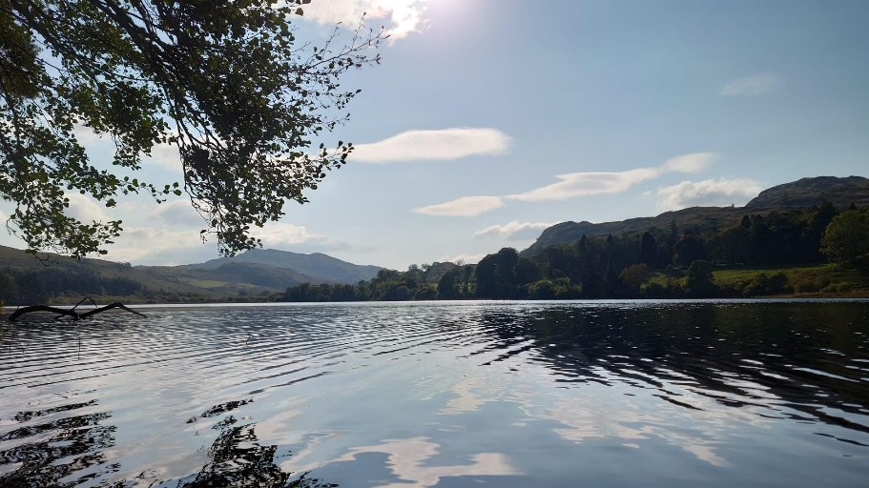

The village and its hinterlands stretch from the centre with the junction with the B840 west out along Loch Awe to the Inverliever River, east along the Loch to Finchairn. It encompasses the Ederline Estate, homes out towards Kilmichael Glen and farms almost to the junction with the A83. 100 or so people live centrally within the village with about the same living in the outer reaches. The village since the 1980s has seen a huge change in terms of demographics. There is currently only one person still living in Ford who was born there. During this period the village lost its school, Hotel and bar, shop, post office and most recently its church. It is rated in the lowest decile for access to services in the SIMD survey of Argyll and Bute. The village hall is the only remaining community asset in Ford.

**Ford Village**

*Our vision for the future*

**Over the next three years we will build on our strengths to create:**

* A village hall which is a warm and welcoming space for the village and wider community.
* A community which has access to services and events which help to overcome Ford’s rural isolation.
* A well-connected community, outward and forward looking and with strong internal cohesion.
* A community with the infrastructure to face the future and to provide for the needs of our community.
* A community where the quality of life is excellent and where people are welcomed.
* A community which has access to the countryside and its associated fauna and flora.
* A green community which protects and sensitively develops

our natural assets

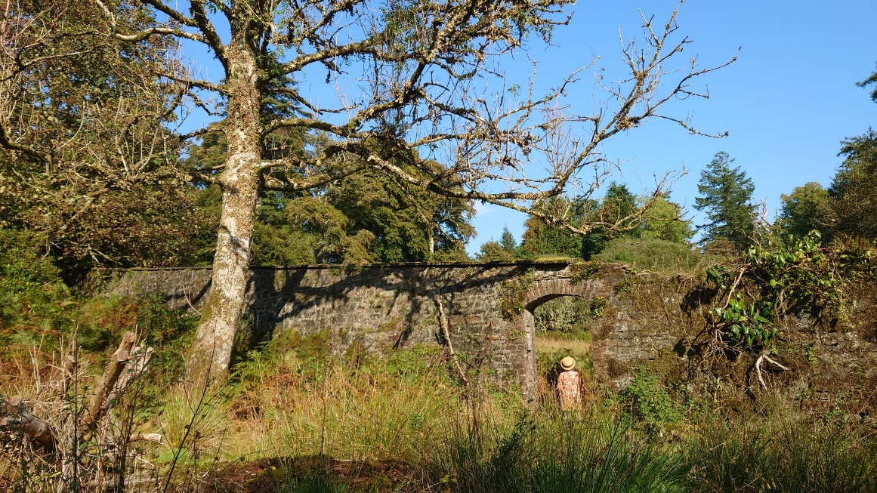

Ford Village CAP Themes:

* **Community**
* **Access**
* **Environment**
* **Wider Links**

**Theme 1: Community**

Priority 1:

*A village hall fit for purpose*

* Seek and secure funding to repair and renovate the current hall so that it is a warm, safe and welcoming place for Ford and the wider community.
* Provide a plan to renovate the hall and grounds once funding is secured.
* Provide funding to support local events and group without charge in the hall.
* Open the hall to external organisations and events for minimum charge.

Priority 2:

*A decarbonised and modernised hall*

* To seek further funding in order to secure the future of the hall for the next two decades.
* Create a project plan that will deliver this future for the hall.
* Decarbonise the energy use of the hall.
* Examine the opportunities to broaden the use of the hall – a shop, public toilets and village café.

Priority 3:

*Strengthen local traditions and bonds through social events*

* Once again put on annual events popular with the local community which have been traditional for a long period: e.g. - Christmas Party, Summer Gala Day, Halloween
* Ensure that other events are regular features of village life: e.g. – pop up pub nights, Quiz Nights, coffee mornings, cinema nights, bar-be-cues.
* Apply and secure for the appropriate licences.

Priority 4:

*Overcome rural isolation by providing the groups and organisations requested by the community*

* Use the village hall committee to facilitate the creation of groups which promote interests, education, skill development and community building.
* These groups will help tackle loneliness and promote mental health and community resilience.
* The groups will be led by local people, supported by the village hall committee and will reflect suggestions provided by the CAP consultation.
* These groups will include: Astronomy Club, Gardener’s Club, Knitting Club, Board Game Club, History and Heritage Club, Walking and Wildlife Club, Circuit Training.
* Identify and secure funding to support these groups going forward.

Priority 5:

*Improve and professionalise community communications*

* Build and develop a village hall website
* Create a Facebook presence for the Village Hall
* Develop a communications strategy and policy.
* Publish a paper newsletter which is delivered to the local area at least once a season.

**Theme 2: Access**

Priority 1:

*Use the hall to support access for all to community activities*

* Maintain a village hall so that it is warm and welcoming all year round
* Provide access to the hall free of charge for local groups
* Provide access to the hall at minimum charge for groups from the wider community
* Social events to be heavily subsidised for local people

Priority 2:

*Explore opportunities to improve the access of local people to the environment, history and wildlife of their locality.*

* Access to the local area for leisure reasons was identified by a majority of local people. This was particularly relevant to Loch Awe’s shoreline in and around Torran Bay and the southern end of the Loch. The committee will support local individuals and groups who seek to broaden access to our local area
* Develop and strengthen relationships with local land owners in order to ensure local footpaths and tracks are accessible.
* Create and support two groups based out of the village hall which develop local people’s understanding, knowledge and access to local flora, fauna and history
* Develop links to existing wildlife, environment and history organisations: e.g. Argyll Beaver Centre, Kilmartin Museum
* Explore the use of the village green in order to maximise its potential for the local community

**Theme 3: Environment**

Priority 1:

*Decarbonise the Village Hall*

* To seek further funding in order to secure the future of the hall for the next two decades.
* Create a project plan that will deliver this future for the hall.
* Decarbonise the energy use of the hall.

Priority 2:

*Examine the possibilities of developing a community garden*

* Investigate the possible use of the village hall land to create a community garden
* Consult with local residents regarding a community garden
* Explore what other villages do in this area: e.g. – Kilmartin and Lochgair
* Set up a Gardeners Group within Ford Village

Priority 3:

*Look for opportunities to improve the environment around the village*

* Be aware of opportunities to improve the local environment through flower/tree planting.
* Tackle “dog poo” through raising awareness, education and placing dog poo bins around the village.
* Cooperate with groups which seek to improve and secure the fauna and flora of the local environment.

**Theme 4:** Wider Links

Priority 1:

*Support local businesses*

* Ford Village Hall Committee will fully support the Fair Work First Commitment. In seeking contractors to provide services to the Hall we will give priority to those who can demonstrate that they pay their employees a living wage regardless of gender, are committed to providing their employees with a workplace voice and skills training and avoid restrictive and unfair workforce practices such as zero-hour contracts
* The Committee will support local businesses when we seek partners to fulfil aspects of the CAP and providing support to social events
* The Committee will support local organisations and businesses by providing opportunities for them to gain access to the local community

Priority 2:

*Strengthen and build links with local organisations*

* Ensure that the Hall hosts the monthly meetings of the SWI
* Work with local alternative energy companies to provide a channel for consultation with the community.
* Work with local charities, stakeholders, local councils to improve the standard of life of local people: e.g. – Kilmartin Museum, Forestry, land owners, Dunadd Community Council, other local village halls/committees, local and regional funding groups.

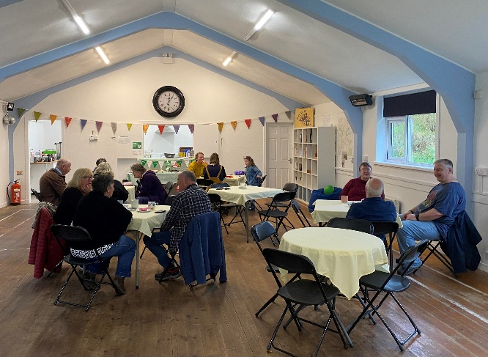

**Making It Happen**

The priorities in this action plan will be taken forward by:

* Ford Village Hall Committee

The Action Plan will be reviewed annually.

If you would like to get involved with any of these initiatives or for further information please contact:

Ford Village Hall Committee

Email: [fordvillagehallargyll@gmail.com](mailto:fordvillagehallargyll@gmail.com)

