Depending on your walking speed this should take less than 1 hour each way.
(the dotted lines on the map are other Rights of Way).
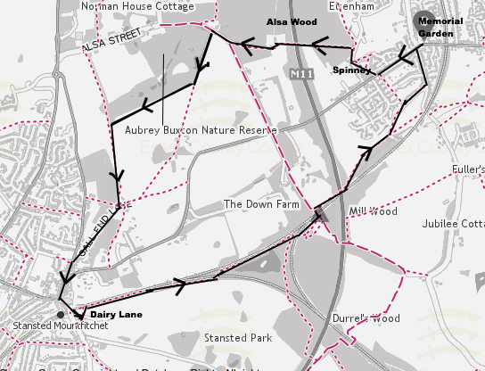

Start at the Memorial Garden (opposite the Post Office).
Head along Stansted Road and turn right through the Spinney, across Isabel Drive and into Alsa Wood.
Over the motorway bridge to the edge of Aubrey Buxton Nature reserve.
Around the outside of the reserve and across to Gall End.
Down into Stansted past the Dog & Duck and Wine Bars.
At Church Road turn left over the railway bridge.
Turn left into Dairy Lane then bear left towards the Railway Line.
The path then runs alongside the railway line all the way back to Rush Lane. Turn left onto Robin Hood Road and back to the Memorial Garden.

