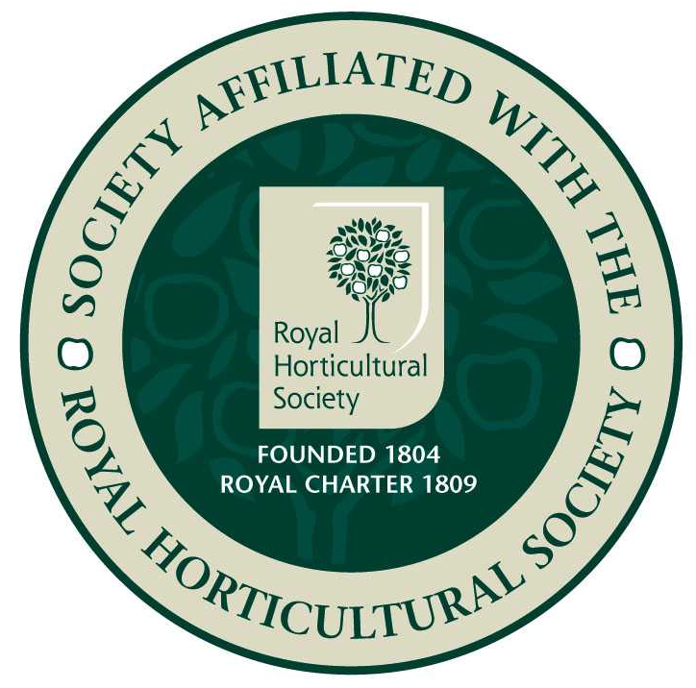
Epsom Garden Society: June 2022

Newsletter: Margaret Haslam 01372 724138, 3 Elm Grove Epsom KT18 7LZ
Membership Secretary and Newsletter Distribution: Steve Roebuck 0208 394 2168
Show Secretary: Cathy Flitter 07821 277708

Dear Member, if you have any news or garden related small ads that you would like to be included in the Newsletter, please phone me, 01372 724138, or email me, margarethaslam6@gmail.com

Looking forward to our Flower Show on Saturday 23rd July.

Despite having to cancel our coach trip, several members organised a trip to Leonardslee Gardens in two cars and had a lovely day.

On April 25th Tim Winter gave us a talk about 'Woodland Industries in Southern England.' We really didn't know what to expect from this talk, but Tim had been highly recommended by other societies, so we were looking forward to it. It turned out to be a study of how our ancestors worked in the local woods to produce useful everyday items, particularly near Haslemere where Tim lives.
He had collected photo cards of men working in the woods and tried to find out their names and what they were doing. The first card showed six men cutting down a huge oak tree. This would have taken several hours without the electric saws we take for granted nowadays. Further photos of the scene show the bark being carefully removed to be used for tanning. The bark was more valuable than the timber, and was easier to remove when the sap was rising in the Spring. Sometimes if they weren't going to need the wood until later in the year they would still remove the bark at the right time and leave the tree as a white ghost until they were ready to deal with it. The Womens' Land Army helped with removing the bark with a barking spoon, that Tim showed us: sharp edged spoon at one end and a wooden handle with a round end for hammering at the other. The bark was carefully stacked in a rick with a tarpaulin on top to keep the rain out. In 1818 a bill shows that Alice Holt Forest in Hampshire had sold trees to the navy for ship building, but had sold the bark separately for more money for tanning use.
Another important industry was charcoal production. A picture of charcoal burners was what fired Tim's interest – he worked for the forestry commission, and thought he would see what other industrial cards he could find while they were still about. Charcoal kilns take three to five days to burn the wood into charcoal, and once the smoke rising from the top changes in colour to blue it means that 80/90% is ready, and the heap should be quickly opened and damped down to stop the fire.
Barrel hoops were cut from split hazel and bent by the Cooper on the quay side to make packing cases. Steve Puttick was one of the last hoop shavers and famous as a man of few words. At the start of the working week he would say 'Morning All!' and that would be it until the following week. Girls using sharp knives would gut the herrings and pack them in the barrels. The record was 67 herrings a minute.
Clogs were mostly made in Lancashire. There were still five clog shops in Brighton in the 1850s. The wood was cut and shaped and left in a pile to season before the leather uppers were attached. Metal studs were then fixed on the bottom. Tim brought two clogs to show us, and we saw how beautifully made they were, and one would have fitted a baby, but was probably a sample.
Hop Poles are still growing in Puttenham as they have been for many years, as craft beer companies still want their individual choice of hops.
Hurdles are still cut for fencing. Hazel nuts were a by-product from hazel coppicing and sent in sacks to Covent Garden. Nowadays the squirrels seem to eat them all a few weeeks before they are ready.
Besom Brooms used to be bound with strips of willow or bramble stems. This was a winter occupation for children, sitting round the kitchen table stripping the bramble stems. Here Tim showed us an old film of visitors arriving to see George Berry, a besom broom maker. The technician transferring the film so that it could be seen on modern equipment wanted to cut out the first few minutes, but I am glad he didn't, it showed a family arriving in a new-fangled car at George's cottage and apple-cheeked Mrs Berry bustling out to admire the baby and usher the lady inside, while the men pushed past the flowers round the back to see the broom production. George collected a big bundle of sticks and fastened them together with some wire, tensioned against a hook. He inserted the handle, shook it all up to level the ends and banged a nail through to stop the handle coming loose. He had such large strong hands that we wouldn't have been surprised if he had just banged the nail in without needing a hammer at all!
Walking sticks were mostly made at Chiddingfold, where there were two factories. The handles were bent with steam and then cooled in sand. One enterprising owner, Mr Lintot, thought of a new production method where he grew cherry saplings at an angle and then cut them next to a bud so that a straight piece would sprout. He could then cut this to make a stick with a natural bent handle.
Blacksmiths made tools too. If ever you find a billhook with 'Rapson' stamped on it, please let Tim know, because that was made by his Great-Grandad.
Thanks Tim, for this lovely talk. We really felt we had been back in time.

In 1841 one book changed the life of many women of elevated classes for ever! It was Mrs Jane Loudon's 'Practical Instructions in Gardening for Ladies.' It was the first book to encourage ladies to get their hands dirty and even take on a faint glow of perspiration.This was so novel at the time, ladies were expected mainly to be decorative, with perhaps a little music practice or water colour painting to while away the hours. 'Gardening for Ladies' bravely insisted that women could manage gardening independent of male supervision if they simply observed a few sensible precautions – working steadily but not too vigorously, using only light tools, but never standing on damp ground because of the unhealthy emanations that would rise up through their skirts. The book appeared to assume that the reader had scarcely ever been outside, let alone laid hands on a gardening tool.
Here for instance, is Mrs Loudon explaining what a spade does: ' The operation of digging, as performed by a gardener, consists of thrusting the iron part of the spade, which acts as a wedge, perpendicuarly into the ground by the application of the foot, and then using the long handle as a lever, to raise up the loosened earth and turn it over.'
The whole book is like that, describing in almost painful detail the most mundane and obvious actions, like which end of the spade to put into the ground. It is practically unreadable now, and probably wasn't greatly read then. The value of 'Gardening for Ladies' wasn't what it contained so much as what it represented: permission to go outside and do something. It came at exactly the right moment to catch the nation's fancy. In 1841 middle class women everywhere were thoroughly bored by the rigidities of life and grateful for any suggestions of diversion.'Gardening for Ladies' remained lucratively in print for the rest of the century. And it really did encourage them to get their hands dirty, the whole of the second chapter was devoted to manure.

Our Open Garden group is up and running with several members' gardens to visit, contact John Lucking, john.lucking@outlook.com 01372 722843.

Banstead Horticultural Society would like to invite us to their talk on 9th July. Pippa Greenwood is coming to talk about 'My Life in Gardening', and this will be at Banstead Community Hall, Park Road SM7. It starts at 2pm for 2.30pm, and tickets are £12 through their website www.bansteadhorticulturalsociety.com. Ticket holders only.

Ecological are organising a half day workshop about Summer Currant Pruning on 25th June from 10am – 1. They will explain pruning techniques for gooseberries, red and white currants. Mid-summer will be an ideal time for this short practical workshop to give you the skills and confidence you need to tackle your own fruit garden. Full instructions will be provided and lots of notes to take away so that you can nurture your currant bushes and grow bumper harvests for years to come. This will be held outside, so be prepared for the great British Summer! Held at Carshalton Community Allotment, [access between 33-35 Colston Avenue] SM5 2PW. Book at foodecolocal.org.uk, or phone 020 8404 1522.

Have you ever thought about exhibiting at an RHS Show? They are free to enter, and open to all, with prize money, cups and glassware to compete for. For further information, schedules and entry forms look at the website https://www.rhs.org.uk/shows-events/exhibit-at-a-show/rhs-horticultural-competitions or contact Georgina Barter, the competitions manager at georginabarter@rhs.org.uk.

Best wishes Margaret

