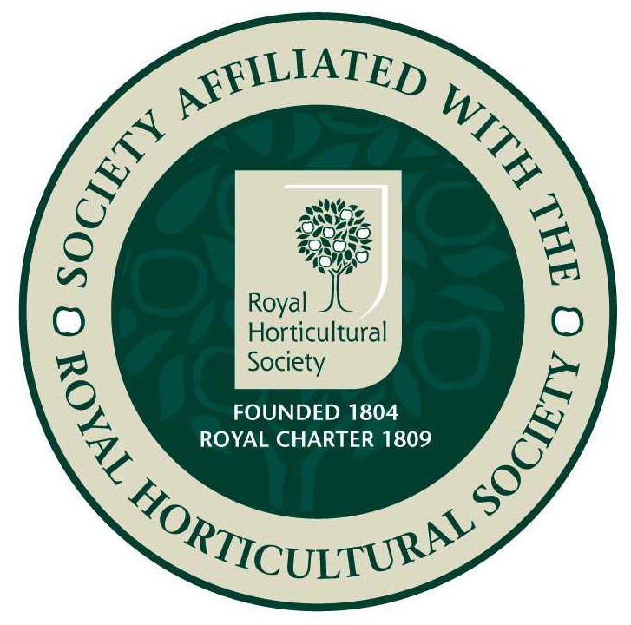
Epsom Garden Society: February 2023

Se
Newsletter: Margaret Haslam 01372 724138, 3 Elm Grove Epsom KT18 7LZ
Membership Secretary and Newsletter Distribution: Steve Roebuck 0208 394 2168
Show Secretary: Cathy Flitter 07821 277708

Dear Member, if you have any news or garden related small ads that you would like to be included in the Newsletter, please phone me, 01372 724138, or email me, margarethaslam6@gmail.com

Marian Oliver and Sue Glover have arranged an outing for us to Ramster Gardens, Petworth Road, Chiddingfold, GU8 4SN on Tuesday 9th May. Plenty of Spring colour with rhododendrons, azaleas and camellias, also a sculpture trail. Make your own way, to arrive at 10.30. Cost £8, pay on arrival. Refreshments available, and return for lunch at 1.15. Further details email Sue Glover on outings.egs@gmail.com, or phone Marian 0208 393 8019. If you would like to come please let them know as the owner will need to know numbers, and please take a companion if you have mobility problems as the garden is quite large and we may not all stay together. Also, let Sue know if you either need or can offer a lift.

Two members of our Society have died recently. Annette Pawson was a stalwart Flower Arranger and helped to encourage children to participate, and Margaret Challis, widow of George, who was our President for several years some time ago. George was Chief Commoner in the City of London and once gave us a talk about his work there. He had organised a trade exhibition to Russia back when we wanted to increase trade opportunities. George's idea was to make a copy of a workers house, perhaps a steelworker's terrace house from Sheffield for the Russians to walk through. They weren't quite sure what to do about the teenage daughter's bedroom, but George said they should do it as it was, and the Russians loved it and came up after the tour to shake his hand and tell him that their daughters had messy bedrooms too! The Society have made donations to the Princess Alice Hospice and the Red Cross.
On the 18th December Kim Shrosbree and partner Tom Pope organised a very sociable and jolly Quiz Night. The Quiz was about gardening topics with a festive theme, bought by Viviane Sinnock as an emergency standby in case of speaker failure some years ago. It all seemed quite simple at first with printed questions and a choice of four answers on the screen. Amusing animated decorations helped the seasonal theme. Unfortunately I didn't know very much and ended up with only 13 right out of 24. Do you know which family of birds the red breasted robin belongs to, or what best describes how cranberries are grown and in what habitat? Quite. The winner was Cathy Flitter, with an amazing score of 23.
Kim and Tom were very pleased with the performance of their projector. It had been thrown away in a skip after an office clearance. Evidently no one had wanted it, but it looked like new and worked beautifully.
On 20th February Graham Blunt from Plantbase Nursery in Kent is coming to talk to us about 'Growing and Overwintering Exotics and Similar.' With a plant sale, at St.Barnabas, earlier start time of 7.45pm.

On the 7th January Epsom Library organised another popular talk to finish off their Tree Month. John Madden from Lingfield Nature Reserve came to explain how this had come into being. It was a good story and he enjoyed telling it. The site is twenty-five acres, partly in the middle of Lingfield village, with open countryside on two sides. It is publicly owned, and the councils plan had been to build houses on it back in 1994. It didn't look anything special, just grazing land with rusty barbed wire fencing. However the villagers objected to the housing plan and a group of volunteers twenty years ago decided to turn it into a Nature Reserve for the benefit of local people and wild-life. There are sixty people signed up on the helper list, and about twenty turn out when workers for projects are needed. The land is used by many people. The scouts and cubs hut is next to the site, there is a play area, an art group, the mental health group enjoy quiet walks, and it is a safe journey to school away from the traffic for many children. John enjoys seeing people using the reserve and likes to ask which group they are from.
There is a great need for Wild-life conservation. Britain is only 189th out of 218 assessed counties for our conservation efforts and one in seven species are at risk of extinction. Of the survivors 56% are in decline. When asked, most people say that they like the countryside to look neat and tidy. When asked about wild-life they say 'What wild-life?' We were shown a slide of a green field of grass in the sunshine. It looked lovely, but was all the same variety and would have been as sterile as a desert for a wild creature needing food or a home. John has been leaving his grass verge outside his house to grow wild flowers and shelter creatures, and showed us a beautiful slide of buttercups and daisies and even some wild orchids. Admittedly it does look a bit straggly by November, when he cuts it all to the ground, but it comes back better every year.
Every week John takes a fixed walk to notice butterflies and then reports to the Conservation Council what he has seen. This last Summer over thirty species were recorded, more than in wild districts of Northern Ireland, and they were mentioned in Parliament. Also a local Moth expert runs a moth trap and reports his findings to the Committee.
There has been success with great crested newts, 38 found in the pond in 2021, and these seem to be threatened all over Europe. They moved in by themselves, but were then menaced by goldfish emptied into the pond by locals looking for a home for them. Now a new pond has been dug specially for goldfish and peace has returned. Pond dipping became very popular with children a few years ago, but now they use the goldfish pond and the newts aren't disturbed.
It seemed sensible to set up various habitats to please different creatures. The Butterfly Garden and the Quiet garden next to it are planted with flowers and shrubs to provide nectar over a long period specially to attract butterflies, moths, bees and other pollinating insects. The shelter of the surrounding shrubs and trees provides a warm and still area to please these insects and for some, a place to lay their eggs. Birds also enjoy this garden as it is relatively secluded.
The Community Orchard is planted as a traditional orchard with wide spacing between the trees and many are old varieties. The fruit is not grown for commercial use, but shared between the birds, insects and animals as well as human visitors.
[I was amused at this because years ago my sister took her children and a friend's little boy to Wisley's Apple Day. They walked happily through the orchard, where there were lots of windfalls, until the little boy suddenly announced 'I have eaten seventeen.' He was alright!
The Meadowlands are mown annually in late Summer once the wild-flower seeds have fallen. The cut hay is removed to reduce the soil fertility and allow the wildflowers to compete with the more dominant grasses. These areas support an increasingly diverse community of meadow plants including Yellow rattle, Bird's Foot Trefoil, Knapweed, Meadow Buttercup and Tufted Vetch. It took twenty-five years of reducing the fertility of the grass before the Bird's Foot Trefoil would grow happily, but they are so pleased it is growing now as there as a particular Blue Butterfly that needs it. Some surprises have come up by themselves, Corky Fruited Water Dropwort suddenly was seen, and usually only grows much further west. It looks like a small dainty cow-parsley, with odd corky seed pods. Devil's Bit Scabious is a lovely blue, and many butterflies enjoy it. Common Spotted Orchid is becoming more common, John collected some seed from a lay-by in Crawley that was being trashed by heavy lorries driving over it. You are not supposed to do this, but they are happy in their new home. John counted fifty flower spikes in 2017 and over 400 in 2021. The Yellow Rattle seeds were collected from Regents Park and improve the habitat for wild flowers by weakening the roots of grass species. They are also the food plant of a rare moth.
The committee are always pleased when moles make hills, they are a key-stone species as they bring bare soil to the surface for plants to colonise and bring up buried seed.
Young grass snakes have been seen basking, pleased they were young as it shows they are breeding, also lizards, but no photos as they hear you coming and disappear. Nocturn Bats come out in the early evening. They are Britain’s largest bat. Bird watchers are surprised at the variety of birds that can be seen at the reserve. Bull finches used to be seen everywhere and Yellow hammers, but are becoming rare. Last year the villagers were thrilled to hear a nightingale. Birds of prey have been seen flying over, they were surprised to see a white tailed sea eagle checking the place out. Many species of Dragonfly have settled in, including Willow Emeralds, new to this country. John had to look them up to identify them. The defining mark is a small white fleck on the outside of the wing at the top.
We asked what we should do to help wild-life and the answer was make a pond and a compost heap, possibly leave an area of grass to grow and not to be too obsessively tidy!

One of our members was given a weighty novel for Christmas and has already been woken up twice by it falling on her when she was reading in bed. The title? 'Strike.'

Best wishes Margaret

