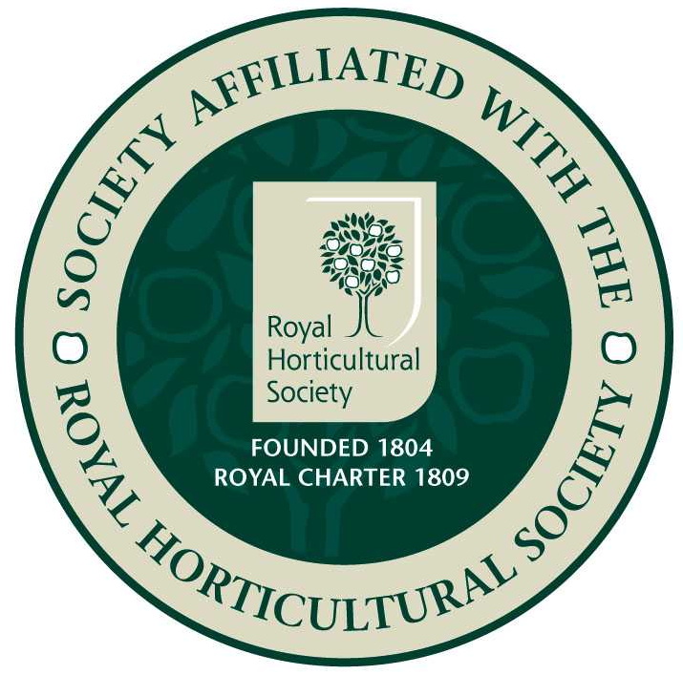
Epsom Garden Society: October 2019

Newsletter: Margaret Haslam 01372 724138, 3 Elm Grove Epsom KT18 7LZ
Membership Secretary and Newsletter Distribution: Steve Roebuck 0208 394 2168
Show Secretary: Cathy Flitter 07821 277708

Dear Member, if you have any news or garden related small ads that you would like to be included in the Newsletter, please phone me, 01372 724138, or just tell me when you see me at the meeting.

As I write we are looking forward to our lovely Autumn Show. The Show Report will be in the next newsletter.

On the 18th November we will have our AGM at 8pm, at St Barnabas Church Hall, Temple Road, Epsom.
The business part to discuss is:
- Minutes of the AGM held on the 19th November 2018, matters arising from these Minutes.
- Chairman's Report.
- Treasurer's Report.
- Membership Secretary's Report.
- Elections of officers and Committee. Please send all nominations for the Committee to our Hon. Chairman Heather Martindale, 078402 97077, by 1st November.
- Any other business.
Please don't bring raffle prizes for this: we will finish with our usual fancy cheese and wine refreshments.

Many thanks to Steve and Pat Roebuck who hosted our Garden Party on 11th August. This is held to thank all our road reps. who deliver our Newsletters and people who help at Shows. As usual it was surprising to see how many are involved, and the Society couldn't manage without you! The weather looked O.K. for once, but Steve kindly put up gazebos for some shade from the sun. We all enjoyed delicious food and drink, and conversation ranged freely.
We discussed the wine making craze of the 1960's. One lady had even picked dandelions from the park very early in the morning and then painstakingly removed all the green backs as they were supposed to make the wine taste bitter. Also everyone had fewer plums on their trees this year. Maybe there was a frost at just the wrong time.
We wondered if there had been a windmill near Windmill Lane.
Also we noticed how very smart everyone was looking. One lady on our table had been wearing her disreputable gardening trousers until the last minute before she changed to come. Her daughter had worried about her outfit and been told 'Oh, I am not ready yet, I have to tip coffee down my top first!' Needless to say, she looked quite beautiful when she arrived.
One lady had tried boiled beetroot as a vegetable with her dinner for the first time, as her neighbour had a glut of them, and really enjoyed it, although it took a lot of cooking.
I was feeling slightly self concious as I had made a dress for the occasion. Roses rioting across a pale background. This led to an enjoyable chat about Norman Hartnell using just one or two dress patterns for the Queen for many years, just varying the length of the sleeves. I shall pay attention next time I see her! Thank you Steve and Pat for your generous hospitality!

Back on the 15th July Russell Bowes gave us a talk about 'Say it with Poison.' Russell pretended that we had inherited a fortune from his Aunt Agatha, and led us through a garden filled with poisonous plants hoping that we would try one and perhaps clear the pitch! First up was tobacco, brought here in the 1560's and named by John Nicco from Portugal. Sailors hid leaves under their shirts to avoid paying duty, but then some absorbed enough nicotine that they died from nicotine poisoning. This was also used by Ed McBain in a story about a murderous dentist who filled a tooth with nicotine under a thin cap. Tomatoes at first had a reputation for being poisonous, and maybe they were when sliced and left on pewter plates. The acid would have dissolved some of the lead in the pewter.
In Agatha Christie's novels more than half of her victims are poisoned, in ingenious ways, usually disguising the flavour with a strong taste. Agatha had trained in a hospital dispensary which gave her lots of ideas for poisons, but she didn't know much about firearms, so they don't feature as often in her stories. Sometimes it's just the amount of dose that's the trouble, a small amount of aspirin cures your headache but a lot dissolves your stomach lining. Some plants have sap that can make your skin blister.
Next Russell speculated on deaths in history. In wet winters wheat would sometimes become infected with ergot, a fungus that duplicates the DNA of the crop it is infesting. Maybe this is what killed the first born sons in Egypt as they were given more bread than their siblings? In 1641 the Witch Trials near Salem followed an unusually warm and wet Summer. The whole thing seemed to fizzle out the next year when the old flour was used up and new wheat was used.
Some plants seem to use poison as a defence mechanism. Nettles inject formic acid between your skin layers - if you were suddenly stung over a large area you could suffer anaphylactic shock. There is an even worse nettle, probably the one that Jim Buttress stung himself on in Tom Hart-Dyke's world garden, called the Dendrocnide moroides plant. This looks fairly pretty with green heart shaped foliage and is found in rainforests in Australia and Indonesia, but it is covered with hollow stinging needles that contain a powerful neuro-toxin, moroidin, that causes excruciating pain. The extreme itching is so painful that it has been known to kill dogs and horses and drive humans mad with agony. If this happens to you apply dilute hydrochloric acid and remove the tiny stinging hairs with wax hair removal strips or they will continue stinging for months.
Hemlock is another famous poison. Socrates was killed with this. It works by affecting your blood cells and freezing them individually so that you know you are dying but remain lucid until the end.
In 'Romeo and Juliet' Friar Lawrence gives Juliet a poison that sounds like Mandrake, which slows down heart-rate and stops your lungs inflating properly. Snow White is given a red apple which puts her into a sleeping death, maybe mandrake again. Alan Turing apparently was very taken with the film of Snow White, and enjoyed cackling around like the wicked Queen and frightening people! [Can't believe this!] He poisoned himself with a cyanide dipped apple and it is said that Apple Computers' symbol is an apple because of this. Many fruit seeds such as apples, cherries and peach stones contain cyanide.
Sometimes plant poisons are used in real murders. Georgi Marcov was killed in London with a ricin pellet injected with a stab from an adapted umbrella in 1978 and died three days later. There was an attempt to kill another dissident a few days later on the French underground, but luckily the weather had got rather chilly so he was wearing several layers and the umbrella stab could not penetrate!
All this and not even mentioning toadstools and rhubarb! An interesting if rather chilling talk.
On October 21st our talk will be 'Fascinating Fungi: Friend or Foe?' given by Dr Peter Herring. £2, 8pm at St Barnabas Church Hall, Temple Road, Epsom to include refreshments and raffle.

Langley Vale Wood with Woodland Trust update: car park, paths and memorial area have been approved apart from some conditions which are being worked on. Four arable plants have been found growing on the site for the first time: Corncockle, Corn Marigold, Corn Chamomile and Field Woundwort, all found and identified by excited volunteers. Some guided walks have taken place and been much enjoyed. Unfortunately there has been some damage to the fruit and trees in the Sainsbury's Community Orchard, next years' harvest may be small and plans to host cider press days may be delayed. Also some damage has been done by contractors putting up a fence for a neighbour, cuttting down trees and compacting the soil by driving heavy machinery across it. Plans and work continue!

South of England Agricultural Society Autumn Show and Game Fair will be held at Ardingly, South of England Showground , West Sussex RH176TL on Saturday and Sunday 5th and 6th October.
Same dates: Great Dixter Autumn Plant Fair, free with a garden ticket [£10], Specialist Nurseries from across Europe will be there.

Ewell Horticultural Association talk at Bourne Hall: Russell Bowes – 'The Capable Mr Brown' on Tuesday 8th October at 8pm. Visitors £4. About life and career of Lancelot 'Capability' Brown.
Alpine Garden Society talk on Tuesday 1st October, Bob Charman will talk about 'Kyrgystan and the Roof of the World,' and on the 5th November they will have their AGM and Members' talks. Doors open 7.15 for 7.45pm start of talk. Visitors very welcome, £1. Christchurch Hall, Christchurch Road, Epsom KT19 8NE.

Small Ads.: An Easy Chair, no arms, saxe-blue velveteen. Free, 0779 640 5752.
Man's extra large very waterproof overcoat, navy blue. Free, 0779 640 5752. Best wishes Margaret

