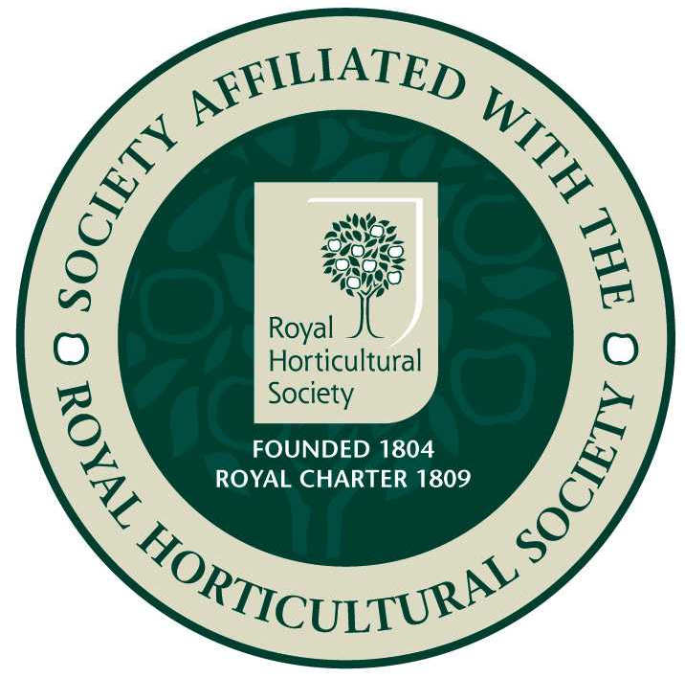
Epsom Garden Society: November 2019

Newsletter: Margaret Haslam 01372 724138, 3 Elm Grove Epsom KT18 7LZ
Membership Secretary and Newsletter Distribution: Steve Roebuck 0208 394 2168
Show Secretary: Cathy Flitter 07821 277708

Change of Rules and Appeal for Committee Members

It has been proposed by the current committee that, because of their low number, that there should be a change to the Society rules (these rules can be found on the Society Website). Currently a quorum at their meetings is six. It is proposed that this be reduced to 5. The proposed rule change would read as follows: -
“7. COMMITTEE MEETINGS
Committee Meetings shall be called from time to time as deemed necessary. Five members shall form a quorum. The Committee shall have full powers to fill” etc etc.
I also have to announce that our Chairman, Heather Martindale is resigning after six years in office. We will miss her guidance and sincerely thank her for all that she has done. She has offered to continue to help the Society and we are grateful for this offer.
Because there is such a short time before the AGM and this gives little time to find and propose a replacement Chairman, the members of the Committee have agreed to share chairing committee meetings until further notice. We do, however, very urgently require members to volunteer to immediately join the committee. Currently the committee consists of:
Secretary, Susan Anderson
Treasurer, Pam Davis
Show Secretary, Cathy Flitter
Membership Secretary, Steve Roebuck
Newsletter Editor, Margaret Haslam
Committee, Patience Morriss and Audrey Simpson
A committee of this size is far too small to run this Society and this means that extra strain is put onto each of them. Please, please carefully consider joining them, you won’t regret it. If you do volunteer, please get in touch with the Secretary, Susan Anderson, 0208 339 0892, No horticultural expertise is required, rather an appreciation of plants and gardens and a very organised, logical bent.

Alan Moody President

Epsom Garden Society: November 2019

Newsletter: Margaret Haslam 01372 724138, 3 Elm Grove Epsom KT18 7LZ
Membership Secretary and Newsletter Distribution: Steve Roebuck 0208 394 2168
Show Secretary: Cathy Flitter 07821 277708

Dear Member, if you have any news or garden related small ads that you would like to be included in the Newsletter, please phone me, 01372 724138, or just tell me when you see me at the meeting.

On the 18th November we will have our AGM at 8pm, at St Barnabas Church Hall, Temple Road, Epsom. Plenty of parking behind the Hall.
The business part to discuss is:
- Apologies for absence.
- Minutes of the AGM held on the 19th November 2018, matters arising from these Minutes.
- Matters arising from the Minutes.
- Chairman's Report.
- Treasurer's Report.
- Membership Secretary's Report.
- Elections of officers and Committee Members, including a request for a new Chairman and volunteers to join the committee.
- Proposed change to the Rules of the Society regarding number of committee members needed to form a quorum.
- Any other business.
Please don't bring raffle prizes for this: we will finish with our usual fancy cheese and wine refreshments.
Following talk: on 9th December Steve Bradley will tell us about 'Winter in the Garden.' 8pm at St Barnabas Church Hall, Temple Road, Epsom. Plenty of parking behind the hall.

Autumn Show Report – September 2019, by Cathy Flittter, our Show Secretary: Well the Autumn Show has been and gone in what seems a blink of an eye! We had a glorious September day for one of the ‘oddest’ shows I’ve known! Hardly any of our usual helpers or indeed exhibitors were available, which was a tad stressful, yet we had more new Novices and Junior entries than we have had in a long time and the most magnificent group of assistants to make this a really wonderful Show. I would like to say a really big thank you to everyone who turned up to help, particularly on the Friday evening to set up. Many of whom have never been especially involved in our Shows (and I am sure they didn’t have a clue who I was!), it was wonderful to have them ‘shift tables, set up refreshments, lay out categories etc, etc. There are too many of you to thank you individually, but I really hope you enjoyed it as much as I did and we will hopefully see you in the Spring!
It was a really fabulous Show for two ladies in particular. Jill Farnham (our ex and much missed Show Secretary), who secured the EGS Autumn Trophy, the Challenge Trophy and the Rosette for best Food exhibit (the most gorgeous Apricot jam) and shared with her equally talented and dedicated sibling Jo Farnham, the Len Humphreys Vegetable Trophy, who also took the Bill Ramage cup for some superb, well matched potatoes! Vicky Holmes did her brilliant best to win everything in the flower arranging. She took the Kathleen Finch trophy for highest points in Show, the Madge Mansley Floral Art for highest points this year as well as the Best in Show and Judges Choice certificates! An amazing year and huge congratulations to her. Annette Pawson, with her beautiful entries in the ‘Open classes’ this year again took the Barbara Meineck trophy and I really hope she knows why this time around – congratulations Annette – such talent! I was particularly thrilled to have more Novices and Juniors at this Show than we have had for a very long time. Long time member Ann Windle secured the Percy Grimes Memorial Trophy as Novice Champion, with her son in law really not far behind. I really hope that they will carry on as they are clearly talented gardeners. In the Juniors, Imogen Flitter finished her career as a junior with a fabulous ‘haul’ of awards. Having won the Bernard Vyvyan trophy both as a ‘little one’ and now as a very tall fifteen year old, she took home her final trophy as overall Champion for the twelth time! As a bonus, she also secured the Phyllis Dunbar Novice Award for flower arranging for the highest points as a Novice in 2019 and the judges also awarded her the RHS Junior Certificate of Achievement. Congratulations Imogen, we really hope you will carry on as an ‘adult’. To make up for the fact that Imogen will be moving on, we had some lovely new Juniors to take over. Huge thanks to Jill Farnham, who has been liaising with our local Brownie and Guide packs, Elena and Sophia entered and won for some beautiful exhibits in the Bird Feeder, Fairy Cakes and for growing on some summer Begonia plug plants, hopefully there will be some badges to win for these super entries. These girls will be our seniors next year and I look forward to seeing them and their friends taking over the trophies for 2020. Along with Millie Barnes, Oscar Loftus, Juliet Fowler, Mateus Abreu and the many pre-schoolers from Appletree Nursery, I am really looking forward to the Juniors expanding and taking forward gardening. As an aside, we have a former ‘Junior RHS Ambassador and RHS Tatton Show Gold medal winner, Jamie Butterworth, coming to speak to us in July 2020, really inspirational and an example of where gardening can take young people these days.
I know I said I wouldn’t select individuals as you have been all so amazing. However, especial thanks have to go to Pam Davis, our Treasurer, who helped bring stuff over to set up the Show, laid out categories, carted tables and spent the entire Saturday from 8.00am assisting with everyone's entries (more carting tables!). She also took charge of logging awards, prize money and trophies – what more can I say Pam, you are an absolute star! Vivienne, Margaret Angus, Annelies, Patience and June ran the refreshments, plant sales and raffle without which this Show could not take place – a thousand thanks! Finally, the ‘heavy boys’… Brian Angus and Tony Harber, who lifted, shifted and carried huge weights without a word of complaint – I am totally indebted and so are my arthritic joints! Thank you one and all and see you in the Spring – Saturday 28th March 2020. Look forward to seeing you all there Cxxx
NOTES: As mentioned in the above report, we were so pleased to have more Novices entering. Jill Farnham has kindly offered to prepare a helpful leaflet giving tips on ‘how to enter Shows’. Having started from scratch myself just over twelve years ago and eight times winner of the Len Humphrey’s trophy, I really do know this is a wonderful idea and hope it will really prove useful to our Novice entrants. On the subject of Novices and new members, we have been thrilled to have over twenty-eight new members/families join our Society this year alone. We really want you to feel part of the society and take part in our various activities. We were wondering if perhaps a coffee morning or similar event would appeal, to give you a chance to meet our Committee/ask questions/feel more involved, would be of interest? Your comments would be gratefully received.

Please, please do come and support us at the AGM. New committee members are really desperately needed. If you feel this is too much, we have a list of ‘non committee, but incredibly helpful’ people, who run everything from refreshments throughout the year (Vivienne), junior liaison/printing/schedule/101 other things (Jill), publicity (Anneliese), Newsletter/refreshments (Margaret) etc. We urgently need more help in these areas and others so please, please come along or send any comments/agenda items to our Secretary Susan Anderson at susananderson51@yahoo.com 07988 343959.

Alpine Garden Society talk: On Tuesday 5th November they will have their AGM and Members' talks, and on the 3rd December George Hounsome is going to talk about 'A Wildlife Miscellany.' Doors open 7.15 for 7.45pm start of talk. Visitors very welcome, £1. Christchurch Hall, Christchurch Road, Epsom KT19 8NE.

Back on 16th September Pamela Holt gave us a lovely talk about 'Italian Lakeside Gardens.' First came a talk about all the lakes and gardens, and then beautiful photos of all the places mentioned followed. This did leave some of us a little confused about which lake or garden we were looking at, but the skies were blue and the sun was shining in each one. Prince Borromeo owned a lot of the islands, and apart from sounding like a character from Narnia, he kindly left some of his palaces and gardens to the Italian equivalent of the National Trust. One palace has been converted to a very grand hotel that Pamela was keen to visit. You have to be staying there to be allowed to look around the garden, so she had lunch, [end of the season so not quite so expensive!] and flashed her Barclaycard when asked for her room number, and that worked perfectly well. The Prince had converted one room into a small theatre for his children to act out plays! The Hotel was so grand that they had staff standing by to hand you your tennis racket or towel! There were statues of unicorns throughout as that was their family's symbol. Some of the lakes have water taxis that you can hop on and off. A lovely talk that left us wishing we were there!
Best wishes Margaret

