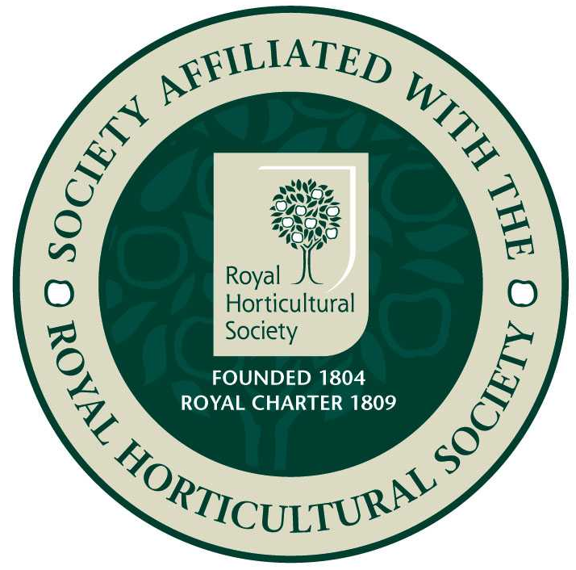
Epsom Garden Society: March 2019

Newsletter: Margaret Haslam 01372 724138, 3 Elm Grove Epsom KT18 7LZ
Membership Secretary and Newsletter Distribution: Steve Roebuck 0208 394 2168

Dear Member, if you have any news or garden related small ads that you would like to be included in the Newsletter, please phone me, 01372 724138, or just tell me when you see me at the meeting.

As I write we are looking forward to our lovely Spring Show on 23rd March. The Show report will be in the next Newsletter. Helpers to put out tables and set everything up would be very welcome at St. Martin’s School on Friday 22nd at 5pm, and helpers for various jobs on the day would be invaluable. Entries for the Show should be with Cathy Flitter by 8pm on Thursday 21st at the latest! Email her on catherine.flitter2@ntlworld.com.

Our next meeting will be about ‘Pruning’ with Mark Dobell at 8pm on 18th March.
This will be at St Barnabas Church Hall, Temple Road, Epsom KT19 8HA and starts at 8pm. Plenty of parking behind the hall.

Open Gardens Group: John Lucking will be putting together the Open Garden Group programme during early March. The Open Garden Group is a group of EGS members who like to visit each other’s gardens. If you would like to join the group, you would be welcome as a visitor, and even more welcome if you are prepared to open your garden for the group for a few hours in the spring or summer. John contacts the group members mainly by email, so please let him have your email address, or at least your phone number, if you want to be included. All existing group members will be contacted automatically, so existing members only need to let him know if they have changed their email addresses. John’s contact details are john.lucking@outlook.com, tel. 01372 722843.

Ewell Horticultural Association invite us to their AGM and free talk on 12th March 2019. Ian Clemens will talk about ‘Land of the Giant Vegetables’, which is a look to see what we can grow at home but can’t buy in the shops. AGM at 7.30pm then talk at 8pm at Bourne Hall.

Would anyone like to organise outings for us? We would like two local outings, on different days of the week, evenings or afternoons, perhaps private visits to yellow book gardens, that people would get to with their own transport. These have been very popular in previous years. There would be no need to join the committee. If you would like to do this, please phone Heather Martindale, 07840 297077.
Also Steve and Pat Roebuck would love to hear from a volunteer who would take Newsletters round when the regular road rep. is away on holiday. At the moment they deliver them themselves, but have their own rounds to do and help would be lovely. Please phone Steve, 0208 394 2168 if you can help.

On Tuesday 25th June 2019 our Secretary Susan Anderson is arranging an outing to RHS Hyde Hall in Essex. The cost of the trip is £16.00 per person (based on a minimum of 35 people) which includes a tip for the driver. The Gardeners Rest Restaurant and the Clover Café both offer a range of teas, coffee, sandwiches and lunches for you to purchase. The garden is built on a hillside, but if required, there is transport to the top. The coach will leave the car park in Christchurch Road promptly at 9.15 am and will depart Hyde Hall at 4 pm. The Dry Garden was created in 2001 and aims to show visitors how they can work with the environment and use drought tolerant plants. Robinson & the Woodland Gardens were planted by Hyde Hall’s original owners, and in 2006 The Robinson Garden was reworked to create a contemporary garden with three distinct boggy areas. Hilltop Garden has a number of different areas to explore, including ponds, borders, rose borders and island beds.
You can contact Susan by email at susananderson51@yahoo.com or phone on 07988 343959.

Trip to RHS Hyde Hall, 25th June 2019. Cheques written to Epsom Garden Society please.

Name/s……………………………………………………………………Phone No. .………………….
Friends and relations are very welcome to come too.
Please send this slip and your cheque to Susan Anderson, 98 Waverley Road, Epsom. KT17 2LS.

Alpine Garden Society: On the 5th March Arthur Nicholls will talk about ‘Autumn in the Peloponnese’. Doors open 7.15 for 7.45 start of talk. Visitors very welcome, £1. Christchurch Hall, Christchurch Road. Epsom KT19 8NE.

Florimania will be at Hampton Court again this year from 29 – 31st March. This is Mothering Sunday weekend. Florally inspired embroidered treasures have been chosen and each one thoughtfully interpreted by an accompanying floral arrangement. At 11.30 and 14.00 NAFAS will share tips during flower arranging demonstrations in The Stone Room in William 111’s apartments. The cost is normal admission prices.

RHS are holding their Spring Flower Shows in different locations this year: on Friday 22nd March – 24th the Early Spring Plant Fair will be at Wisley, on 8th April – 10th Spring Launch and Orchid Show will be at Hyde Hall and 8th April – 10th is also the date for the London Urban Garden Show at Westminster Hall. There will be spring plants for sale at all of them.

We are invited to attend Surrey Horticultural Federation’s Spring Talk on Sunday 10th March at 2.30, where Nick Bailey, plants-man and broadcaster on Gardeners’ World will be telling us how to ‘Revive Your Garden’. This will be at Normandy Village Hall, Glaziers Lane, Normandy, Guildford GU3 2DT. Tickets are £10 on the day.

Chrysanthemum and Dahlia Society’s Daffodil Show is at Abinger Hammer Village Hall, Felday Road, RH5 6QX on Sunday 7th April, open from 1.30, awards presented 3.30pm.

I have been reading such a lovely book, The Plant Messiah by Carlos Magdalena, NAT 581.467. He works at Kew and has a passion for conserving plants on the edge of extinction. One of these was the Café Marron plant from the Island of Rodrigues in the Indian Ocean. No one had seen it for years until it was re-discovered by a little boy collecting leaves on a nature walk, only two metres from a busy main road. But then, before the botanists could get busy, it was chopped down overnight because the branches were supposed to make a good hangover cure! The plant had a metal cage fastened round it, and three precious leafy twigs were sent to Kew safely in the cockpit with the pilot. Everyone was very excited when these managed to make roots and fourteen years later the wonderful plants were growing with huge white flowers all year round, but no sign of setting seed.
There seemed to be some mechanism in the flower itself that blocked the growth of the pollen tubes. There were plenty of flowers and nothing to lose, so Carlos experimented by cutting across the flower and putting the pollen directly into the style. After trying this two hundred times with no success, in the hot summer of 2003, Carlos was quietly feeding and pruning plants in the shade when he looked up and saw a fruit! The seeds all failed, but the principle worked, maybe temperature and light levels were important? After more experimentation – they grew! Now the species is restored and returned to Rodrigues where it is a very popular plant. One odd thing, apart from having male and female plants, the juvenile leaves are thin and narrow and red, it is only once the plants are over a metre tall that the proper dark green leaves grow. Carlos thinks this may be because giant tortoises used to live there, and the thin miserable looking leaves may have developed as protection as they looked not worth eating!
The last chapter brought really good news about chocolate cosmos. You probably have grown this, a lovely dark red daisy plant that smells most surprisingly of chocolate. Back in the 1920s you could buy seeds in plant catalogues to grow this, but then suddenly all the plants seemed to stop producing seed and although plants could still be grown from cuttings, it was extinct as they couldn’t reproduce themselves in the wild. Then – a lady in New Zealand was growing a big clump of them in her garden and was amazed to see seed pods amongst her flowers. She sent some to Kew and they were found to be viable and a few seedlings were raised! It took a hundred years and a journey from Mexico to Kew to New Zealand and back to Kew again before seeds could at last be preserved in the Millennium Seed Bank at Wakehurst Place!

Small Ad.: A Bosch Shredder AXT 2200 H, with instructions: A ‘roll-up’ plastic track for a veg. patch and a ‘Scotts’ fertiliser spreader. Any reasonable offer accepted. 020 8393 1749.
Best wishes Margaret

