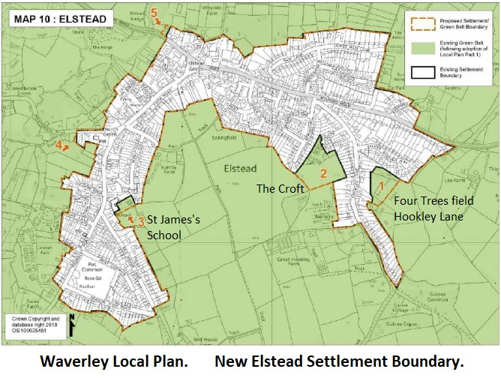

Habitats Directive update
Published Thursday, 24 May 2018
Due to matters outside Waverley Borough Council’s control, there is likely to be a delay to the determination of any applications for new dwellings within 5km of any Special Protection Area (SPA).
This is a result of a recent European Court of Justice ruling (Case C 323/17 - People Over Wind and Sweetman 2018) relating to the Habitats Directive.
As such, the council is currently in the process of reviewing its decision making processes in respect of new dwellings within the Buffer Zones of the Wealden Heaths and Thames Basin Heaths SPAs.
The council is currently awaiting further legal advice on this matter and is liaising closely with Natural England to ensure that future decisions made by the council in these areas are lawful and to avoid the possibility of legal challenge.
https://simonicity.com/2018/04/20/eu-court-ruling-ignore-mitigation-measures-in-habitats-screening/

