Elstead Housing sites – Waverley Local Plan
Part 2 of the new Waverley Local Plan is currently in public consultation until July 9th.
The exhibition in Elstead on Monday June 4th displayed a lot of very general information and Waverley Planning staff were available to answer detailed questions about Elstead.
A major item under discussion is the number of new homes proposed for the three sites by Waverley:- a field behind The Croft (28), another field off Hookley Lane (20) and Sunray Farm (12) off West Hill.
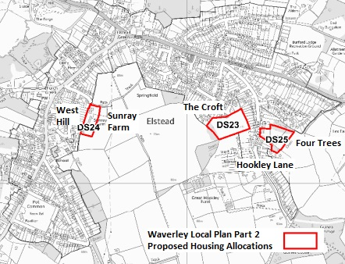
The three proposed development sites.
Wherever the 59 new homes proposed by Waverley are built will have an impact on traffic in the village.
Developing two Hookley Lane sites will cause traffic problems at the Milford Road junction at peak periods and along the lane itself.
The number of houses on the Croft Nursery site will double, with a big increase in vehicles using the very narrow and bendy service road off Hookley Lane, which has no pedestrian foot ways.
The Neighbourhood Plan team has recommended more homes for Sunray Farm (31) with none at Four Trees. Sunray Farm is in walking distance of the School and close to village shops and facilities. They also want development to be spread more evenly.
You can influence these decisions.
If you are concerned about any of this you can comment on any part of this online document:
http://consult.waverley.gov.uk/consult.ti/LPP2PreferredOptions/consultationHome or write to Waverley at:
email: planningpolicy@waverley.gov.uk or post to:
LPP2, Planning Policy, Planning Services, Waverley Borough Council, The Burys, Godalming GU7 1HR.
Relevant extracts from and links to the planning documents are now on the ELSTEAD'S FUTURE part of the ELSTEAD ONLINE website: www.elstead.info

