Eaton Constantine Village History
An Exhibition
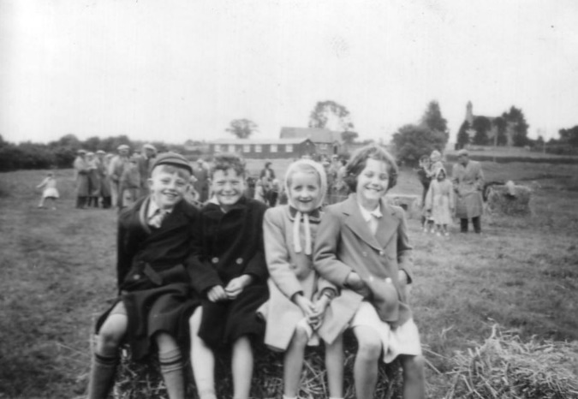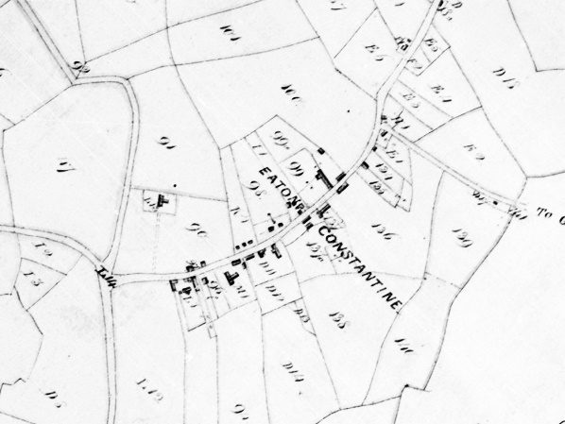
How times have changed! Our Village
17th -23rd March at the Village Hall

Houses, people, events. Photos, maps, documents.
Past, present, future
Free entrance – Share your stories
Check opening times (01952 510309, notice boards/facebook/website)
Monday 17th 10am - 12pm, Thursday 20th 2pm - 4pm
Saturday 22nd 10am - 12pm, 5pm - 8pm, Sunday 23rd 10:30am -12pm
Illustrated talk Saturday evening 6:30pm
