September 2019 Newsletter
Drylaw Parish Church
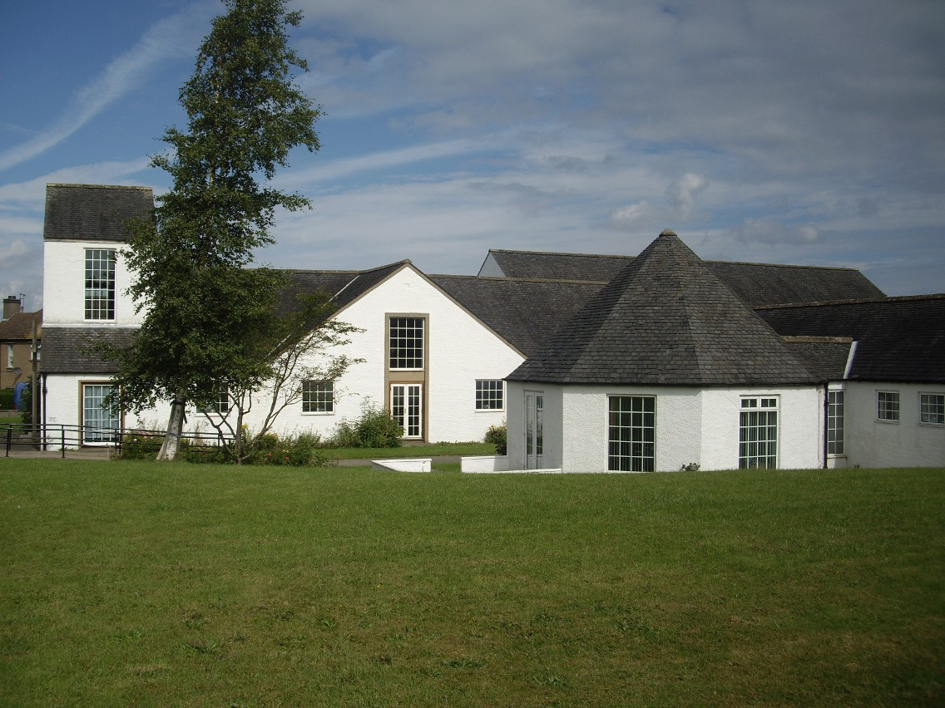

Dates for Your Diary
Special Services

Remembrance Service
Sunday November 10th 10.30am
Mosque - We are planning a visit to the Mosque provisionally Tuesday 26th November - please let the office know if you are interested to come
Fundraising Events
Family Prize Bingo
Friday 11th October 6.45pm – eyes down 7pm

Christmas Fair
Saturday 30th November
11.00am – 1pm
Tables for hire – contact the office.

Groathill Road North, Edinburgh, EH4 2RG
0131 332 6863 Email: drylawparishchurch@btinternet.com

Stay and Play
Tuesday and Thursday Mornings 9am – 11am
A group of parents, babies and toddlers. Do come along and join them. Our large hall provides a good large play area where the wee ones love to run around. Messy play is on offer from time to time; singing together a regular feature. Only £1.50. Visit them on Facebook page Drylaw Stay and Play.
Yoga
Thursday 10.30am – 12 noon
For those of a more mature age. Visit Bethany Grace Yoga facebook page for further details.
Brownies and Guides
Tuesday Evenings
We have brownies and guides on a Tuesday evening – visit Girl Guiding Scotland website for more details
or contact the Church Office.
Singing Group for People with Dementia and their Carers
2nd and 4th Wednesday in the month 2pm – 3.30pm
Contract - Nwsinging@gmail.com for more details
Amanda Kane School of Dance
Wednesday and Thursday
Contract Amanda on 07703178731 for more details.
Open Door
Winter times starting 8th October
Every second Tuesday 1pm – 3pm
All welcome
From The Minister
We live in uncertain times, uncertain politically, uncertain within the church, uncertain issues on the world stage. Jesus also lived in uncertain times, Israel controlled by the Romans, the super-power of the time, religious authorities in the synagogue who needed to change.
There are two central messages from the gospels that I suggest can offer us support and direction in the midst of external instability.
The first is to remember that in God’s eyes every single human being is important. We may disagree with other people in terms of politics or their views about what matters in our church community but that is not a reason to speak badly of them, to put them down or consider them less than ourselves. The Biblical community that Jesus initiated was clear about welcoming the Jew, Gentile, women and the poor and the rich. It was definitely an inclusive community. At times of political division one of things we can do is to be willing to at least listen to others and in our speech to be careful about what we say and not to sow division. None of us want to be living in a society where violence reigns and so we all have our small part to play in building community, understanding and, at minimum, tolerance of difference.
Secondly Jesus was clear that he did not primarily have a political role and that he needed to walk his own path, doing what God had called him to do. He resisted those who thought he ought to fight the Romans in some way. So for most of us, we do not have a big public role to fulfil, we asked to quietly get on with living as well as we are able, fulfilling our call to offer love and support to family, friends and whatever voluntary commitments we have. In this way we focus our energy on what brings life to others and ourselves.
God’s call is always for life, creating community and hope, helping human beings to live constructively avoiding the temptation to focus on difference. For when we do that and pursue self-interest, which can so easily result in violence, then human beings usually end up being less than they could be, hurting one another, destroying life.
May we all in these uncertain times do what we can to support unity, peace, love, and trust in God who is always with us through the bad times and the good.
Reverend Jenny Williams
We have now registered with Eco Congregation Scotland movement. This expresses our concern about the environment and expresses our intention to do something about it!!!! So watch this space………..

The Rainbow Day Care Centre
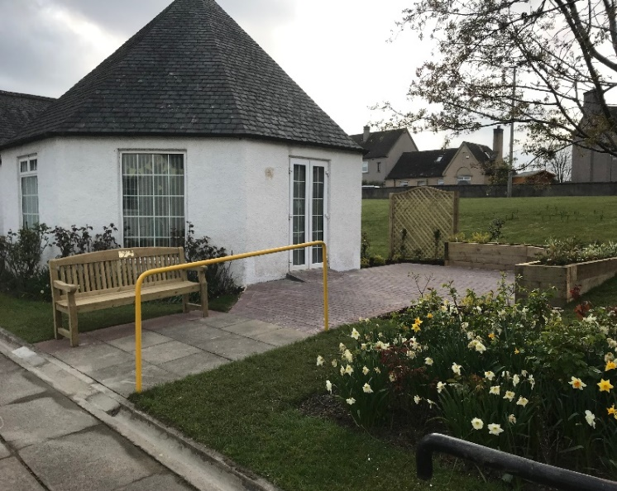 | Sensory Garden  As reported in our last newsletter, Rainbow Club Daycare successfully applied for a grant from “Working Through Landscapes” to extend the patio area outside the Three Penny Hall and to create some raised beds which those attending could help to look after. Using a legacy from Harry Macdonald, who used to look after the church garden, the Church was able to contribute a bench that now has a plaque commemorating his work and dedication to Drylaw Parish Church. A community event was held to open the Sensory Garden which was well attended by local councilors, community police officers, school and nursery children who all received an easter egg from the Easter Bunny after their hunt in the church grounds. After the church service on Easter Sunday we had a blessing and dedication of the bench and garden.

Scotland Rocks!  The Rainbow Club Day Centre held an event called Scotland Rocks on the 4th of September from 1-4pm, it was well attended including day centre users, carers and locals from the community. Some of the feedback after the event was, “Entertaining and enjoyed the food”, “It was well organised and I met some new people,” “music was excellent”, “ I thoroughly enjoyed the day”. The Rainbow would like to thank everyone for coming and a Big thank you to all that donated raffle prizes, and we look for to seeing you at the Christmas party on the 11th December, tickets on sale now | 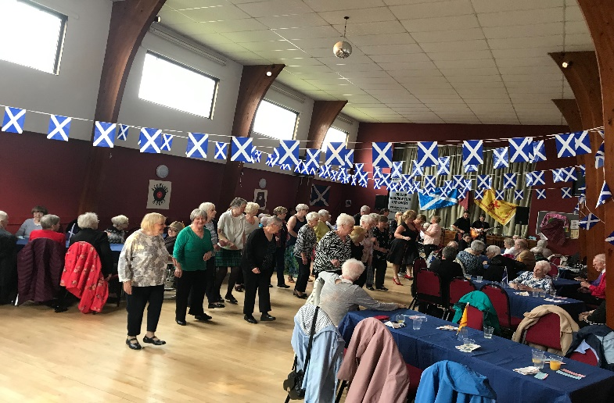

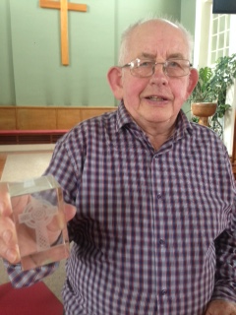 | Honoured  Henry Macdonald has been working in the cloakroom of the General Assembly for many years now. At this year’s Assembly his work was honoured by giving him a beautiful engraved Celtic cross in glass, thanking him for 30 years faithful service. Actually Henry said, it is 40 years!!!

Its a joy to report that the Singing Group is growing from strength to strength and now in its second year of operation has become a firmly established group. In the Spring we produced new publicity material and distributed it widely throughout north west Edinburgh.
As a result since May we have welcomed 15 new members. Sadly, we have also lost a few members as a result of their progressive illness, a reminder of our members’ vulnerability. Our programme continues to evolve, with new songs, rounds and musical quizzes. The introduction of percussion instruments to accompany some songs has proved very popular, with members enjoying contributing to the rhythm with shakers, tambourines and drums. Singing together generates a sense of well-being and we all go home with a spring in our step. Please get in touch if you would like to volunteer to help, or know of someone who would like to attend at “Nwsinging@gmail.com”.

Drylaw Community Project Previously run by Edinburgh Council workers this project is now run by the Action Group, who work from our Small Hall each week day. We are very glad to welcome their team of workers managed by Nadia Taylor.
Amanda Kane School of Dance
The dance school continues to thrive and grow and this year we have received funding from Creative Scotland giving local children the opportunity to have dance classes for free and participate in our Christmas Show at the end of the year. This project has children from Ferryhill Primary and Craigroyston Primary attending each week. On the competition side we have had a very successful summer and I am pleased to report that Katie Lawson won the Scottish National Championship at the Cowal Highland Gathering, also gaining fifth place overall in the Scottish Championship at Cowal and finalizing for the World Championships and gaining a medal there too. We will again be taking our team to Paris in November to compete in the International Gathering of Scottish Highland Dancing, which we are all looking forward to.

Thanks to Stay and Play for this beautiful banner that has been at the front door and the communion table.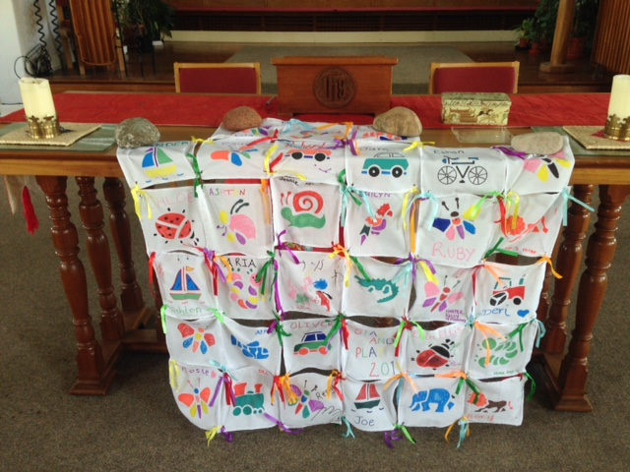
Church News
New Chairs We are delighted and very grateful to have received a Community Grant from the City of Edinburgh Council – Inverleith Area to enable us to replace all the chairs in our halls. These are now in our hall and we hope that all our groups who use our halls and local people attending events will enjoy the new seating. We are keen to recycle our old chairs, if you know of anyone needing some, please get in touch with us at the office.
Resignation and New Appointment Judith Crawford moved to Fife over a year ago and has come to the point of deciding it is time to resign from our Kirk Session and her responsibility of looking after our property. The latter is a big job and we are really grateful to her doing this on her own for most of the last three years; getting many things in order and working through all the required work set us by the quinquennial visit last year. We wish you very well and hope that you find your next steps as you look for a new job.
We are also extremely glad to have Scott Lawson stepping up to take on this responsibility. Scott’s day job is looking after the building at the Royal Infirmary of Edinburgh. He says he has never looked after a church before and we really hope that this proves interesting for him and that we will benefit from his expertise! We are also very glad to have the help of Jim Mackenzie, Jim is a retired minister but before that he was a building engineer and has been helping with several jobs around the church over recent months from tiling in the kitchen to painting the outside wall.

The Open Door We have supported Dr Graham’s Home in Kalimpong for many years and our coffee afternoon in July raised the sum of £91.00 which we rounded up to £100.00. Many thanks are due to the congregation for their generosity by giving £120 in the retiral collection after church. We have now sent off the sum of £220 to their trustees for the furtherance of their work.
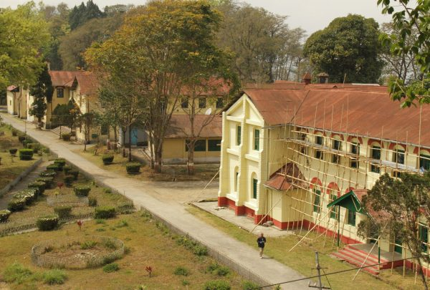

Coming Soon
Seated Exercise - Wednesday mornings at 10.30am in the large hall starting 23rd October, followed by tea/ coffee and a blether.

Breathe, Move, Relax starting on a Thursday 24th October at 9.15am in the large hall. If you are interested, or know friends who might be interested, please let us know in the office and we can contact you when details are finalised.

