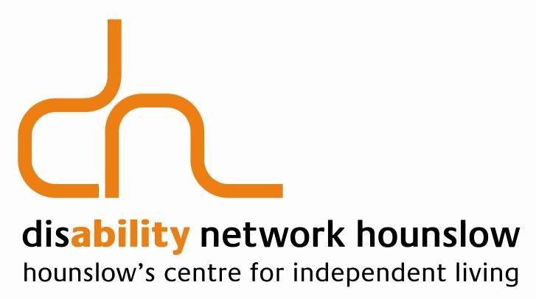
Disability Network Hounslow
63-65 Bell Road, Hounslow, Middlesex TW3 3NX
MEMBERSHIP FORM
Title | First Names surname
* Age if under 21 [ ]
Please tick if you are: 21-50 [ ] 51-70 [ ] 71 and over [ ]
Address

Post Code |  | Email
Home phone number |  | Other phone number
Do you think of yourself as having a disability? YES [ ] NO [ ]

If Yes Type of Disability:

Do you care for or support anyone with a disability? YES [ ] NO [ ]

Preferred Language:
I wish to apply to become a Member of Disability Network Hounslow, a Company Limited by Guarantee, and I agree to be bound by its memorandum and articles of association and any rules made under these. I enclose my £10 membership fee I enclose a donation £
Total £............

Please consider setting up a Direct Debit to DNH to reduce our expenses and makes the most of your membership and donations. DNH will give you details. If you pay income tax we can claim 25% Gift Aid from the government on your recent and future donations. Please ask DNH for a form.
DNH complies with data protection law on collecting, storing and processing personal data. We do not share your details with other organisations.
Thank you for your support.

