SOFA19
BAPP SOFA staff are experienced at working with disabled young people. We will do our best to support you – please tell us what we can do to support you. If you want to bring a key worker or Personal Assistant, that is fine. We do need to know this for transport.

Accessible transport is available for all activities.
Please tick on the booking form if you would like to use transport.
We will NOT be able to drop anybody off other then pick-up and drop-off points.
Seatbelts MUST be worn at all times
Pick- up locations are Odd Down Community Centre, Bath or Morrisons Car Park, London Road, Bath, Keynsham Wellsway School, Radstock, Midsomer Norton Sports Centre and Peasedown St. John by the Primary School

Times vary each day and those activities further away will be longer days but generally 9/10am to 3/4pm
Some activities will require a change of clothes or old clothes and every day, young people need to bring packed lunch and plenty of drinks, clothes/shoes for the weather, any medication or aids, pads and wipes where used and sun cream (hopefully!)

Mon 5th August | Longleat  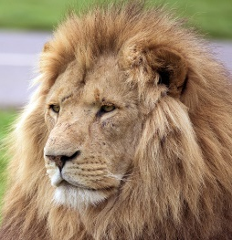 | Famous safari park – hopefully the monkeys will not  Steal the wheels from the bus!  Brand new for 2019; Koala Creek, Adventure Castle,  Jungle Kingdom, Monkey Temple, and the Hedge Maze.
Tues 6th August | White water rafting  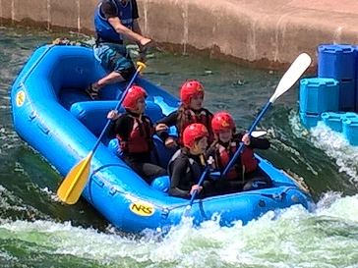 | Young people will be working as a team in rafts of  up to 8 people, helping to steer down a winding man  made shallow course  Must be able to wear a helmet and buoyancy aid as  will not be able to take part without and be able to swim
Weds 7th August | Basecamp – lots of  Activities at Odd  Down Community  Centre | Graffiti, Smoothie making  Marbling - (bring a t- shirts) - if not on paper or card  Music karaoke, Sports on the court, Sensory play
Thurs 8th August | Cinema & bowling | Ten pin bowling followed by a film at the cinema  A text will be sent once the films are released for  that week giving a choice of 2
Friday 9th August | Woodland Day | 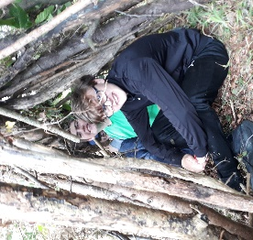  Environmental session with  shelters and dens,  Cooking marshmallows and  smores and fun team  challenges outside in the woods
Mon 12th August | Beach day  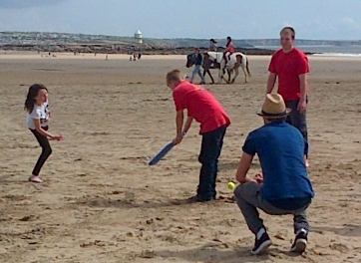 | Kite flying, rock pools, paddling,  beach cricket and  Volleyball and maybe an  ice-cream (bring change)
Tues 13th August | Sailing/powerboating  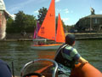 | Fully accessible sailing in 2 man boats. Young people  Will go with a member of staff and enjoy the movement  On water. Power boating with a qualified driver and  Staff at high speeds across the harbour  Must be able to wear a helmet and buoyancy aid as  will not be able to take part without and be able to swim
Weds 14th August | Basecamp - lots of  Activities at Odd  Down Community  Centre | 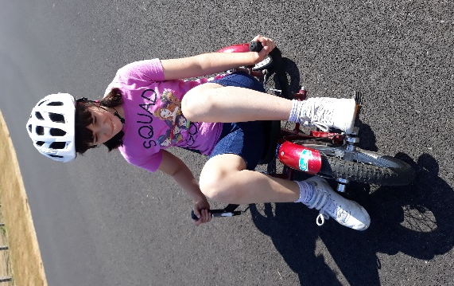  Cycle Circuit and Wheels4All bikes  Henna & tattoos  Baking  Dancing/disco  Sports on the court  Circus skills  Sensory play
Thurs 15th August | Brean | Leisure Park with dodgems, water rides, Astro Storm,  Sizzler, Magic Mouse, Farm Train, Fantasia, Trampolines, Caterpillar and Carousel and many more!
Friday 16th August | Fun Day  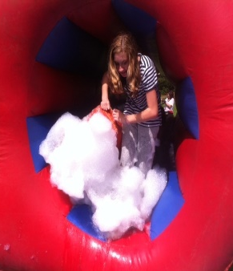 | Bring a change of clothes as you will  get wet! A series of team challenges  outside and fun with inflatables,  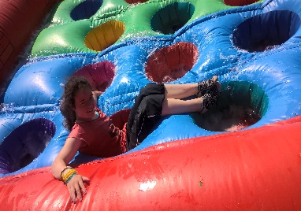  water and foam

