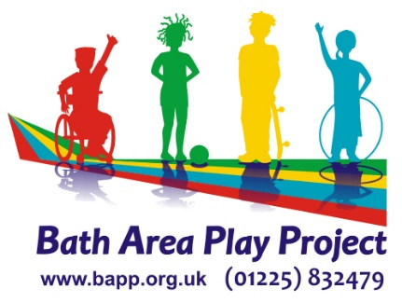

Job Title: Short Breaks Playworker

Job Purpose
- To facilitate and enable children to experience a wide range of play opportunities and experiences that enable participation, inclusion and support wellbeing.

To assist in the organisation and running of age-appropriate play opportunities and activities in play sessions for disabled children / young people aged five to twelve/nineteen/21 years in school holidays, overnights and Saturdays.
- To work as part of a team and in partnership with parents/carers and professionals, promoting awareness of the child’s right to play and their access to socially inclusive play opportunities

Pay £11.65 per hour including proportional holiday pay

Duties and Responsibilities

To be accountable to the Senior Playworker and Director.
- To work as part of a team and maintain open communication.
- As a team, plan space and resources to best meet the play needs of children including sensory and tactile play opportunities, variety and scope of opportunities for a diverse group of children and supervising accordingly
- Tidy and clean playscheme / centre at the end of sessions including use of cleaning products to ensure surfaces and touchpoints and shared equipment are disinfected between groups and supporting childrens’ hand washing and toilet cleaning throughout the day
- Undertake individual risk/benefit assessments and ensure that children are supported in their play to take safe risks and acquire the skills for self-managed risk assessment
- Where required, organise and supervise day trips as and when required including supervision of children / young people on transport..
- To work to all BAPP’s policies and procedures at all times and within the Staff Code of Conduct
- To attend and contribute to planning and review of provision at weekly staff team meetings / debriefings, training as required.
- To work in an inclusive and non- discriminatory way and provide a positive role model for children and young people, recognising and respecting differences.
- Support children with any personal needs and administer medication/treatments in line with BAPP’s ethos and policies ensuring the child’s rights to respect and dignity.
- To support children to eat and drink as required which may require positive role modelling and physical assistance for some children.
- To support all cleaning and hygiene requirements to maintain a safe environment for staff and children
- To encourage children / young people to be involved in behaviour / ground rule setting and to be fully participative and provide a consistent approach to behaviour management.
- To provide a professional approach to keeping children safe from harm and keeping them safe on site and working within agency and B&NES Safeguarding Policies including sharing information about any concerns appropriately including CSE and Prevent.
- To ensure the environment for work and play meets all health and safety requirements including a daily site check before children arrive, maintaining a safe environment through clearing and cleaning as incidents occur and being mindful of risks such as exits and people coming onto the site.
- Help to evaluate the local impact of the services & activities by collating data to evidence the outcomes for children and their families
- Challenge any poor practice and contribute to service improvement
- Undertake any other duties as may be required from time to time

Person Specification E = Essential D = Desirable

- Experience of volunteering / working with disabled and non-disabled children and young people, preferably in an out of school environment. E
- Practical skills in direct work with children e.g. carpentry, communication, drama, arts, sports, etc. E
- Understanding of issues facing disabled children, young people and their families E
- Good communication skills for working with children and young people as well as parents and professionals in a form and manner that is consistent with their level of understanding, culture, background and preferred way of communicating E
- Knowledge and understanding of Health & Safety and Safeguarding principles including appropriate information sharing, raising concerns and responsibility for keeping children and yourself safe. E
- Must be a team player and able to work with others to achieve shared objective. E
- Have attended or willingness to attend CPD training including Hoist and handling, Paediatric First Aid and Medication Administration training E
- Qualified to Level 2 or 3 in Playwork or Childcare or Youthwork or other appropriate area (please see list of accredited qualifications www.qca.org.uk) and/or willingness to undertake training D
- Commitment to every child’s right to play and importance of anti-discriminatory practice in playwork. D
- Understanding of safety and security issues in play settings including registering children, trips off site and sporting activities and assessment of appropriate risk D

Times and Hours of Work
30 - 35 hours per 5 day week; days are 7 hours long
Playschemes open 9am – 2.30pm, Hours of work 8 / 8.30am – 3.30pm. Additional time can be allocated at the beginning and end of each playschemes for setting up and moving equipment and clearing away.
Length of playscheme varies according to school holiday.
Saturday Clubs run for 3 hours with 30 minutes either side for set up and briefing and after for cleaning and debrief, 4 hours work each term time Saturday.

THIS POST IS OFFERED AS A SHORT-TERM CONTRACT.

Further work is available during other school holidays, evenings and weekends. Once successful, you will be offered the opportunity to work again without the need to reapply.

