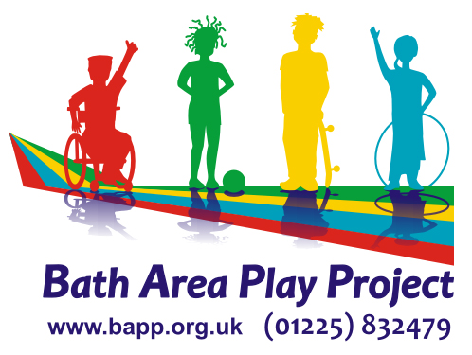

Reg. Charity No. 1013897

JOB APPLICATION FORM

INSTRUCTIONS TO CANDIDATES:
- Complete application as requested.
- Do not send CVs or enclose any other documents, as they will be detached and will not be used in the selection process.

POST APPLIED FOR:

PERSONAL DETAILS:

Full Name: Title:

Address:

Post Code:

Phone Number:

Mobile Number:
Email:

This first page will be detached on receipt. The first and second pages will have been numbered beforehand, enabling the interview panel to shortlist candidates anonymously.
EDUCATION
Please start with the most recent and go back to include secondary school.
School / College | From / to | Qualifications

Please list any relevant qualifications and training courses attended:

Other relevant experience and interests (Voluntary work / Interests):

EMPLOYMENT
Please list details of previous work experience (paid or unpaid) starting with your most recent or current position. Any gaps will be asked about at interview.
Post Held | From / To | Name and Address of Employer

Please give the name, address and telephone number of two referees, one of which should be your current or most recent employer.
Name:  Address:  Email:  Tel No:  Position:  How do they know you?  May we contact? Yes | Name:  Address:  Email:  Tel No:  Position:  How do they know you?  May we contact? Yes / No
References will only be taken up if you are shortlisted.

SUPPORTING INFORMATION (Please see Job Description)
Please describe how your skills and experiences relate to the Person Specification and responsibilities for this post. Please also indicate why you are applying for this post. Continue on a separate sheet if necessary.

ENTITLEMENT TO WORK IN THE UK
All Applicants will be asked at interview to provide documentary evidence of their right to work in the UK – do you have any restrictions that apply to you?
Yes No
If yes, please give details of any restrictions:

REHABILITATION OF OFFENDERS ACT
This post is NOT protected by the Rehabilitation of Offenders Act 1974. You are therefore required to disclose information of ALL convictions in a court of law, no matter when they occurred, or if they led to a conditional discharge. In the event of employment, failure to disclose all previous convictions may result in dismissal. As this job involves working with children, all employees and volunteers are checked. All information will be treated in confidence and will only be taken into account where necessary.

Do you have any convictions (including motor offences) to declare?
Yes or No

If ‘yes’, please provide full details:

ENHANCED DBS DISCLOSURE
All posts defined as “regulated activity” are subject to an Enhanced DBS check so that any criminal background including any spent convictions, bind-over orders or cautions, are disclosed. We cannot employ anyone without this check.
The position for which you are applying involves contact with vulnerable groups and is exempt from the Rehabilitation of Offenders Act 1974 and all subsequent amendments and therefore you are not entitled to withhold any information that would be considered “spent”.

Do you hold an Enhanced Disclosure Certificate? Yes
If ‘no’, would you be willing to undergo a check? Yes / No

If Yes, please give details:
DBS No: Date of Issue:
Registered Person/Body:
Online Registered Reference Number:
Date of Birth:
Are you registered on the Update Service?

FURTHER INFORMATION
Are you a car driver? Yes Do you have any bus driving experience? No

Do you have a clean licence? Yes

NATIONAL INSURANCE NO:

EQUAL OPPORTUNITIES STATEMENT OF INTENT

Bath Area Play Project recognises that certain groups and individuals in society experience both direct and indirect discrimination because of their age, class, gender, HIV status, caring responsibilities, marital status, disability, race, colour, ethnic or national origin, religion or sexual orientation.

Bath Area Play Project is committed to positive action to counter discrimination in all aspects of its work including employment, recruitment, volunteers, membership, composition of committees and services delivery.

To ensure its effective implementation Bath Area Play Project will regularly monitor and evaluate this policy.

DECLARATION
If appointed I will abide by the Equal Opportunities Statements of Intent and the Declaration of Non-Discriminatory Practice to ensure good practice in accordance with the preceding Policy Statement and Declaration. I will also undertake to safeguard and protect children in my care at all times and to work to the BAPP Safeguarding Policies and procedures including regard for the Prevent Duty. This includes abiding by our Social Media and E-safety Policies.

As part of the GDPR requirements, any personal and sensitive data that you provide to us as part of your employment, will be confidential and kept securely. We will only ask for data that we require in terms of employing you. Some of this data is shared with our payroll company, Dunkley’s who have equivalent Data Protection systems in place. You will be asked to sign our Confidentiality Agreement and DP & IG Policy

I declare that to the best of my knowledge, the information I have given is correct. If appointed, I understand that any deliberate omissions, incorrect statements or canvassing with BAPP Trustees or staff could jeopardise my employment and may lead to dismissal. Any offer of employment is subject to satisfactory checks.

Signed: Date:

DECLARATION OF NON-DISCRIMINATORY PRACTICE
I understand that my application to work with Bath Area Play Project as a paid worker / volunteer can be accepted only if I am prepared to ensure this service is provided in accordance with BAPP’s Equal Opportunities Policy.

I therefore declare that:

- I will treat the children for whom I am asked to care, for whom I actually provide care, with equal concern, and in doing so, agree to meet their specific needs with regard to racial origin, culture, religion and language, as well as their gender and disability.
- Whilst providing care I undertake to help children and to enable them to develop positive attitudes to differences of race, religion, culture, language, gender and disability.

