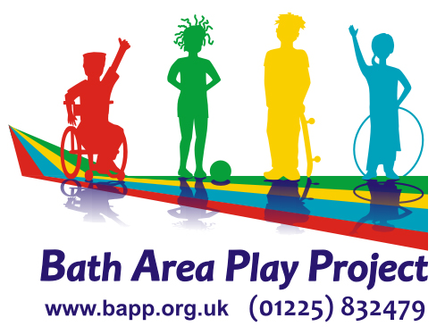
Job Description – Early Years Assistant

Job Title: Early Years Assistant

Responsible to: Leader and Deputy

Responsible for: Children, Volunteers and students

Hours of Work: Term time only, Wednesdays 08.45 to 15.15

Purpose of Job:
To work as part of the Early Years team at the Hut under the direction of the Nursery leader to provide safe, high quality education and care for young children aged from 6 months to 4.5 years

Main duties

- To be accountable to the Nursery Leader and Director

- To input and assist with the planning of activities within the EYFS curriculum.

- To work as part of a team providing a high-quality service for children and their parents

- To help to set up the space for the daily programme and to help tidy away at the end of the session.

- To support children’s learning through play, liaising closely with parents/carers and ensuring each child's needs are recognised and met.

- To advise the leader/deputy of any concerns e.g. over children, parents or the safety of equipment, preserving confidentiality as necessary.

- To undertake health and safety checks on equipment and environment before children arrive and ensure the security of children at all times.

- To supervise and facilitate appropriate play for children in your care, both inside and outside.

- To work to all BAPP’s policies and procedures at all times.

- To ensure resources and equipment are cleaned, tidied and stored safely.

- To teach children, offering an appropriate level of support and stimulation.

- To input and attend staff meetings.

- To attend in-service training courses and meetings as required.

- To keep completely confidential any information regarding the children, their families or other staff that is acquired as part of the job & sign the Confidentiality agreement.

- To undertake any other reasonable duties as directed by the Nursery/Creche leader, in accordance with the service business plan/objectives.

- To support other staff, Trainee’s and Volunteers.

NB: This post is exempt from the Rehabilitation of Offenders Act 1974. Applicants must be prepared to disclose any convictions they may have and any orders which have been made against them.

Person specification

Essential criteria

- Willingness to learn and undertake professional development

- NVQ Level 2 in Children’s Care Learning and Development or equivalent level 2 childcare qualification or willingness to train.

- Previous experience of working with young children.

- Commitment to equalities and inclusion.

- Understanding of issues facing young children and families.

- Friendly, flexible approach.

- Health cleared for the role.

- Ability to work on own initiative

- To be flexible in hours and duties in order to meet the needs and requirements of the service

Desirable criteria

- Safeguarding Training.

- Full and valid Paediatric First Aid Certificate.

