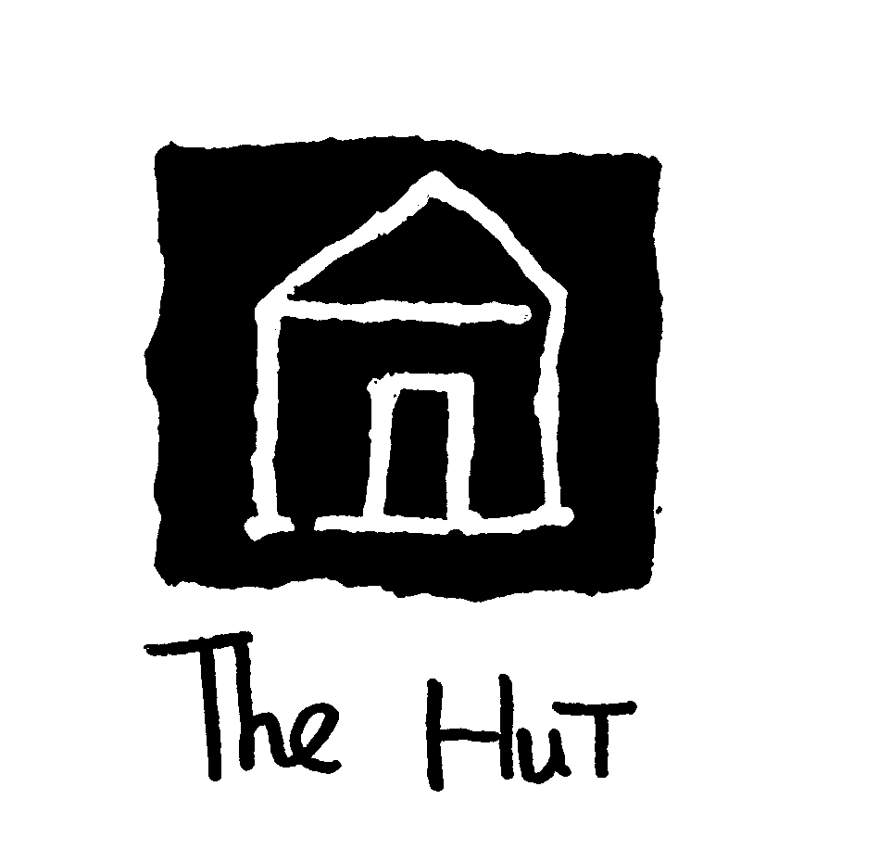
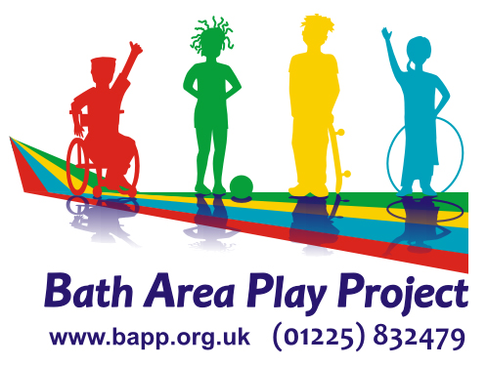

HUT PRE-SCHOOL BOOKING FORM

Your Child’s Name ____________________________________________

How many sessions would you like to use each week? Please tick

Monday |  | Tuesday |  | Wednesday |  | Thursday |  | Friday
AM |  | AM |  | AM |  | AM |  | AM
Lunch |  | Lunch |  | Lunch |  | Lunch |  | Lunch
PM |  | PM |  | PM |  | PM |  | PM

What date will be the first date you will use The Hut __________________201__

Would you ONLY be using the Hut pre-school? Yes / No

If No, would you also be using a School Nursery or other early years setting e.g. Twerton Infants Nursery or Roundhill Nursery as well as the Hut pre-school? Yes / No

Fees at the Hut, Nursery & pre-School

- A morning session 9am – 12pm is £15.00
- An afternoon session 12-3pm is £15.00
- Therefore, a whole day from 9am to 3pm would be £30

Where you are eligible for the Early Years Entitlement you will receive 15hours free childcare per week, However will need to pay an additional charge of £3.00 per day (or £1.50 per half day) to go towards consumables including snacks and resources.

In order to receive the Early Years Entitlement, you will need to complete a form.(EYE2) You will need to specify on the form that you will be using the Hut pre-school in order that we know how much potential income we can claim from B&NES. Please complete and return this form with your Registration Form.

Thank you

