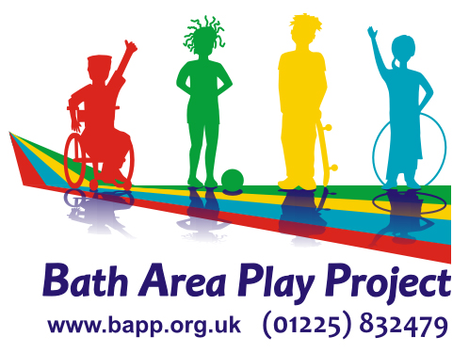

TRAINING BOOKING FORM

Title of Training _______________________________________________

Dates of Course _______________________________________________

Your Name __________________________________________________

Name of Organisation _________________________________________

Your Address________________________________________________

___________________________________ Post Code _______________

E-Mail Address______________________________________________

Telephone No./ Mobile ________________________________________

Have you completed any first aid training previously? ________________________________________________________

Do you have any support needs in order to attend the course? _____________________________________________________

Signed _______________________________ Date _________________

PRINT NAME ________________________________________________

Please return with payment to: BAPP, Odd Down Community Centre, Odins Road, Bath, BA2 2TL.
Please make cheques payable to: Bath Area Play Project
Places are allocated on a first come, first served basis. Places will not be allocated unless booking form and payment have been received. You will only be contacted if we are unable to offer you a place on the course.

