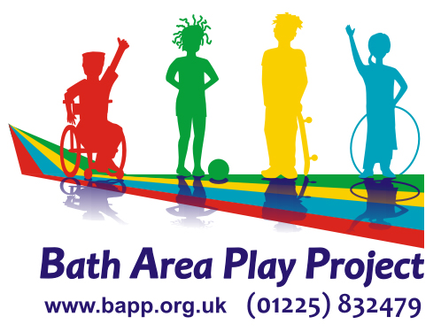

VOLUNTEER APPLICATION FORM

Name _______________________________ Date of Birth ____________

Address ____________________________________________________

___________________________________ Postcode _______________

Email address ______________________________________________

Telephone No. _______________________________________________

Have you volunteered for BAPP before – if YES please give details i.e project/year
___________________________________________________________

How did you hear about volunteering for BAPP?
___________________________________________________________

What experience of working, especially with children, have you had - even informally for family or friends? ___________________________________________________________

___________________________________________________________

Please tick a box for the type of volunteering you wish to do:
- Community Play events (Spring / Summer/ October school holidays): Foxhill/Odd Down  Weston  Southdown  

- Closed access playschemes (school holidays):
The Hut, Twerton  Threeways  

c) SOFA programme (summer only):  d) Pre-school The Hut,Twerton  e) Family Play Hubs  f) Teenage Rampage  g) Office Admin  h) Garden/ maintenance i) Volunteer Driver 

I have read and understood the enclosed Staff and Volunteer Code of Conduct and Declaration of Non-Discriminatory Practice, and will abide by this whilst at the setting.

Signed___________________________________ Date__________________

Please write the Names and Addresses of two people who we can contact for a reference for you. One should be your form teacher or tutor and the other can be a community member (not family) who knows you well.

Name __________________________ Name __________________________

Address ________________________ Address _________________________

_______________________________ ________________________________

_______________________________ ________________________________

Email address:___________________ Email address:_____________________

Post Code ______________________ Post Code________________________

Telephone No. __________________ Telephone No. _____________________

How do they know you? ___________ How do they know you? _____________

______________________________ _________________________________

Please let us know if there is anything we should know about you in order to support you to volunteer with us:

Do you hold an Enhanced DBS Disclosure? YES/NO

If No, would you be willing to complete one? YES/NO

If yes, then please bring your certificate when you come to meet us.

Please return this form to: Bath Area Play Project, Odd Down Community Centre, Bath BA2 2TL or save as and return as an attachment

Office Use Only

 | Date received / completed | Seen / approved
Reference 1
Reference 2
Code of practice
Declaration of ADP

