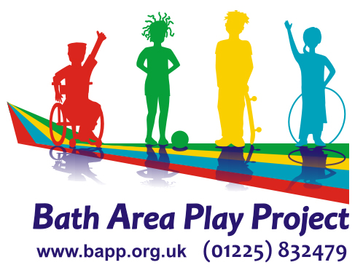
TURTLE
Toy Library
Membership Leaflet & Application
Who Can Join?
- Any family living in B&NES with children aged 16 years or under.
- Anyone with caring responsibility for a child 16 years or under.
- Any child or young person aged 16 years or under with parent / carer’s permission.
- Settings working with children in B&NES
How Can I Join?
- Read the terms and conditions of membership.
- Complete and sign the application form.
- Bring proof of identity and your membership fee with you to the library session.
When Can I Borrow Toys?
- Once you have joined we will issue you with a membership card.
- You can then start borrowing toys.
IT’S AS SIMPLE AS THAT! Join today!
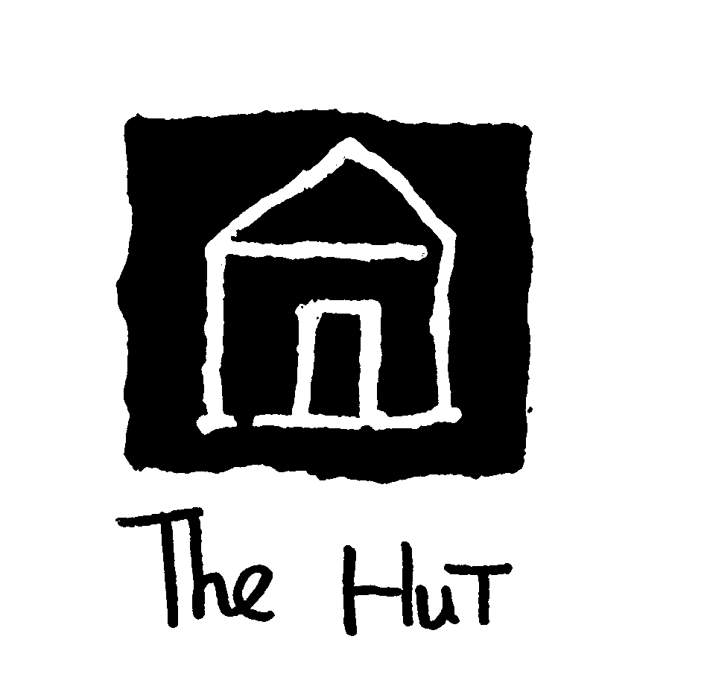
At: The Hut, Hinton Close, Newton Road,
Twerton, Bath, BA2 1RX
Tel: 01225 571511 / 832479
Membership is payable in full annually, and is non-refundable

Terms & Conditions
- Proof of identity is required when and individual or family joins. 2 proofs are required ie. utility bill, driving licence, income / child benefit book.

- Maximum loan period is one month. If toys are not returned within this time a reminder will be sent. If the toy is not returned additional hire fees will be requested. If you are unable to return the toy on time, please ring and we will make alternative arrangements.

- Once the toy has been booked out and taken from The Hut / group it is the responsibility of the borrower. Toys should be returned complete and in clean and undamaged condition.

- Where pieces are missing. A fine may be charged.
When pieces are found, please return them as soon as possible.

- Where toys are returned broken or damaged, a donation is asked for, to contribute to repairs or replacements. Toys must be returned.

- Before toys are available to borrow, we will check that they are safe to play with. Whilst you are borrowing them you must ensure they are safe to be used, any possible danger must be reported to the library.

- We reserve the right to cancel membership to anyone who consistently returns toys late, damaged or incomplete.

- A valid membership card must be shown when borrowing and returning toys.

- Where a child borrows a toy, it is their parent / carer’s who is responsible for its return.

- Some toys are age dependent and we reserve the right not to allow toys to be borrowed. Where toys and equipment need to have adult supervision. Only an adult will be entitled to borrow them.

TWERTON ULTIMATE RADICAL TOY LENDING EXPERIENCE

Application Form for Membership

I wish to join T.U.R.T.L.E toy library.
I agree to pay the annual fee.
I understand that membership of T.U.R.T.L.E entitles me to borrow toys games and equipment at a small charge per week.
I will respect all that I hire and will bring it back at the correct time and in a clean and working order.
I understand that membership can be terminated at any time if I do not abide by this agreement.
The membership of T.U.R.T.L.E entitles me to take part in the management and running of the toy library.
I have read, understood and agreed the terms and conditions of membership.

Please complete the section below

Parent / carer’s name:_____________________________________________

Address:________________________________________________________

_______________________________________________________________

Postcode:_________________________

Tel No:___________________________

Children’s Names and Dates of Birth

__________________________________________________________

__________________________________________________________

Signed:_____________________________ Date:__________________
It is your responsibility to inform the toy library of any change of details.
Office use only:
ID checked______________________________________________
_______________________________________________________
Identification Used________________________________________
_______________________________________________________
Date____________________

Set up and run by
Bath Area Play Project
An organisation set up in 1979 to provide and promote quality play opportunities for children.
Bath Area Play Project
Odd Down Community Centre
Odins Road
Bath
BA2 2TL

