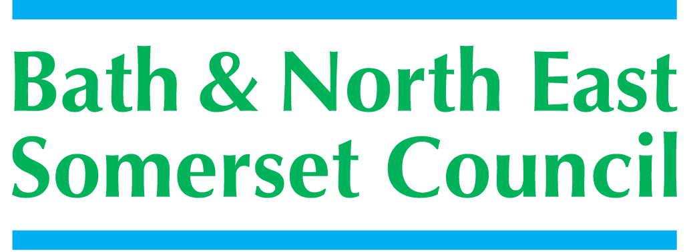 | Children’s Service  School Improvement & Achievement Service  Riverside, Temple Street,  Keynsham, Bristol BS31 1DN
 | Telephone : (01225) 394502
 | Facsimile : (01225) 395147
 | E Mail : kate_murphy@bathnes.gov.uk
 | Date: May 2016
National PSHE CPD Programme
Service Level Agreement

Name of School / Setting / Organisation _________________________

Name of Teacher / Nurse / Other Professional ________________________

The PSHE CPD Team will:-
- Provide 4 days training
- Provide one-to-one sessions as required
- Provide a mentor to support each participating colleague
- Be available for one-to-one correspondence / support to all participating teachers / nurses / professional throughout the programme

The school / other setting will:-
- Release staff for the 4 compulsory training days ( December 8th and 9th , February 21st and May 10th ) at the Ammerdown Centre , Radstock.
- Support an opportunity for the participating colleague to deliver / disseminate aspects of related training to appropriate staff during or upon completion of the programme
- Ensure payment of the course fees (£100 for LA schools / settings , £350 for academies / independent schools)

The teacher / nurse / other professional will:-
- Attend and respond to all training sessions
- Complete the assignments (lesson / session plan, lesson / session evaluation, reflection of learning)
- Have 1 PSHE session observed by a local lead
- Contribute to a staff training session in their workplace related to PSHE learning and practice, informed by the programme
- Maintain communication with their mentor or PSHE lead at all times, informing them of progress and/ or challenges

Signed _____________________________ Headteacher / Line Manager (electronic signature is fine)

Signed _____________________________ Participant

Participant’s e-mail _________________________________________

Date __________________

Please return to Deborah_carter@bathnes.gov.uk by September 23rd 2016

