Bugs Count!


Take part in a brand new wildlife survey this summer and contribute to valuable scientific research. Bugs Count is the latest survey from the OPAL project, and is being led by the Natural History Museum, London.

Anyone can take part – no previous knowledge of invertebrates is needed!

Discover the invertebrates that we share the built environment with by exploring your patch and recording the invertebrates you find. Your results will support research into how invertebrates may be affected by the spread of our towns and cities, as well as other changes in the environment, such as climate change.

What you need to do
Print out an OPAL Bugs Count survey pack from www.bugscount.org or request one by emailing bugscount@opalexplorenature.org. This includes all the information you need!

The survey starts with recording which micro-habitats your patch provides for invertebrates to live in, then you can choose between three bug hunting challenges. Each takes 15 minutes and you can do as many as you like!

Send your results back in, either online or using the freepost address given in the Field Notebook. This is important whether you find hundreds or just a handful of invertebrates!

Ones to watch out for throughout the summer
Part of the OPAL Bugs Count survey asks you to keep an eye out for six particular invertebrates that we want to record to species level – the Species Quests. Please report these, whenever and wherever you see them, regardless of whether you do the rest of the Bugs Count survey.

If you see them, please try to take a photo – this will ensure your record can be added to national distribution maps and will be valuable for years to come.

Enter your sightings online at www.bugscount.org or email them to bugscount@opalexplorenature.org.

The six Species Quests are:

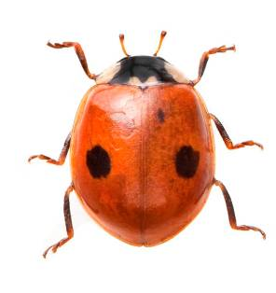
Two-spot ladybird (Adalia bipunctata)
It is thought that this ladybird is declining in numbers due to competition from the invasive Harlequin Ladybird. Help gather more data on Two-spot Ladybird distribution so we can understand the relationship better.

ID tips: 4-5mm long. Two-spot ladybirds are sometimes black with four red spots.

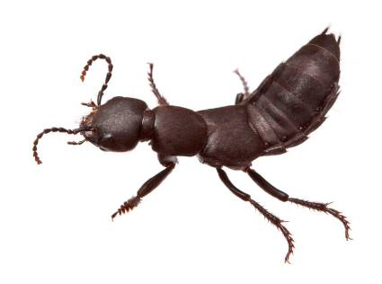
Devil’s Coach Horse (Ocypus olens)
This beetle is quite under-recorded, especially in urban settings. Does it occur more frequently in urban or rural areas?

ID tips: Around 25mm long – other beetles look similar but are much smaller. It rears up its tail when threatened.

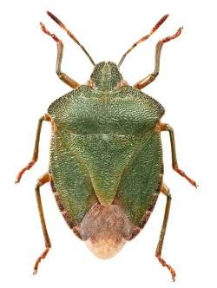
Green Shieldbug (Palomena prasina)
This shieldbug used to be primarily a southern species but in recent years it has been spreading north, probably due to climate change. Help add dots to the distribution maps.

ID tips: A shield-shaped bug, 11-12mm long. Green all over except the brown wing tips.

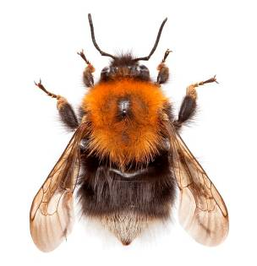
Tree Bumblebee (Bombus hypnorum)
This bee is non-native to the UK, but arrived under its own steam in 2001. It has spread rapidly since its arrival and is often seen in urban areas. Help us track how far it has spread.

ID tips: It’s the only bee with this colour pattern – from head to tail it is orange, black then white.

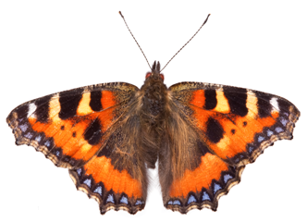

Small Tortoiseshell (Aglais urticae)
This butterfly used to be common in gardens but has suffered significant declines in recent years. Help gather more sightings - is it found more commonly in rural or urban areas?

ID tips: Look for the blue dots on the edges of the wings.

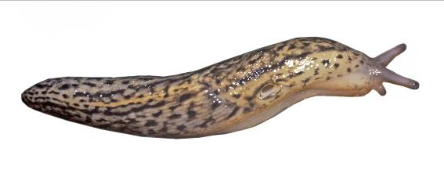
Leopard Slug (Limax maximus)
How important are parks and gardens as a habitat for this huge slug? Don’t worry, this one doesn’t eat your plants – it only eats dead plant material, fungi, and other slugs.

ID tips: A very large slug, up to 16cm long. The body is pale brown or grey with ‘leopard print’ markings on the front part of its body (the mantle) and stripes or spots towards the back. It is white underneath.

All photos copyright OPAL.

If you don’t have access to the internet but would like to take part, write to Lucy Carter, Department of Botany, Natural History Museum, London. SW7 5BD or call 020 7942 5188 and I will send you a survey pack.

