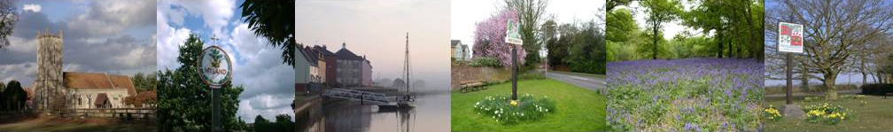
COLCHESTER ASSOCIATION OF LOCAL COUNCILS

- MINUTES OF THE MEETING HELD ON: 5th December 2024, Marks Tey Village Hall.

- PRESENT: Robert Johnstone, vice Chair, (Myland Community Council), Dan Jordan (Stanway PC), Tracy Bloomfield (Stanway PC), Maggie Holmes (Layer de la Haye PC), Mick Mead (Gt Horkesley PC), James Lambert (Abberton & Langenhoe PC), John Gili-Ross (West Bergholt PC).
Ruth Frost (Clerk)
Stuart Johnson & Jo Wheatley – 20’s Plenty for Essex.

- TO RECEIVE APOLOGIES: Andrew Triolo, Brian Butcher (West Bergholt PC), Barry Walsh (Wakes Colne PC), Vicky Weavers (Abberton & Langenhoe PC).

- TO RECEIVE THE MINUTES OF THE MEETING HELD ON 5th September 2024: All in favour of accepting these minutes as a true record. Proposed and signed by Robert Johnstone.

- MEETING TOPICS & GUEST SPEAKER: – Stuart Johnson and Jo Wheatley.
A very informative talk was presented and all gained valuable information.
This is to be shared on a separate document, which can be accessed by the email attached.

Vision Zero & 20’s Plenty:
Keep on at Essex County Council to try and get a response regarding 20’s Plenty .
Let PFCC know what you have done and remind them of their Vision Zero.

www.20splenty.org

- INFORMATION SHARING:
Local Highways Panel rep: Robert went to the last meeting but not much information to pass on. Next meeting 17th December 2024.
EALC executive rep: AGM went well, feedback being received and will collate information going forward.
Governance Board rep: None received
Treasurers report: To authorise the payment of £241.20 to Ruth Frost (1 meeting plus mileage – 5th December 2024 .
Agreed.To authorise the payment of £38.40 to Marks Tey Village Hall (1 meeting – 5th December 2024). Agreed.

- Q&A
Are we getting a LTCS grant? No one really knows?
Are we getting wheelie bins? Yes April 2026
How many parishes have lost footpaths?
Call for sites, Layer de la Haye are having a meeting with CCC.
PFCC will be paying for NI increase for police and fire rescue.
ECC cycle consultation on Website, ends 10th January 2025.
EALC consultation on remote meetings ends 19th January 2025. This should be down to each individual council, CALC are not going to respond.

- CONSTITUTION:
To undertake the annual review of the Associations’ Constitution and to agree amendments thereto: All in favour of accepting the changes to the Constitution to allow the subscription for Parish Meetings to be nil..

- Date/location of next meeting: 7pm, 6th March 2025 at Stanway Village Hall, Villa Road, Colchester, CO3 0RH. Wheelchair accessible.

- GUEST SPEAKER: Mike Eldred Chair of EALC.

There being no further business the Chairman closed the meeting at 8.36pm and thanked everyone for attending and providing valuable feedback.

Signed……………………………………………………………….………………. Date………………………….

- CALC clerk – Ruth Frost- Telephone – 07799 623529
- e-mail – calc.clerk@gmail.com
Postal address - 102 Stourview Avenue, Mistley, Essex, CO11 1UF.
- Chairman – Brian Butcher Telephone - 07836 348955
e-mail – cllr.butcher@westbergholt-pc.gov.uk

