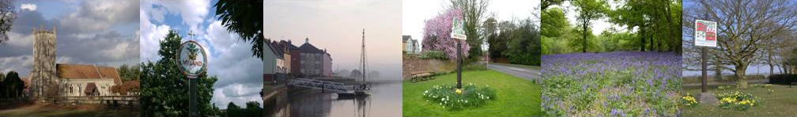
COLCHESTER ASSOCIATION OF LOCAL COUNCILS

MINUTES OF THE MEETING HELD ON: Thursday 7th March 2024 Via Zoom

PRESENT:
Cllr Brain Butcher – Chair Ruth Frost – Clerk
Cllr Sue Allen-Shepherd – Tiptree PC Cllr Maggie Holmes – Layer de la Haye PC
Cllr Mick Mead – Great Horksley PC Cllr Angela Mclauchlan – Boxted PC
Cllr Roger Pittock – Winstred Hundred PC Cllr Teresa Baines – Stanway PC
Cllr Dan Jordan – Stanway PC Cllr Robert Johnstone – Myland PC
Cllr John Gili-Ross – West Bergholt PC Cllr John Jardine – Eight Ash Green PC
Cllr Mike Lambert – Aldham PC Cllr Alan Frost – Abberton & langehoe

- TO RECEIVE APOLOGIES – Langham Parish Council, Cllr Dougherty, Abberton & Langehoe

- TO RECEIVE THE MINUTES OF THE MEETING HELD ON: Thursday 7th December 2024, Thursday, February 8th 2024 Proposed Cllr Brain Butcher – All in favor

- MEETING TOPICS & GUEST SPEAKER – Sue Lissimore – Chair, Local Highways panel

Sue Lissimore has been the Chair of the Local Highways Panel for 3 years.
This was formed to try and get the small and frustrating jobs done. A Budget of £250,000 was set up to try and achieve this.
As this has been very successful, they have become busier with many tasks in hand.
It has been decided that Cabinet Minster Tom Cunningham is now implementing a new supergroup to help with the bigger tasks. No details of this yet.
Some schemes are taking in the region on 3 years to complete.
Year 1 is speed and pedestrian checks, Year 2 is the design, and Year 3 is the implementation.
A lot of problems have arisen from new development not having enough residents to be able to complete the pedestrian check.
Sue has advised that when a new development is in the planning stages make sure that footpaths, Zebra crossing, etc are in those plans from the start. So that the need for LHP is not necessary.
The main point of contact if the LHP is needed is always your County Councillor.
Sue has also suggested an APP called Baseball Speed Gun APP to help show residents the speed of cars in their area of concern.
Another suggestion is trying to funnel pedestrians to a certain area to use as a crossing so that they are not crossing along the length of the road and therefore a survey would be easier to complete.
Any traffic incidents must be reported to the police as this helps build a record of anything concerning or dangerous.
There have been delays from the supplier of bus stops which does not help
Several Councillors raised concerns for their Council, sue advised everyone to go back to the County Councillors and keep on top of the issues.

- TO RECEIVE REPORTS

- Treasurer’s Report & Barclays update - To authorise payment of £225.00 to Ruth Frost
(1 meeting – 7th March 2024) Proposed Cllr Butcher – all in favor. A balance of £1558.50 from 15/12/2023 in the Barclays account.
Brian spoke to Barclays on 28/02/2024 and has requested statements be sent to him. This should take approx. 10-15 working days.
- Local Highways Panel – No meeting this month. Next meeting 9th April 2024.
- Governance Report - Nothing to report
- EALC executive – Have 2 new members of staff, 1 to cover maternity and 1 for admin.
The two main committees meet every 2-3 months. Finance to cover the business and Personnel.
There is now a Training Contractors agreement in place for all trainers. Except when they are employed by EALC.
All staff are now qualified for CiLCA or are now studying.
The EALC AGM is at Colchester Stadium, on 24th September 2024 starting after lunch.

- INFORMATION SHARING

Installation of EV charging points. – please see the additional page with notes regarding this.
DD Commemorative Flag – Cllr Jadine suggested buying one and donating it to the local school.
National Highways – please see the separate email with details.
Aldam Parish Council – New emails have been set up. – Kevin Money – Clerk.
Portrait of King – Now available information on EALC newsletter.

- DATES OF NEXT MEETINGS:
Date – June 13th 2024 Meeting & AGM
Location – Marks Tey Village Hall
Time – 7 pm
Guest speakers – Karen Syrett – CCC Planning

There being no further business the Chairman closed the meeting at 8.27 pm and thanked everyone for attending and providing valuable feedback.

Signed……………………………………………………………….………………. Date
CALC clerk – Ruth Frost - Telephone – 07799 623 529e-mail – calc.clerk@gmail.com
Postal address - 102 Stourview Avenue, Mistley Essex. CO11 1UF
Chairman – Brian Butcher Telephone - 07836 348955
e-mail – cllr.butcher@westbergholt-pc.gov.uk

