
English Primary Schools Chess Association

Rapidplay
Championships

Saturday 8th February 2020

At Broadgreen International School
Liverpool L13 5UQ

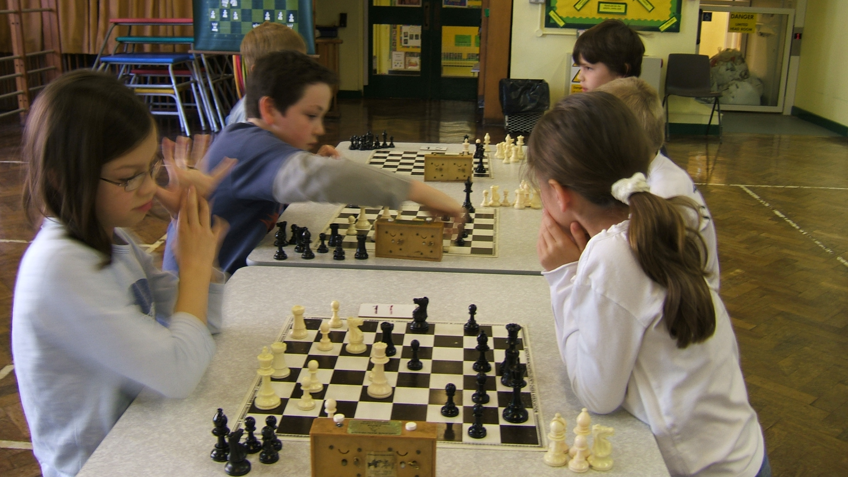
7 sections to suit age and ability

COMPETITIONS

- English Open Rapidplay Primary Championships open to all children Under 11 on 1st September 2018
Results from this section will count towards selection for the EPSCA Under 11 team trial. This section will be graded. Entries must be ECF silver members.

2. Under 11 B Section 5. Under 9 A Section

3. Under 10 A Section 6. Under 9 B Section

4. Under 10 B Section 7. Under 8 Section

N.B. An U 10 hoping for a trial place should enter 1.The A section is for fairly strong players (top 10-15 of an association team or equivalent.)

Entry Fee £15 (Cheques payable to EPSCA)
( £12 for ECF Solver members.)

ACCOMMODATION

Lists available from Welcome Centre 0845 6011125
Closing Date
Thursday 31st January 2020

TIMETABLE
Round One 11.00-12.00 Round Two 12.20-1.10
Round Three 1.30-2.20 Round Four 2.40-3.30
Round Five 3.50-4.40
The organisers reserve the right to add an extra round in the U8 section.

Prize giving: - 5.20 in your own sections
Rate of Play
All moves in 20 minutes with 5 second increments
Prizes
Trophies for first and second places
……………………………………………………………………………………….
All Entries are now on line.

Individual entries go to www.EPSCArapidplay.com and fill out the form, completing all sections. Payment can be made by BACS or simply tick pay on the day.

Group entries can be made by selecting the “Group entry” option on the website.
Please note that entries will not be accepted on the day and that entries will not be accepted by post/email/phone.

Directions to
Broadgreen International School
By Public Transport:-Train to Lime Street Station
Please check
Buses from by the Adelphi to Oakvale Church then walk up Broadgreen Road to Heliers Road.
Taxi Ask for Broadgreen School
By Car:- At end of M62 follow signs for City Centre through traffic lights then take first right in to Broadgreen Road and 5th right in to Heliers Road. School is 100 yards up this road.

Entry Form
- Please fill in all sections. EPSCA will not accept entries without an emergency telephone number
- Payment on the day should be cash or cheque. EPSCA cannot handle card payments on the day..
Safeguarding
- The event is controlled by staff with appropriate police clearance.
- The event has a first aider present
- The event is held on a school premises with appropriate security.
- BUT children remain the responsibility of their parents throughout the day.
Refreshments
- Light refreshments and hot drinks are available throughout the day.

