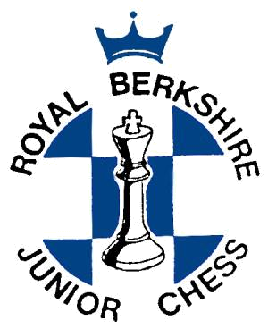

Berkshire Junior Chess County Team Trials

Saturday 8 October 2016

11:30am arrival for 12:00 noon start; 6:00pm Prize Giving

Venue: Claires Court Junior Boys School,

Ridgeway, The Thicket,

Maidenhead SL6 4QQ

Do you like playing chess? Would you like to join a successful chess team?

Were you born after 31 August 2005? Do you want to play for the Berkshire Under 11 Chess Team? Were you born after 31 August 2007? Do you want to play for the Berkshire Under 9 Chess Team?
We also run a girls Under 11 team, and there is a separate section at the trial for this team.

If your answer was “yes” to either of the above questions then you are invited to a Chess Tournament on the above date. This event will be used as the initial basis to select the 2016/2017 Berkshire Under 9, Under 11, and Under 11 Girls Squads.

The county teams need large squads of players (at least 24 for the U11 squad for instance) – so if you’re interested in representing your county at exciting and enjoyable team events - have a go!

Format: 6 rounds (minimum) Swiss; 25 minutes for each player for all moves; please arrive at 11:30am for the 12:00 noon start.

There will be trophies to keep for those finishing in the first three places and certificates for all competitors. If you would like to participate in the trial, please return the slip on the back.

The entry fee is £5 for entries received by 4th October (£2 extra for late entries including on the day).

For more information about Berkshire Junior Chess events and activities, please see our web-page www.bjca.org.uk, or feel free to contact Ken Coates (Under 9 Team Manager, u9Team@bjca.org.uk), Keith Tunstall (U11 Team Manager, u11Team@bjca.org.uk), or Paul Harris (U11 Girls Team Manager, u11GirlsTeam@bjca.org.uk).

Parents, if you can help on the day that would be much appreciated, please let us know.

DIRECTIONS to the venue :
At Maidenhead Thicket roundabout (junction of A4 & A404), turn towards Maidenhead (A4 Bath Road), and then immediately right at the roundabout into Cannon Lane. Go under the bridge and then immediately hair-pin right into the private road to the school.

Postcode for your sat-nav: SL6 4QQ

Parental Responsibility: The organisers accept no responsibility for any loss, theft or accident during the event. Adult supervision will only be provided in the playing areas. Parents are responsible for their children during the event, and agree to the terms and conditions in this entry form as a condition of their entry, and that a player’s grading information may be published electronically.

ENTRY FORM - Berkshire Team Trial 2016, Saturday 8 October 2016

SECTION: Under 9 | Under 11 | Under 11 Girls (delete as applicable)

FULL NAME____________________________

ADDRESS______________________________

_____________________________________

_____________________________________

_____________POST CODE_______________

EMAIL________________________________

TELEPHONE____________________________

DATE OF BIRTH_________________________

AGE on 31-Aug-16 ______________________

SCHOOL_______________________________

CHESS CLUB (If any) _____________________

GRADE (If any) _________________________

ENTRY FEE (£5)__________________________

LATE FEE after 4-Oct-16 (add £2)__________

TOTAL REMITTANCE____________________

Make cheques payable to: Berkshire Junior Chess Association

Please send the entry form to:
Keith Tunstall
11 Garston Grove
Wokingham
RG40 4YG

