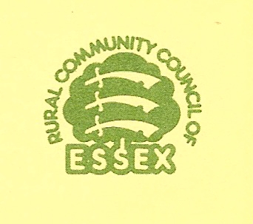
WHY DO A VILLAGE DESIGN STATEMENT?

A certain amount of new development is desirable for a living countryside. One role of a Village Design Statement (VDS) is to show how new development and changes that are acceptable in principle can be accommodated to fit its location and respect local character. In this way a VDS can be a positive influence on development, giving local people a recognised voice in the planning system rather than having to rely on protest to make their views heard.

For the majority of rural settlements the design guidance available sets out general principles for layout and design but does not deal with specific local character. The Essex Design Guide, published in 1997 by the Essex Planning Officers Association, provides guidance about characteristics to be found in Essex and how, in general terms, new development should harmonise with these. The VDS will further refine the design guidance to make it appropriate to your village.

If approved for use as a material consideration, a VDS can
- give designers and developers positive guidance on acceptable design from the communities point of view which can help avoid conflict later on in later planning negotiations.
- improve design in rural areas by being applied consistently in the development control process. It becomes part of the planning process for planning applications and therefore could help local planning authorities reject planning applications on the grounds of poor design.
- help protect visually important buildings and open spaces.

Without approval, a VDS can still be used but its effectiveness will be considerably reduced. A VDS cannot prevent development from taking place - the question of whether development should be permitted is a matter for the local planning authority in implementing the policies in its Local Development Framework.

Some development does not require specific planning permission (see appendix 1 – Permitted Development) and the VDS can be a vehicle that offers advice on permitted development. However, an important point to note is that these permitted developments cannot be controlled by the content of the VDS (see appendix 1 – Article 4 directions). The cumulative impact of minor changes can sometimes have as much effect on local character as new, larger developments. Local people, by being involved in carrying out the work for the VDS, become aware that they have a responsibility for safeguarding the village identity in the small-scale developments for which they as householders are responsible. The VDS encourages them to conserve local character when making alterations to their properties (e.g. extensions, a new porch, changes to windows). The VDS demonstrates local commitment to high quality design and appropriate development that will improve the village environment.

Producing a VDS can establish better understanding between the community, the local planning authority, designers and developers. It will also strengthen and support the role of the parish council when consulted over planning applications and can be used as material evidence at appeals.

(Note: This document has been re-produced by the permission of the Rural Community Council of Essex)

VDS 5

