What’s On?

The Newsletter of Bulmer - December 2008
(Including Bulmer St., Bulmer Tye, Finch Hill, Batt Hall, Upper & Lower Houses, Church Road and Hedingham Road).

Do you live or worship in Bulmer?

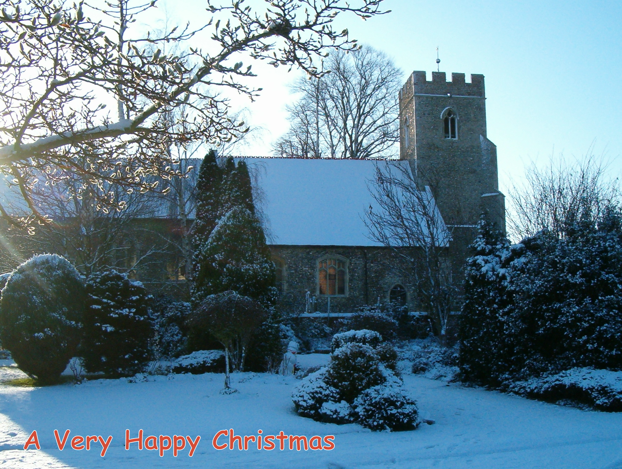
Then this is a personal invitation from me (Fr Eoin), for you to attend a public meeting in St Andrew’s Church on Saturday 24th January at 10am (refreshments will be provided). There will be the opportunity to hear about and discuss the proposed extension to St Andrew’s Church. I and members of the PCC will be on hand to chat with you in person about the vision surrounding the extension and Jeff Wright will be explaining some of the more technical details of his proposed design for the building.

Why an extension, well I don’t really want to offer too much detail in this article. I think that talking together at this very early stage in the proposal is a more constructive avenue and one that will help to make sure that we are “all singing from the same hymnbook” (another issue for the Team Rector!). However, I do think it important that we all understand that St Andrew’s is a central focus for the village and is the place where people often come ‘to find God’. For centuries Bulmer folk have worshipped, prayed, mourned and rejoiced in this wonderful church – that is where it gains its holiness, through the prayerful action of the people. None of us want to destroy the integrity of that holiness but we do need to make sure that our church building meets the needs of current and future generations.

Let me close with a note of reassurance to the wider community. The possible extension to St Andrew’s is designed to enhance the Church’s ability to meet the demands of mission and ministry in this millennium; that involves more than Sunday morning worship. What I do not want to do is diminish the central, vital role the Village Hall plays in the life of Bulmer; if ever I thought that would be the case then both my colleagues and I would be very reluctant to continue with this proposed vision for St Andrew’s.

I look forward to being able to talk with you on 24th January. Until then may I wish you every blessing over this Christmas season and for the New Year.

Fr Eoin – Parish Priest


Throughout this edition is a Christmas quiz, with multi-choice answers, see how many you can get right by checking the answers on the last page – and no peeking at the answers first. Here’s the first question:

1. The custom of decorating a "Christmas" tree was introduced to England by whom? A: Charles Darwin B: Prince Albert C: John Evelyn
~~~~~~~~~~~~~~~~~~~~~~~~~~~~~

~~~~~~~~~~~~~~~~~~~~~~~~~~~~~
As I'm writing this, large flakes of damp snow are sloshing against the window and it's only 23rd of November. We had planned to meet some friends down at Shotley for a spot of bird watching, but allowing for the conditions outside, we didn't feel so bad about having to chicken out. Hanging about on the edge of a windswept estuary, in a blizzard, is not my idea of fun! Yes, winter has arrived with a vengeance, a good excuse to sit in the warm and take stock of the past few months. Firstly the comings and goings of our migrant birds, for the most part seen in our garden.
Departures, Summer visitors, last Swift 19th Aug; Willow Warbler 31st Aug; Blackcap 12th Sept; Whitethroat 13th Sept; Swallow 28th Sept; House Martin 2nd Oct and Chiffchaff 6th Oct. (Of these the chiffchaff and the Blackcap, will sometimes over winter in this country).
Arrivals, winter visitors, both Redwings and Fieldfares, put in an appearance on the same day, 18th Oct. There were about eight Fieldfares, but little groups of Redwings kept flying across, maybe a hundred or so, all heading westward. On 31st Oct. we had two Bramblings feeding with the Chaffinches under the bird feeder, but we don't get these every year. A pair of Stonechats was an unusual sighting in the Upper Houses Lane on 24th Oct. (Another one was reported by Ashley Cooper on one of the Goldingham Hall fields, at the beginning of December).

Back in the middle of September we took a walk past Henny Ryes and through the new woodland, planted about eight years ago, by the late Phil Morton. It was the perfect autumn day, pleasantly warm and sunny (we've had few enough of them this year). At this stage of the wood's development, there is plenty of space and light for a wide variety of wild plants to establish themselves. This in turn attracts other wildlife, on this day the young wood was alive with butterflies. We counted seven species, including the brilliantly coloured Common Blue and the Small Copper, both of which shone like jewels in the mellow sunlight. Such a peaceful and relaxing spot to visit and a very fitting memorial to Phil.
Re-cycling, of course is nothing new in the natural world. One years plant growth decays down into the soil to provide nutrient for the following years greenery, the remains of any creature that has succumbed to life’s struggles, are eagerly scavenged by the likes of Carrion Crows, or used as nurseries by Blow Flies, their eggs hatching out to produce fat maggots that can make your skin crawl just to look at them. That's just a couple of examples; the list could go on and on. But this autumn we've watched a more amusing example. Our neighbour Maudie's walnut tree bore a real bumper crop, but for most of September two Grey Squirrels made it their business to systematically strip the tree of this bounteous crop. The nuts were still in their green husks. A little cache of five or six nuts was made on the edge of our lawn, and then each one was stripped of the husk, before being buried, usually on the lawn, a few yards away. It amazed us that, despite knowing roughly where they were buried, we found it almost impossible to find them, so well were they concealed. Here comes the re-cycling bit. At the end of the month, a couple of Jays turned up. They wasted no time in locating some of the hidden nuts and made off with several. They were disappearing for only a very short time, certainly not long enough to open the nut and eat it. It was obvious that they were re-burying the nuts! They are of course famous for burying acorns and thereby producing young oak trees. No doubt we will have loads of seedling walnuts next year.
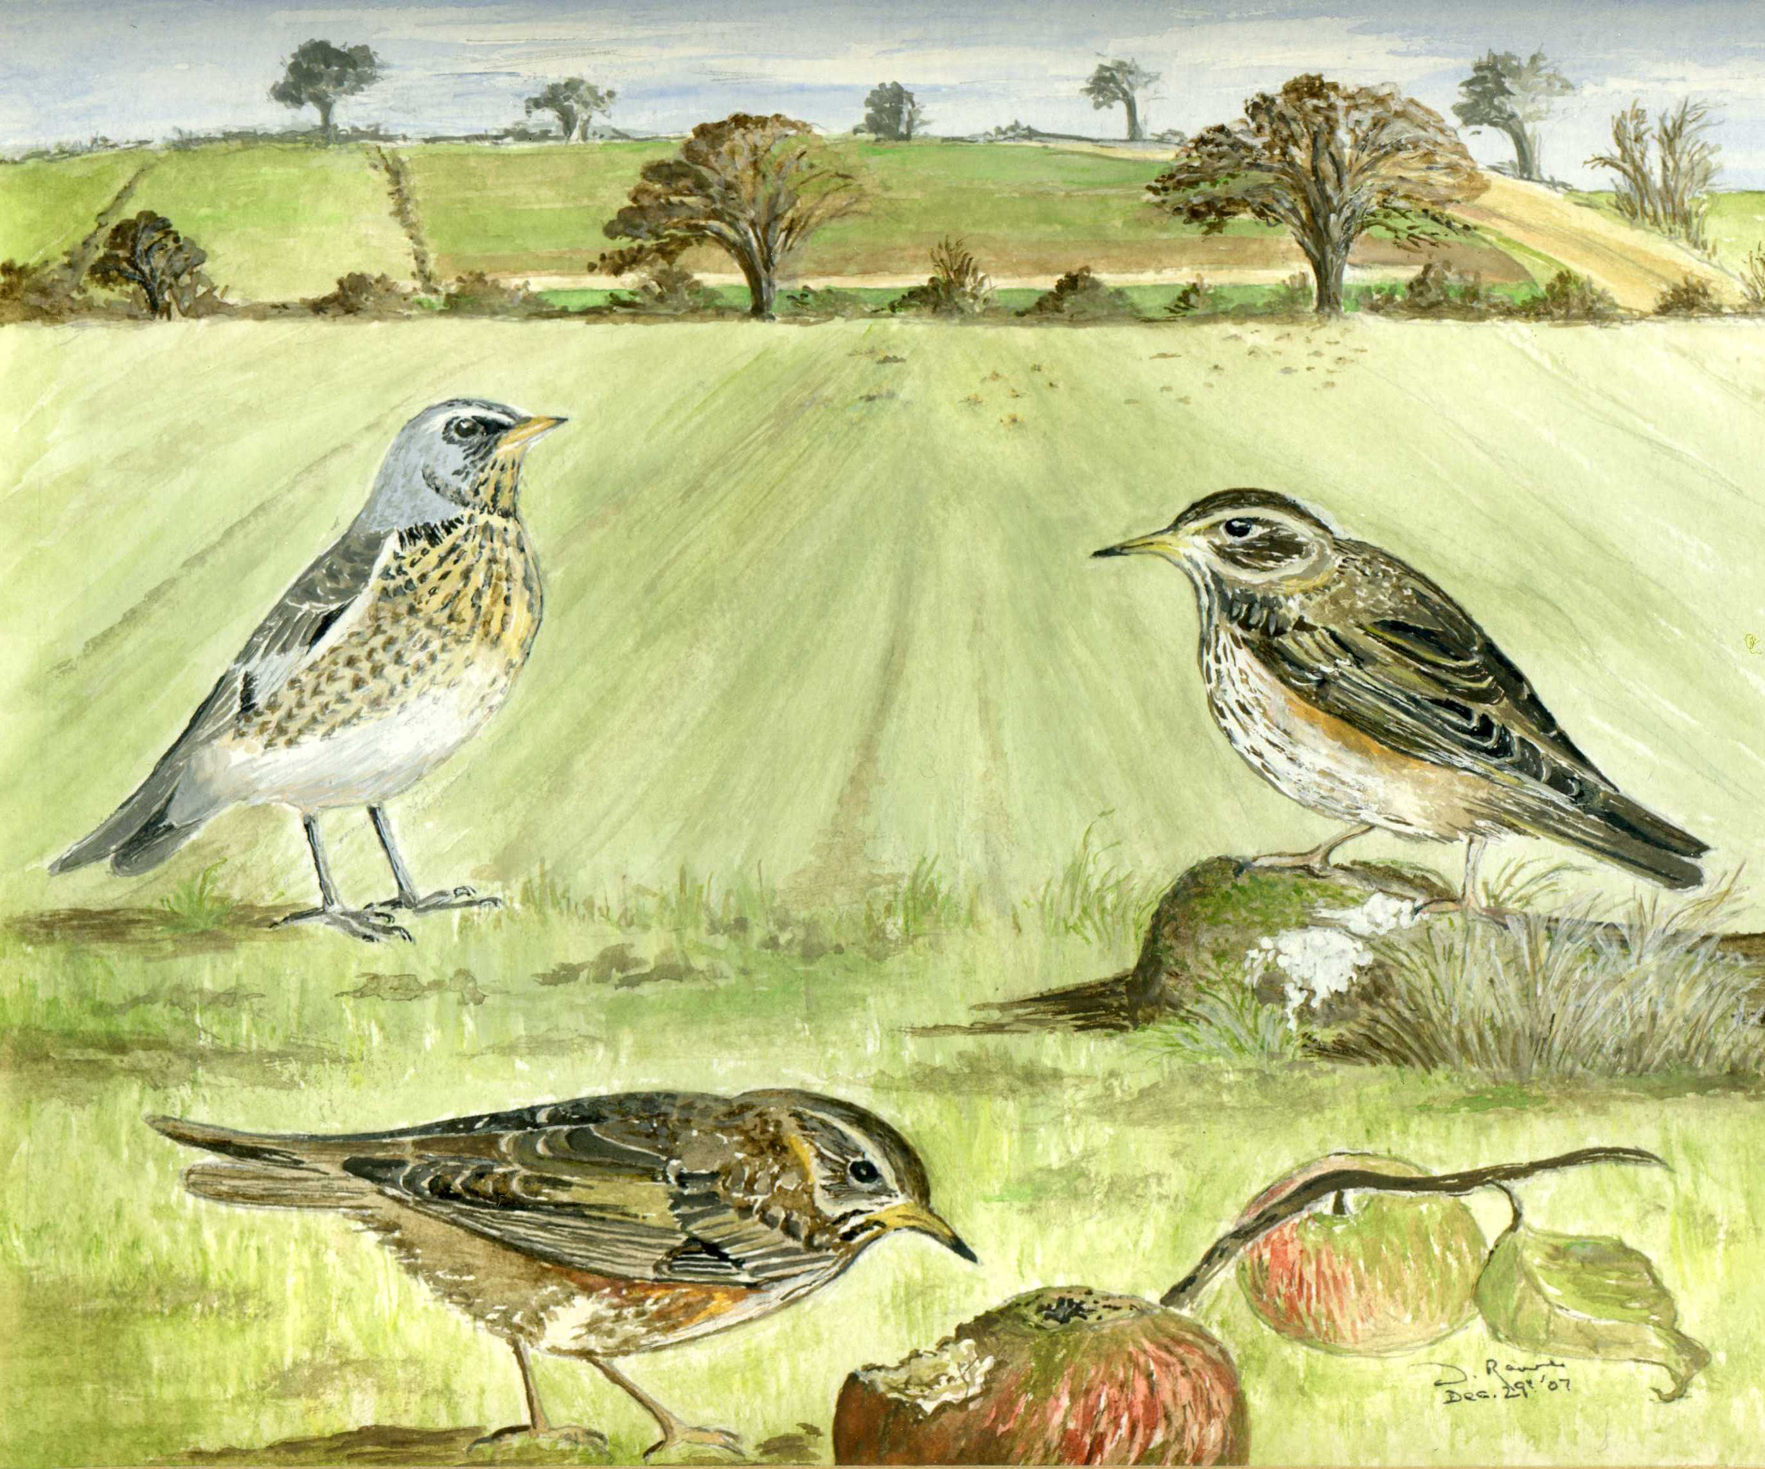
Fieldfare and two Redwings – by Wendy Rowe

Walnuts weren't the only bumper crop this year; many hedgerows were laden with blackberries. On our only blackberrying trip, we picked six and a half pounds in no time. Gorgeous fruit, even if the pips do get infuriatingly stuck between my well-filled molars! Whilst gathering them we came across a clump of ivy heavy with flowers.
A few hornets were buzzing around, feeding on the pollen, but also trying to ambush the flies that were also feeding on the flowers. This put me in mind of a happening from years ago. A group of us were on a visit to North Warren, The RSPB reserve near Aldeburgh. One of the group spotted what he thought might have been the quite rare white admiral butterfly. It disappeared behind an inaccessible clump of brambles. Having exhausted our patience, after several minutes someone threw a stick and succeeded in flushing out the uncooperative butterfly. For a split second it was there, then in a whirr of wings, it was whipped away in the clutches of a large dragonfly (probably an Emperor) Having been patiently waiting to see what it was, we all quite spontaneously burst out laughing, despite the mini tragedy played out in front of us. We never did find out what it was!
On 5th December we took the bus to Gestingthorpe and walked back home across the footpaths. With the exception of dozens of Pheasants and partridges and a nice little flock of Goldfinches, we saw very few birds until we crossed into Bulmer near Gallows Green. No sooner were we playing at home, so to speak, than there were birds everywhere (am I partisan, or what?) A buzzard was the first that greeted us. Then a Heron and Six Pied Wagtails on the field edge. Further up on the field beside Deal Nursery, about sixty Golden Plover were feeding with a few Lapwings and Common gulls. Golden Plovers are winter visitors to this area, nesting further north in upland Britain, or further north in Iceland or Northern Europe.

Little Dean Spinney update.
In September George Millins again surveyed the site for Common Lizards and found no less than fifteen juveniles, a mixture of this year and last years young, but strangely enough, no adults. None the less, a very good result.

A Path Through Fresh Seasons
I'm pleased to say that my DVD is now available and is selling well. It contains a wide range of local wildlife subjects, including flowers, fungi, birds, butterflies, mammals, snakes, lizards and even dragons and damsels! Filmed over the past five years, 1hour 20 mins long. The profit will be split between St. Andrews Church, St Nicholas Hospice and the Wildlife Trust. Available, price £9 from Peter Rowe, Cornfields, Bulmer Street or phone 01787 375935

Peter Rowe

~~~~~~~~~~~~~~~~~~~~~~~~~~~~~
2. It is a basic feature of our Christmas decoration, but you court disaster if you bring holly into the house before: A: 1 December B: 12 December C: 24 December
~~~~~~~~~~~~~~~~~~~~~~~~~~~~~

VILLAGE LOTTERY WINNERS
The Lottery still provides 3 lucky winners each month. Are you a member? The more members the more funds for the Village Hall and the bigger the prize! Please contact Dawn at the Post Office (376676) if you would like to join.
Month | First | Second | Third
Sept. | Mrs B Rawlins | Mr & Mrs T Dickinson | Mrs E Brown
Oct. | Mr & Mrs D Whillock | Mrs M Dixey | Mr & Mrs A Cobb
Nov. | Mrs J Steed | Mrs J Leech | Mr & Mrs P Owen
~~~~~~~~~~~~~~~~~~~~~~~~~~~~~VILLAGE HALL NEWS

The Village Hall Committee would like to thank everyone for their support over the past year. Most of our events have been well supported especially the Ferret Race evening which saw many families attending, something which the Committee is very keen to promote. Due to rising costs it is very difficult to continue to keep rents low and to keep the building in a good state of repair, but with your support at our events and to the lottery, we hope we can still maintain the building and add further improvements during 2009.
The major item to be undertaken next year is to have the floor stripped and resealed and polished. Sounds simple but is quite a task and hopefully it will give the floor an extended life. We are always happy to hear from you if you have any areas you would like to see improved or any event you would like us to organise.

Our plans for 2009 are still being discussed but the ever-popular Barn Dance is already booked for April. Watch the Parish notice boards and the web site www.bulmeressex.co.uk for details.

We are also considering re-opening the Friendship Club. The aim of the club is for those of you who have retired, are on your own, or would just like to come along for a cup of tea and a chat. Everyone will be welcome. Of course volunteers would be needed to either help with transport or tea making etc. so, if you think you would be able to help or wish to know more please ring Maggie on 374758.

The Committee would like to wish all of you a very happy and peaceful New Year.
~~~~~~~~~~~~~~~~~~~~~~~~~~~~~
BULMER AND DISTRICT W.I.
We will be finishing our year with a Christmas meal at The Cherry Tree, Knowle Green. This venue was chosen as it has played host to our darts team over the past two years. Our last speakers for this year were, as usual, both varied and entertaining. Liz Powell gave us her memories of nursing, "Being a Police Chaplin" was the Rev'd Stenner's title of his talk and Paula Short gave us a little peep into Castro's Cuba.

It is with great sadness that Bulmer and District W.I has been forced to close. This is due mainly to a decrease in numbers and a failure to recruit new members. However the closure is not final as the decision was taken to suspend the Institute for a maximum period of three years with the hope that it can be re-opened within eighteen months if more support can be found.

The Committee would like to thank all members past and present for their support and hope that Bulmer W.I. will once more become a flourishing Institute in the not too distant future.

TROOP APPEAL
Bulmer and District W.I would like to thank everyone for their most generous donations to the Troop Appeal. A total of 15 boxes were dispatched to Afghanistan in the hope that they will give our Servicemen and Women a little comfort over the festive period.
~~~~~~~~~~~~~~~~~~~~~~~~~~~~~
3. Furthermore, it is said you must bring holly into the house for Christmas before the ivy or you will risk: A: A female-dominated household B: Infertility C: Rain throughout January

~~~~~~~~~~~~~~~~~~~~~~~~~~~~~

BULMER STITCH & SEW CLUB
What has happened to all the “Sewers” in the village? We need new members; it would be a great pity if we have to close down. It is held in the Village Hall on the 4th Tuesday in each month from 7:15 – 9:30pm. Come on Ladies (or Gents) we have a chat and coffee while sewing or knitting – it only costs £3 for membership fee and £1 per night. We would love to see some more people so we could have a full room. Contact 01787 376392 or 01787 312915 for further details.
~~~~~~~~~~~~~~~~~~~~~~~~~~~~~

St. ANDREWS SCHOOL - BULMER
Congratulations to the following children who came 1st – Cloe Morris, 2nd – Daisey Newton, 3rd – Amber Clackett and 4th - Gabriel Slatter in the Cross Stitch for under 14s in the Sudbury Horticultural Show in September. Once again they swept the board.
If any child would like to enter the competitions for next year, dates are the 4th & 5th July and 19th & 20th September. Further details can be obtained from the Chairman J Middleditch on 01787 375205.
~~~~~~~~~~~~~~~~~~~~~~~~~~~~~

BULMER FLOWER CLUB
Feel like learning a new skill or brushing up on an old one? Then why not come along to the Village Hall on the 2nd Tuesday of every month and learn the art of Flower Arranging. The class is run by a qualified florist who will guide you through your work and also demonstrate new and exciting arrangements.
Why not make a New Year resolution to do something different and very enjoyable. You will go home every week with an arrangement to stun your friends and family. Previous experience is not required.
INTERESTED? Then come along to the Village Hall at 7.30pm or ring Carol on 01787 881797 for more information.
~~~~~~~~~~~~~~~~~~~~~~~~~~~~~

BULMER HISTORY GROUP –AUTUMN 2008
Maybe it had something to do with the Bulmer History Group managing to get not one, not two, but three local celebrities to give up their valuable time on the 10th October that we achieved such a tremendous turnout. The car park was chaos, some wanting raffle tickets were disappointed due to a sell out and extra chairs had to be set up for such an unexpected sizeable audience. Even in the hope he may reveal some parliamentary scandals Sir Alan Haselhurst MP didn’t fill the village hall to this extent.

Getting the evening underway with another episode in the history of the Bulmer Brick and Tile Company, Peter Minter was our first celebrity to take to the floor. After the Bulmer Bat Brick and the involvement with the modernisation of St Pancras station I was amazed by further claims to fame with the connection to the local wartime airfields. Although mainly supplying drainage pipes for the airfields during WWII they did continue brick production for building work at the Duxford airfield, now The Imperial War Museum. So now when visiting the War Museum perhaps you will take a closer look at the buildings too. As well as the production of the pipes and bricks, Peter also told us of how the materials used were transported and with the labour of local children how the goods reached their destinations. As always, Peter delivered his unbelievable knowledge to the audience aided by his quirky comical look at history, whilst sharing his invaluable memories of life at the Brick Works throughout these stages of history. A book should undoubtedly and will hopefully sometime be written about this historical little gem in Bulmer.

Next up was Margaret Mills with some bits and pieces. Margaret’s bits and pieces consisted of mostly recent historical artefacts that have been significant to her throughout her lifetime. To begin Margaret produced some items relevant to her early years as a young lass growing up in a rural Northumbrian community. One such item being a small spoon given as a gift from the local hunt to its members, which had been passed down to her. One other item Margaret had brought along, which I didn’t much like the look of was an iron. And for those of you who think ironing is an arduous task now, have some sympathy with the ladies of the older generations. Their irons weren’t light in weight by any means, contained no flex of electrical wires, had no thermostatic heat control let alone a self clean steam mechanism. The irons of yesteryear had to be constantly replaced on to the Aga to reheat to achieve any pressing power which then after a whole days ironing probably left you with a minimum number of garments that didn’t contain an iron shaped scorch mark. Us girls these days don’t realise just how lucky we are. Another item Margaret had brought along was from a more recent part of her life in Bulmer. It looked like the soul of a shoe made from metal and was discovered during the renovations of the lovely Jenkins farmhouse. It was helpfully pointed out by a member of the audience that throughout some periods of history such items were placed in the structures of buildings to ward off evil spirits. After Margaret’s comment on the southern hunting fraternity being slightly snobbish, I think when she had finished with her bits and pieces she hot footed back to Jenkins to put her soul back where it came from, to ward off any irate Bulmer residents.
~~~~~~~~~~~~~~~~~~~~~~~~~~~~~

4. A kiss under the mistletoe once held special significance. Did it signify: A: An alliance of families B: Forgiveness C: A proposal of marriage
~~~~~~~~~~~~~~~~~~~~~~~~~~~~~
Our final celebrity of the evening was local Lord of the manor, Ashley Cooper. Ashley told us of his dilemma a few years ago, that on the completion of the mortgage payments for Goldingham Hall he had no idea what to do with his extra amount of cash each month. It was then, due to his vague interest in history, Ashley decided to spend his extra money on having the manorial documents for Goldingham Hall translated from Latin into modern day English. Not the most obvious use of some spare cash but very interesting. Probably in the hope of discovering some deep dark secrets of the inhabitants of Goldingham Hall several pages were being translated. However, no deep dark secrets were being revealed and the continuation of this project was looking unlikely. Thankfully intrigue won the day and Ashley was able to then go on and give us a lively insight into the dealings and disputes of Medieval Bulmer through the translation of the manorial court documents. On final reflection, Ashley concluded that Medieval Bulmer was not that much different to Bulmer today.

The next meeting of the Bulmer History Group will be Friday March 6th 2009 - To include Tom Dickinson speaking on 'Law and Disorder in Bulmer & District' and Andrew Phillips will speak on 'Sudbury the Crucible of English Independence'.
Lisa Sandford
~~~~~~~~~~~~~~~~~~~~~~~~~~~~~
SPEED INDICATOR DEVICE (SID)


The device has now been located at all designated locations & is now re-circulating. This now gives us an opportunity to compare readings taken approximately 12 months ago. The first of these locations was Bulmer Street near the telephone box, monitoring the traffic from Sudbury in a westerly direction, a 30mph zone.

 | 2007 |  | 2008
Speed | No. of Vehicles | % | No. of Vehicles | %
1-30 | 12,407 | 43 | 10,545 | 43
31-40 | 12,218 | 42 | 11,357 | 46
41-50 | 3,852 | 13 | 3,535 | 14
51-60 | 219 | 0.8 | 220 | 0.9
61-70 | 12 | 0.04 | 4 | 0.01
71-80 | 1 | 0.003 | 0 | 0
Total | 28,709 |  | 24,461

Under Community Speed Watch (which is continuing), the number that would have been reported to the Police is 8,764 or 36% in 2008 and 9,478 or 33% for 2007. So from these statistics it appears there has been very little difference in people’s attitude towards speed.
All these statistics and others as always are passed to the police and Essex Highways for further action/analysis.
So please watch your speed, if not, could you be the one with a grumpy smile?
~~~~~~~~~~~~~~~~~~~~~~~~~~~~~

PARISH COUNCIL NEWS

YOUR PARISH COUNCILLORS
Margaret Mills (Chairman) | - 01787 269377
Mike Crome (Vice Chairman) | - 01787 378155
Peter Rowe | - 01787 375935
Ron Mansfield | - 01787 375301
Peter Fultcher | - 01787 269935
Stephen Morgan | - 07973 341048
Stephen Coombes | - 4 Park Lane

Barbara Rawlins (Parish Clerk) - 01787 370845

~~~~~~~~~~~~~~~~~~~~~~~~~~~~~
5. Mistletoe has been used in herbal medicine since the Dark Ages. Which ailment is it not used to treat? A: Toothache B: Chapped lips C: Animal bites
~~~~~~~~~~~~~~~~~~~~~~~~~~~~~

DATES OF FUTURE PARISH MEETINGS
All meetings are bi-monthly, normally held on the second Friday of the month in the Village Hall at 7:45pm
- 9th January 2009
- 13th March 2009

GARDEN & RUBBISH WASTE
It has been reported to the Parish Council once again garden waste etc. has been left in fields behind residential properties. May we respectfully remind people that this is unsitely, not pleasant for people walking by and un-necessary. If you are unable to compost it, currently the weekly refuse collectors will take ONE black sack of garden waste per week/per household, and there is the re-cycling centre in Sandy Lane less than 2 miles away. Please keep the countryside tidy & pleasant for everyone to enjoy.
~~~~~~~~~~~~~~~~~~~~~~~~~~~~~
6. Today we only think of sage as a herb for mixing with onions to stuff the turkey, but once it was a valued medicinal herb taken in the form of: A: A tea B: A poultice C: An oil
~~~~~~~~~~~~~~~~~~~~~~~~~~~~~
MINUTES OF THE MEETING OF BULMER PARISH COUNCIL HELD ON 12th. SEPTEMBER 2008
PRESENT: Councillors Margaret Mills (Chairman), Stephen Coombes, Mike Crome, Peter Fulcher, Ron Mansfield, Stephen Morgan, Peter Rowe and the Clerk.
Rob Sippitt - Police Community Support Officer.
Tony Howland - Community Warden.
Also 8 members of the public
APOLOGIES FOR ABSENCE: David Finch CC, Nigel Harley DC.
DECL. OF INTERESTS: Cllr. Rowe re planning on Back House Croft. Cllr. Crome on TPO 6 Vicars Orchard. Cllr. Morgan on vacant allotment land at Bulmer Tye. Members will remain in the meeting, but take no part in any discussions or proposals relating to their interest.
PUBLIC QUESTIONS: Mrs Fulcher wished to give the Parish Council an update on her continuing fight, with Highways, to find a remedy for the many accidents occurring on the B 1058 (Hedingham Road) in the region of Bulmer Orchard. Highways have agreed to repair/ resurface the road, but not before April 2009. Mrs. Fulcher felt this was not good enough as we had the winter to go through when the road would deteriorate even more. Mrs. Fulcher will press for the repairs to be carried out earlier. In the meantime, Highways have placed 'beware slippery road' signs at both ends of the z-bends. A senior maintenance engineer was surprised at the speed motorists drive through the bends.
PCSO ROB SIPPITT collar number 71507 - advised the Council that, like Cllr. Fulcher, he is also experiencing difficulty in making contact with Adam Pipe (Police Officer overseeing Community Speed Watch), but will continue in his efforts. Recent speed checks carried out in the village by Rob and his partner have resulted in 4 penalties being issued in the last five months. Rob's duties cover 22 villages and deals mainly with criminal damage - Bulmer is one of the quieter villages. Contact No: 01787 237254. Mobile: 07855 781127.
Cllr. Fulcher (Bulmer CSW co-ordinator) said that unless Adam Pipe contacts the speeding vehicle drivers and warns them that their speed has been noted, the CSW will become ineffectual.

TONY HOWLAND has taken over the duties of Community Warden. As he was not familiar with Bulmer, Cllr. Crome offered to show him around the village and its outreaches. Contact No: 01376 332316 Mobile: 07770 542591
APPROVE THE MINUTES of the meeting held on 4th July 2008. Proposed Cllr. Crome, seconded Cllr. Rowe.

MATTERS ARISING: None
COE's MEADOW:
Cllr. Fulcher reported that the RoSPA inspection is due to take place on 27th September and that a member of the CMMC will attend with the Inspector.
Estimates are being requested for the repair of the car park entrance.
Would the Parish Council suggest to Highways that a sign 'children playing' be erected near the recreation ground to warn approaching vehicle drivers. The Clerk will deal with this. A Christmas Fayre is being planned to take place on the Meadow. The date to be advised.
A Tree Preservation Order has been requested to fell and replace 2 lime trees at the top of the Avenue behind the bungalows. The 2 limes were planted around 15 years ago without much thought to their location. They are now intruding into the light of nearby housing and blocking the pathway. It is proposed to replace one of the limes with pyrus chanticleer and the other, with shrubs.
PLANNING:
Back House Croft, The Street. - replacement of existing dwelling and erection of 2 dwellings. The Parish Council could not support this application on the grounds that it was an over development of the site. It would also increase vehicle movements to an already busy site. The application has been Refused by the BDC Planning Services.
Land adjacent to Keys Barn, Church Road - erection of single storey 4 bed house. The Parish Council were opposed to this application as it is outside the village envelope and appears to be very large. It was felt that the building would have an impact on other properties in Park Lane who are attempting to build new properties.
Chapel Cottages, The Street - construction of vehicular access. No objections from Parish Council.
4 Bulmer Tye - erection of single detached garden store/workshop. Withdrawn.
6 Vicars Orchard - TPO to lop a variegated Acer. No objection from Parish Council. Church Avenue, Coe's Meadow - TPO (see description above under item Coe's Meadow). No objection from Parish Council.
7. Which famous "Holy Thorn" sometimes blooms on the old Christmas Day (January 5th) prompting the vicar to send a flowering branch to the Queen? A: Shrewsbury B: Cambridge C: Glastonbury
~~~~~~~~~~~~~~~~~~~~~~~~~~~~~
8. Which common garden herb was popular for decorating churches at Christmas before holly became a universal favourite? A: Rosemary B: Bay C: Sage
~~~~~~~~~~~~~~~~~~~~~~~~~~~~~
VACANT ALLOTMENT LAND AT THE TYE:
Three residents have formed themselves into a shareholding, namely Bulmer Grazing. They will be renting the 6 acre Almshouse field as grazing and the Almshouse pieces will be used for hay making. Bulmer Grazing will maintain the land and all hedges. The Parish Council has drawn up a Licence, which is presently in the process of being agreed between the two parties.
CORRESPONDENCE & NOTICES:
1. Essex Highways have taken on board that they are responsible for surfacing part of Old Church Lane. They have decided to take up the existing planings from the lane and the dirt build up and make good any potholes. They will then patch and prepare the ground in February ready for surface dressing in the Spring 2009. In the meantime, the old planings will be kept down to protect the surface over the winter.
2. SID - the Parish Council had been withholding payment to Traffic Technology following a dispute over a repair bill. After a lengthy discussion in which it became clear that the Council felt it better to remain on good terms with Traffic Technology for possible future repairs, a majority decision was taken to pay the invoice in full, but under protest. The Clerk was asked to convey the feelings of the Council to Traffic Technology.
3. BT pole sited on the corner of Church Road/Park Lane. The Parish Council has put the matter into the hands of County Highways who have been informed that the issue has been passed onto BT Complaints Div.
4. Brambley Hedge New School building - the Parish Council decided to leave any decision on a donation towards the building until the premises gets the go ahead.
5. Following concerns as to the various business activities in the Back House Croft outbuildings, the Planning Inspector had been informed...... Permission for the catering business was granted only to Mr. Clarke in 1999. Splinters has now made a retrospective planning application to regularise the situation. The Inspector said he would contact the property owner regarding the use of the other outbuildings.
6. Belchamp Walter Parish Council wishes to discuss/review the weight limit placed on Bardfield Bridge. The Bulmer Parish Council has agreed to meet for further discussion.
7. A resident is very concerned about the Horse Chestnut tree leaf miner which is causing the leaves of the trees to turn brown and drop. The Parish Council was asked if they could organise working parties to con~ct as many dropped leaves as can be achieved in an effort to reduce the spread of the virus. The Clerk was asked to contact Simon Harris (tree warden), to explain to the resident that there are many Chestnut trees throughout the village and to collect leaves would be an impossible task.
8. The BT phone box in The Street has been under threat of removal. After strong protests from the Parish Council, the box is to remain for the time being.
BUS SHELTER - A131:
The shelter has again been damaged by vehicles. The Clerk is endeavouring to obtain details of the vehicles and drivers concerned, from the police. The Clerk has also contacted the shelter manufacturers (Littlethorpe), who state that in view of the main posts being cracked, the shelter is a write-off.
Although the bus shelter has been situated on the A131 for more than 50 years, it has now been badly damaged twice in the last 18 months. The Parish Council is of the opinion that the shelter would be better situated at the top of Church Road and will ask Nigel Burke if we could use a small section of his land for this purpose.
~~~~~~~~~~~~~~~~~~~~~~~~~~~~~
9. Our most famous Christmas tree is erected each year in Trafalgar Square, a gift from which capital city in gratitude for Britain's help during World War Two? A: Stockholm B: Oslo C: Copenhagen
~~~~~~~~~~~~~~~~~~~~~~~~~~~~~
RECEIPTS:
Coe's Meadow | - small profit from Fun Day | £27.00

PAYMENTS:
Great Bardfield PC | - re VDS | £5.00
Colne Stour Assc’n. | - subscription (ten year) | £50.00
BALC | - fees re Training Day | £52.00
R. Mortimer | - grass cutting (see Other Business) | £1,226:73 inc VAT
Anglian Water | - Park Lane allotments  - Coe's Meadow | £48.73  £26.18
Thorntons | - fees re Almshouse Field | £88.13 inc VAT
Cllr. Crome | - training expenses to Great Dunmow | £31.11
B. Rawlins | - salary (6 mths)  - expenses (6 months) | £875.00  £60.60 inc VAT
B. Rawlins | - re cost of 7 yellow safety jackets | £13.93 inc VAT
Cllr. Rowe | - fuel for strimmer | £10.01 inc VAT

The Charity Commission Annual Update for Coe's Meadow was completed and duly signed by the Chairman on behalf of the Parish Council as Custodian Trustee.
OTHER BUSINESS:
No interest has been shown in the Parish surgeries, but it was agreed to carry on for a further 6 months.
Mortimer's have completed 10 grass cuts this season. As the grass is still growing the Parish Council has agreed to a further 2 cuts.
The Clerk was asked to contact Mr. Wicker regarding the replacement of hedging between his property and allotment land.
Cllr. Crome has added a 'Discussion Forum' on the Parish website (www.essexinfo.net/bulmer)
The Clerk was asked to report a pothole on the county border at Batt Hall.
There being no other business, the meeting closed at 9.35pm
~~~~~~~~~~~~~~~~~~~~~~~~~~~~~
PARISH PATH WALKS - AUTUMN 2008
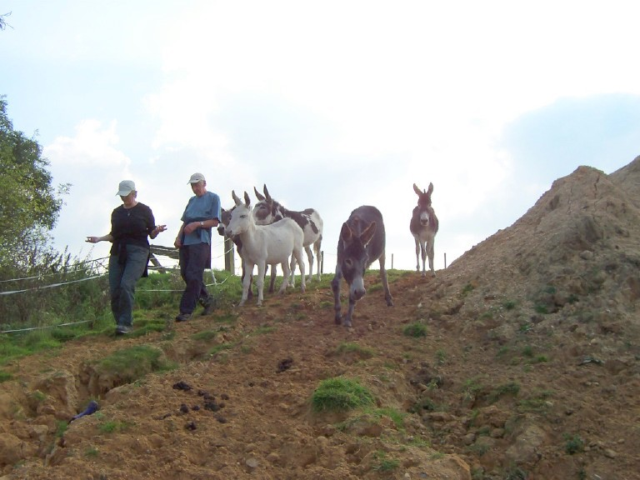
As we headed into autumn, finally a little bit of summer arrived. Just in time for another parish path walk, when in September Margaret took us to Twinstead via loshes. It was a lovely day as we left Plough Green heading for Ryes lane via the fields behind The Fox. Turning right we headed towards Henny church then down to the fields by loshes. Some of the paths around loshes Margaret had chosen were ones I’d not walked before, and although there were vast amounts of varying designs of electricity pylons as far as the eye could see I don’t think they spoilt the beauty of the valley at all. Some may disagree, but I think the paths chosen had shown the landscape at its best. As well as the usual sights of this charming part of our countryside we spied a field of alpacas not too far from our path. The homeward stretch of our walk took us through Fenn farm and Dove House farm, where against all obstacles Margaret forged ahead using the official footpaths. After having to leap over locked gates, dodge donkeys, provide safe passage past pigs and a take a hasty trot through a field of horses we made it onto the exiting bridge before winding our way back through the old rectory, then back onto the fields behind The Fox to get back to Plough Green.

In October we went to Borley Green and back. Margaret had done this walk before but I missed it first time around so it was nice to see what I’d missed. Leaving the village hall we headed down to Smeetham Hall Lane towards Finch Hill. Then turning left we headed down towards Bardfield bridge and took the field path up towards Borley. We passed through the village and then through the grounds of Eyston Hall. Some parts through here were a little wet underfoot but conditions improved as we went down to Forty Acres and round by Belchamp Walter church. From the church we then headed back up and used the paths through the fields behind the houses of Bulmer Street to return to the village hall.
~~~~~~~~~~~~~~~~~~~~~~~~~~~~~
10 Which flower, brought by monks to England so that it naturalised near monasteries, became a church flower replacing the image of the Virgin Mary at Candlemas? A: Hellebore B: Crocus C: Snowdrop
~~~~~~~~~~~~~~~~~~~~~~~~~~~~~
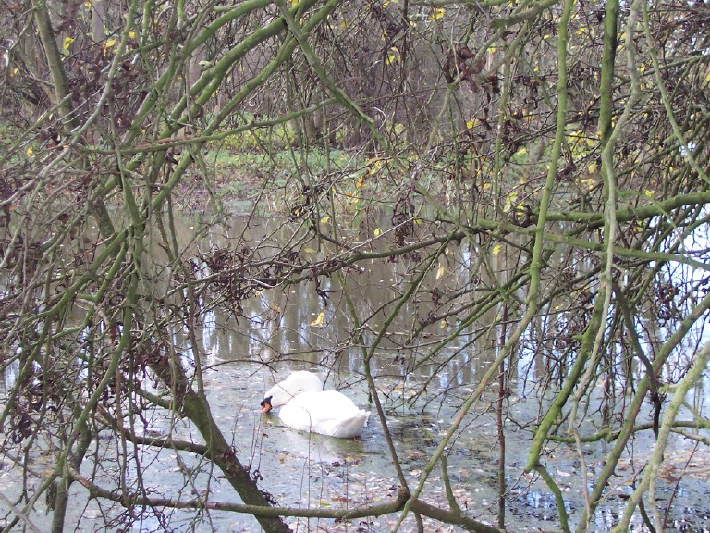
Our final walk of the Autumn, which now felt more like Winter, was from Foxearth village hall. Although absolutely freezing cold it was a beautifully bright day as Margaret took us on a lovely walk around Foxearth, Pentlow and Liston. There were little stretches of road walking but mainly we used field paths and tracks. Most were quite waterlogged and some were still a little flooded but you could see where the water had receded to thankfully become passable. Our paths from Foxearth took us to Pentlow where we passed the Nethergate Brewery, then on to Liston where we passed fairly close to the Bush Booke Allen factory. Grateful that no smells were escaping from there, as many years on the noxious smell from their onion brewing plant is one that still stays with me. The wildlife also seemed to think it was a lovely day to be out as we saw some grazing deer, thanks to Pete’s binoculars, a fairly confident sighting of a cormorant and a beautiful swan feeding in the flooded waterways behind Cannon Avent. Delighted by such a marvellous walk, I still think we were relieved to get back to our cars in the hope of some warmth, but also in the hope that we will return to the footpaths of Foxearth, Pentlow and Liston again some day.
As always, we must thank Margaret for organising and leading another wonderful seasons walks. For more information and dates of future walks check the local What’s On or the Bulmer website www.bulmeressex.co.uk
Lisa Sandford
~~~~~~~~~~~~~~~~~~~~~~~~~~~~~
11 The poinsettia, that favourite Christmas plant is a native of: A: Persia B: New Zealand C: Mexico

~~~~~~~~~~~~~~~~~~~~~~~~~~~~~
FUTURE PARISH WALKS
One suggested resolution for the New Year - walk more! Here are three walks to help get you started using the lanes, tracks and field paths in our beautiful local area. Most are suitable for adult accompanied children; dogs on fixed leads are also welcome.
Boxing Day 26th December at 10:30am
“A Holly Hike”
Distance 4 miles.A walk led by Lisa & Martin. Meet at Village Hall
Sunday 25th January at 2pm
“Over the hill to Gestingthorpe”
Distance 5½ miles. Meet at Village Hall.
Saturday 21st February at 2.30pm
“Wickham St. Paul and Twinstead”
Distance 5 miles. Meet at Butlers Hall
Sunday 22nd March at 2.30pm
“Walk West of Melford”
Distance 5 miles. Meet in Car Park at lower end of Melford Green (next to the Old School).
Further details on all walks from Margaret Mills 269377.
~~~~~~~~~~~~~~~~~~~~~~~~~~~~~

COE’S MEADOW
Some of you will have noticed the planting behind the Vicars Orchard bungalows in ‘Lime Avenue’. Shrubs/Trees that have been planted are ornamental pear (pyrus chanticleer) on the west side and on the east side spindle, wayfarer trees, dogwood, guelder rose and field maple. This is to brighten up this part of the Avenue without being a too formal area. The saplings were all part of a donation made by Essex County Council as part of their initiative to plant 250,000 trees/shrubs.
~~~~~~~~~~~~~~~~~~~~~~~~~~~~~~~~~~~~~
CHRISTMAS QUIZ ANSWERS
1.B. In 1840 the German Prince Albert cut a small fir tree on the Windsor Castle estate and brought it inside to amuse his young wife, Queen Victoria. This was decorated with candles, sweets, small presents and paper chains. An angel stood on the uppermost branch — the Christmas tree had arrived.
2.C. It is unlucky to bring holly indoors before Christmas Eve and it must be put out on Twelfth Night — to break this rule is to court disaster.
3.A. You also have to be careful to bring in the holly before the ivy on Christmas Eve if you are a male chauvinist — in that way you can ensure that the man will rule the household. To bring in ivy first would result in a woman-dominated house.
4.C. The origin of the kissing custom is unknown, but we do know that it was once a much more serious affair — to kiss a girl under the mistletoe in public meant a proposal of marriage
5. A or C. Mistletoe has been used in herbal medicines since the Dark Ages. It was popular with the early herbalists — "Good for the grief of sinew, itch, sores, toothache and the biting of mad dogs or venomous snakes," says Culpeper.
6. A. Sage tea has long been regarded as an excellent stimulant, with digestive properties — but in some countries of the world it was regarded as a brain stimulant, hence the common name.
7. C. There is a hawthorn in Somerset which is world famous — it is the Holy Thorn of Glastonbury. It occasionally blooms on old Christmas Day (5th January) and in earlier times this was regarded as a miracle by simple people who were used to seeing hawthorn trees burst into season in May.
8. A. Rosemary was popular for decorating churches at Christmas before holly became such a universal favourite, and it has long been associated with remembrance.
9. B. Our most famous Christmas tree is erected each year in Trafalgar Square — a gift from Oslo in gratitude for Britain's help in World War II.
10. C. Early monks travelling back and forth to Rome brought the flower to England and it has become naturalised in the vicinity of old monasteries. It became a church flower and on Candelmas (2nd February) the image of the Virgin Mary was taken down and snowdrops spread in its place.
11.C. The symbol of Christmas indoors now is the Poinsettia a native of Mexico with its large scarlet flower-heads. All Poinsettias are varieties of Euphorbia pulcherrima. Red is the favourite colour — types include "Barbara Ecke Supreme", "Mrs Paul Ecke" and "Angelica". Pinks such as "Dortthe" are not very popular but the whites and pale creams ("Regina, "Ecke's White") are widely available. The most unusual Ponsettia is "Marble" — the bracts are deep cream with a rosy-red heart.
~~~~~~~~~~~~~~~~~~~~~~~~~~~~~
CHRISTMAS SUDOKU
Now try this, instead of numbers each 3 x3 squares contain the characters to form the word CHRISTMAS and an X. Same rules apply as a normal numerical Sudoku, each row or column must also only contain the characters CHRISTMAS and an X.
I |  |  | H |  |  | R
 |  | T |  |  | M
 |  |  | C |  | T |  | H | A
S |  | M |  |  |  | T
 |  | C |  |  |  | S
 |  |  |  |  |  |  |  | R
 | I |  | A | R |  |  | C | H
 |  | H
A | R |  |  |  |  |  | S
~~~~~~~~~~~~~~~~~~~~~~~~~~~~~
The next edition will be published at the end of March 2009, could I please have all articles, events etc. by the 15th March. Either by email to mike@mcrome.fsnet.co.uk or snail mail to 6 Vicars Orchard.

Finally, I would like to wish you all a very Happy Christmas and New Year, and to thank all those who contribute to this Newsletter, without them it would not be possible. Mike Crome

