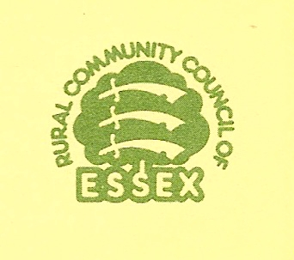
WHAT IS A VILLAGE DESIGN STATEMENT?

A Village Design Statement (VDS) gives a detailed description of the existing character and main features of design in the village and guidelines for how this should be respected in any new development. It identifies the physical qualities and characteristics of the village and its surroundings that are valued by local people and the aspects they would like to conserve and protect. It is an advisory document for planners, designers, developers and local people. There is wide involvement in its production so that the finished VDS represents the views of the village as a whole. If it meets the requirements of the local authority, it can be suitable for use as a material consideration in the determination of planning applications (see page 4).

The distinctive local character is identified at three levels
- the village in its countryside or landscape setting,
- the form of the settlement as a whole,
- the characteristics of the buildings and spaces within the village.

The historical aspects and growth of the village over the centuries should be understood in terms of the influence that the past has had on its present character but the village’s history should not be allowed to dominate the VDS.

The VDS should be considered within the context of the Local Development Framework to see which issues and recommendations are appropriate to planning policy. Discussions are likely to arise about issues which are not capable of inclusion in the VDS, for example, leisure facilities, village services, traffic volumes, employment, health etc. These are all important issues and relevant to the quality of life of the community but only their impact on the character and future development of the village should be included in the VDS. The “non design” issues can be notified to the Parish Council which might have to refer some of them to another body such as the highways authority, environmental health or social services. The Parish Council may already be aware of these issues but the concerns raised will indicate the strength of feeling in the community. Some villages have tackled social and economic issues affecting village life in a Parish Plan resulting from a Village Appraisal or Participatory Survey. Information about Parish Plans is available from your RCCE fieldworker.

It may be helpful to focus on the following:

The VDS is a planning tool to manage change. It expands on existing local plan policies – it cannot create new local plan policy;

- It should describe the visual character of the village
- It is not an appraisal of social or economic issues.
- It is not a history project.

(Note: This document has been re-produced by the permission of the Rural Community Council of Essex)

VDS 3

