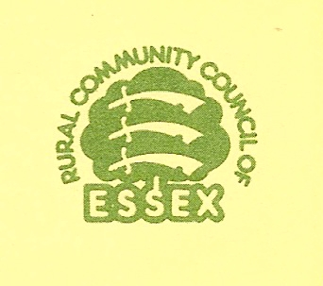
A VILLAGE DESIGN STATEMENT WITHIN

THE PLANNING PROCESS

A Village Design Statement (VDS) can influence the way the planning system operates locally through its approval as a material consideration in the determination of planning applications. Approval by the local planning authority will only be possible if the VDS is compatible with the statutory planning system and the local planning context.
The planning process and relevant policy documents are summarised below. Your local authority planning officer can provide information on local development framework policies specific to your district/borough. An officer may also be able to attend meetings and provide some planning expertise at key stages of the VDS process to ensure it will work effectively within the planning system. The planning officer is there to advise you but should not be asked, or indeed allowed, to write the VDS on your behalf.

NATIONAL

STATUTE
Planning and Compulsory Purchase Act 2004

NATIONAL

GOVERNMENT POLICY
Planning Policy Statements
REGION

REGIONAL PLANNING
East of England Plan (Regional Spatial Strategy)
COUNTY

COUNTY PLANNING
Minerals and Waste Development Framework for
Essex, Southend and Thurrock

DISTRICT / BOROUGH

LOCAL PLANNING
Local Development Framework

PARISH

TOWN AND VILLAGE PLANS
Village Design Statements

(Note: This document has been re-produced by the permission of the Rural Community Council of Essex)

