What’s On?

The Newsletter of Bulmer – March 2009
(Including Bulmer St., Bulmer Tye, Finch Hill, Batt Hall, Upper & Lower Houses, Church Road and Hedingham Road).

Have you had your say yet?
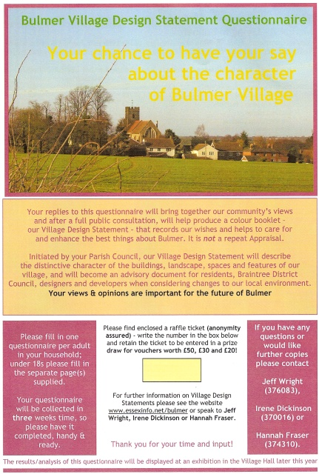
During February questionnaires were issued to all residents to indicate how they would like to see Bulmer developed in the future. If you did not receive a copy or have mis-placed it and would like one, please call Mike on 378155.
The questionnaires have now been collected and are being collated to provide input to the final Village Design Statement (VDS), which when adopted by Braintree District Council (BDC) will form part of their consultation process on any future planning applications submitted to BDC from Bulmer. A copy of the final document will be issued to every household so that residents & their architects can also consult the guidelines contained within the VDS before submitting their plans. Your views and opinions are therefore extremely important to this document. If you have completed your questionnaire and it has not been collected, then please contact Mike on 378155 to arrange collection or deliver it to 6 Vicars Orchard. So far, just fewer than 50% have been returned, yours could make it 50% or more. Don’t forget there is the opportunity for you to win £50, £30 or £20 worth of vouchers of your choice, but only if your questionnaire is completed and returned in time for the draw on 8th May at the Parish Council AGM. The result will be published in the June ‘Whats On’, on Notice boards and the PC website www.essexinfo.net/bulmer, so watch out for the winning numbers, your name will not be known to the VDS Group, and you must claim your prize by producing the green raffle ticket that was attached to your questionnaire.

Before the document is finally drafted, an exhibition will be held in the Village Hall later this year (date to be published) for further views/opinions to be obtained on photographs taken at last years photographic workshop and matters raised in the questionnaires. You can find more about a VDS on the above website and www.braintree.gov.uk/Braintree/planning/Planning+Policy/VillageDesignStatements.htm

BULMER CHURCH PROJECT UPDATE
A very warm thank you to all those who attended Bulmer Church on 24th January to view and comment on the plans for an extension to St Andrew’s; I know that my colleagues and I were very encouraged by the constructive comments that people made.

As a project group we have now had a chance to review those comments. Where suggestions were made or concerns expressed regarding matters that are to some degree within our control then we have used them to inform our future thinking on this exciting and very necessary project. As a result we undertook what one might term a “reality check” even re-visiting the possibility of utilising existing internal space to achieve our aims. In the end that process of re-evaluation concluded with the group agreeing that to compromise on the original vision would be both a pointless and a more costly exercise.
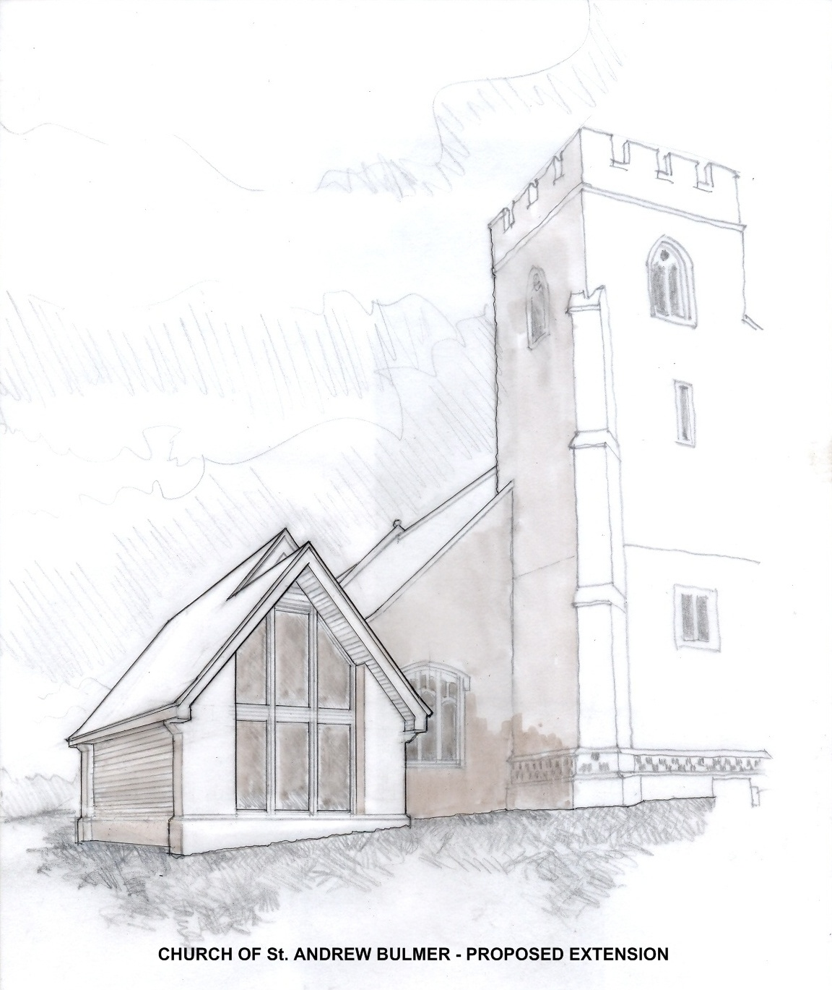

One of the main concerns expressed related to the size of the extension and the visual impact it might have. In the light of those concerns Jeff Wright has done an excellent job of re-evaluating the overall footprint of the extension. The result is that the group have decided to reduce the external measurement out from the existing church to 6.5metres; you will remember that the original plan showed an outreach of some 9.0metres. This reduces the overall footprint to 69square metres (the original was 97 square metres). This new design would also lower the height of the extension’s roofline and would reduce the height of the wall under the eaves.
Obviously we want to keep you informed as things progress but for now I think that is the key update I have for you. Once again my thanks for all your input and support.
God bless
Fr Eoin
~~~~~~~~~~~~~~~~~~~~~~~~~~~
Pigeonholed. The field behind Bulmer Street is growing rape this year. In late October it was lush with the speedily growing crop. Then came the wood pigeons --- hundreds of them. By the middle of January huge swathes of the field had been reduced to nothing much more than stalks. At times there must have been upwards of five hundred pigeons feeding on the rapidly disappearing crop, despite the gas operated bird scarers. As one wit commented “It's good of the farmers to advertise their crops, the birds only have to hear bird scarers going off and they head straight for the field!”. Although some of these marauders may have been “Bulmer residents”, the vast majority of them would have been migrants from further north, be it Britain or Europe. There is no doubt about it, this plentiful supply of winter feed will ensure that they go into the breeding season in good fettle, which will result in still more of these airborne raiders returning next winter. There is a theory that, up north, due to the wet autumn not as much rape was sown as usual, so that more pigeons have been forced to come further south.
Winter flowers. We've certainly had a long drawn out winter this year and it was mid January before there were any noticeable signs of spring. A few snowdrops here and there with just the odd hazel catkin out. Whereas, most years you can find the odd nut stub sporting a full show of dancing, fluffy, “lambs tails” at the turn of the New Year. Another early starter is the celandine, the odd flower can often be found in mid January, but this year it was 26th February before one ventured out, close beside the Upper Houses lane. At Upper Houses, I always look for one little patch of double snowdrops. My mother first showed me them, when I was a youngster. They can be seen growing beside the driveway of “Leycroft”. My grandmother planted them there, when she was a schoolgirl, in the 1870s. Her family lived in an old thatched cottage, which then occupied the site. Each spring, quite unfailingly, this little self-renewing patch of history pops up to rekindle some fond memories of my dear old granny.

Freezing feathers. On January 9th, we awoke to see all the trees covered in hoar frost. Had we been blessed with sunshine that freezing morn, the trees would have made a magical, glistening wonderland. But we were condemned to damp, dull, dreary fog, and an all-encompassing gloom. In the garden, around 8am, some seven or eight blackbirds were feeding. One of these displayed a very strange, mottled plumage. Part albino? -- Not a bit, this poor bird was covered, like the trees, with hoar frost, it's tail in particular. A closer look at it's companions, revealed two more birds with a light dusting of frost. I suppose that they had roosted where they were exposed to the damp, freezing atmosphere. Over half an hour later, their feathers still glistened with frost. This caused me to ponder on the efficiency of feathers as thermal insulation. One might have expected the tail feathers to have remained frozen, but those patches on their backs? Surely the birds’ body warmth would work through and melt these ice crystals. But no, they remained frozen, a good example of natural thermal technology.
Bulmer's Treescape. Time to look forward now, to the days not far around the corner, when our hedgerow trees will, one by one, erupt into a dozen subtle shades of green. However, winter is the time to fully appreciate the essential character and structure of our trees. The graceful symmetry of the birch, with it’s delicate tracery of slender branches and gleaming white trunk. The ash is less showy than the birch, it's thicker twigs bear stubby black buds, and the trunk is a uniform grey, but still a very handsome tree. The upward thrusting horse chestnut, whose upper branches sometimes send down a cascade of thinner branches, to touch ground and even take root. Lost now, are the proud elms, tall and billowing, often with a forest of epicormic growth masking the lower part of the trunk. Until the onslaught of Dutch elm disease a few decades ago, they were the defining feature of much of our Bulmer landscape, adding their special character, to so many of our hedgerows. Another tree, never very common, is the black poplar. Invariably growing close to water and usually leaning, these can be truly massive trees, always sporting large burrs, bark covered woody excrescences, which grow out from the deeply furrowed trunk. Of course the grandest of our trees is the mature oak. With it's reassuringly massive trunk and sturdy upper limbs spreading out to support a mini forest of twiggy, criss crossed branches. Silhouetted against a winter sky, these veterans often display scars from some ancient battle with the elements. The old oak on Church Meadow lost huge limbs in the 1947 tornado, (when we kids in the old Bulmer school, were huddled under our desks for safety, together with our infant teacher, Miss Hunter!) I think you can still see the evidence on the tree. The Church Meadow oak is probably around 200 years old, but is a mere teenager compared with at least one other in
the village.
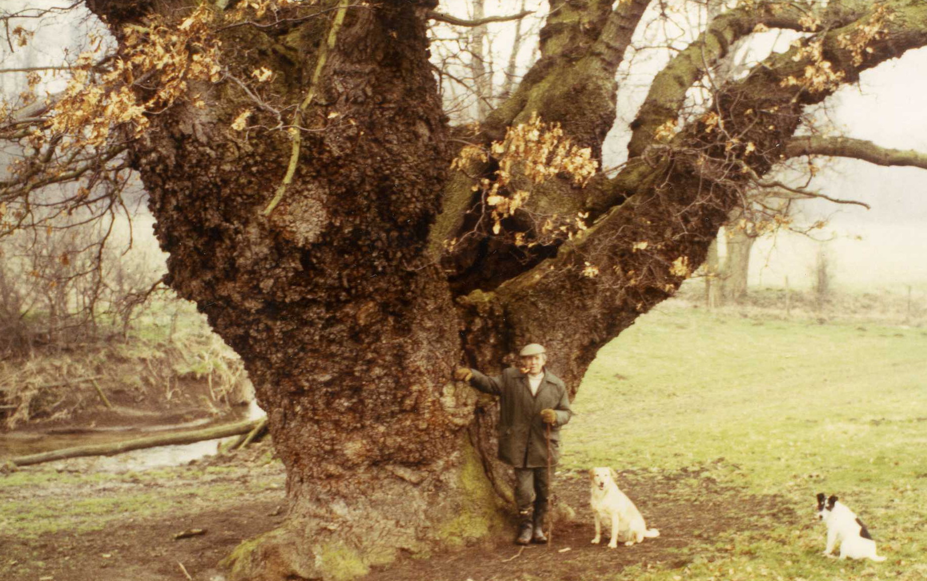
What is almost certainly the largest and oldest tree in Bulmer is a pollarded oak. At least 500 yrs old. It stands close to the Belchamp Brook in one of the Smeetham Hall fields. The photograph above shows Anthony Hyde Parker’s father, the late Bunny Hyde Parker, standing in front of this monster tree, in the mid 1970s. Since the photograph, it has lost the two
large branches on the right.
(Photo kindly supplied by Anthony Hyde Parker)
Dotted around our ancient hedgerows, are more pollards, all relics of the farming practices of yester-year. (Since the demise of all the mature elms, these are invariably oaks).

A pollard is a tree that has been cut off about 8 -10ft. from its base, above the height that cattle or other animals could reach to feed on the new shoots. A new crop of branches grows from this point to be harvested for firewood, or useful rough timber, every 15 -20 years. This very much extends the natural life of the tree, provided that the pollarding is carried out at
reasonably regular intervals.

The problem now, however, is that there has been no economic reason to continue pollarding these trees for donkey's years, and most of our Bulmer pollards are top heavy, with huge branches. The weight of these branches is often too much for the trunk to carry, especially if it is hollow. Sooner or later, either the big branches will shear off, or worse, the trunk itself will split open, leading to the demise of the tree.
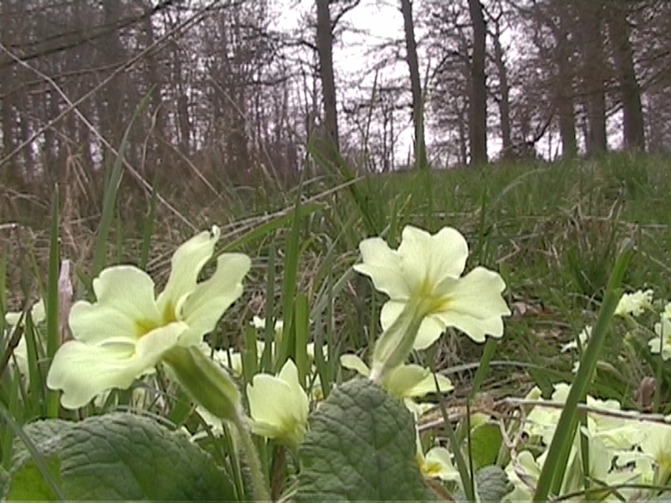
Off with her head! There is a remarkable group of pollard oaks in Bradgate Park Leicestershire. A ruined mansion in the park was once the home of Lady Jane Grey. When she was beheaded in 1554, all the oak trees in the park had their heads taken off, either in protest, or out of respect. Either way, many of these ancient trees are still standing, most of them hollow. With some of these, you can walk right inside the trunk. The remarkable thing about one or two of these, is that bark actually grows on the inside of the hollow trunk having grown round the broken edge.
Hopefully we can now look forward to some warmer weather and the joy of discovering a few more Spring flowers, like these primroses.
Peter Rowe

~~~~~~~~~~~~~~~~~~~~~~~~~~~~~

VILLAGE LOTTERY WINNERS
The Lottery still provides 3 lucky winners each month. Are you a member? The more members the more funds for the Village Hall and the bigger the prize! Please contact Dawn at the Post Office (376676) if you would like to join.

~~~~~~~~~~~~~~~~~~~~~~~~~~~~~VILLAGE HALL NEWS
Month | First | Second | Third
Dec. | Mr J Battersby | Mrs M Skipper | Mr & Mrs R Tomlinson
Jan. | Mr & Mrs Cobb | Mr & Mrs Burbidge | Mrs V Crome
Feb. | Mrs P Daniels | Mr & Mrs P Rowe | Mrs J Steed
A.G.M
The A.G.M. of the Village Hall Committee will take place on Friday 22nd May at 8pm. Please come along to show your support or simply to moan at us for our running of the Hall! If you feel you can spare a few precious hours to sit on the Committee then please let us know, we are very keen to welcome new members as a few of us are getting a bit frayed around the edges!
OTHER NEWS
We hope you all like the work that has been carried out on the Hall floor. We all feel that it has brightened up the room and hope that it will extend its life. We have been assured that, despite its age, it is still in very good condition, which is all thanks to everyone who has looked after it in the past.
Following our recent Committee meeting, it was decided that despite there being no rent rises for several years, we will not consider any changes to hiring costs during this economic downturn. However, this does mean that we will still have to raise revenues to meet rising running costs by other means. The Parish Council are very generous with a most welcome grant and the lottery does help but we must still fund raise. With this in mind, we will be organising various events throughout the year and will greatly value your support at them.
Events planned so far are:
Barn Dance –Ron Coxall | Friday 3rd April | £5.00 including Ploughmans Supper
Table Top Sale | Sat. 18th July | £5.00 per hire of table
Family Beetle Drive | Date to be arranged

For further information please ring 374758 or
Check out www.bulmeressex.co.uk
~~~~~~~~~~~~~~~~~~~~~~~~~~~~~

St. ANDREWS SCHOOL


Do you have a few hours to spare this summer?

Would you be willing to help out your local school?

This summer we're holding our Summer Fair on Friday 26th June 3.30pm-6.30pm.
It promises to be a fun event for families, which will also, raise funds for the school. We are currently saving for a new bank of laptops to make IT more mobile. We're looking for volunteers that could help us run stalls and generally help out. If you think you could come along and join in the fun and help us, then please contact Mr Nigel Hill, our Office Manager, on 01787 372383.
We look forward to hearing from you soon
~~~~~~~~~~~~~~~~~~~~~~~~~~~~~
BULMER HISTORY GROUP - MARCH 2009
After the spectacular audience for the History Groups October meeting I truly didn’t believe the village hall could hold any more people but come March the numbers were so high I thought we were going to have borrow pews from the church to seat everybody. We continued the theme of having three short talks by three local speakers, which included a well-respected retired policeman. It soon became clear why people left their homes in droves arriving at the village hall well before the advertised starting time to secure a seat.

~~~~~~~~~~~~~~~~~~~~~~~~~~~~~

PARISH COUNCIL NEWS
As you will see from the latest minutes below, two of your Councillors have resigned from the Parish Council. As a result, Chris Leigh (Chairperson of Coe’s Meadow Management Committee) has decided to re-join the Council. This still leaves one vacancy to fill. If you feel you would like to stand, but would like more information before deciding, then please speak to any of the councillors below or contact the Clerk. Your village needs you!

YOUR PARISH COUNCILLORS
Margaret Mills (Chairman) | - 01787 269377
Mike Crome (Vice Chairman) | - 01787 378155
Peter Rowe | - 01787 375935
Peter Fultcher | - 01787 269935
Stephen Morgan | - 07973 341048
Chris. Leigh | - 01787 378133

Barbara Rawlins (Parish Clerk) - 01787 370845
~~~~~~~~~~~~~~~~~~~~~~~~~~~~~

DATES OF FUTURE PARISH MEETINGS
All meetings are bi-monthly, normally held on the second Friday of the month in the Village Hall at 7:45pm
- 8th May 2009 (AGM)
- 10th July
- 11th September
- 13th November
- 8th January 2010
~~~~~~~~~~~~~~~~~~~~~~~~~~~~~
GARDEN WASTE
The green waste collection is back. Collection points are Park Lane (9:25 – 9:45) and Vicars Orchard (10:00 – 10:30) on the following Saturday mornings.

28th March | 2nd May
13th June | 11th July
8th August | 12th September
10th October | 7th November

REFUSE & RECYCLING COLLECTION SERVICE
Please note with effect from October 2009, Braintree District Council will be dispensing with the ‘black sack’ collection and introducing wheelie bins. Each household will be receiving leaflets explaining how the system will work with a ‘grey bin’ for non-recycling/compostable materials, ‘green bin’ (optional) for garden waste & compostable matter and the ‘clear sacks’ for recyclables.
More details can be found at:-
http://www.braintree.gov.uk/Braintree/environment/recycling/Extension+of+Alternate+Weekly+Refuse+and+Recycling+Collections+(Wheeled+Bin+Roll+Out+2009).htm
~~~~~~~~~~~~~~~~~~~~~~~~~~~~~

MINUTES OF THE BULMER PARISH COUNCIL HELD ON 16th JANUARY 2009

PRESENT: Councillors Margaret Mills (Chairman), Mike Crome, Peter Fulcher, Stephen Morgan, Peter Rowe and the Clerk. One member of the public.

Councillor Ron Mansfield came, before the meeting started, to hand in his resignation. He was, therefore, not eligible to take part in the meeting and left.
The Council was extremely sorry to hear of Ron's decision. Ron has been a true servant to Bulmer for over 20 years, nine of which were as Chairman. During his chairmanship several large issues were either ongoing or raised, not least of which was the securing of Church Pasture (Coe's Meadow) for a recreation ground and the leasing of Bakers Field to the primary and nursery schools, all requiring public meetings.
Councillor Stephen Coombes also handed in his resignation. Although Stephen had only been a Councillor for a short time, his input and comments were valued and will be missed.
Notices for two casual vacancies will be advertised on noticeboards, post office and web site, as required by the Electoral Registration Officer. Applicants should contact the Clerk, in writing.
APOLOGIES FOR ABSENCE: None
DECL. OF INTERESTS: Cllr. Rowe declared that he was related to the planning applicant at Back House Croft.
PUBLIC QUESTIONS: As Mrs. Fulcher was unable to attend the meeting Cllr. Peter Fulcher gave an update on the highway problems on the B1058 Hedingham Road. The 'beware slippery surface' temporary A-board signs have now been replaced by permanent signs. The road surface will be dealt with later in the year.
APPROVE THE MINUTES of the meeting held on 31st October 2008. Proposed Cllr. Crome, seconded Cllr: Morgan.
MATTERS ARISING: None
As Cllr. Morgan needed to leave the meeting early, due to a prior engagement, the Agenda was changed to take in any matters requiring decisions. The Minutes, however, will follow the Agenda.
COE's MEADOW:
The car park entrance repairs and extension have been completed, as also the tree/shrub planting behind the bungalows. RoSPA wanted to see more safety/warning signs in evidence and 'playground ahead' signs in The Street - all are in hand. Benches are to be replaced into the field ready for the Spring.
The Christmas Event had been called off due to lack of interest, but a Coe's Meadow Fun Day is planned for 6th September 2009 (n.b. since this meeting it has been changed to the 21st June 2009)
PLANNING:
Bacchus, Smeetham Hall Lane - TPO, crown and reduce 1 sycamore. The Parish Council was unable to comment on this application due to late return of the comment form.
4 Bulmer Tye - erection of single storey detached garden store/workshop. Not supported by BPC
Splinters, Back House Croft, The Street - retrospective consent for change of use of building for preparation and storage of food in assoc. with catering business. No objections from BPC
Back House Croft (Land rear of) - erection of detached dwelling. Proposed building still too large for the site and in a Special Landscape Area it will not enhance the Conservation Area. The boundary of the new property will pass through the existing garage/annex, which totally goes against conditions laid down when the garage/annex was built.
There is also concern that if the building is approved it could be seen as setting a precedence for infill behind existing properties within the village envelope and conservation area.
The Parish Council does not support this application.
BUS SHELTER: The Clerk has applied to Essex CC for a grant to cover the new bus shelter to be erected at the top of Church Road.
CONSERVATION AREA REVIEW: The Parish Council was appalled at the number of errors in the Conservation Area Review for 2009, which is being carried out by consultants for Braintree DC. The Clerk was asked to write pointing out the mistakes. Several of the Councillors wrote under their own names and residents who will be involved in the changes were asked by Braintree to send their comments. The Parish Council told Braintree that in their opinion the consultation was a waste of taxpayer's money when all they had to do was consult with some of the older residents of Bulmer or contact the Bulmer History Group.
CORRESPONDENCE & NOTICES:
1. After further consultation over the weight limit restriction at Bardfield Bridge, no agreement could be reached for changing the present situation. It will, therefore, be left as it is for the time being.
2. A resident has suggested that a 3 to 4m, border of uncut grass be left along the inside of the hedge on Church Meadow and around the central oak to create a wild life area. The Parish Council thought this was a good idea and will advise the grass-cutting contractor accordingly.
3. The sites for the 'playground ahead' signs have been agreed. Cllr. Crome said he would speak to Mrs. Macaree as one of the signs will be outside Clement Cottage incorporated onto 30mph repeater sign.
4. We have still not heard if the phone kiosk in The Street is safe from disconnection by BT.
PRECEPT:
It was proposed by Cllr. Crome, seconded by Cllr. Fulcher and carried unanimously to adopt a precept of £4500 for 2009/10 (no change for the fifth year). The following allowances were agreed
- grant to BPCC - £650
- grant to Bulmer Village Hall - £1000
- grant to Coe's Meadow - £1000 held in reserve for any expenses occurring.
- grant to Friendship Club - £70 for when it is set up.
- Clerk salary increase - £50 (Annual salary £1800)
- any overspend to be covered by capital in hand.

RECEIPTS:
Allotment Rents |  | £364.67
Allianz Insce | – refund of premium for damaged bus shelter at the Tye | £4,961.00

PAYMENTS:
Anglia water | - Park Lane  - Coe’s Meadow | £43.46  £18.27
Audit Commission. | - audit fees | £460.00 inc VAT
T. Raymond | - expenses on Almshouse field/pieces | £60.00
G Nichol | - tree work at Coe’s Meadow | £275.00 VAT
King & Co | - materials re tree work | £87.89 inc. VAT
S Harris | - saplings/shrubs for Coe’s Meadow | £67.50 inc VAT
R Mortimer | - grass cutting | £168.05 inc. VAT
Chilton Office Supplies | - newsletter | £82.80 inc VAT
Wiles | - car park work on Coe’s Meadow | £1,673.25 inc VAT
Chris Leigh | - expenses re Coe’s Meadow | £32.82 inc VAT

The Parish Council resolved to - Adopt the Freedom of Information Act New Model Publication Scheme without modification. Information can be obtained from the Parish Clerk in hard copy at 20p per A4 sheet plus pp. or, on the website free of charge.

The Clerk announced that the Annual Accounts for 2007/8 have been signed off by the Audit Commission with no comments. Notices have been posted up accordingly.
Capital Investments - it was proposed by Cllr. Crome, seconded by Cllr Rowe that the Parish's capital should be split into three investment holdings. It was suggested that Nationwide would be suitable and Cllr. Morgan added that HSBC was a good substantial bank, which did not seem to be having the problems of others. The Clerk was asked to set up the third holding. It was agreed to review the investments at each meeting.
The Clerk mentioned that with the resignation of Ron Mansfield the Council was now short on signatories (currently Cllrs. Mills, Crome and Rowe). It was agreed that Cllrs. Fulcher and Morgan should also be authorised to sign Council cheques.
OTHER BUSINESS:
1. Activity Days - the Parish Council was quite willing for the Braintree Leisure Development Team to have the use of the village hall for one day during the summer holidays.
There being no other business, the meeting closed at 10.03pm.
~~~~~~~~~~~~~~~~~~~~~~~~~~~~~
PARISH PATH WALKS - WINTER WANDER LAND
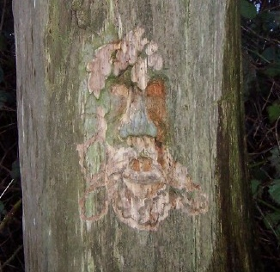
From the Holly Hike in December to Februarys walk around Wickham-St-Pauls and Twinstead we seem to have leapt from winter into spring. After what seems a very lengthy and cold winter the very noticeable warmer temperatures as we head for spring are no doubt a welcome delight. In addition to the increasing hours of daylight and the arrival of the spring flowers with their delicate appearance yet vibrant blooms, I’m hoping that the oncoming parish path walks of spring will persist in gifting us with such charms.

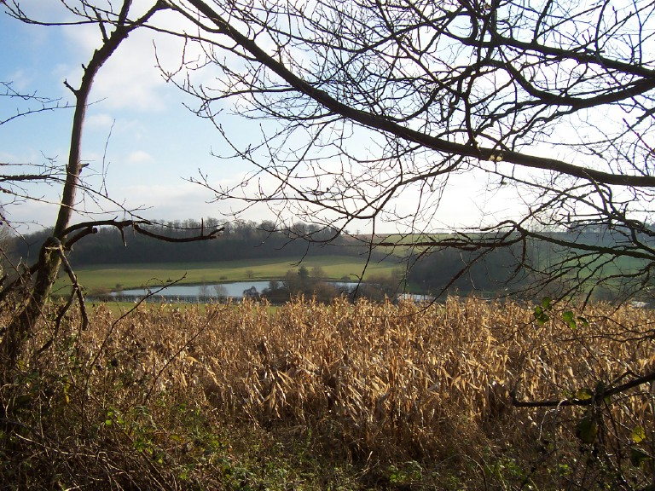
Starting with the chilly climes of Boxing Days “Holly Hike” Martin was left in charge to lead us along
The lake on the Aubries estate in Sandy Lane
some of the paths of Essex and Suffolk. Margaret and Ken deserting us for locations more clement, we departed from the village hall heading for Sandy Lane, Brundon Lane and the paths of the dismantled railway. Leaving behind the high sided banks of Sandy Lane there was no denying the nip in the December air, but the skies were blue and the winter sun shone down which made for a glorious walk. Turning away from the dismantled railway we took the path that emerges at the brow of Finch Hill but not before stopping for a sweet break. Not the ceremonial wine gums but some rather agreeable succulent fruit jellies. Moving on from Finch Hill we crossed over to Smeetham Hall Lane and returned to the village hall via Lime Avenue and the churchyard. Our thanks go to Martin for a lovely little walk in aid of the digestion of the turkey, or nut roast.

By January, after spending Christmas sunning herself by the Grand Union Canal Margaret had returned to lead us over the hill to Gestingthorpe. Precipitating most of the Grand Union Canal over us as we walked however, we did manage to welcome a newcomer to the parish path walkers and after preparing ourselves with sticks, cagoules and sou’westers we marched from the village hall onward bound. We walked through the churchyard then turned left to take the path behind the houses on The Street and St Andrews Rise. Joining the road we headed for Upper Houses taking our next path just past the conservation area beside the first house to trample the fields of Ashley Cooper. Not content with roaming his pastures we then hoofed it down his driveway too. At the foot of the driveway adorning the wall are some rather interesting sculptures.
Something of a historical nature I shouldn’t wonder. Moving on to more fields and areas of woodland we spotted some snowdrops. Although pleased to see a little colour returning to the fields and hedgerows they certainly weren’t looking their best soaked and shivering in the freezing rain. From the fields and woodlands of Gestingthorpe Margaret then lead us back to the Bulmer brick yard and up Wesborough Hill. One of the first trees of the byway exhibiting a rather intriguing carving. Nearing the end of our walk we came back to Upper House and returned to the village hall taking the bridle path of Brakey Hill feeling a little like those poor snowdrops we saw in Gestingthorpe, wet and cold.

In February we walked the paths of Wickham-St-Pauls and Twinstead. There was a good show of people, possibly due to the improving weather conditions but not including last months newcomer. It was a lovely day with the sun emitting a little warmth as we left Butlers Hall heading across the fields to emerge on Rectory Lane. Here we crossed the road to walk along side the green up to Stones Farm where we took the field path opposite the house. This path passed through a little wooded area halfway before bringing us back to the road. We walked a short distance along the road before starting on our next field path situated between Park Farm and Old House. These paths then led us to the main road at Long Gardens where we crossed over into the fields of Twinstead Riding School. No diversions were needed on this occasion either as our route had been cleared of bramble thickets and from here we walked on to Green Lane spotting some deer in a field, but not before they had spotted us I might add. More field paths brought us on to Watery Lane but not before an appearance of some foxes fruits and darks to tantalise our taste buds. This was besides the customary wine gums which had returned with Margaret, and not just a little bag, but a whole great tin. Giving us that extra burst of energy we then completed our walk by crossing back over the main road and back into the fields returning to Butlers Hall. It was now just beginning to feel a little cooler as the wind became more noticeable with the departing of the sun. An all round superb walk combining lovely weather with the paths that allow the scenery surrounding the countryside of Wickham-St-Pauls and Twinstead to be viewed at their finest.

Our thanks once again go to Margaret for taking the time to organise these walks and encouraging more of us to get out in the fresh air. A thank-you to Martin on this occasion also. Go to www.essexinfo.net/bulmer for details of walks in April, May & June.
Lisa Sandford
~~~~~~~~~~~~~~~~~~~~~~~~~~~~~
CALLING ALL GARDENERS:
Noël’s annual plant sale at Bulmer Tye House will take place this year on Saturday 6 June, 10am – 4pm, in aid of Bulmer Church and Brambley Hedge Nursery Trust. The garden and workshop will be open, and there will be refreshments and raffle as usual.

All contributions of perennials, annuals, bedding plants, bulbs, vegetables, aquatics and shrubs will be most welcome. Please ring Noël (01787 269315) to arrange collection during the week before.
~~~~~~~~~~~~~~~~~~~~~~~~~~~~~
PARISH PATHS WALKS
Here is another collection of walks two of which start in Bulmer and two slightly further away. Hopefully there will be less mud than on some recent outings, but strong footwear is still advised. All the walks are suitable for adult accompanied children. Well behaved dogs on fixed leads are also welcome.
Easter Monday 13th April
A return to Ponds and Peggles in Belchamps Walter and Otten.
5 miles - Meet at Belchamp Walter Church at 2.30pm
Bank Holiday Monday 4th May
The Bulmer Bluebells. A shorter walk to see our local lovelies
Only 3 miles - Meet on Plough Green at 10.30am
Spring Bank Holiday Monday 25th May
A walk around Alphamstone and Lamarsh.
6 miles - Meet at Alphamstone Church at 2.30pm
Sunday 28th June
A walk to Middleton and Henny - we may find orchids en route.
5 miles - Meet on Plough Green at 2.30pm
For more information please contact Margaret Mills on 01787 269377
~~~~~~~~~~~~~~~~~~~~~~~~~~~~~

COE’s MEADOW FUNDAY is now SUNDAY 21st JUNE


Every Friday morning in the Village Hall between 9:30 and 11:30.
This session offers a wide selection of toys for children between the ages of 0 -5 years.
There is a contribution of 50p per family for toast & tea/coffee, juice. Come along and take the opportunity to have chat and make new friends.
For further information please contact Louisa on: 01787 223673 or 07500 864 641.
~~~~~~~~~~~~~~~~~~~~~~~~~~~~~
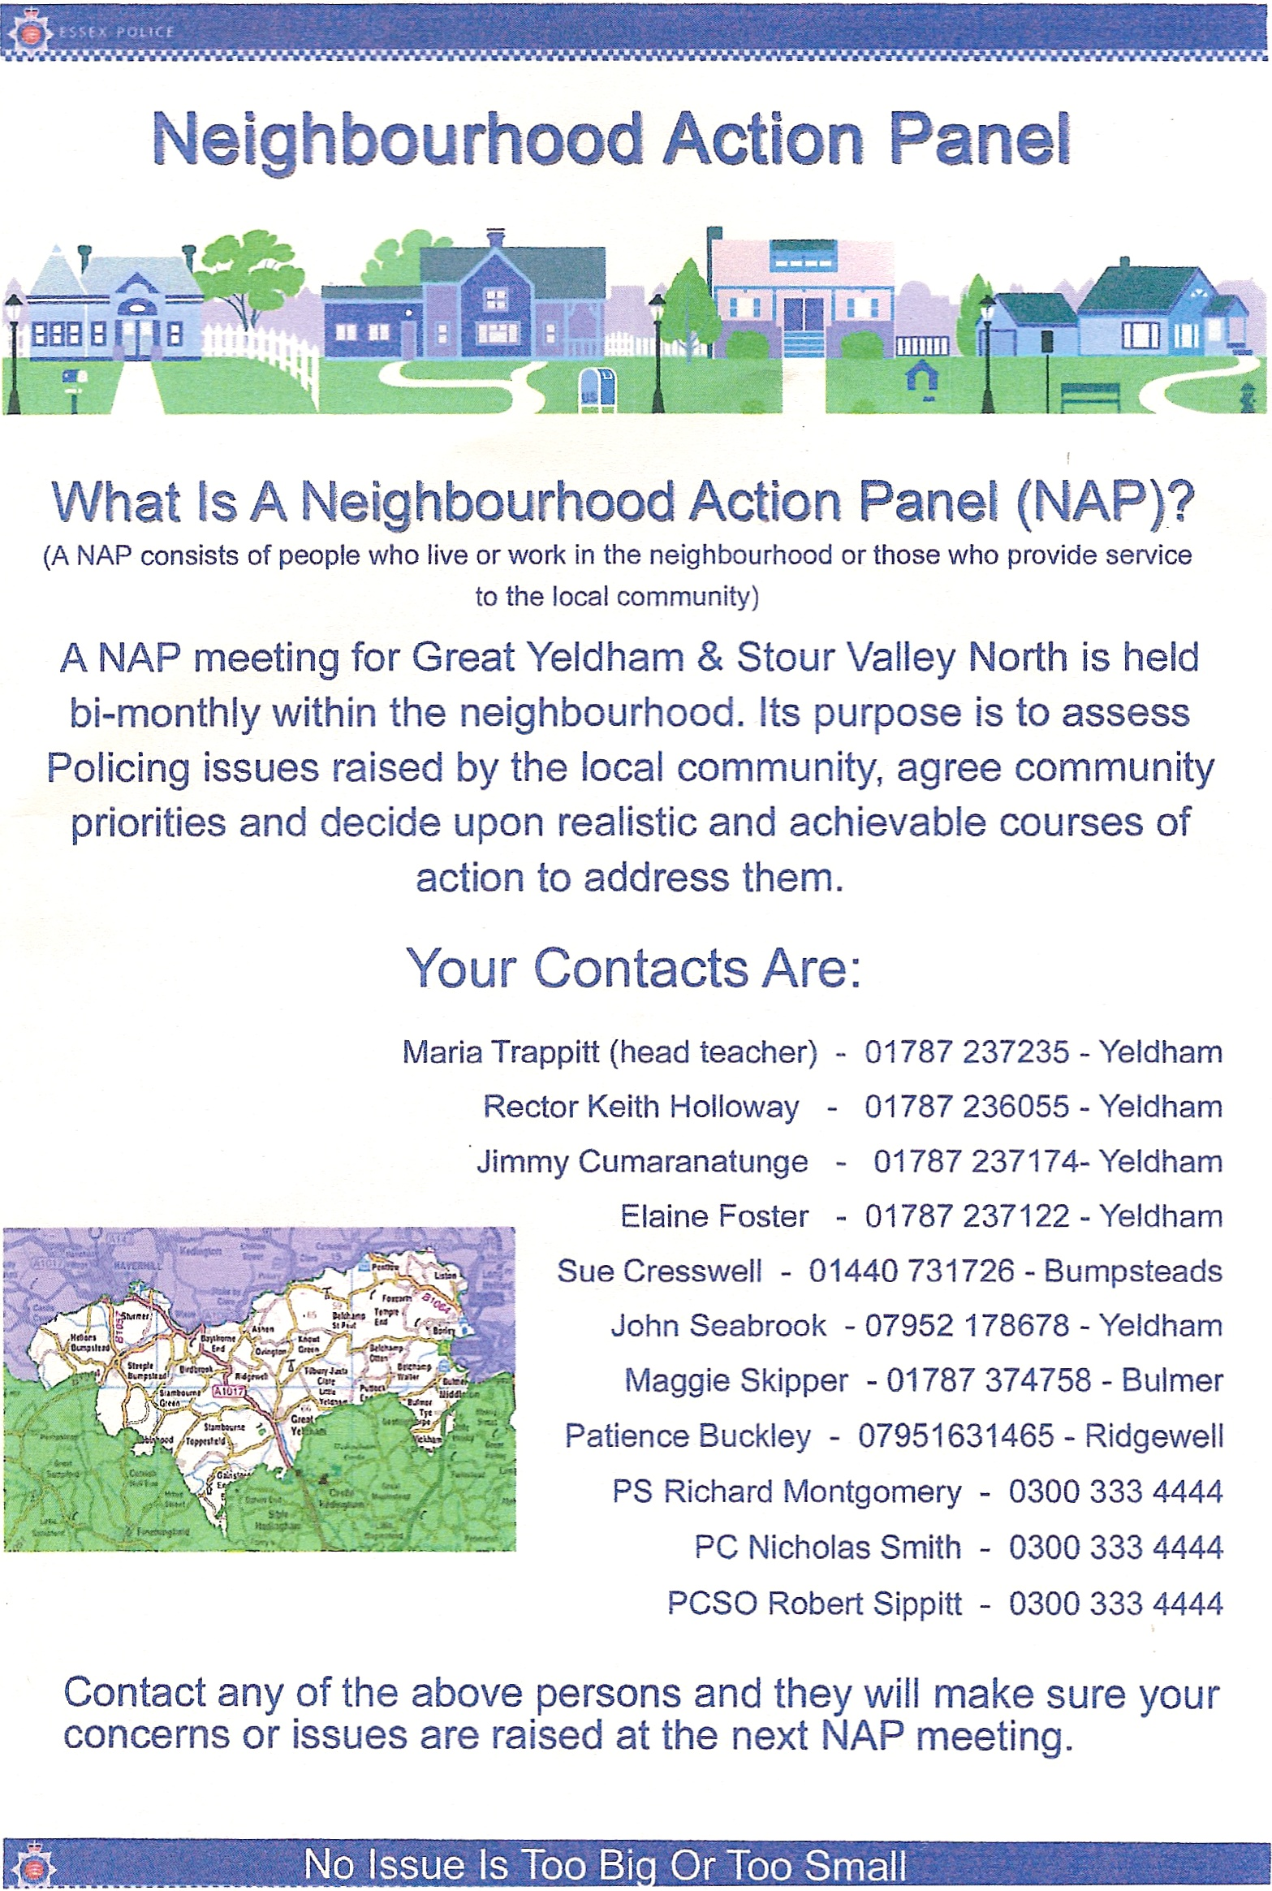
The next edition of ‘Whats On?’ will be published at the end of June 2009, could I please have all articles, events etc. by the 15th May. Either by email to mike@mcrome.fsnet.co.uk or snail mail to 6 Vicars Orchard.

