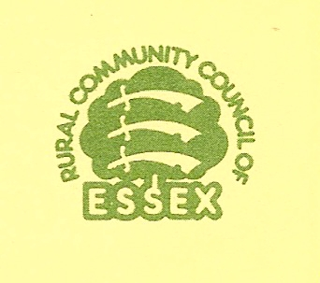
HOW TO CARRY OUT A VILLAGE DESIGN STATEMENT

From the many examples of completed VDS, it is clear that communities have adopted different approaches and methods in producing the final document.
This pack outlines best practice to produce a good quality VDS suitable for approval by the local authorities in Essex. It is recommended that the broad framework of this pack is followed although accepted that some of the stages may need to be adapted to suit local circumstances.

The primary requirements are that the VDS is
- compatible with the planning process
- representative of the views of the whole community

Consultation is a priority and needs to be undertaken from the outset. More consultation will give greater weight to the final document. A high level of response is desirable but it is unrealistic to expect 100% participation. The important factor is that everyone in the community is given the opportunity to contribute to, and get involved in, every stage of the process. It is essential that the information circulated and events organised are recorded in a “VDS Community Diary” as evidence of full consultation. Keep copies of posters, letters, magazine articles, drafts distributed etc, and record dates and details of events, lists and numbers of groups and individuals invited, attending and responding/ making comments.

It is important that publicity is organised throughout the process to maintain public interest. The community must be kept informed of progress to ensure continuing support and enthusiasm.

The VDS process can be summarised in four main stages:

STAGE 1 – Planning Steps 1 to 3

STAGE 2 – Proceeding Steps 4 to 7

STAGE 3 – Approval and Production Steps 8 to 10

STAGE 4 – Partnership Steps 11 & 12

Your length of time taken to complete the process will be determined by the community and will depend to a large extent on other commitments of the volunteers. The average VDS takes about a year to complete but it is important not to rush through it. It is an influential document and each stage deserves careful consideration. It may be useful to think about the timing of the initial workshop and the character assessment stages, bearing in mind that there is a better impression of the built form in the winter months and of landscape setting in the summer months. You may decide to undertake the character assessment over an extended period and thereby increase your timescale.

(Note: This document has been re-produced by the permission of the Rural Community Council of Essex)

VDS 7

