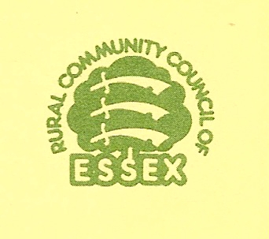
AN EFFECTIVE VILLAGE DESIGN STATEMENT …

is developed, researched, written and edited by local people

is representative of the views of the village as a whole

has involved a wide section of the village community in its production

describes the visual character of the village

demonstrates how local character and distinctiveness can be protected and enhanced in new development

is compatible with the statutory planning system and the local planning context

is suitable for use as a material consideration in the determination of planning applications

is applicable to all forms and scale of development

is about managing change in the village, not preventing it

(Village Design – CCP 501)

(Note: This document has been re-produced by the permission of the Rural Community Council of Essex)

VDS 8

