BRADWELL-ON-SEA
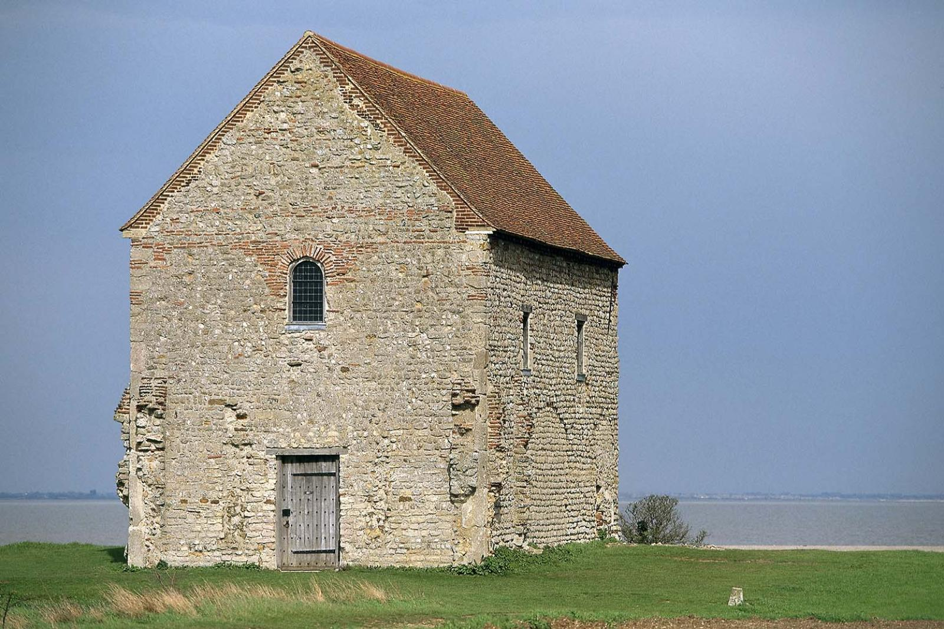

PARISH COUNCIL
Ms Kelly Andrews, Clerk to the Council
Westwood, Grange Road, Tillingham, Southminster, Essex CM0 7UR
Tel: 07483 321780 Email: clerk@bradwellonsea-pc.gov.uk
https://e-voice.org.uk/bradwellonseaparishcouncil

COUNCIL MEETING

Members are summoned to attend the Bradwell-on-Sea Parish Council Meeting
to be held on Monday 17 March 2025 at 7.30pm at Bradwell Village Hall
to transact the business as shown on the agenda.

K Andrews
Clerk to the Council
12 March 2025

Cllr M Neall (Chairperson) Cllr P Davidson Cllr J Noble Cllr M Martin
Cllr J Meehan Cllr H Baker Cllr D Allen

Note to Councillors: If you are unable to attend the meeting, please telephone your apologies to the Clerk on 07903 312394 or email Clerk@bradwellonsea-pc.gov.uk

AGENDA

- WELCOME to the Bradwell-on-Sea Village Council Meeting of 17 March 2025.
A reminder to everyone in attendance and who will be participating in the meeting that they may be filmed, recorded, photographed, or otherwise reported about.

- APOLOGIES FOR ABSENCE

- MEMBERS DECLARATION OF INTERESTS
Members are invited to declare Disclosable Pecuniary Interests, Other Pecuniary Interests and Non-Pecuniary Interests relating to items on this agenda.

- DISPENSATIONS
To consider member’s applications for dispensations.

- MINUTES OF THE LAST MEETING
To approve as a correct record, the minutes of the meetings held on 17th February 2025.

- PUBLIC FORUM
Any members of the public or Councillors wishing to address the Council may do so during this time.

- FINANCE
- To receive the bank reconciliations as at 31st January and 28th February 2025
- To receive the comparison of Actual to Budgeted for 2024/2025
- To approve the payment of Accounts for March 2025 and to agree a transfer of funds to meet the Parish Council financial requirements.

- ANNUAL GOVERNANCE AND ACCOUNTABILITY RETURN 2023/2024
The External Auditor Report and Certificate 2023/2024 has been completed. The Notice of Closure of Audit has been issued.
To resolve to discuss the external audit report and any matters raised

- MARY BROWN TRUST INVESTMENT STRATEGY
To resolve to review the Investment Strategy in accordance with the Statutory Guidance on Local Government Investments (3rd Edition) issued under section 15(1)(a) of the Local Government Act 2003 and effective for financial years commencing on or after 1 April 2018.

- REVIEW OF THE BRADWELL ON SEA PARISH COUNCIL STANDING ORDERS
The NALC model standing orders 2018 had been revised in 2020. The Clerk has reviewed the standing orders and confirms that these remain up to date.
To resolve to adopt Bradwell on Sea Parish Council Standing Orders for the financial year 2024/2025.

- TO REVIEW THE ADEQUACY AND EFFECTIVENESS OF THE SYSTEM OF:
- INTERNAL CONTROL
- INTERNAL AUDIT
- FINANCIAL RISK MANAGMENT
A document detailing the procedures undertaken in respect of the above had been circulated to members.
To resolve that Members considered the findings of the review at the meeting.
To resolve to approve the document detailing the procedures.
To resolve to appoint a member to undertake internal control to verify bank reconciliations produced by the RFO in accordance with Financial Regulation 2.2. and to receive a report from the internal checker that bank reconciliations have been completed monthly by the RFO and checked monthly by the appointed internal checker.
To resolve to appoint John Watson as a competent and independent Internal Auditor for 2024/2025.

- ANNUAL REVIEW OF THE ASSET REGISTER
To resolve to review and accept the Asset Register.

- ANNUAL REVIEW OF THE RISK ASSESSMENTS
To resolve to review and accept the Risk Assessments.

- PLANNING
Applications received from Maldon District Council.
To respond as a consultee.
25/00188/TCA
T2 Holme Oak - Crown reduce by 2.5m. T3 Holme Oak – Fell. T4 Conifer Lawsoniana – Height reduction by 2m.
6, Caidge Row, East End Road, Bradwell-on-Sea.
25/00183/WTPO | (TPO 10/91) T1 Horse Chestnut - Crown lift up to 3m and crown reduction by 4m. | 6 Caidge Row East End Road Bradwell-on-sea Southminster Essex CM0 7PY

25/00183/WTPO
(TPO 10/91) T1 Horse Chestnut – Crown lift up to 3m and crown reduction by 4m.
6, Caidge Row, East End Road, Bradwell-on-Sea.
25/00183/WTPO | (TPO 10/91) T1 Horse Chestnut - Crown lift up to 3m and crown reduction by 4m. | 6 Caidge Row East End Road Bradwell-on-sea Southminster Essex CM0 7PY

Appeals
NONE RECEIVED

Decisions advised by MDC
24/00989/HOUSE
Proposed single storey rear extension with fenestration alterations and addition of rooflights.
Naps End, Bacons Chase, Bradwell-on-Sea
APPLICATION APPROVED

- HIGHWAYS & PUBLIC FOOTPATHS
- To report any new highways or public footpath defects and to report any repairs or updates on existing defects.

- GROUNDSMAN
- Report from the groundsman

- VILLAGE HALL & PLAY AREA
- Update from the village hall committee
- Update/reports on any findings on Councillors weekly checks of the hall. Any immediate repairs to be decided on.

- VILLAGE HALL/PARK CHECKLIST & VILLAGE HALL MAINTENANCE SCHEDULE
To resolve to receive an update regarding the routine checklist and maintenance schedule of the village hall.

- NOTICES, MEETINGS AND TRAINING COURSES.
Training courses offered by the EALC for councillors can be booked via the Clerk.
To receive and consider reports on and minutes of meetings attended or information relating to meetings coming up.
Maldon Parish & Town Council Forum – Tuesday 25th March Noon till 1pm - Clerk to attend.
Maldon Parish & Town Council Forum – Tuesday 25th March 1pm till 3pm – For Councillors.
EALC Village Halls Course – Thursday 27th March 10am till 3pm EALC training centre – Clerk to attend.
Dengie Hundred Group of Parish Councils – Wednesday 16th April 7pm

- DISTRICT & COUNTY COUNCILLORS REPORT
To receive a report from the District Councillor.

- VILLAGE DEFIBRILLATOR
To resolve to receive an update on correspondence with Brad Luff regarding the defibrillator demonstration. To resolve to receive an update on the progress of the grant funding for the new defibrillator.
- VILLAGE HALL LEASE
To resolve to receive an update on the village hall lease.
- CHURCH WALL DAMAGE
The church wall needs repair due to severe damage caused by a public bus colliding into the wall. To resolve to discuss how this repair will be financed and carried out.
- BIO-DIVERSITY DUTY
To resolve to receive an update of what is required of Bradwell on Sea Parish Council to assist with improving local environmental and climate concerns and consider the options.
- THE BRADWELL ON SEA ANNUAL PARISH MEETING
This meeting must be held between the 1st of March and 1st June. It is not a council meeting although the Parish Council Chairperson must chair the meeting.
To resolve to set a date for the Bradwell on Sea Annual Parish Meeting and to invite guest speakers.

- DATE OF NEXT MEETING
The next meeting will be held on Monday 21st April 2025 at 7.30pm in the Parish Room of Bradwell Village Hall. However, this may change dependent on planning applications received or other urgent business that may arise.

- NOTICE OF ITEMS TO BE TAKEN INTO CONSIDERATION AT THE NEXT MEETING
If Councillors wish motions to be included on the next Agenda, they need to be sent to the Clerk before Friday the 11th of April.

- EXCLUSION OF THE PRESS AND THE PUBLIC
To resolve that under the Public Bodies (Admission to Meetings) Act 1960 s.1(2), the public and press be excluded from the meeting for agenda items 24-25/412 and 24-25/414 as publicity would be prejudicial to the public interest by reason of the confidential nature of the business to be transacted.
- EMPLOYEE SALARIES
To resolve to review the employee contract for the groundsman and the responsibilities required to maintain the village property and assets.

- VILLAGE HALL LEASE
To resolve to review any financial decisions to be made concerning the terms of the latest edition of the Village Hall Lease.

- CHURCH WALL REPAIR
To resolve to review any financial quotations received for the repairs to the damaged church wall.

- CLOSURE
To close the meeting having considered and determined all items of business.

