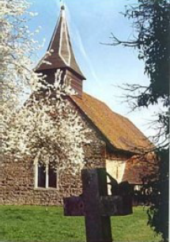
Bradwell with Pattiswick
Annual Parish Assembly Meeting

Monday 13 May 2024
7.00pm Bradwell Village Hall
Church Road, Bradwell, CM77 8EP

The Annual Parish Assembly Meeting is the yearly public meeting, chaired by the Parish Council, where residents are invited to come along to find out more about the work of community groups as well as the work of the Parish Council.
Agenda
- Welcome from the Chair
- PC James Draper, Braintree Community Safety & Engagement Officer, Essex Police
- Kelly Bleasdale, Senior Manager, Essex Dementia Care, The Dementia Society
- Michael Turner, Bradwell Village Hall Committee
- Cllr. Tony Dunn, Chair of Bradwell with Pattiswick Parish Council. Tony will be providing residents with an update on the Neighbourhood Plan re-fresh taking place later this year.

The meeting will close at 7.30pm and be followed by the Bradwell with Pattiswick Parish Council Annual Meeting (at 7.30pm*), and Bradwell with Pattiswick Parish Council Meeting (at 8.00pm*)

*These timings may be subject to change

