AN INVITATION
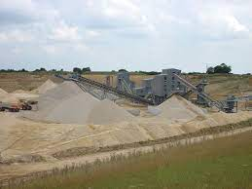
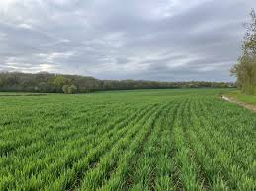
TO
“SAVE THE STISTED THREE”
A public consultation on the Replacement Minerals Local Plan for Essex commenced on Tuesday 6th February.
Three of the proposed sites are in/adjoin our beautiful and tranquil village. See maps below
Any one of these sites, if chosen, will have a devastating effect on the life of our village for both residents and those non-residents who visit Stisted.
It is up to all of us to ensure that such a calamity does not happen.
You are invited to an open drop-in meeting from 7.30 on 21 February in Stisted Village Hall
Information will be available on the three sites, plus help with responses.
We all need to work together on this

The PC website will have on-going up to date information on www.stisted-pc.co.uk Go to “Planning” tab
The full consultation documents are available on www.essex.gov.uk/minerals-review
Consultation closes on 19 March. All villagers and visitors are encouraged to comment
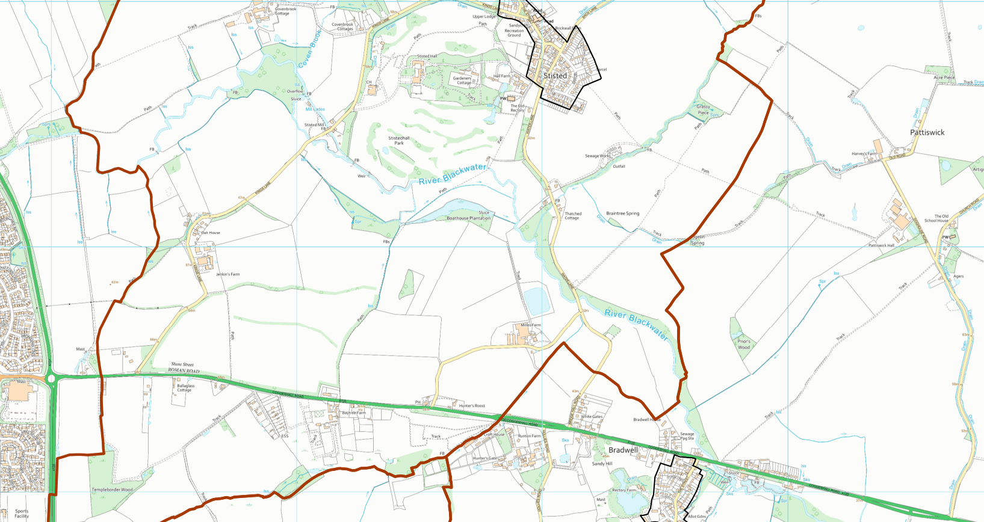
Covenbrooke Hall Farm A89 Pattiswick Hall Farm A92 & A93
Red Line: Proposed Sites Brown Line: Parish Boundaries
Any Queries: email stistedparishcouncil@yahoo.co.uk or Phone 07432 561177 (Alan Routledge)
SAGE 2024 (Stisted Against Gravel Extraction)

