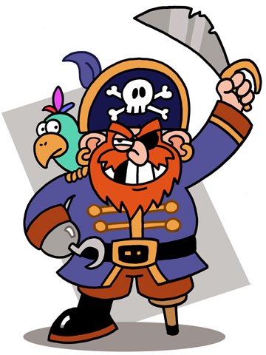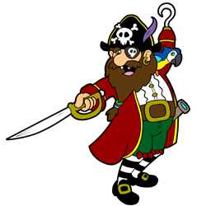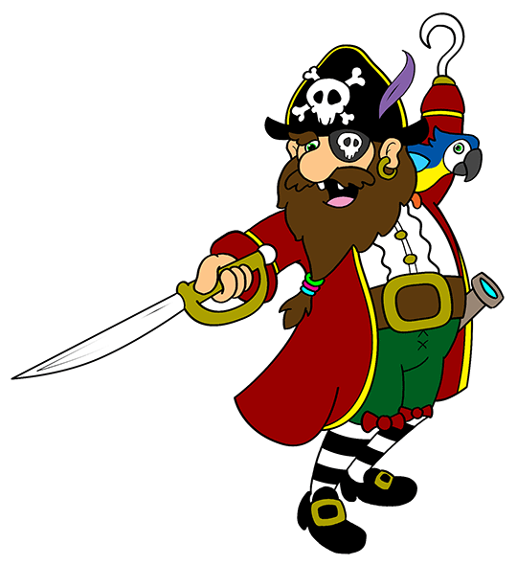
Ole' Blackeye was a pirate,
But he wasn't very good.
He wore patches over both eyes,
And a parrot on his foot!
His rotten ship and fraying flag,
Had seen much better days.
And his crew had all but left him,
'Cause they were not getting paid!
Ole' Blackeye couldn't read a map,
Or sail a route by star.
So he floated round in circles,
For near to not too far!
His wooden leg was broken,
And his beard a tangled mess.
The only help he had these days,
Was a scruffy dog called Jess.
Ole' Blackeye was a pirate,
And he knew at that he stunk.
So he packed it in and sold his boat,
Before he'd gotten sunk!
Ole' Blackeye was a pirate,
But he wasn't very good.
He wore patches over both eyes,
And a parrot on his foot!
His rotten ship and fraying flag,
Had seen much better days.
And his crew had all but left him,
'Cause they were not getting paid!
Ole' Blackeye couldn't read a map,
Or sail a route by star.
So he floated round in circles,
For near to not too far!
His wooden leg was broken,
And his beard a tangled mess.
The only help he had these days,
Was a scruffy dog called Jess.
Ole' Blackeye was a pirate,
And he knew at that he stunk.
So he packed it in and sold his boat,
Before he'd gotten sunk!

By Gareth Lancaster

