[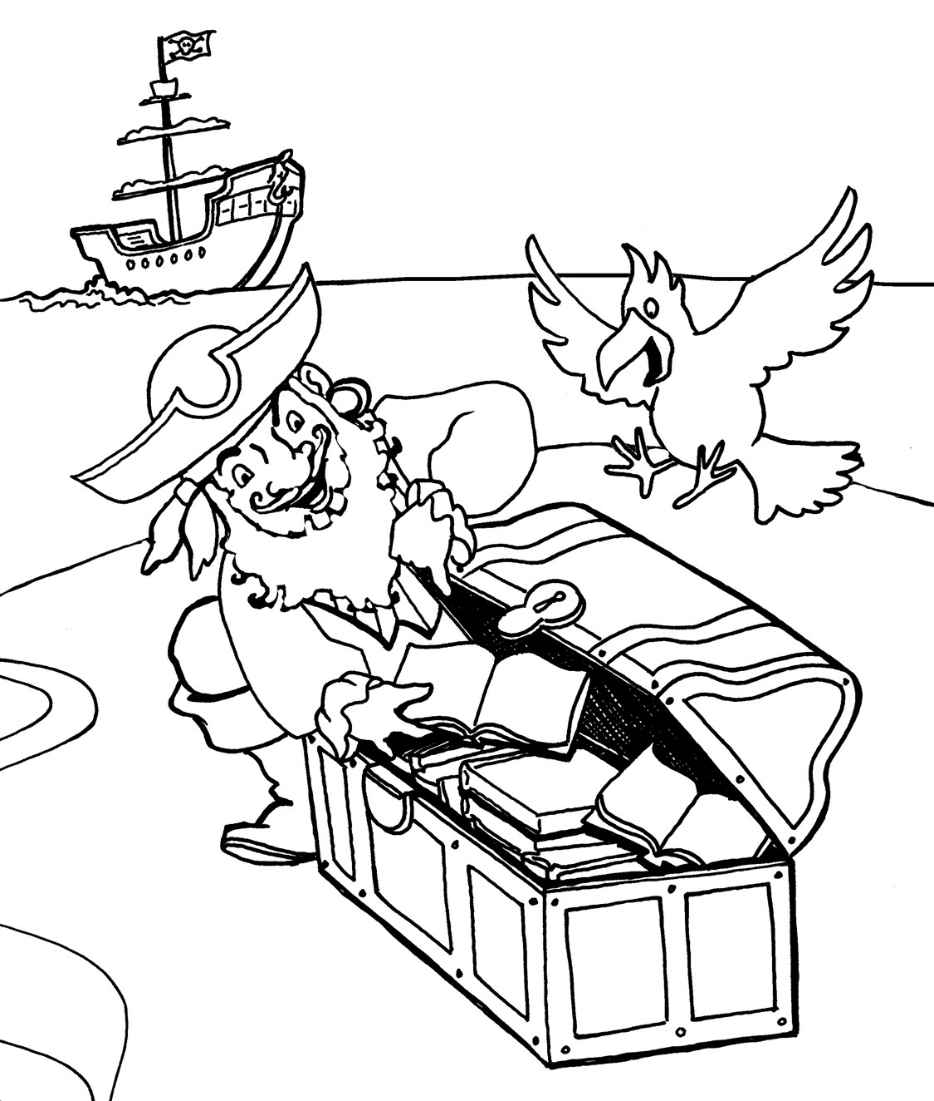](http://www.google.co.uk/url?sa=i&rct=j&q=&esrc=s&frm=1&source=images&cd=&cad=rja&uact=8&ved=0CAcQjRw&url=http://coba.nabilahbatik.com/&ei=QPeIVcSmCsG-UvL3gZAN&bvm=bv.96339352,d.ZGU&psig=AFQjCNEL2QFy2N6nq4W9lU2zR6qe_rcoLQ&ust=1435125905938208)