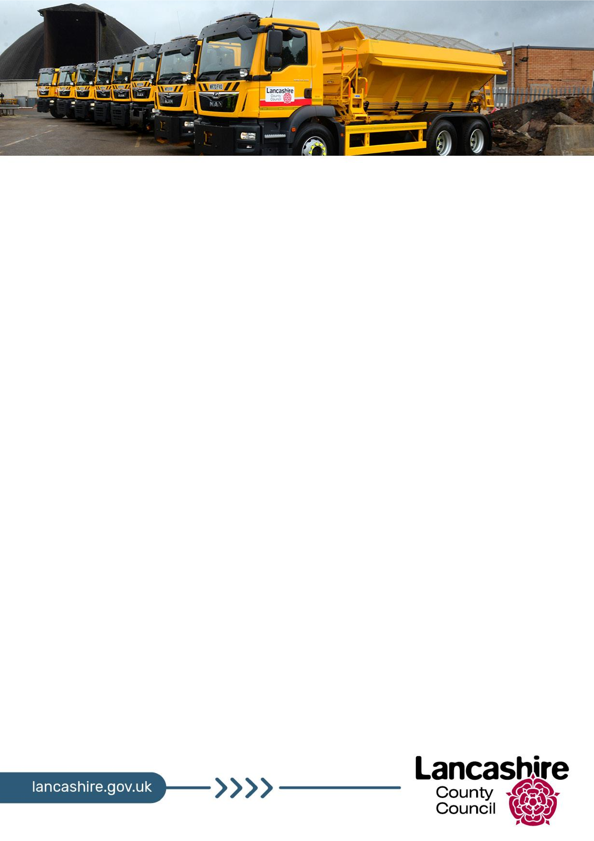

**Winter Service Briefing**

**202**

**3**

**/2**

**4**

**What is the winter service?**

Lancashire County Council has a legal duty to ensure, as far as reasonably practicable, that

people can use the highways safely without being endangered by ice and

snow. This means

we do everything we can to keep traffic moving on priority roads and work to minimise delays

and accidents where ice or snow is a contributory factor.

That is why we clearly identify the principal carriageways and footways that receive priority

treatment for salting and snow clearing, and

ask everyone to take steps to make sure that,

when severe winter weather strikes, they are prepared and able to manag

e.

The

[Winter Service Pla](https://www.lancashire.gov.uk/council/strategies-policies-plans/roads-parking-and-travel/)

[n](https://www.lancashire.gov.uk/council/strategies-policies-plans/roads-parking-and-travel/)

sets out these priorities.

**Winter 202**

**2**

**/2**

**3**

The 202

2

/2

3

winter season saw

more frequent pre

-

salting

due to ice

and some periods of

snow

resulting in 4224 actions over 80 days compared with 4000

treatments

over 90 days in

2021/22

. We used

19,044

tonnes of grit over the course of the season which is

more than

2021/22

when we used

16,700

.

**Forecasting the weather**

Between 1 October and 30 April, we use daily weather forecasts along with the data from our

own 12 weather stations to gather information about road surface temperature, air

temperature, humidity and an indication of rain, to make

a decision on whether gritting is

necessary.

**Where we grit**

Of the 4,300 miles of roads which we are responsible for, around a third (approximately 1,500

miles) are part of our priority road network for gritting and snow clearing. In severe weather

conditio

ns, we rotate our drivers so we can keep the gritters on the road 24/7 if needs be.

We always treat the following roads first as part of our

[priority road networ](https://www.lancashire.gov.uk/winter/gritting/gritting-map/)

[k](https://www.lancashire.gov.uk/winter/gritting/gritting-map/)

[:](https://www.lancashire.gov.uk/winter/gritting/gritting-map/)

▪

**Non**

**-**

**trunk motorways and A roads**

–

the main routes across the county.

▪

**B roads**

–

other main roads in and out of towns.

▪

**Single rou**

**tes in and out of all villages.**

We also aim to treat the second most important roads during periods of **continuous ice or snow**, in daylight hours and after the higher priority roads have been treated. We've also identified priority footway networks in each of the districts, and we work with district councils to treat these footpaths during periods of ice or heavy snow.

Highways England is responsible for gritting the M6, M55, M58, M61 and M65 to Junction 10, the A56 between the M66 and M65 and the A585 between the M55 and Fleetwood.

**How we have prepared**

* **Salt** – we have approximately 22,800 tonnes of salt, located in seven operational depots and with the remainder in strategic locations around the county. We also have 30,000 litres of liquid de-icer available for circumstances where temperatures fall below the threshold where salt becomes ineffective and compacted snow proves resistant to snow ploughing. It will only be used on key strategic locations such as junctions on our main arterial roads.



* **Staff** – there are approximately 160 staff on the winter service rota, 53 of whom are on call 24/7. They are directly employed by the county council and also have daytime commitments.
* **Grit bins** – we have 2,930 grit bins/salt piles stocked with 750 tonnes of salt for use on the highway in strategic locations based on a strict criteria. All grit bins are re-stocked in the lead up to winter and throughout the season when needed.
* **Fleet** - 45 front line gritters operate countywide from seven depots with a reserve fleet of 15. All gritters are paired with a dedicated plough for use in times of snow. These are supplemented by snow blowers, tractors, 4-wheel drive utility trucks, and footway gritting equipment.
* **Vehicle navigation system** - satellite navigation and GPS controlled automatic salting systems allow any driver to drive any route if necessary.
* **Agricultural contractors** – a number of farmers and contractors who have equipment to carry out snow clearing works on roads provide additional support at times when our resources are stretched. They can be deployed at short notice predominantly for use on the rural network.

**Additional resources during severe weather**

We work with district councils, parish and town councils through the Lancashire Association of Local Councils (LALC) and with interested farmers and contractors to improve resilience in dealing with prolonged severe winter weather.

**How much does it all cost?**

We budget **£4m** per year on the winter service, however it is a demand-led service and when the winter weather is more severe, the service will continue to be delivered, subject to the availability of a wide range of resources, not least salt. We spent **£4.64m** responding to severe weather in 2022/23, which included delivering the winter service and responding to storm events involving flooding and strong winds.

**We all have a role to play this winter - we're prepared, are you?**

**We do everything we can to keep traffic moving on priority roads and we are open about the fact we cannot grit every road in Lancashire. Even if we had the resources needed we couldn't grit them quickly**

**enough to make a real difference.**

**No council does this. It is important people understand there are limitations to the service we can**

**provide.**

**That is why we ask residents to take steps to make sure that when severe winter weather strikes they** **are prepared and able to manage.**

As an important stakeholder you can help communicate our winter policies and procedures, and the circumstances in which we implement them. We need your support to help manage public expectations.

**Advice for residents:**

* **Find out if you are on a gritting route and don't block the road** -if you park your car on a main road or gritting route during winter, please make sure it's not causing an obstruction as blocked roads could mean we are unable to grit that road. [Gritting map.](http://www.lancashire.gov.uk/winter/gritting/gritting-map)
* **Stock up on salt/grit** -stock up on salt/grit for your personal use from a range of DIY stores. It's also useful to have a snow shovel, a torch, batteries and a first aid kit handy.
* **Schools** - schools are classed as private grounds and gritting them is not a county council function. We do however give schools in Lancashire the opportunity to buy grit from us at the start of the winter. [School closures.](http://www.lancashire.gov.uk/winter/unavoidable-closures)
* **Take extra care** -during freezing conditions do not assume a road has been treated and drive with caution, ice could have formed despite our efforts.
* **Clearing snow and ice yourself** -there is no law about clearing snow and ice on the pavement outside your property or public spaces. [More information about clearing snow.](https://www.lancashire.gov.uk/winter/were-prepared-are-you/tips-for-clearing-snow-and-ice/)
* **Prepare your business** - [advice for businesses](https://www.lancashire.gov.uk/winter/were-prepared-are-you/prepare-your-business/) in helping them stay operational during winter.
* **Support for businesses** - we give permission for some businesses to use, at their own expense, an approved contractor to clear snow from roads that are not on the county council's priority or secondary networks.
* **Travelling safely during the winter** - check the weather forecast before you set off and leave extra time for your journey during winter. [Travelling safely.](https://www.lancashire.gov.uk/winter/travelling-safely/)
* **Looking after older and vulnerable people** - look after yourself and keep an eye on friends, relatives and older neighbours who may be more vulnerable to the cold weather, especially if they suffer from any ongoing medical conditions.
* **Grit bins** - how often we re-fill grit bins depends on a number of factors including weather, the number of grit bins needing to be filled, and the availability of material. Help everyone by not using the grit for purposes other than for gritting the roads and pavements in the vicinity of the bin. They are placed in strategic locations to help deal with specific hazards and using the grit for other purposes could lead to unnecessary risks to other people if the grit runs out. We restock grit bins throughout the season, however they are all mapped on Love Clean Streets and any which are empty can be reported to us via the app or the county council's website.

**Share and post messages**

* Help us by sharing messages on Facebook and Twitter and promote the work of our gritting team by posting positive messages which direct people to our winter website. Gritting updates are also posted on the website and our social media channels.

**Website** - [www.lancashire.gov.uk/winter](http://www.lancashire.gov.uk/winter)

**Twitter/X** -[www.twitter.com/lancashirecc](http://www.twitter.com/lancashirecc)

**Facebook** - [www.facebook.com/lancashirecc](http://www.facebook.com/lancashirecc)

* **Winter bulletins** - during continuous severe weather we will also issue regular winter bulletins to keep you updated on the weather forecast and gritting activity.